UNITED STATES
SECURITIES AND EXCHANGE COMMISSION
WASHINGTON, D.C. 20549
_____________
FORM 10-K
_____________
(Mark One)
☒ |  |  | ANNUAL REPORT PURSUANT TO SECTION 13 OR 15(d) OF THE SECURITIES EXCHANGE ACT OF 1934
For the fiscal year ended October 31, 2023
OR

☐ |  |  | TRANSITION REPORT PURSUANT TO SECTION 13 OR 15(d) OF THE SECURITIES EXCHANGE ACT OF 1934
For the transition period from to
Commission file number: 001-39561
_____________

MISSION PRODUCE, INC.
(Exact name of Registrant as specified in its charter)
_____________

Delaware
(State or Other Jurisdiction of
Incorporation or Organization)
2710 Camino Del Sol
Oxnard, California
(Address of Principal Executive Offices)
95-3847744
(I.R.S. Employer
Identification No.)
93030
(Zip Code)

Registrant’s Telephone Number, Including Area Code: (805) 981-3650
_____________
Securities registered pursuant to Section 12(b) of the Act:

Title of each class |  |  |  |  |  | Trading Symbol(s) |  |  |  |  |  | Name of each exchange on which registered
Common Stock, par value $0.001 per share |  |  |  |  |  | AVO |  |  |  |  |  | NASDAQ Global Select Market
Securities registered pursuant to Section 12(g) of the Act: None

Indicate by check mark if the registrant is a well-known seasoned issuer, as defined in Rule 405 of the Securities Act. Yes ☐ No ☒
Indicate by check mark if the registrant is not required to file reports pursuant to Section 13 or Section 15(d) of the Act. Yes ☐ No ☒
Indicate by check mark whether the registrant (1) has filed all reports required to be filed by Section 13 or 15(d) of the Securities Exchange Act of 1934 during the preceding 12 months (or for such shorter period that the registrant was required to file such reports), and (2) has been subject to such filing requirements for the past 90 days. Yes ☒ No ☐
Indicate by check mark whether the registrant has submitted electronically every Interactive Data File required to be submitted pursuant to Rule 405 of Regulation S-T (§232.405 of this chapter) during the preceding 12 months (or for such shorter period that the registrant was required to submit such files). Yes ☒ No ☐
Indicate by check mark whether the registrant is a large accelerated filer, an accelerated filer, a non-accelerated filer, a smaller reporting company, or an emerging growth company. See the definitions of “large accelerated filer,” “accelerated filer,” “smaller reporting company,” and “emerging growth company” in Rule 12b-2 of the Exchange Act.
Large accelerated filer |  |  | ☐ |  |  |  |  |  | Accelerated filer |  |  | ☒
Non-accelerated filer |  |  | ☐ |  |  |  |  |  | Smaller reporting company |  |  | ☐
Emerging growth company |  |  | ☐
If an emerging growth company, indicate by check mark if the registrant has elected not to use the extended transition period for complying with any new or revised financial accounting standards provided pursuant to Section 13(a) of the Exchange Act. ☐
Indicate by check mark whether the registrant has filed a report on and attestation to its management’s assessment of the effectiveness of its internal control over financial reporting under Section 404(b) of the Sarbanes-Oxley Act (15 U.S.C. 7262(b)) by the registered public accounting firm that prepared or issued its audit report. Yes ☒ No ☐
Indicate by check mark whether the registrant is a shell company (as defined in Rule 12b-2 of the Act). Yes ☐ No ☒
If securities are registered pursuant to Section 12(b) of the Act, indicate by check mark whether the financial statements of the registrant included in the filing reflect the correction of an error to previously issued financial statements. ☐
Indicate by check mark whether any of those error corrections are restatements that required a recovery analysis of incentive-based compensation received by any of the registrant’s executive officers during the relevant recovery period pursuant to §240.10D-1(b). ☐
As of April 30, 2023, the aggregate market value of the registrant’s common stock held by non-affiliates of the registrant was approximately $483 million, based on the closing price of the registrant’s common stock on the Nasdaq Global Select Market on April 28, 2023 of $11.39 per share.
As of December 1, 2023, the registrant had 70,729,717 shares of common stock at $0.001 par value outstanding.

DOCUMENTS INCORPORATED BY REFERENCE
Certain sections of the registrant’s definitive proxy statement for the 2024 annual meeting of stockholders to be filed with the Securities and Exchange Commission pursuant to Regulation 14A not later than 120 days after the end of the fiscal year covered by this Form 10-K are incorporated by reference into Part III of this Form 10-K.

MISSION PRODUCE, INC.
TABLE OF CONTENTS

FORM 10-K
FISCAL YEAR 2023

PART I
Item 1. |  |  |  |  |  | Business |  |  | 1
Item 1A. |  |  |  |  |  | Risk Factors |  |  | 4
Item 1B. |  |  |  |  |  | Unresolved Staff Comments |  |  | 16
Item 2. |  |  |  |  |  | Properties |  |  | 16
Item 3. |  |  |  |  |  | Legal Proceedings |  |  | 17
Item 4. |  |  |  |  |  | Mine Safety Disclosures |  |  | 17
PART II
Item 5. |  |  |  |  |  | Market for Registrant’s Common Equity, Related Stockholder Matters and Issuer Purchases of Equity Securities |  |  | 17
Item 6. |  |  |  |  |  | Reserved |  |  | 19
Item 7. |  |  |  |  |  | Management's Discussion and Analysis of Financial Condition and Results of Operations |  |  | 19
Item 7A. |  |  |  |  |  | Quantitative and Qualitative Disclosures About Market Risk |  |  | 30
Item 8. |  |  |  |  |  | Financial Statements and Supplementary Data |  |  | 31
Item 9. |  |  |  |  |  | Changes in and Disagreements with Accountants on Accounting and Financial Disclosure |  |  | 31
Item 9A. |  |  |  |  |  | Controls and Procedures |  |  | 31
Item 9B. |  |  |  |  |  | Other Information |  |  | 32
Item 9C. |  |  |  |  |  | Disclosure Regarding Foreign Jurisdictions that Prevent Inspections |  |  | 32
PART III
Item 10. |  |  |  |  |  | Directors, Executive Officers and Corporate Governance |  |  | 32
Item 11. |  |  |  |  |  | Executive Compensation |  |  | 33
Item 12. |  |  |  |  |  | Security Ownership of Certain Beneficial Owners and Management and Related Stockholder Matters |  |  | 33
Item 13. |  |  |  |  |  | Certain Relationships and Related Transactions, and Director Independence |  |  | 33
Item 14. |  |  |  |  |  | Principal Accountant Fees and Services |  |  | 33
PART IV
Item 15. |  |  |  |  |  | Exhibit and Financial Statement Schedules |  |  | 33
Item 16. |  |  |  |  |  | Form 10-K Summary |  |  | 35
 |  |  |  |  |  | Signatures |  |  | 36

FORWARD LOOKING STATEMENTS
This annual report on Form 10-K contains forward-looking statements within the meaning of the federal securities laws, including the Private Securities Litigation Reform Act of 1995, which statements involve substantial risks and uncertainties. Forward-looking statements generally relate to future events or our future financial or operating performance. In some cases, you can identify forward-looking statements because they contain words such as “may”, “will”, “should”, “expects”, “plans”, “anticipates”, “could”, “intends”, “target”, “projects”, “contemplates”, “believes”, “estimates”, “predicts”, “potential” or “continue” or the negative of these words or other similar terms or expressions that concern our expectations, strategy, plans or intentions. Forward-looking statements involve known and unknown risks, uncertainties and other important factors that may cause our actual results, performance or achievements to be materially different from any future results, performance or achievements expressed or implied by the forward-looking statements. We believe that these factors include, but are not limited to, the following:
•Risks related to our business, including: limitations regarding the supply of fruit, either through purchasing or growing; fluctuations in the market price of fruit; increasing competition; risks associated with doing business internationally, including Mexican and Peruvian economic, political and/or societal conditions; inflationary pressures; establishment of sales channels and geographic markets; loss of one or more of our largest customers; general economic conditions or downturns; supply chain failures or disruptions; disruption to the supply of reliable and cost-effective transportation; failure to recruit or retain employees, poor employee relations, and/or ineffective organizational structure; inherent farming risks, including climate change; seasonality in operating results; failures associated with information technology infrastructure, system security and cyber risks; new and changing privacy laws and our compliance with such laws; food safety events and recalls; failure to comply with laws and regulations; changes to trade policy and/or export/import laws and regulations; risks from business acquisitions, if any; lack of or failure of infrastructure; material litigation or governmental inquiries/actions; failure to maintain or protect our brand; changes in tax rates or international tax legislation; risks associated with global conflicts; and inability to accurately forecast future performance.
•Risks related to our common stock, including: the viability of an active, liquid, and orderly market for our common stock; volatility in the trading price of our common stock; concentration of control in our executive officers, and directors over matters submitted to stockholders for approval; limited sources of capital appreciation; significant costs associated with being a public company and the allocation of significant management resources thereto; reliance on analyst reports; failure to maintain proper and effective internal control over financial reporting; restrictions on takeover attempts in our charter documents and under Delaware law; and the selection of Delaware as the exclusive forum for substantially all disputes between us and our stockholders.
•Risks related to restrictive covenants under our credit facility, which could affect our flexibility to fund ongoing operations, uses of capital and strategic initiatives, and, if we are unable to maintain compliance with such covenants, lead to significant challenges in meeting our liquidity requirements and acceleration of our debt.
We have based the forward-looking statements contained in this report primarily on our current expectations and projections about future events and trends that we believe may affect our business, financial condition, results of operations, prospects, business strategy and financial needs. The outcome of the events described in these forward-looking statements is subject to risks, uncertainties, assumptions and other factors described in “Item 1A. Risk Factors” and elsewhere in this report. These risks are not exhaustive. Other sections of this report include additional factors that could adversely impact our business and financial performance. Furthermore, new risks and uncertainties emerge from time to time and it is not possible for us to predict all risks and uncertainties that could have an impact on the forward-looking statements contained in this report. We cannot assure you that the results, events and circumstances reflected in the forward-looking statements will be achieved or occur, and actual results, events or circumstances could differ materially from those described in the forward-looking statements.
In addition, statements that “we believe” and similar statements reflect our beliefs and opinions on the relevant subject. These statements are based upon information available to us as of the date of this report, and while we believe such information forms a reasonable basis for such statements, such information may be limited or incomplete, and our statements should not be read to indicate that we have conducted an exhaustive inquiry into, or review of, all potentially available relevant information. These statements are inherently uncertain and investors are cautioned not to unduly rely upon these statements.
You should read this report, including documents that we reference and exhibits that have been filed, in this report and have filed as exhibits to this report, with the understanding that our actual future results, levels of activity, performance and achievements may be materially different from what we expect. We qualify all of our forward-looking statements by these cautionary statements.
The forward-looking statements made in this report relate only to events as of the date on which such statements are made. We undertake no obligation to update any forward-looking statements after the date of this report or to conform such statements to actual results or revised expectations, except as required by law.
This annual report may also include trademarks, tradenames and service marks that are the property of the Company and also certain trademarks, tradenames and service marks that are the property of other organizations. Solely for convenience, trademarks and tradenames referred to in this annual report appear without the ® and ™ symbols, but those references are not intended to indicate, in any way, that we will not assert, to the fullest extent under applicable law, our rights, or that the applicable owner will not assert its rights, to these trademarks and tradenames.

We maintain a website at www.missionproduce.com, to which we regularly post copies of our press releases as well as additional information about us. Our filings with the Securities and Exchange Commission (“SEC”), are available free of charge through our website as soon as reasonably practicable after being electronically filed with or furnished to the SEC. Information contained in our website does not constitute a part of this report or our other filings with the SEC.

PART I

Item 1. Business
Overview
Mission Produce, Inc. together with its consolidated subsidiaries (“Mission Produce” or the “Company,” “Registrant,” or “Issuer,” and generally referred to as “we” or “us”), is a global leader in the avocado industry. The Company’s expertise lies in the farming, packaging, marketing and distribution of avocados to food retailers, distributors and produce wholesalers worldwide. The Company procures avocados principally from California, Mexico and Peru. Through our various operating facilities, we grow, sort, pack, bag and ripen avocados and a small amount of other fruits for distribution to domestic and international markets. We report our results of operations in three operating segments which are also reportable segments:
•Marketing and Distribution sources fruit from growers and then distributes fruit through our global distribution network;
•International Farming owns and operates orchards from which the vast majority of fruit produced is sold to our Marketing and Distribution segment. The segment’s farming activities range from cultivating early-stage plantings to harvesting from mature trees. It also earns service revenues for packing and processing fruit for both our Blueberries segment, as well as for third-party producers of other crops. Operations are principally located in Peru, with smaller operations emerging in other areas of Latin America.
•Blueberries is a farming operation that cultivates blueberry plants in Peru. The entity farms high-quality varieties of blueberries, and has plants in various stages of development, from seedling to mature.
Products and services
We primarily source, produce, pack and distribute avocados. The avocados we sell are primarily of the Hass variety. We sort and pack avocados and match their specifications to respective customer requirements. We sell both pre-ripe and ripened avocados, and with our network of ripening facilities, we can adjust the level of ripeness to the needs of our customers. Our custom ripening programs provide customers with the option of ordering avocados at five different stages of ripeness – hard, preconditioned, breaking, firm-ripe and ripe – which are delivered on specifically tailored schedules according to stage of ripeness. In 2021, we also began marketing mangos on a limited scale. Mangos are complementary to avocados as they typically have opposite seasons, allowing us to leverage and maintain absorption of our distribution network.
We also provide value-added services including ripening, bagging, custom packaging, logistical management, and quality assurance. In addition, we provide our customers with merchandising and promotional support, insights on market trends and hands-on training to assist with their retail sales of our avocados. For example, we operate category management, merchandising and packaging programs, such as our “Avo Intel,” “Minis—small but mighty,” “Emeralds in the Rough,” “Ready,” “Size Minded,” “Jumbos—more to eat, more to love” and shelf-life extension programs, to promote the sale of avocados that might otherwise be underutilized, to identify ready-to-eat and various size avocados for consumers and to increase shelf life.
In our Blueberries segment, we act as growers. Our exclusive supply agreement with an exclusive distributor allows us to utilize our existing infrastructure and workforce in Peru during complementary periods between avocado harvest and processing seasons.
Customers
We primarily market avocados to retail, wholesale and foodservice customers. We focus on delivering quality avocados on time and within customer specifications. We forecast avocado sourcing costs for the season for our own production, which enables us to enter into fixed price contracts with customers for a season without bearing pricing risk from spot market purchases. We do not have long-term supply contracts with our customers and focus instead on building strong, long-term relationships based on product quality and specifications, on-time delivery and customer support and service.
Supply chain and distribution network
Our global distribution network includes strategically located forward distribution centers across North America, China, Europe, and the U.K. equipped to offer value-added services such as ripening, bagging, custom packaging and logistical management. Our network of distribution facilities puts us in close proximity to our customers, allowing us to provide fruit based on customer timing, specification, and volume needs. Within the United States, we can deliver avocados within approximately eight hours or less.
Before being forwarded to distribution centers, avocados are sorted and packed at one of our four state-of-the-art packing facilities in Mexico, Peru, and California, or by co-packers in various locations. Our packing facilities are located in close proximity to
1

growers, allowing us to control the logistics of the supply chain from tree to packing, to distribution. Transportation logistics are managed across truck, ocean, air and rail platforms, depending on origin and end markets.
Competition
We compete based on a variety of factors, including the appearance, taste, size, shelf life and overall quality of our fruit, price and distribution terms, the timeliness of our deliveries to customers and the availability of our products. The avocado and fresh produce business is highly competitive, and the effect of competition is intensified because our products are perishable. Marketing competitors include other distributors, producers, and other smaller packers and marketers. Farming competitors include other farming businesses of all sizes, from large-scale businesses and cooperatives, to individual farms.
Resources
We source avocados primarily from Mexico, Peru, and California, as well as Colombia, Guatemala, South Africa, Chile, and other locations. Our diverse sourcing network mitigates the impact of potential geographical or grower-specific supply disruptions and optimizes our ability to fulfill year-round global demand.
Third-party growers
We have relationships with thousands of third-party growers. Our large scale and long track record of working with growers contributes to strong existing relationships and facilitates new relationships with third-party growers. We do not have exclusive sourcing contracts with growers.
Farming
In addition to purchasing avocados from third-party growers, we have vertically integrated farming operations where we grow avocados on owned or leased land. In Peru, we own farmland with developed orchards that are in various stages of maturity. Since fiscal 2020, we have progressively planted new orchards in Guatemala on land under long-term leases, to diversify our vertical integration sourcing strategy. We also invest in a joint venture in Colombia that owns land that is under development. After planting, avocado trees begin to produce avocados in approximately three years and typically reach full production in approximately five to seven years, depending on location. We continue to innovate our farming practices to control the quality of our fruit, through various test plots, seed research, and soil analysis.
As of October 31, 2023, our approximate international avocado planted acreage, by age and rounded to the nearest hundred, was as follows:
 |  |  | Avocado Acreage by Age
Country |  |  | 0-3 years |  |  | 4-6 years |  |  | >7 years |  |  | Total
Peru |  |  | 2,400 |  |  | 800 |  |  | 6,400 |  |  | 9,600
Guatemala |  |  | 1,800 |  |  | — |  |  | — |  |  | 1,800
Colombia(1) |  |  | 1,500 |  |  | 200 |  |  | — |  |  | 1,700
Total |  |  | 5,700 |  |  | 1,000 |  |  | 6,400 |  |  | 13,100
(1) Acreage in Colombia is farmed through a joint venture.
We are also involved in the farming of other fruits on a limited scale. We have planted mango orchards in Peru to enable us to realize synergies from labor and facility management during the avocado off-season. We have also invested in a blueberry farming joint venture, Moruga. While we do not market blueberries, our investment in Moruga further allows us to leverage labor and facility investments in Peru.
Intellectual property
We have registered or submitted registrations for certain trademarks with the United Stated Patent and Trademark Office and with the appropriate bodies in international jurisdictions, including The MISSION & TOWER DESIGN® and MISSION PRODUCE™. In addition, we have several issued patents and copyrights that are not material to our business at this time.
Seasonality
The total sales and sales price of avocados fluctuates throughout the year due to variations in supply of avocados based on geographic location. For example, in California and Peru, the harvest of avocados typically peaks between April and September. In Mexico, avocados are harvested year-round, but the harvest typically peaks between December through March. Although these
2

geographical differences may lead to fluctuations in the purchase price of avocados, our diverse geographical avocado growth and production capabilities help us mitigate volatility in our access to supply of avocados. As a result of the volumes sourced from our farming operations in Peru, we realize a greater portion of our gross profit during the third and fourth quarters of our fiscal year. Sales in our Blueberries segment are concentrated in the first and fourth quarters of our fiscal year in alignment with the Peruvian blueberry harvest season, which typically runs from July through January.
People
As of October 31, 2023, we had approximately 3,300 employees located worldwide, of which, 1,800 were located in Peru, 600 were located in Mexico, 500 were located in the U.S., and 400 were located in other regions such as Guatemala, the U.K., Europe and Canada. Our headcount in Peru is inclusive of our Moruga blueberry operation. Due to the cyclical nature of avocado production, we also hire temporary and seasonal workers on our farms in Peru and packing houses in the U.S. and Mexico to meet our needs.
We seek to provide an attractive workplace for our people by adhering to and demonstrating our values: FIRST – fun, innovative, reliable, successful, and trustworthy. We are actively involved in supporting our surrounding communities, and we contribute to important causes, including those focused on children, families, and agriculture education.
Regulation and Industry Associations
Our business is impacted by general and industry-specific government regulations and requirements. Below is a summary of some of the significant industry or commodity-related regulations that impact our business.
As an agricultural producer and marketer of consumable products, our operations are subject to extensive regulation by various federal government agencies, including the FDA, the USDA and the Federal Trade Commission (“FTC”), as well as state and local agencies, with respect to product attributes, packing, labeling, storage and distribution. Under various statutes and regulations, these agencies prescribe requirements and establish standards for safety, purity and labeling. In addition, advertising of our products is subject to regulation by the FTC, and our operations are subject to health and safety regulations, including those issued under the Occupational Safety and Health Act (“OSHA”). Our packing facilities and products are subject to periodic inspection by federal, state and local authorities, including FDA review of our compliance with the Food Safety Modernization Act ("FSMA") at all of our U.S. facilities. In addition, our operations in Mexico are subject to Mexican regulations, our operations in Peru are subject to Peruvian regulations, and our operations in Europe and the U.K. are subject o applicable regulations for those regions.
We are subject to numerous federal, state, local and foreign environmental laws and regulations. These laws and regulations govern, among other matters, the treatment, handling, storage, use and disposal of, and exposure to, hazardous materials and waste, including herbicides, fertilizers, pesticides and other agricultural products, the remediation of contaminated properties and climate change.
In the U.S., the Hass Avocado Board was established by the USDA to promote the sale of Hass variety avocados. This board provides a basis for unified funding of promotional activities based on an assessment on all avocados sold in the U.S. marketplace. The California Avocado Commission, which receives its funding from California avocado growers, has historically shouldered the promotional and advertising costs supporting avocado sales. We believe that the incremental funding of promotional and advertising programs in the U.S. will, in the long term, positively impact average selling prices and will favorably impact our avocado businesses. Similarly, Avocados from Mexico (“AFM”) was formed in 2013 as the marketing arm of the Mexican Hass Avocados Importers Association (“MHAIA”) and the Association of Growers and Packers of Avocados From Mexico (“APEAM”). In Peru, the organization Pro Hass promotes the marketing of high-quality Hass avocados, providing support to the local industry with technical research, packaging, and production.
Available Information
Our corporate headquarters are located at 2710 Camino Del Sol, Oxnard, California, and our telephone number is (805) 981-3650. Our internet address is www.missionproduce.com. The information on or that can be accessed through our website is not incorporated by reference in this report.
We make available free of charge certain reports and amendments that we file with the SEC, such as our annual reports on Form 10-K, quarterly reports on Form 10-Q, current reports on Form 8-K, our directors’ and officers’ Section 16 reports, as soon as reasonably practicable after filing or furnishing such materials to the SEC on the “Investor relations” section of our website. They are also available free of charge on the SEC’s website at www.sec.gov.

3

Item 1A. Risk Factors
You should carefully consider the following risk factors, together with the other information contained in this annual report on Form 10-K, including our financial statements and the related notes and “Management’s Discussion and Analysis of Financial Condition and Results of Operations,” before making a decision to purchase or sell shares of our common stock. We cannot assure you that any of the events discussed in the risk factors below will not occur. These risks could have a material and adverse impact on our business, results of operations, financial condition and growth prospects. If that were to happen, the trading price of our common stock could decline. Additional risks and uncertainties not presently known to us or that we currently deem immaterial also may impair our business operations or financial condition.
Risks Related to Our Business
Our ability to generate revenues is limited by the supply of fruit and our ability to purchase or grow additional fruit.
Our ability to distribute fruit is limited by our ability to acquire supply from third-party growers and to produce on our own farms. With a limited number of trees on our farms and on the farms from which we purchase, our ability to obtain supply from third parties and adapt to any changes in demand of our product is constrained. If we are unable to purchase sufficient volumes from third-party growers at acceptable prices or demand for our products were to increase in the future, we would need additional production capacity, which may take time, whether by purchasing additional fruit from third-party suppliers or by waiting for our younger plants to bear fruit. These purchases may expose us to increases in short-term costs and additional production exposes us to additional long-term operating costs. If supply decreases dramatically, whether as a result of damage to farms, inclement weather, drought, labor issues, or other problems, prices have and could dramatically increase and we may not be able to purchase sufficient fruit. The impact of the limited supply and increased prices could decrease our revenues or increase our costs of goods sold, which would harm our business and financial results.
Our profitability is sensitive to fluctuations in market prices of our products which we do not control.
The pricing of fruit we purchase for distribution depends on supply, and excess supply can lead to price competition in our industry. Growing conditions in various parts of the world, particularly weather conditions such as windstorms, floods, droughts, wildfires, abnormally warm or cold weather patterns, and freezes, as well as diseases and pests, are primary factors affecting market prices because of their influence on the supply, size, and quality of product.
Pricing also depends on quality. Fresh produce is highly perishable and generally must be brought to market and sold soon after harvest. The selling price received depends on the availability and quality offered by us to customers and what comparable offerings are available in the market generally.
Pricing also depends on demand, and consumer preferences for particular food products are subject to fluctuations over time. Shifts in consumer preferences that impact demand at any given time can result from a number of factors, including dietary trends, price, attention to particular nutritional aspects, concerns regarding the health effects of particular products, attention given to product sourcing practices, economic factors, sustainability and ethical issues associated with supply chain practices, and general public perception of food safety risks. Consumer demand for our products also may be impacted by any public commentary that consumers may make regarding our products, as well as by changes in the level of advertising or promotional support that we employ or that are employed by relevant industry groups or third parties. If consumer preferences trend negatively with respect to our products, our sales volumes may decline as a result.
We are subject to increasing competition that may adversely affect our operating results.
The market for our products is highly competitive. Competition for the purchase of our products from suppliers and the sale of our products to our customers primarily comes from other distributors. If we are unable to consistently pay growers a competitive price for their fruit, these growers may choose to have their fruit marketed by alternative distributors. If we are unable to offer attractive prices or consistent supply to retail and wholesale customers, they may choose to purchase from other companies. Such competition may adversely affect our volumes and prices, which would harm our business and results of operations.
We are subject to the risks of doing business internationally and our current international operations are subject to a number of inherent risks.
We conduct a substantial amount of business internationally, including: doing business with growers and customers who are located outside the United States; purchasing fruit from growers and packers in Mexico and other countries; owning or leasing thousands of acres of farms in other countries, operating packing facilities in Peru and Mexico, having a farming joint venture in Colombia and a minority investment in South Africa, operating sales and distribution offices in China and in Europe, and selling products to foreign customers. We also continually explore sourcing, distribution and sales opportunities in additional countries. Conducting business internationally has exposed, and continues to expose, us to a variety of risks, including:
•Changes in legal or regulatory requirements affecting foreign investment, taxes, labor, imports and exports or changes in or interpretations of foreign regulations that may adversely affect our ability to sell our products, repatriate profits to the United States or operate our foreign-located facilities;
4

•increased demands on our limited resources created by our operations may constrain the capabilities of our administrative and operational resources and restrict our ability to attract, train, manage and retain qualified management, technicians, scientists and other personnel;
•difficulties associated with staffing and managing foreign operations;
•multiple, conflicting and changing laws and regulations such as tariffs and tax laws, export and import restrictions, employment laws, regulatory requirements and other governmental approvals, permits and licenses;
•potential failure by us or third parties we rely on to obtain and/or maintain regulatory approvals for the sale or use of our products in various countries;
•difficulties in managing global operations;
•logistics and regulations associated with shipping products, including infrastructure conditions and transportation delays;
•financial risks, such as longer payment cycles, difficulty enforcing contracts and collecting accounts receivable, and exposure to currency exchange rate fluctuations;
•reduced protection for intellectual property rights, or lack of them in certain jurisdictions;
•economic weakness or instability, economic recessions, political and economic instability, including corruption, wars and regional or global conflicts, terrorism and political unrest, outbreak of disease, boycotts, curtailment of trade and other business restrictions;
•failure to comply with the Foreign Corrupt Practices Act, or other similar laws, including its books and records provisions and its anti-bribery provisions, by maintaining accurate information and control over sales activities and distributors’ activities;
•failure to comply with restrictions on the ability of companies to do business in foreign countries;
•restrictive U.S. and foreign governmental actions, such as restrictions on transfers of funds and trade protection measures, including import/export duties and quotas and customs duties and tariffs, or unexpected changes in tariffs, trade barriers and regulatory requirements;
•compliance with tax, employment, immigration and labor laws;
•taxes, including withholding of payroll taxes;
•currency fluctuations, which could result in increased operating expenses and reduced revenue, and other obligations incident to doing business in another country;
•workforce uncertainty in countries where labor unrest is more common than in the United States;
•production shortages or disruptions in supply, labor, transportation and trading; and
•business and shipping interruptions resulting from pandemics and natural or other disasters including earthquakes, volcanic activity, hurricanes, floods and fires.
We have encountered many of these risks, which has affected our international expansion and operations and, consequently, could have an adverse effect on our financial condition, results of operations and cash flows.
Our business is also impacted by the negotiation and implementation of free trade agreements between the United States and other countries, particularly in Mexico, which is the largest source of our supply of avocados. Such agreements can reduce or increase barriers to international trade and thus affect the cost of conducting business internationally, including the cost of purchasing avocados.
Inflationary pressures and increases in costs of commodities or other products we use in our business, such as fuel, packing, and paper, could adversely affect our operating results.
The price of various products that we use in packing, shipping, or distributing our products can significantly affect our costs. Fuel and transportation costs are a significant cost component and make up a meaningful portion of the price of much of the fruit that we purchase from growers. There can be no assurance that we will be able to, or to what extent we can, pass on to our customers the increased costs we incur in these respects.
The cost of paper is also significant to us because most of our products are packed in cardboard boxes. As the price of paper increases, our operating income will decrease if we are not able to effectively pass these price increases along to our customers.
We may not have sufficient and established sales channels and geographic markets for growing industry and owned supply or to meet our growth goals.
We may fail to effectively develop an effective customer strategy for our existing customers, or we may fail to establish and grow emerging channels and geographic channels, which may result in reduced profitability and negatively impact financial results. We are also subject to an increasing number of customer requirements and operational requests that affect our costs.
5

Failure to provide adequate resources or to adopt a customer satisfaction strategy may damage relationships with key customers or subject us to loss of customers.
The loss of one or more of our largest customers, or a reduction in the level of purchases made by these customers, could negatively impact our sales and profits.
Sales to our top 10 customers amounted to approximately 65% of net sales for the year ended October 31, 2023 and 59% of net sales for both years ended October 31, 2022 and 2021. We expect that a significant portion of our revenues will continue to be derived from a relatively small number of customers. We believe these customers make purchase decisions based on a combination of price, product quality, consumer demand, customer service performance, desired inventory levels and other factors that may be important to them at the time the purchase decisions are made. Changes in our customers’ strategies or purchasing patterns, including a reduction or increase in the number of suppliers from which they purchase, may adversely affect our sales. Additionally, our customers may face financial or other difficulties which may impact their operations and cause them to reduce their level of purchases from us, which could adversely affect the results of operations. Customers also may respond to any price increase that we may implement by reducing their purchases from us, resulting in reduced sales of our products. If sales of our products to one or more of our largest customers are reduced, this reduction may have a material adverse effect on our business, financial condition, and results of operations. Any bankruptcy or other business disruption involving one of our significant customers also could adversely affect our results of operations.
Mexican economic, political and societal conditions may have an adverse impact on our business.
Mexico is the largest source of our supply of avocados, and our business is affected by developments in that country. Shipments from Mexico to the United States are dependent on the border remaining open to imports, which has closed from time to time. In addition, security institutions in Mexico are under significant stress as a result of organized crime and gang and drug-related violence, which also could affect avocado production and shipments. This situation creates potential risks that affect a large part of our sourcing in Mexico and would harm our operations if it impacts our facilities or personnel. In addition, Mexican growers strike from time to time to obtain higher prices for their avocados. We cannot provide any assurance that economic conditions or political developments, including any changes to economic policies or the adoption of other reforms proposed by existing or future administrations, in or affecting Mexico will not have a material adverse effect on market conditions or our business, results of operations or financial condition.
We are also subject to various legal and regulatory changes impacting labor in Mexico. In November 2020, the President of Mexico signed a reform bill on subcontracting matters to add and repeal various articles of Mexico’s Federal Labor Law, Social Security Law, Law of the National Workers’ Housing Fund Institute, Federal Fiscal Code, Income Tax Law, the Value Added Tax Law, and other laws and regulations. This Reform on Outsourcing bill was later approved and published in the Official Gazette of the Federation in April 2021. The bill, amongst other things, prohibits the subcontracting of personnel unless the subcontracted personnel provides services or executes specialized works that are not part of the corporate purpose of economic activity of the beneficiary of the services. In November 2022, the Secretary of Labor and Social Welfare set forth the criteria for subcontracting inspections and noted that cutting, harvesting or picking would be considered the predominant economic activity of companies who are engaged in the cultivation, packing, distribution, and export of fruit. Under this interpretation, we may be required to directly employ the avocado harvesting and picking crews in Mexico and may no longer be able to subcontract such personnel. We are analyzing the impact of this on our business and contemplating all avenues available to us to challenge and/or comply with both the bill and the criteria released in November 2022 for inspections. We have challenged the legality of the criteria before the Tax Court which has granted a favorable suspension of enforcement. Such suspension was appealed by the defendant authorities, and the Tax Court has ruled in favor of the Company and confirmed the definitive suspension granted to the Company. The Tax Court has also ruled that the ban on subcontracting of cutters, pickers, and harvesters is illegal and does not apply to the Company. An appeal on these grounds can still be made by the defendant authorities. If we are unsuccessful in our challenges, if any, or if we fail to comply with these regulations, we could be subject to fines, penalties, unfavorable tax and other positions, and/or we may have to employ a significant number of picking and harvesting personnel in Mexico, and we may not have the infrastructure in place to do so in the time period required. This and other impacts from this bill could have a material impact on our operations, business, financial performance, and profitability.
Peruvian economic and political conditions may have an adverse impact on our business.
A significant part of our farming operations are conducted in Peru. Accordingly, our business, financial condition or results of operations are affected by changes in economic or other policies of the Peruvian government or other political, regulatory or economic developments in the country. During the past several decades, Peru has had a succession of regimes with differing policies and programs. Past governments have frequently intervened in the nation’s economy and social structure, and they and businesses associated with them also faced money laundering and corruption issues. Among other actions, past governments have imposed controls on prices, exchange rates and local and foreign investments, as well as limitations on imports, have restricted the ability of companies to dismiss employees and have prohibited the remittance of profits to foreign investors.
Because we have significant operations in Peru, political developments and economic conditions, including changes to economic policies or the adoption of other reforms proposed by existing or future administrations, in Peru and/or other factors could have a material adverse effect on market conditions, prices of our securities, our ability to obtain financing and our results of operations and financial condition.
6

Our performance may be impacted by general economic conditions or an economic downturn.
An overall decline in economic activity could adversely impact our business and financial results. Economic uncertainty, recessions, or inflationary pressures may reduce consumer spending as consumers make decisions on what to include in their food budgets. This could be caused by political unrest, wars or other conflicts, health pandemics or other matters beyond our control. This could also result in a shift in consumer preference. Shifts in consumer spending could result in increased pressure from competitors or customers that may require us to increase promotional spending or reduce the prices of some of our products and/or limit our ability to increase or maintain prices, which could lower our revenue and profitability. Instability in financial markets may impact our ability, or increase the cost, to enter into new credit agreements in the future. Additionally, it may weaken the ability of our customers, suppliers, third-party distributors, banks, insurance companies and other business partners to perform their obligations in the normal course of business, which could expose us to losses or disrupt the supply of inputs we rely upon to conduct our business. If one or more of our key business partners fail to perform as expected or contracted for any reason, our business could be negatively impacted.
Failure to optimize our supply chain or disruption of our supply chain could have an adverse effect on our business, financial condition and results of operations.
Our ability to make, move and sell products in coordination with our suppliers is critical to our success. Our inability to maintain sufficient internal production capacity or our inability to enter into co-packing arrangements on terms that are beneficial to the Company could have an adverse effect on our business. Failure to adequately handle increasing production costs and complexity, turnover of personnel, or production capability and efficiency issues could materially impact our ability to cost effectively produce our products and meet customer demand.
Additionally, damage or disruption to our collective production or distribution capabilities resulting from weather, any potential effects of climate change, natural disaster, disease, crop spoilage, fire or explosion, terrorism, wars or regional/global conflicts, pandemics, strikes, repairs or enhancements at our facilities, or other reasons, could impair our ability to produce or sell our products. Failure to take adequate steps to mitigate the likelihood or potential impact of such events, or to effectively manage such events if they occur, could adversely affect our business, financial condition and results of operations, and may require additional resources to restore our supply chain.
Our ability to serve our customers is a function of reliable and cost-effective transportation. Disruption of the supply of these services and/or significant increases in the cost of these services could impact our operating income.
We use multiple forms of transportation to bring our products to market. They include sea, truck and air-cargo. Transportation costs include ship and truck operating expenses, using chartered refrigerated ships and trucks and container equipment related costs. Disruption to the timely supply or availability of these services or dramatic increases in the cost of these services for any reason including availability of fuel or labor for such services, labor disputes, governmental regulation, or governmental restrictions limiting specific forms of transportation could have an adverse effect on our ability to serve our customers and consumers and could have an adverse effect on our financial performance.
In the past, we have experienced increases in transportation costs, decreases in the availability of shipping, and other global supply chain complexities, including labor shortages. Such complexities have and could continue to result in delays in customer shipments which may negatively impact our ability to recover costs, retain or attract customers, and/or sell our product effectively. Significant disruptions could continue to occur and put pressure on transportation and shipping infrastructure. The fluctuation in transportation costs cannot always be predicted and there can be no assurances that such costs and/or shipping disruptions will not increase in the future. To the extent that we experience increased costs, we may increase our prices, pass the increase along to customers, or otherwise take actions to offset the impacts. We may not be able to offset increased costs fully or at all, and there can be no assurances that increasing prices will fully mitigate the impact of increases, which could adversely impact our results.
We depend on our key personnel and an effective organizational structure to run our business and if we lose the services of any of these individuals, fail to attract and retain additional key personnel, or fail to optimize our organization structure, we may not be able to implement our business strategy or operate our business effectively.
Our future success largely depends on the contributions of our management team, including Stephen Barnard, our CEO. We believe that these individuals’ expertise and knowledge about our industry and their respective fields and their relationships with other individuals in our industry are critical factors to our continued growth and success. Failure or inability of key management team members to deliver on the Company’s strategic goals, execute on action items and plans, and/or operate the business in an effective manner may have a material adverse effect on our business and financial condition, We have had departures of members of senior management and other members of senior management could depart the Company . This could have a material adverse effect on our business and prospects. Our success also depends upon our ability to attract and retain qualified personnel.
The operation of our facilities depends on adequate and affordable supply of labor and good labor relations with our employees. Our employees are essential to our operations and our ability to farm, package and/or deliver our products. We are subject to inflationary pressures in labor as well as a tight labor market for recruitment and retention of skilled, short- and long-term labor. If we are unable to attract and retain enough skilled personnel at a reasonable cost, our results may be negatively affected.
7

We and our growers are subject to the risks that are inherent in farming, including those related to climate change.
Our results of operations may be adversely affected by numerous factors over which we have little or no control and that are inherent in farming, including reductions in the market prices for our products, adverse weather including drought, floods, abnormally high or low temperatures or weather patterns, high winds, earthquakes and wildfires. Growing conditions, pest and disease problems and new government regulations regarding farming and the marketing of agricultural products can impose additional costs on, or make it more difficult to conduct, our business.
In addition, the timing of harvests from global sourcing regions and the distribution, including transportation, of our products is dependent upon a number of factors, including weather, natural events, and climate change. The potential impact of climate change is uncertain and may vary by geographic region. The possible effects could include changes in rainfall patterns, water shortages, changing storm patterns and intensities, and changing temperature levels that could adversely impact our costs and business operations and the supply of our products. Our operations also rely on the availability of dependable and efficient transportation services and routes. A disruption in transportation services our routes as a result of climate change may also significantly impact our results of operations.
Legal, regulatory or other market measures to address climate change could negatively affect our business operations. The increasing concern over climate change may result in more regional, federal, foreign and/or global legal and regulatory requirements aimed to reduce or mitigate the effects of greenhouse gases and/or require extensive disclosure and third-party audits of climate-related data. Recent California legislation and similar or additional legislation or regulation in the future increases the requirements that we and our suppliers must undertake to monitor our emissions and improve energy and resource efficiency and will cause us to experience significant increases in costs and expenditure of resources. We may not be able to pass any resulting cost increases to our customers. Furthermore, we may be required to make additional investments of capital to maintain compliance with new laws and regulations. As a result, climate change or increased concern over climate change could negatively affect our business or operations.
Due to the seasonality of the business, our revenue and operating results may vary from quarter to quarter and year to year.
Our earnings may be affected by seasonal factors, including:
•the availability, quality and price of fruit;
•the timing and effects of ripening and perishability;
•the ability to process perishable raw materials in a timely manner;
•fixed overhead costs during off-season months at our farms; and
•the impacts on consumer demand based on seasonal and holiday timing.
System security risks, data protection breaches, cyber-attacks and systems integration issues could disrupt our internal operations or services provided to customers, and any such disruption could reduce our expected revenue, increase our expenses, damage our reputation and adversely affect our stock price.
Our internal computer systems and those of our current and any future partners, contractors and consultants are vulnerable to damage from cyber-attacks, computer viruses, unauthorized access, natural disasters, terrorism, war and telecommunication and electrical failures. System failures, accidents or security breaches can cause interruptions in our operations and can result in a material disruption of our business operations. Experienced computer programmers and hackers may be able to penetrate our information technology security and misappropriate or compromise our confidential information or that of third parties, create system disruptions or cause shutdowns, or develop and deploy viruses, worms, and other malicious software programs that attack our programs or otherwise exploit any security vulnerabilities of our products. In addition, sophisticated hardware and operating system software and applications that we produce or procure from third parties may contain defects in design or manufacture, including “bugs” and other problems that could unexpectedly interfere with the operation of the system. The costs to us to eliminate or alleviate cyber or other security problems, bugs, viruses, worms, malicious software programs and security vulnerabilities could be significant, and our efforts to address these problems may not be successful and could result in interruptions, delays, cessation of service and loss of existing or potential customers that may impede our sales, production, distribution or other critical functions.
Portions of our information technology infrastructure have and may in the future experience interruptions, delays or cessations of service or produce errors in connection with systems integration or migration work that takes place from time to time. We have experienced difficulties, and may not be successful in the future, with implementing new systems and transitioning data, which have and could cause business disruptions. These difficulties have resulted in and may result in increased costs, time consuming and resource-intensive remediation efforts to address issues, and disruption to the business. Such disruptions have and could adversely impact our ability to fulfill orders and interrupt other key business processes. We have experienced delays and lower profit from these disruptions and may experience such difficulties in the future. As a result, our financial results, stock price, or reputation have and may be adversely affected.
8

We are subject to stringent privacy laws, information security laws, regulations, policies and contractual obligations related to data privacy and security and such laws, regulations, policies and contractual obligations affect our business.
In the ordinary course of business, we collect, store, process and transmit confidential business information and certain personal information relating to customers, employees and suppliers. We are subject to data privacy and protection laws and regulations that apply to the collection, transmission, storage and use of personally-identifying information, which among other things, impose certain requirements relating to the privacy, security and transmission of personal information. The legislative and regulatory landscape for privacy and data protection continues to evolve in jurisdictions worldwide, and there has been an increasing focus on privacy and data protection issues with the potential to affect our business. Failure to comply with any of these laws and regulations could result in enforcement action against us, including fines, imprisonment of company officials and public censure, claims for damages by affected individuals, damage to our reputation and loss of goodwill, any of which could have a material adverse effect on our business, financial condition, results of operations or prospects. Ongoing efforts to comply with evolving laws and regulations may be costly and require ongoing modifications to our policies, procedures and systems.
Data privacy remains an evolving landscape at both the domestic and international level, with new regulations coming into effect, including, for example, the California Consumer Privacy Act of 2018 (“CCPA”) and the General Data Protection Regulation, or GDPR, and others. If our or our partners’ or service providers’ privacy or data security measures fail to comply with requirements, we may be subject to litigation, regulatory investigations, enforcement notices requiring us to change the way we use personal data and/or fines, as well as compensation claims by affected individuals, negative publicity, reputational harm and a potential loss of business and goodwill.
It is possible that these laws may be interpreted and applied in a manner that is inconsistent with our practices and our efforts to comply with the evolving data protection rules may be unsuccessful. We must devote significant resources to understanding and complying with this changing landscape. Failure to comply with federal, state and international laws regarding privacy and security of personal information could expose us to penalties under such laws. Any such failure to comply with data protection and privacy laws could result in government-imposed fines or orders requiring that we change our practices, claims for damages or other liabilities, regulatory investigations and enforcement action, litigation and significant costs for remediation, any of which could adversely affect our business. Even if we are not determined to have violated these laws, government investigations into these issues typically require the expenditure of significant resources and generate negative publicity, which could harm our business, financial condition, results of operations or prospects.
Food safety events, including instances of food-borne illnesses, could create negative publicity for our customers and adversely affect sales and operating results.
Food safety is a top priority, and we dedicate substantial resources to ensure that our customers enjoy safe, quality products. However, food safety events, including instances of food-borne illness, have occurred with avocados in the past, and could occur in the future. Food safety events experienced by our customers, whether or not they involve our fruit, could adversely affect sales to those customers. In addition, customers who purchase our fruit for their food products could experience negative publicity, or experience a significant increase in food costs if there are food safety events. If such customers experience a decline in sales as a result of such food safety event, our results of operations would be adversely affected.
A recall of our products could have a material adverse effect on our business. In addition, we may be subject to significant liability claims should the consumption of any of our products cause injury, illness or death.
The sale of food products for human consumption involves the risk of injury to consumers. Such injuries may result from tampering by unauthorized third parties, product contamination or spoilage, including the presence of foreign objects, pathogenic bacteria, substances, chemicals, or residues introduced during the growing, storage, handling or transportation phases. While we are subject to governmental inspection and regulations and believe our facilities comply in all material respects with all applicable laws and regulations, we cannot be sure that consumption of our products will not cause a health-related illness in the future or that we will not be subject to claims or lawsuits relating to such matters. Even if a product liability claim is unsuccessful or is not fully pursued, the negative publicity surrounding any assertion that our products caused illness or injury could adversely affect our reputation with existing and potential customers and our corporate and brand image.
We are subject to possible changing United States Department of Agriculture and Food and Drug Administration regulations that govern the importation of our products into the United States.
The USDA has established, and continues to modify, regulations governing the importation of our products into the United States, and also limits the countries from which our products may be imported. Our permits that allow us to import foreign-sourced products into the United States generally are contingent on our compliance with these regulations. Our results of operations may be adversely affected if we are unable to comply with existing and modified regulations and are unable to secure import permits in the future.
The FDA establishes, and continues to modify, regulations governing the distribution of our products, such as the Food Safety Modernization Act, which implements mandatory preventive controls for food facilities and growing operations to comply with mandatory produce safety standards. Our results of operations may be adversely affected if we are unable to comply with these existing and modified regulations.
9

Changes to U.S. trade policy, tariff and import/export regulations may adversely affect our operating results.
Changes in U.S. or international social, political, regulatory and economic conditions or in laws and policies governing foreign trade, development and investment in the territories or countries where we currently conduct our business, as well as any negative sentiment toward the U.S. as a result of such changes, could adversely affect our business. The U.S. has instituted or proposed changes in trade policies that include the negotiation or termination of trade agreements, the imposition of higher tariffs on imports into the U.S., economic sanctions on individuals, corporations or countries, and other government regulations affecting trade between the U.S. and other countries where we conduct our business.
As a result of policy changes and government proposals, there may be greater restrictions and economic disincentives on international trade. The new tariffs and other changes in U.S. trade policy could trigger retaliatory actions by affected countries, and foreign governments have instituted or are considering imposing trade sanctions on U.S. goods. Such changes have the potential to adversely impact the U.S. economy or sectors thereof, our industry and the global demand for our products, and as a result, could have a negative impact on our business, financial condition and results of operations.
We are subject to health and safety laws, which restrict our operations and increase our operating costs.
We are required to comply with health and safety laws and regulations in the United States, and in other countries where we do business and/or conduct our operations, including Peru and Mexico, and are subject to periodic inspections by the relevant governmental authorities. These laws and regulations govern, among others, health and safety workplace conditions, including high risk labor and the handling, storage and disposal of chemical and other hazardous substances. Compliance with these laws and regulations and new or existing regulations that may be applicable to us in the future, restrict our operations and increase our operating costs and could adversely affect our financial results of operations and cash flows.
Compliance with environmental laws and regulations, including laws pertaining to the use of herbicides, fertilizers and pesticides or climate change, or liabilities thereunder, could result in significant costs that adversely impact our business, results of operations, financial position, cash flows and reputation.
We are subject to a variety of federal, state, local and foreign laws and regulations relating to environmental matters. In particular, our business depends on the use of herbicides, fertilizers, pesticides and other agricultural products and the use and disposal of these products in some jurisdictions are subject to regulation by various agencies. These laws and regulations may require that only certified or professional users apply the product or that certain products only be used in certain types of locations. These laws and regulations may also require users to post notices on properties at which products have been or will be applied, notification to individuals in the vicinity that products will be applied in the future, or labeling of certain products or may restrict or ban the use of certain products. We can give no assurance that we can prevent violations of these or other laws and regulations from occurring. If we fail to comply with these laws and regulations, we could be subject to, among other things, substantial penalties or fines, partial or complete cessation of our operations or a ban on the sale of part or all of our products in a jurisdiction. Even if we are able to comply with all such laws and regulations and obtain all necessary registrations and licenses, we cannot guarantee that the herbicides, fertilizers, pesticides or other products we apply, or the manner in which we apply them, will not be alleged to cause injury to the environment, people or animals, or that such products will not be restricted or banned in certain circumstances. A decision by a regulatory agency to significantly restrict the use of or ban such products that have traditionally been used in the cultivation of one of our principal products could have an adverse impact on us. Under the Federal Insecticide, Fungicide and Rodenticide Act, the Federal Food, Drug and Cosmetic Act and the Food Quality Protection Act of 1996, the U.S. Environmental Protection Agency, or EPA, undertakes a series of regulatory actions relating to the evaluation and use of pesticides in the food industry. Similar regulations in the EU and Asia govern the pesticide approval and use process. Actions regarding the availability and use of herbicides, fertilizers, pesticides and other agricultural products, the costs of compliance, consequences of non-compliance, remediation costs and liabilities, unfavorable public perceptions of such products or products liability lawsuits could have a material adverse effect on our business, results of operations, financial position, cash flows and reputation.
There has been a broad range of proposed and promulgated state, national, local and international regulation aimed at reducing the effects of climate change. Such regulations apply or could apply in countries where we conduct operations or have interests or could conduct operations or have interests in the future. In the United States, there is a significant possibility that some form of regulation will be enacted at the federal level to address the effects of climate change. Such regulation could take several forms that could result in additional costs in the form of taxes, the restriction of output, investments of capital to maintain compliance with laws and regulations, or required acquisition or trading of emission allowances. Climate change regulation continues to evolve, and while it is not possible to accurately estimate either a timetable for implementation or our future compliance costs relating to implementation, such regulation could have a material effect on our business, results of operations, financial position or capital expenditures. To the extent that climate change affects our farms, including their water supply, our ability to grow crops could be harmed.
The acquisition of other businesses could pose risks to our financial condition and results.
We intend to review acquisition and investment prospects that would complement our business. Future acquisitions by us could result in accounting charges, potentially dilutive issuances of equity securities, and increased debt and contingent liabilities, any of which could have a material adverse effect on our business and the market price of our common stock. Acquisitions entail numerous risks, including the integration of the acquired operations, diversion of management’s attention to other business concerns, risks of entering markets in which we have limited prior experience, assumption of liabilities and the potential loss of key
10

employees of acquired organizations. We may be unable to successfully integrate businesses or the personnel of any business that might be acquired in the future, and our failure to do so could have a material adverse effect on our business and on the market price of our common stock. We may also not be able to achieve an attractive return on our investments.
We depend on our infrastructure to have sufficient capacity to handle our business needs.
We have an infrastructure that supports our production and distribution, but if we lose machinery or facilities due to natural disasters, mechanical failures, or other reasons, we may not be able to operate at a sufficient capacity to meet our needs. We will also continue to make investments in existing and new facilities to meet our needs. Any inability to have sufficient facilities, or loss or failure of facilities, could have a material adverse effect on our business, which could impact our results of operations and our financial condition. In addition, we have invested heavily in our distribution centers and packing facilities. Failure to utilize, manage, and operate such facilities, including preservation and maintenance of machinery and management and resource allocation related to labor, in an effective and efficient manner could cause operational and financial losses.
The efficient management of our operations depends upon our ability to protect our computer systems and network infrastructure against damage from theft, casualties such as fire, power loss, telecommunications failure or other catastrophic events, as well as from internal and external security breaches, denial of service attacks, viruses, worms, malware, ransomware, breaches of the algorithms they or their third-party service providers use to encrypt and protect data and other malicious or disruptive events. We employ both internal resources and external consultants to conduct auditing and testing for weaknesses in our computer systems and network infrastructure to reduce the likelihood of any cybersecurity incident and have developed a multi-discipline response plan to help ensure that our executives are fully and accurately informed and manage, with the help of content experts, the discovery, investigation and auditing of, and recovery from any cybersecurity incidents. Despite these efforts, we can provide no assurance that these measures will successfully prevent all cybersecurity incidents or mitigate losses resulting from a cybersecurity incident.
Available cyber-risk insurance coverage and policy limits may not adequately cover or compensate us in the event of a cybersecurity incident. Our financial performance could be materially adversely affected if our operations are interrupted by a cybersecurity incident from which we are not able to promptly and fully recover, if any cyber-risk insurance is unable to fully address our losses and/or if we become subjected to litigation or regulatory action because of such an incident.
Adverse results in material litigation or governmental inquiries and actions could have an adverse financial impact and an adverse impact on our business and financial condition.
We are involved in various legal proceedings arising in the ordinary course of business including, among other things, disputes related to employee matters such as our pending class action lawsuits, disputes with respect to vendors or business partners and clients, as well as inquiries or investigations from governmental agencies. Some proceedings against us involve claims that are substantial in amount and could divert management's attention from operations. These proceedings also may result in substantial monetary damages. Further, the legal actions and government investigations could damage our reputation with investors and adversely affect the trading prices of our securities.
We are subject to extensive government regulation in the jurisdictions in which we do business which can negatively impact our financial condition, results of operation, and cash flows.
We are subject to government regulation in the United States and in the foreign jurisdictions where we conduct business. The application of laws and regulations to our business is sometimes unclear. Compliance with laws and regulations may involve significant costs or require changes in business practices that could result in reduced profitability. If there is a determination that we have failed to comply with applicable laws or regulations, we may be subject to penalties or sanctions that could adversely impact our reputation and financial results. Compliance with changes in laws or regulations can result in increased operating costs and require additional, unplanned capital expenditures. Export controls or other regulatory restrictions could prevent us from shipping our products to and from some markets or increase the cost of doing so. Changes in tax laws and regulations and international tax treaties could affect the financial results of our businesses. Increasingly aggressive enforcement of anti-bribery and anti-corruption requirements, including the U.S. Foreign Corrupt Practices Act, the United Kingdom Bribery Act and the China Anti-Unfair Competition Law, could subject us to criminal or civil sanctions if a violation is deemed to have occurred. In addition, we are subject to laws and sanctions imposed by the U.S. and other jurisdictions where we do business that may prohibit us, or certain of our affiliates, from doing business in certain countries, or restricting the kind of business that we may conduct.
Further, we cannot guarantee that our internal controls and compliance systems will always protect us from acts committed by employees, agents, business partners or that businesses that we acquire would not violate U.S. and/or non-U.S. laws, including the laws governing payments to government officials, bribery, fraud, kickbacks and false claims, pricing, sales and marketing practices, conflicts of interest, competition, export and import compliance, money laundering, and data privacy. Any such improper actions or allegations of such acts could damage our reputation and subject us to civil or criminal investigations in the U.S. and in other jurisdictions and related shareholder lawsuits, could lead to substantial civil and criminal, monetary and non-monetary penalties, and could cause us to incur significant legal and investigatory fees. In addition, the government may seek to hold us liable as a successor for violations committed by companies in which we invest or that we acquire.
11

Our business depends on a strong and trusted brand, and any failure to maintain, protect, and enhance our brand would have an adverse impact on our business.
Consumer and institutional recognition of the Mission Produce word and design marks and related brands and the association of these brands with our sourcing, production and distribution of fresh avocados, and mangos, are an integral part of our business. The occurrence of any events or rumors that cause consumers and/or institutions to no longer associate these brands with our products and services may materially adversely affect the value of our brand names and demand for our products and services.
In addition, certain of our registered trademarks has been opposed, and the registered or unregistered trademarks or trade names that we own or may own in the future may be challenged, infringed, declared generic, or determined to be infringing on or dilutive of other marks. We may not be able to protect our rights in these trademarks and trade names, which we need in order to build name recognition with potential customers. Moreover, third parties have and others may file for registration of trademarks similar or identical to our trademarks; if they succeed in registering or developing common law rights in such trademarks, and if we are not successful in challenging such third-party rights, we may not be able to use these trademarks to develop brand recognition of our technologies and products. Furthermore, there could be potential trade name or trademark infringement claims brought by owners of other registered trademarks or trademarks that incorporate variations of our registered or unregistered trademarks or trade names. If we are unable to establish name recognition based on our trademarks and trade names, we may not be able to compete effectively, which could have a material adverse effect on our business, financial condition, and results of operations.
We could be subject to changes in tax rates, the adoption of new U.S. or international tax legislation or exposure to additional tax liabilities.
We are subject to taxes in the U.S., Mexico, Peru, the Netherlands, the United Kingdom, and other countries. Due to economic and political conditions, tax rates in various jurisdictions may be subject to significant change. Our effective tax rates could be affected by changes in the mix of earnings in countries with differing statutory tax rates, changes in the valuation of deferred tax assets and liabilities, or changes in tax laws or their interpretation.
We are also subject to the examination of our tax returns and other tax matters by the U.S. Internal Revenue Service (“IRS”), the Servicio de Administración Tributaria in Mexico (“SAT”), the Superintendencia Nacional de Administración Tributaria in Peru (“SUNAT”) and other tax authorities. We regularly assess the likelihood of an adverse outcome resulting from these examinations to determine the adequacy of its provision for taxes. There can be no assurance as to the outcome of these examinations. If our effective tax rates were to increase, or if the ultimate determination of our taxes owed is for an amount in excess of amounts previously accrued, our financial condition, operating results and cash flows could be adversely affected.
In December 2021, the Organization for Economic Cooperation and Development (“OECD”), which is an international public policy setting organization comprised of member countries including the U.S., published a proposal for the establishment of a global minimum tax rate of 15% (the “Pillar Two rule”). The OECD has recommended that the Pillar Two rule become effective for fiscal years beginning after January 1, 2024, which is our fiscal 2025. To date, member states are in various stages of implementation and the OECD continues to refine technical guidance.
On December 30, 2020, Peru enacted tax law repealing current tax law which provided benefits to agribusiness entities. The new law subjects us to higher Peruvian corporate income tax rates than the rate in effect on the date of repeal of 15%, as follows: 20% for calendar years 2023 to 2024, 25% for calendar years 2025 to 2027, and 29.5% thereafter.
Global conflicts, including those between Russia and Ukraine and the war in the Middle East may adversely affect our business and results of operations.
Given the nature of our business and our global operations, political, economic, and other conditions in foreign countries and regions, including geopolitical risks such as the current conflicts between Russia and Ukraine and the war in the Middle East, may adversely affect our business and results of operations. The broader consequences of these conflicts, which may include sanctions, embargoes, regional instability, and geopolitical shifts; transportation bans relating to certain routes, or strategic decisions to alter certain routes; potential retaliatory action by governments against companies, including us; increased tensions between the United States and countries in which we operate; and the extent of these conflicts’ effects on our business and results of operations as well as the global economy, cannot be predicted.
Our business is heavily dependent on certain factors and risks such as those we have described in Item 1A that may limit our ability to accurately forecast our future performance and increase the risk of an investment in our common stock.
Our financial results may be significantly affected by variations in pricing on the purchase and sale of fruit and fluctuations in crop sizes and the volume of fruit available from owned and third-party sources. We may not be able to, or we may fail to, appropriately forecast, estimate and predict the significant inputs that impact our financial performance. Any guidance or forward-looking statement regarding future performance is subject to this uncertainty.

12

Risks Related to Our Common Stock
An active, liquid and orderly market for our common stock may not be maintained.
Our common stock began trading on Nasdaq in October 2020, but we can provide no assurance that we will be able to maintain an active trading market for our common stock. The lack of an active market may impair your ability to sell your shares at the time you wish to sell them or at a price that you consider reasonable. An inactive market may also impair our ability to raise capital by selling shares and may impair our ability to acquire other businesses or technologies using our shares as consideration, which, in turn, could materially adversely affect our growth.
The trading price of the shares of our common stock has been, and is likely to continue to be, highly volatile, and purchasers of our common stock could incur substantial losses.
Our stock price has been and is likely to continue to be volatile. The stock market has experienced extreme volatility that has often been unrelated to the operating performance of particular companies. As a result of this volatility, investors may not be able to sell their common stock at or above the price at which they paid. The market price for our common stock may be influenced by those factors discussed in this “Risk Factors” section and many others.
Our executive officers and directors, if they choose to act together, have the ability to control or significantly influence all matters submitted to stockholders for approval. Furthermore, many of our current directors were appointed by our principal stockholders.
Our executive officers and directors, in the aggregate, own approximately 39% of our outstanding common stock as of October 31, 2023. Furthermore, many of our current directors were appointed by our principal stockholders. As a result, such persons or their appointees to our Board of Directors, acting together, have the ability to control or significantly influence all matters submitted to our Board of Directors or stockholders for approval, including the appointment of our management, the election and removal of directors and approval of any significant transaction, as well as our management and business affairs. This concentration of ownership may have the effect of delaying, deferring or preventing a change in control, impeding a merger, consolidation, takeover or other business combination involving us, or discouraging a potential acquirer from making a tender offer or otherwise attempting to obtain control of our business, even if such a transaction would benefit other stockholders.
Because we may not pay any cash dividends on our capital stock in the foreseeable future, capital appreciation, if any, may be your sole source of gain.
We have paid cash dividends on our capital stock in the past but cannot guarantee that we will continue to do so in the future. Any determination to pay dividends in the future will be at the discretion of our Board of Directors and will depend upon results of operations, financial condition, any contractual restrictions, our indebtedness, restrictions imposed by applicable law and other factors our Board of Directors deems relevant. Any return to stockholders will therefore be limited to the appreciation of their stock. Shares of our common stock may not appreciate in value or even maintain the price at which stockholders have purchased their shares.
We incur significant costs as a result of operating as a public company, and our management will be required to devote substantial time to new compliance initiatives.
As a public company, we incur significant legal, accounting and other expenses that we did not incur as a private company. We are subject to the reporting requirements of the Exchange Act, which require, among other things, that we file with the SEC, annual, quarterly and current reports with respect to our business and financial condition. In addition, the Sarbanes-Oxley Act, as well as rules subsequently adopted by the SEC and Nasdaq to implement provisions of the Sarbanes-Oxley Act, impose significant requirements on public companies, including requiring establishment and maintenance of effective disclosure and financial controls and changes in corporate governance practices. Further, pursuant to the Dodd-Frank Wall Street Reform and Consumer Protection Act of 2010, the SEC has adopted additional rules and regulations in these areas, such as mandatory “say on pay” voting requirements. Stockholder activism, the current political environment and the current high level of government intervention and regulatory reform may lead to substantial new regulations and disclosure obligations, including with respect to environmental, social and governance (“ESG”) matters, which may lead to additional compliance costs and impact the manner in which we operate our business in ways we cannot currently anticipate.
The rules and regulations applicable to public companies has and will continue to substantially increase our legal and financial compliance costs and to make some activities more time consuming. If these requirements divert the attention of our management and personnel from other business concerns, they could have a material adverse effect on our business, financial condition and results of operations. The increased costs will decrease our net income or increase our net loss, and may require us to reduce costs in other areas of our business. We cannot predict or estimate the amount or timing of additional costs we may incur to respond to these requirements. The impact of these requirements could also make it more difficult for us to attract and retain qualified persons to serve on our Board of Directors, our board committees or as executive officers.
13

If securities or industry analysts do not publish research or reports or publish unfavorable research or reports about our business, our stock price and trading volume could decline.
The trading market for our common stock depends in part on the research and reports that securities or industry analysts publish about us, our business, our market or our competitors. If no securities or industry analysts commence or continue coverage of our company, the trading price for our stock would be negatively impacted. In the event we obtain securities or industry analyst coverage, if one or more of the analysts who covers us downgrades our stock, our stock price would likely decline. If one or more of these analysts ceases to cover us or fails to regularly publish reports on us, interest in our stock could decrease, which could cause our stock price or trading volume to decline.
If we fail to maintain proper and effective internal control over financial reporting, our ability to produce accurate and timely financial statements could be impaired, investors may lose confidence in our financial reporting and the trading price of our common stock may decline.
Pursuant to Section 404 of Sarbanes-Oxley, our management is required to report upon the effectiveness of our internal control over financial reporting beginning with the annual report for our fiscal year ending October 31, 2021. Our independent registered public accounting firm is required to attest to the effectiveness of our internal control over financial reporting. The rules governing the standards that must be met for management to assess our internal control over financial reporting are complex and require significant documentation, testing and possible remediation. To comply with the requirements of being a reporting company under the Exchange Act, we have implemented additional financial and management controls, reporting systems and procedures; and hired additional accounting and finance staff. If we or, if required, our auditors are unable to conclude that our internal control over financial reporting is effective, investors may lose confidence in our financial reporting and the trading price of our common stock may decline.
There could be material weaknesses in our internal control over financial reporting in the future. Any failure to maintain internal control over financial reporting could severely inhibit our ability to accurately report our financial condition, results of operations or cash flows. If we are unable to conclude that our internal control over financial reporting is effective, or if our independent registered public accounting firm determines we have a material weakness in our internal control over financial reporting, investors may lose confidence in the accuracy and completeness of our financial reports, the market price of our common stock could decline, and we could be subject to sanctions or investigations by Nasdaq, the SEC or other regulatory authorities. Failure to remedy any material weakness in our internal control over financial reporting, or to implement or maintain other effective control systems required of public companies, could also restrict our future access to the capital markets.
Provisions in our charter documents and under Delaware law could discourage a takeover that stockholders may consider favorable and may lead to entrenchment of management.
Provisions in our amended and restated certificate of incorporation and our amended and restated bylaws may discourage, delay or prevent a merger, acquisition or other change in control of us that stockholders may consider favorable, including transactions in which stockholders might otherwise receive a premium for their shares. These provisions could also limit the price that investors might be willing to pay in the future for shares of our common stock, thereby depressing the market price of our common stock. In addition, these provisions may frustrate or prevent any attempts by our stockholders to replace or remove our current management by making it more difficult for stockholders to replace members of our Board of Directors. Because our Board of Directors is responsible for appointing the members of our management team, these provisions could in turn affect any attempt by our stockholders to replace current members of our management team. These provisions provide, among other things, that:
•our Board of Directors has the exclusive right to expand the size of our Board of Directors and to elect directors to fill a vacancy created by the expansion of the Board of Directors or the resignation, death or removal of a director, which prevents stockholders from being able to fill vacancies on our Board of Directors;
•our Board of Directors is divided into three classes, Class I, Class II and Class III, with each class serving staggered three-year terms, which may delay the ability of stockholders to change the membership of a majority of our Board of Directors;
•our stockholders may not act by written consent, which forces stockholder action to be taken at an annual or special meeting of our stockholders;
•a special meeting of stockholders may be called only by the chairperson of our Board of Directors, our chief executive officer, president or our Board of Directors, which may delay the ability of our stockholders to force consideration of a proposal or to take action, including the removal of directors;
•our amended and restated certificate of incorporation prohibits cumulative voting in the election of directors, which limits the ability of minority stockholders to elect director candidates;
•our Board of Directors may alter provisions of our bylaws without obtaining stockholder approval;
•the approval of the holders of at least two-thirds of the shares entitled to vote at an election of directors is required to adopt, amend or repeal our bylaws or repeal the provisions of our amended and restated certificate of incorporation regarding the election and removal of directors;
•stockholders must provide advance notice and additional disclosures in order to nominate individuals for election to the Board of Directors or to propose matters that can be acted upon at a stockholders’ meeting, which may discourage or
14

deter a potential acquirer from conducting a solicitation of proxies to elect the acquirer’s own slate of directors or otherwise attempting to obtain control of our company; and
•our Board of Directors is authorized to issue shares of preferred stock and to determine the terms of those shares, including preferences and voting rights, without stockholder approval, which could be used to significantly dilute the ownership of a hostile acquirer.
Moreover, because we are incorporated in Delaware, we are governed by the provisions of Section 203 of the Delaware General Corporation Law, which prohibits a person who owns in excess of 15% of our outstanding voting stock from merging or combining with us for a period of three years after the date of the transaction in which the person acquired in excess of 15% of our outstanding voting stock, unless the merger or combination is approved in a prescribed manner.
Our amended and restated certificate of incorporation provides that the Chancery Court of the State of Delaware is the exclusive forum for substantially all disputes between us and our stockholders, which could limit our stockholders’ ability to obtain a favorable judicial forum for disputes with us or our directors, officers or employees.
Our amended and restated certificate of incorporation provides that, unless we consent in writing to the selection of an alternative forum, the Chancery Court of the State of Delaware (or, in the event that the Chancery Court does not have jurisdiction, the federal district court for the District of Delaware or other state courts of the State of Delaware) shall, to the fullest extent permitted by law, be the sole and exclusive forum for: (i) any derivative action, suit or proceeding brought on our behalf; (ii) any action, suit or proceeding asserting a claim of breach of a fiduciary duty owed by any of our directors, officers or stockholders owed to us or our stockholders; (iii) any action, suit or proceeding asserting a claim against us arising pursuant to any provision of the Delaware General Corporation Law, our amended and restated certificate of incorporation or our bylaws (as either may be amended from time to time); or (iv) any action, suit or proceeding asserting a claim against us governed by the internal affairs doctrine. We believe this provision benefits us by providing increased consistency in the application of Delaware law by chancellors particularly experienced in resolving corporate disputes, efficient administration of cases on a more expedited schedule relative to other forums and protection against the burdens of multi-forum litigation.
Notwithstanding the foregoing, the exclusive forum provision does not apply to suits brought to enforce any liability or duty created by the Exchange Act, the Securities Act or any claim for which the federal courts have exclusive or concurrent jurisdiction. Our amended and restated certificate of incorporation provides that the federal district courts of the United States of America will be the exclusive forum for resolving any complaint asserting a cause of action arising under the Securities Act. If any such action is filed in a court other than a court located within the State of Delaware (a “foreign action”) in the name of any stockholder, such stockholder will be deemed to have consented to (a) the personal jurisdiction of the state and federal courts located within the State of Delaware in connection with any action brought in any such court to enforce such actions and (b) having service of process made upon such stockholder in any such action by service upon such stockholder’s counsel in the foreign action as agent for such stockholder. Section 27 of the Exchange Act creates exclusive federal jurisdiction over all suits brought to enforce any duty or liability created by the Exchange Act of the rules and regulations thereunder, and Section 22 of the Securities Act creates concurrent jurisdiction for federal and state courts over all suits brought to enforce any duty or liability created by the Securities Act or the rules and regulations thereunder, and notwithstanding the provisions of our certificate of incorporation and our bylaws, compliance with the federal securities laws and the rules and regulations thereunder may not be waived by our investors. The enforceability of similar choice of forum provisions in other companies’ certificates of incorporation has been challenged in legal proceedings, and it is possible that a court could find these types of provisions to be inapplicable or unenforceable.
This choice of forum provision may limit a stockholder’s ability to bring a claim in a judicial forum that it finds favorable for disputes with us or our directors, officers or other employees, which may discourage such lawsuits against us and our directors, officers and other employees. Alternatively, if a court were to find the choice of forum provision contained in our amended and restated certificate of incorporation to be inapplicable or unenforceable in an action, we may incur additional costs associated with resolving such action in other jurisdictions.

Risks Related to Our Indebtedness
We are subject to a number of restrictive covenants under our credit facility, which could affect our flexibility to fund ongoing operations, uses of capital and strategic initiatives, and, if we are unable to maintain compliance with such covenants, it could lead to significant challenges in meeting our liquidity requirements and acceleration of our debt.
The terms of our credit facility contain a number of restrictive covenants, including customary operating restrictions that limit our ability to engage in such activities as borrowing and making investments, capital expenditures and distributions on our capital stock, and engaging in mergers, acquisitions and asset sales. We are also subject to customary financial covenants, including a leverage ratio and a fixed coverage ratio. These covenants restrict the amount of our borrowings, reducing our flexibility to fund ongoing operations and strategic initiatives. These borrowing arrangements are described in more detail in “Liquidity and Capital Resources” under Part II, Item 7 and in Note 9 to the consolidated financial statements under Part II, Item 8 of this annual report. Compliance with some of these covenants is based on financial measures derived from our operating results. If economic conditions deteriorate, we may experience material adverse impacts to our business and operating results, such as through reduced customer demand and inflation. A decline in our business could make us unable to maintain compliance with these financial covenants, in which case we may be restricted in how we manage our business and deploy capital, including by limiting our ability to make acquisitions and dispositions and pay dividends. In addition, if we are unable to maintain compliance with our financial
15

covenants or otherwise breach the covenants that we are subject to under our credit facility, our lenders could demand immediate payment of amounts outstanding and we would need to seek alternate financing sources to pay off such debts and to fund our ongoing operations. Such financing may not be available on favorable terms, if at all. In addition, our term loans are secured by real property, personal property and the capital stock of our subsidiaries. If we cannot repay all amounts that we have borrowed under our term loans, our lenders could proceed against our assets.

Item 1B. Unresolved Staff Comments
None.

Item 2. Properties
Our principal operating, distribution and packing facilities as of October 31, 2023 were as follows:
Location |  |  | Type |  |  | Reportable Segment |  |  | Owned or Leased
North America:
Laredo, Texas |  |  | Distribution |  |  | Marketing & Distribution |  |  | Owned
Oxnard, California |  |  | Distribution, packing |  |  | Marketing & Distribution |  |  | Owned
Swedesboro, New Jersey |  |  | Distribution |  |  | Marketing & Distribution |  |  | Leased
Portland, Oregon |  |  | Distribution |  |  | Marketing & Distribution |  |  | Leased
Atlanta, Georgia |  |  | Distribution |  |  | Marketing & Distribution |  |  | Leased
Denver, Colorado |  |  | Distribution |  |  | Marketing & Distribution |  |  | Leased
Chicago, Illinois |  |  | Distribution |  |  | Marketing & Distribution |  |  | Leased
Calgary, Alberta, Canada |  |  | Distribution |  |  | Marketing & Distribution |  |  | Leased
Dallas, Texas |  |  | Distribution |  |  | Marketing & Distribution |  |  | Leased
Toronto, Ontario, Canada |  |  | Distribution |  |  | Marketing & Distribution |  |  | Leased
Oxnard, California |  |  | Corporate headquarters |  |  | Marketing & Distribution |  |  | Leased
Other:
Dartford, U.K. |  |  | Distribution, packing |  |  | Marketing & Distribution |  |  | Leased
Virú, Peru |  |  | Packing |  |  | International Farming |  |  | Owned
Uruapan, Mexico |  |  | Packing |  |  | Marketing & Distribution |  |  | Owned
Zamora, Mexico |  |  | Packing |  |  | Marketing & Distribution |  |  | Owned
Trujillo, Peru |  |  | Administrative |  |  | International Farming |  |  | Leased
Lima, Peru |  |  | Administrative, sales |  |  | International Farming |  |  | Leased
We own and lease approximately 15,000 of plantable acres of agricultural land under our farming operations. Our principal farming properties as of October 31, 2023 were as follows:
Location |  |  | Type |  |  | Reportable Segment |  |  | Owned or Leased
Olmos, Peru |  |  | Land |  |  | International Farming |  |  | Owned
Virú, Peru |  |  | Land |  |  | International Farming |  |  | Owned
Santa Rosa, Guatemala |  |  | Land |  |  | International Farming |  |  | Leased
Olmos, Peru |  |  | Land |  |  | Blueberries |  |  | Leased
We believe that our facilities are adequate to meet our current needs, and that suitable additional alternative spaces will be available in the future on commercially reasonable terms, if required. For additional information on leased property, see Note 10 of this annual report on Form 10-K.

16

Item 3. Legal Proceedings
We are from time to time involved in legal proceedings and investigations arising in the ordinary course of business, including those relating to employment matters, relationships with clients and contractors, intellectual property disputes and other business matters.
On April 23, 2020, former Mission Produce, Inc. employees filed a class action lawsuit in the Superior Court of the State of California for the County of Los Angeles against us alleging violation of certain wage and labor laws in California, including failure to pay all overtime wages, minimum wage violations, and meal and rest period violations, among others. Additionally, on June 10, 2020, former Mission Produce, Inc. employees filed a class action lawsuit in the Superior Court of the State of California for the County of Ventura against us alleging similar violations of certain wage and labor laws. The plaintiffs in both cases seek damages primarily consisting of class certification and payment of wages earned and owed, plus other consequential and special damages. While the Company believes that it did not violate any wage or labor laws, it nevertheless decided to settle these class action lawsuits. In May 2021, the plaintiffs in both class action lawsuits and the Company agreed preliminarily to a comprehensive settlement to resolve both class action cases for a total of $0.8 million, which the Company recorded as a loss contingency in selling, general and administrative expenses in the consolidated statements of income during the three months ended April 30, 2021. The parties executed a stipulation of settlement agreement on such terms in November 2021. This preliminary settlement was approved by the applicable courts in October 2022. In the course of preparing to send out notices to the settlement class, issues arose regarding the nature and scope of the settlement, specifically with respect to the universe of participants in the settlement class, which the parties were unable to resolve. Plaintiffs filed a motion to enforce compliance with the settlement agreement and the Company filed a cross motion to reform the stipulation of settlement, or in the alternative, to vacate the order of preliminary approval. A hearing before the court was held on this matter in July 2023. The court granted Plaintiff’s motion and directed the parties to proceed with the notice procedures to a class that includes a number of participants that the Company does not feel are appropriate to include. The court did not rule on the fairness of the settlement agreement between the parties and stated that this determination would be made at final approval and that the issues raised in the Company’s motion would be considered at that time. The Company requested an appeal of the ruling and a delay of the mailing of notice to settlement class members, but such request was denied. A final approval hearing date has been set for January 30, 2024.
The outcomes of our legal proceedings and other contingencies are inherently unpredictable, subject to significant uncertainties, and if one or more legal matters were resolved against the Company in a reporting period for amounts above management’s expectations, the Company’s financial condition and operating results for that period could be materially adversely affected.

Item 4. Mine Safety Disclosures
None.

PART II

Item 5. Market for Registrant’s Common Equity, Related Stockholder Matters and Issuer Purchases of Equity Securities
Market Information
Our common stock has been publicly traded on the Nasdaq Global Select Market under the symbol “AVO” since our IPO on October 1, 2020, which was completed at a price to the public of $12.00 per share. Prior to our IPO, there was no public market for our common stock.
Holders of Common Stock
We had 18 shareholders of record of our common stock as of December 1, 2023. This number was derived from our shareholder records and does not include holders of our common stock whose shares are held in the name of various dealers, clearing agencies, banks, brokers and other fiduciaries.
Dividend Policy
We have paid cash dividends on our capital stock in the past but cannot guarantee that we will continue to do so in the future. Any determination to pay dividends in the future will be at the discretion of our Board of Directors and will depend upon
17

results of operations, financial condition, capital requirements, business prospects, restrictions imposed by applicable law and other factors our Board of Directors deems relevant.
Securities Authorized for Issuance Under Equity Compensation Plans
See Item 12 of Part III of this annual report on Form 10-K for information about our equity compensation plans which is incorporated by reference herein.
Comparative Stock Performance Graph
The following performance graph shows a comparison from October 1, 2020 (the date our common stock commenced trading on the Nasdaq Global Market) through October 31, 2023, of the cumulative total return for our common stock, the Nasdaq Composite Index (the annual reports for fiscal years 2021 and 2022 incorrectly labeled the name of the index as Nasdaq Composite Total Return Index) and the Nasdaq US Smart Food & Beverage Total Return Index. The graph assumes $100 was invested on October 1, 2020 in Mission Produce common stock, or the respective indices, including reinvestment of dividends, with the associated plots indicating the relative performance as of the last day of trading prior to the fiscal year end date.

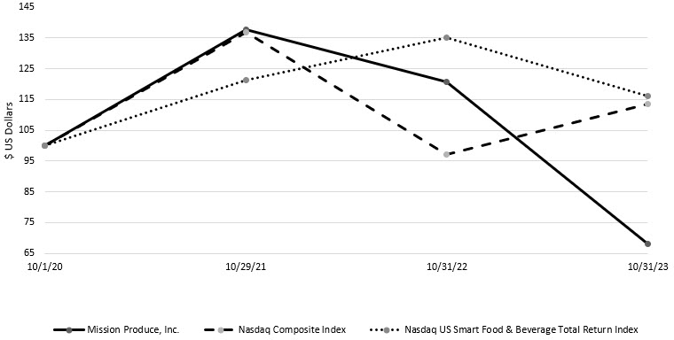

 |  |  | October 1, 2020 |  |  | October 29, 2021 |  |  | October 31, 2022 |  |  | October 31, 2023
Mission Produce, Inc. |  |  | 100.0 |  |  | 137.6 |  |  | 120.6 |  |  | 68.2
Nasdaq Composite Index(1) |  |  | 100.0 |  |  | 136.8 |  |  | 97.0 |  |  | 113.5
Nasdaq US Smart Food & Beverage Total Return Index |  |  | 100.0 |  |  | 121.2 |  |  | 135.1 |  |  | 116.0
(1)The annual reports for fiscal years 2021 and 2022 incorrectly labeled the name of this index as Nasdaq Composite Total Return Index
Unregistered Sales of Equity Securities
None.
Issuer Repurchases of Equity Securities
On September 6, 2023, the Board of Directors approved a stock repurchase program, which permits the Company to repurchase up to $20 million of shares of the Company’s common stock within 36 months from adoption. The shares may be repurchased from time to time in open market or privately negotiated transactions in such quantities and at such prices as may be authorized by certain designated officers of the Company. Share repurchases may be made in open market or privately negotiated
18

transactions and/or pursuant to Rule 10b5-1 trading plans, subject to market conditions, applicable legal requirements, trading restrictions under the Company’s insider trading policy and other relevant factors.
Repurchases by us or our “affiliated purchasers” (as defined in Rule 10b-18(a)(3) of the Exchange Act) of registered equity securities during the fourth quarter of 2023 were as follows:
Period |  |  | Total number of shares purchased |  |  | Average price paid per share |  |  | Total number of shares purchased as part of publicly announced plan |  |  | Approximate dollar value of shares that may yet be purchased under the plan  (in millions)
September 6 - 30, 2023 |  |  | 21,539 |  |  | $ | 9.55 |  | 21,539 |  |  | $ | 19.8
October 1- 31, 2023 |  |  | 45,639 |  |  | $ | 9.09 |  | 45,639 |  |  | $ | 19.4
10b-5(1) Trading Plans
Luis A. Gonzalez, one of the Company’s directors, and his spouse, Rosario Del Pilar Vallejos Hinojosa, have adopted a trading plan that is intended to satisfy the affirmative defense of Rule 10b5-1(c) (the “Gonzalez Sales Plan”) to sell an aggregate of 1,651,500 shares they hold indirectly through Beldar Enterprises S.A., and through Corp SA1, Corp SA2, Corp SA3, and Corp SA4, which are abbreviations for four affiliate corporations that are organized under the laws of Panama. The Gonzalez Sales Plan was adopted on July 14, 2023, with sales commencing under the Gonzalez Sales Plan on October 16, 2023. The Gonzalez Sales Plan terminates on the earliest to occur of (a) the close of business on October 16, 2024 ; (b) the date on which the total shares subject to the Gonzalez Sales Plan have been sold; and (c) the date the Gonzalez Sales Plan is terminated in connection with certain extraordinary transactions as specified by the terms of the Gonzalez Sales Plan.
Jay A. Pack, one of the Company’s directors, has adopted a trading plan that is intended to satisfy the affirmative defense of Rule 10b5-1(c) (the “Pack Sales Plan”) to sell an aggregate of 150,000 shares held indirectly through PFP Investments, Ltd. The Pack Sales Plan was adopted on October 10, 2023, with sales commencing under the Pack Sales Plan on January 18, 2024. The Pack Sales Plan terminates on the earliest to occur of (a) July 17, 2024; (b) the completion of all sales contemplated under the Pack Sales Plan; and (c) the date the Pack Sales Plan is terminated in connection with certain events or transactions as specified by the terms of the Pack Sales Plan.

Item 6. Reserved
Not applicable.

Item 7. Management’s Discussion and Analysis of Financial Condition and Results of Operations
You should read the following discussion and analysis of our financial condition and results of operations together with our financial statements and related notes included elsewhere in this annual report. This discussion and analysis contains forward-looking statements based upon our current beliefs, plans and expectations that involve risks, uncertainties and assumptions. Our actual results may differ materially from those anticipated in these forward-looking statements as a result of various factors. Please refer to the section of this report under the heading “Forward Looking Statements.”

Overview
We are a world leader in sourcing, producing and distributing Hass avocados, serving retail, wholesale and foodservice customers. We source, produce, pack and distribute avocados and a small amount of other fruits to our customers and provide value-added services including ripening, bagging, custom packaging and logistical management. In addition, we provide our customers with merchandising and promotional support, insights on market trends and training designed to increase their retail avocado sales.
Consolidation of VIE
On May 1, 2022, a reconsideration event occurred related to Moruga S.A.C., a holding company with one wholly owned subsidiary, Blueberries Peru, S.A.C. (collectively referred to as “Moruga”), an entity for which we have a 60% equity ownership interest. Moruga was previously accounted for under the equity method of accounting, where investments are stated at initial cost and adjusted for subsequent additional investments and our proportionate share of earnings or losses and distributions. As a result of the reconsideration event, we concluded that Moruga is a variable interest entity (“VIE”), and that the Company is the primary
19

beneficiary with a controlling financial interest. Based on this conclusion, Moruga was prospectively consolidated on May 1, 2022. For more details on Moruga, refer to Note 3 to the financial statements in this annual report.
Reportable segments
We have three operating segments which are also reportable segments. Our reportable segments are presented based on how information is used by our CEO, who is the chief operating decision maker, to measure performance and allocate resources. After the consolidation of Moruga on May 1, 2022, the information used by the CEO was expanded to include the results of Moruga, and as such, we determined our reportable segments to be:
•Marketing and Distribution. Our Marketing and Distribution reportable segment sources fruit from growers and then distributes the fruit through our global distribution network.
•International Farming. International Farming owns and operates orchards from which the vast majority of fruit produced is sold to our Marketing and Distribution segment. The segment’s farming activities range from cultivating early-stage plantings to harvesting from mature trees. It also earns service revenues for packing and processing fruit for both our Blueberries segment, as well as for third-party producers of other crops. Operations are principally located in Peru, with smaller operations emerging in other areas of Latin America.
•Blueberries. The Blueberries segment represents the results of Moruga, subsequent to its consolidation on May 1, 2022. Moruga’s farming activities include cultivating early-stage blueberry plantings and harvesting mature bushes. Substantially all blueberries produced are sold to a single distributor under an exclusive marketing agreement.
Recent business developments
In April 2023, the Marketing and Distribution segment opened a 102,000-square-foot state-of-the-art ripening, packing and forward distribution center in Dartford, United Kingdom. Strategically located with direct access to major international ports and transportation networks, the facility is expected to strengthen our international footprint and optimize product distribution to the Company’s customer base in the U.K.
Regulatory developments
In December 2021, the Organization for Economic Cooperation and Development (“OECD”), which is an international public policy setting organization comprised of member countries including the U.S., published a proposal for the establishment of a global minimum tax rate of 15% (the “Pillar Two rule”) . The OECD has recommended that the Pillar Two rule become effective for fiscal years beginning after January 1, 2024, which is our fiscal 2025. To date, member states are in various stages of implementation and the OECD continues to refine technical guidance. We are closely monitoring developments of the Pillar Two rule and are currently evaluating the potential impact in each of the countries we operate in.

Results of Operations
The operating results of our businesses are significantly impacted by the price and volume of fruit we farm, source and distribute. In addition, our results have been, and will continue to be, affected by quarterly and annual fluctuations due to a number of factors, including but not limited to: pests and disease; weather patterns; changes in demand by consumers; food safety advisories; the timing of the receipt, reduction or cancellation of significant customer orders; the gain or loss of significant customers; the availability, quality and price of raw materials; the utilization of capacity at our various locations; and general economic conditions.
Our financial reporting currency is the U.S. dollar. The functional currency of our most significant subsidiaries is the U.S. dollar and the majority of our sales are denominated in U.S. dollars. A significant portion of our purchases of avocados are denominated in the Mexican Peso and a significant portion of our growing and harvesting costs are denominated in Peruvian Soles. Fluctuations in the exchange rates between the U.S. dollar and these local currencies usually do not have a significant impact on our gross margin because the impact affects our pricing by comparable amounts. Our margin exposure to exchange rate fluctuations is short-term in nature, as our sales price commitments are generally limited to less than one month and orders can primarily be serviced with procured inventory. Over longer periods of time, we believe that the impact exchange rate fluctuations will have on our cost of goods sold will largely be passed on to our customers in the form of higher or lower prices.
20

 |  |  | Years ended October 31,
 |  |  | 2023 |  |  |  |  |  |  |  |  |  |  |  | 2022 |  |  |  |  |  |  |  |  |  |  |  | 2021
(In millions, except percentages) |  |  | Dollar |  |  |  |  |  | % |  |  |  |  |  | Dollar |  |  |  |  |  | % |  |  |  |  |  | Dollar |  |  |  |  |  | %
Net sales |  |  | $ | 953.9 |  |  |  |  | 100.0 |  | % |  |  |  | $ | 1,045.9 |  |  |  |  | 100.0 |  | % |  |  |  | $ | 891.7 |  |  |  |  | 100.0 |  | %
Cost of sales |  |  | 870.6 |  |  |  |  |  | 91.3 |  | % |  |  |  | 956.1 |  |  |  |  |  | 91.4 |  | % |  |  |  | 767.2 |  |  |  |  |  | 86.0 |  | %
Gross profit |  |  | 83.3 |  |  |  |  |  | 8.7 |  | % |  |  |  | 89.8 |  |  |  |  |  | 8.6 |  | % |  |  |  | 124.5 |  |  |  |  |  | 14.0 |  | %
Selling, general and administrative expenses |  |  | 76.4 |  |  |  |  |  | 8.0 |  | % |  |  |  | 77.5 |  |  |  |  |  | 7.4 |  | % |  |  |  | 63.6 |  |  |  |  |  | 7.1 |  | %
Goodwill impairment |  |  | — |  |  |  |  |  | — |  | % |  |  |  | 49.5 |  |  |  |  |  | 4.7 |  | % |  |  |  | — |  |  |  |  |  | — |  | %
Operating income (loss) |  |  | 6.9 |  |  |  |  |  | 0.7 |  | % |  |  |  | (37.2) |  |  |  |  |  | (3.6) |  | % |  |  |  | 60.9 |  |  |  |  |  | 6.8 |  | %
Interest expense |  |  | (11.6) |  |  |  |  |  | (1.2) |  | % |  |  |  | (5.5) |  |  |  |  |  | (0.5) |  | % |  |  |  | (3.7) |  |  |  |  |  | (0.4) |  | %
Equity method income |  |  | 4.0 |  |  |  |  |  | 0.4 |  | % |  |  |  | 5.1 |  |  |  |  |  | 0.5 |  | % |  |  |  | 7.5 |  |  |  |  |  | 0.8 |  | %
Remeasurement gain on acquisition of equity method investee |  |  | — |  |  |  |  |  | — |  | % |  |  |  | 2.0 |  |  |  |  |  | 0.2 |  | % |  |  |  | — |  |  |  |  |  | — |  | %
Other (expense) income, net |  |  | (0.2) |  |  |  |  |  | — |  | % |  |  |  | 4.4 |  |  |  |  |  | 0.4 |  | % |  |  |  | 1.3 |  |  |  |  |  | 0.1 |  | %
(Loss) income before income taxes |  |  | (0.9) |  |  |  |  |  | (0.1) |  | % |  |  |  | (31.2) |  |  |  |  |  | (3.0) |  | % |  |  |  | 66.0 |  |  |  |  |  | 7.4 |  | %
Provision for income taxes |  |  | 2.2 |  |  |  |  |  | 0.2 |  | % |  |  |  | 3.7 |  |  |  |  |  | 0.4 |  | % |  |  |  | 21.1 |  |  |  |  |  | 2.4 |  | %
Net (loss) income |  |  | (3.1) |  |  |  |  |  | (0.3) |  | % |  |  |  | (34.9) |  |  |  |  |  | (3.3) |  | % |  |  |  | 44.9 |  |  |  |  |  | 5.0 |  | %
Net loss attributable to noncontrolling interest |  |  | (0.3) |  |  |  |  |  | — |  | % |  |  |  | (0.3) |  |  |  |  |  | — |  | % |  |  |  | — |  |  |  |  |  | — |  | %
Net (loss) income attributable to Mission Produce |  |  | $ | (2.8) |  |  |  |  | (0.3) |  | % |  |  |  | $ | (34.6) |  |  |  |  | (3.3) |  | % |  |  |  | $ | 44.9 |  |  |  |  | 5.0 |  | %
Net sales
Our net sales are generated predominantly from the shipment of fresh avocados to retail, wholesale and foodservice customers worldwide. Our net sales are affected by numerous factors, including the balance between the supply of and demand for our produce and competition from other fresh produce companies. Our net sales are also dependent on our ability to supply a consistent volume and quality of fresh produce to the markets we serve.
 |  |  | Years ended October 31,
(In millions) |  |  | 2023 |  |  |  |  |  | 2022 |  |  |  |  |  | 2021
Net sales:
Marketing and Distribution |  |  | $ | 889.9 |  |  |  |  | $ | 1,016.1 |  |  |  |  | $ | 872.0
International Farming |  |  | 11.6 |  |  |  |  |  | 19.1 |  |  |  |  |  | 19.7
Blueberries |  |  | 52.4 |  |  |  |  |  | 10.7 |  |  |  |  |  | —
Total net sales |  |  | $ | 953.9 |  |  |  |  | $ | 1,045.9 |  |  |  |  | $ | 891.7
Net sales decreased $92.0 million or 9% in fiscal year 2023 compared to the previous year, primarily due to a 24.0% decrease in average per-unit avocado sales prices, partially offset by increases in avocado volume sold of 12.0%. Price decreases and higher avocado volume sold were driven by higher industry supply out of Mexico in the current year as compared to limited supply out of Mexico in the previous year. Net sales were favorably affected by the full-year impact of consolidating revenue from our Blueberries segment.
Net sales increased $154.2 million or 17% in fiscal year 2022 compared to the previous year, primarily due to a 28% increase in average per-unit avocado sales prices, partially offset by decreases in avocado volume sold of 11%. Price increases were due to lower industry supply out of Mexico for much of the fiscal year, as well as inflationary pressures. Lower avocado volume sold was primarily driven by lower Mexican supply. Domestic volumes declined at a lower rate relative to export markets, demonstrating the resiliency of demand for avocados amid higher price points in the U.S. market.
Gross profit
Cost of sales is composed primarily of avocado procurement costs from independent growers and packers, logistics costs, packaging costs, labor, costs associated with cultivation (the cost of growing crops), harvesting and depreciation. Avocado procurement costs from third-party suppliers can vary significantly between and within fiscal years and correlate closely with market prices for avocados. While we have long-standing relationships with our growers and packers, we predominantly purchase fruit on a daily basis at market rates. As such, the cost to procure products from independent growers can have a significant impact on our costs.
21

Logistics costs include land and sea transportation and expenses related to port facilities and distribution centers. Land transportation costs consist primarily of third-party trucking services to support North American distribution, while sea transportation cost consists primarily of third-party shipping of refrigerated containers from supply markets in South and Central America to demand markets in North America, Europe and Asia. Fuel prices as well as variations in containerboard prices, which affect the cost of boxes and other packaging materials, impact our product cost and our profit margins. Variations in the production yields, and other input costs also affect our cost of sales.
In general, changes in our volume of products sold can have a disproportionate effect on our gross profit. Within any particular year, a significant portion of our cost of products are fixed. Accordingly, higher volumes produced on company-owned farms directly reduce the average cost per pound of fruit grown on company owned orchards, while lower volumes directly increase the average cost per pound of fruit grown on company owned orchards. Likewise, higher volumes processed through packing and distribution facilities directly reduce the average overhead cost per unit of fruit handled, while lower volumes directly increase the average overhead cost per unit of fruit handled.
Gross profit percentage will fluctuate based upon per-unit sales price levels in relation to per-unit costs. Margin is primarily managed on a per-unit basis in our Marketing & Distribution segment, which can lead to movement in gross profit percentage when sales prices fluctuate.
 |  |  | Years ended October 31,
 |  |  | 2023 |  |  |  |  |  | 2022 |  |  |  |  |  | 2021
Gross profit (in millions) |  |  | $ | 83.3 |  |  |  |  | $ | 89.8 |  |  |  |  | $ | 124.5
Gross profit as a percentage of net sales |  |  | 8.7 |  | % |  |  |  | 8.6 |  | % |  |  |  | 14.0 |  | %
Gross profit decreased $6.5 million in fiscal year 2023 compared to the previous year to $83.3 million, and gross profit percentage increased by 10 basis points to 8.7% of revenue. The decrease in gross profit was concentrated in our International Farming segment and driven by lower pricing on avocados sold from Company-owned farms. Lower pricing conditions were driven by higher worldwide supply of avocados, driven by a stronger Mexican crop, combined with quality issues and a compressed Peruvian harvest season brought about by El Niño-related weather events. Gross profit percentage remained flat as higher volume of avocados sold and improved per-unit margin at lower average sales prices in our Marketing & Distribution segment and higher volume of blueberries sold by Blueberries segment largely offset the negative impact from our International Farming segment.
Gross profit decreased $34.7 million in fiscal year 2022 compared to the previous year to $89.8 million, and gross profit percentage decreased by 536 basis points to 8.6% of revenue. Within our Marketing and Distribution segment, the decreases were primarily driven by the impact of lower avocado volume sold, as well as temporary and unforeseen operational challenges created by the ERP implementation, which limited our ability to effectively manage our supply chain during the first quarter of 2022. Within our International Farming segment, we experienced gross profit decreases primarily due to inflationary cost pressures impacting ocean freight costs, packaging costs, and farming input costs, partially offset by increased avocado production at our farms.
Selling, general and administrative expenses
Selling, general and administrative (“SG&A”) expenses primarily include the costs associated with selling, professional fees, general corporate overhead and other related administrative functions.

 |  |  | Years ended October 31,
(In millions) |  |  | 2023 |  |  |  |  |  | 2022 |  |  |  |  |  | 2021
Selling, general and administrative expenses |  |  | $ | 76.4 |  |  |  |  | $ | 77.5 |  |  |  |  | $ | 63.6
SG&A expenses decreased $1.1 million or 1% in fiscal year 2023 compared to the previous year, primarily due to lower ERP and insurance costs. The reduction in ERP expense was concentrated in non-recurring process reengineering costs, while reduced insurance expense was attributed to lower rates on directors and officers liability coverage. These reductions were partially offset by an increase of approximately $2.4 million of expenses from the Blueberries segment, a large portion of which was attributed to amortization of an intangible asset recognized in the business combination.
SG&A increased $13.9 million or 22% in fiscal year 2022 compared to the previous year, due to ERP costs in our Marketing and Distribution segment, higher employee-related costs, higher professional fees, and higher travel costs. ERP costs consisted of noncapitalizable implementation costs and nonrecurring process re-engineering costs. Employee-related costs were impacted by labor inflation and higher stock-based compensation expense. Higher professional fees were in part due to our change in SEC filer status from an emerging growth company to a large accelerated filer on October 31, 2021. Travel costs increased as COVID-related travel restrictions eased relative to prior year. The consolidation of Moruga increased selling, general and administrative expenses by $1.7 million, which included amortization of an intangible asset recognized at acquisition.
22

Goodwill impairment
A noncash impairment loss of $49.5 million was recognized in the consolidated statements of income during the fourth quarter of fiscal 2022. No goodwill impairment was recognized in fiscal years 2023 or 2021. For more information, refer to Note 4 to the consolidated financial statements.
Interest expense
Interest expense consists primarily of interest on borrowings under working capital facilities that we maintain and interest on other long-term debt used to make capital and equity investments. We also incur interest expense on finance leases, computed using each leases’ explicit or implicit borrowing rate.
 |  |  | Years ended October 31,
(In millions) |  |  | 2023 |  |  |  |  |  | 2022 |  |  |  |  |  | 2021
Interest expense |  |  | $ | 11.6 |  |  |  |  | $ | 5.5 |  |  |  |  | $ | 3.7
Interest expense increased $6.1 million or 111% in fiscal year 2023 compared to the previous year, primarily due to the effect of rising interest rates on our credit facility, which is subject to variable rates, as well as higher average outstanding debt balances. Additionally, the Blueberries segment incurred interest expense of $2.2 million related to a long-term finance lease of land as well as short-term bank borrowings and financed payables.
Interest expense increased $1.8 million or 49% in fiscal year 2022 compared to the previous year, primarily due to higher interest rates, as the majority of our outstanding debt is subject to variable rates.
Equity method income
Our material equity method investees include Henry Avocado (“HAC”), Mr. Avocado, Copaltas, and up until May 1, 2022, Moruga. On May 1, 2022, Moruga became a variable interest entity and prospectively consolidated into our financial statements.

 |  |  | Years ended October 31,
(In millions) |  |  | 2023 |  |  |  |  |  | 2022 |  |  |  |  |  | 2021
Equity method income |  |  | $ | 4.0 |  |  |  |  | $ | 5.1 |  |  |  |  | $ | 7.5
Remeasurement gain on acquisition of equity method investee |  |  | — |  |  |  |  |  | 2.0 |  |  |  |  |  | —
Equity method income decreased $1.1 million or 22% in fiscal year 2023 compared to the previous year, primarily due to lower income from HAC, driven by inflationary pressure on SG&A expense.
Equity method income decreased $2.4 million or 32% in fiscal year 2022 compared to the previous year, primarily due to the effect of consolidation of Moruga, partially offset by stronger operating performance from HAC.
Other expense (income), net
Other expense (income), net consists of interest income, currency exchange gains or losses, interest rate derivative gains or losses and other miscellaneous income and expense items.
 |  |  | Years ended October 31,
(In millions) |  |  | 2023 |  |  |  |  |  | 2022 |  |  |  |  |  | 2021
Other expense (income), net |  |  | $ | 0.2 |  |  |  |  | $ | (4.4) |  |  |  |  | $ | (1.3)
Other expense was $0.2 million in fiscal year 2023, compared to other income of $4.4 million in the previous year. Current year expense is primarily attributed to foreign currency transaction losses primarily due to the weakening of the U.S. dollar relative to the Mexican peso. In the prior year, gains were generated on interest rate swaps as a result of rising interest rates during the period.
Other income increased $3.1 million or 238% in fiscal year 2022 compared to the previous year, primarily due to gains on our interest rate swaps driven by market movements in short-term interest rates. The interest rate swaps are intended to hedge against variable interest rate exposure associated with our term debt facility.
23

Provision for income taxes
The provision for income taxes consists of the consolidation of tax provisions, computed on a separate entity basis, in each country in which we have operations. We recognize the effects of tax legislation in the period in which the law is enacted. Our deferred tax assets and liabilities are measured using enacted tax rates expected to apply to taxable income in the years we estimate the related temporary differences to reverse. Realization of deferred tax assets is dependent upon future earnings, the timing and amount of which are uncertain.
We recognize a tax benefit from an uncertain tax position only if it is more likely than not the tax position will be sustained on examination by the taxing authorities, based on the technical merits of the position. The tax benefits recognized from such positions are then measured based on the largest benefit that has a greater than 50% likelihood of being realized upon settlement. Interest and penalties related to unrecognized tax benefits are recognized within provision for income taxes.
Our effective tax rate is impacted by income attributable to foreign jurisdictions which is taxed at different rates from the U.S. federal statutory tax rate of 21%, changes in foreign exchange rates taxable in foreign jurisdictions and nondeductible tax items.

 |  |  | Years ended October 31,
 |  |  | 2023 |  |  |  |  |  | 2022 |  |  |  |  |  | 2021
Provision for income taxes (in millions) |  |  | $ | 2.2 |  |  |  |  | $ | 3.7 |  |  |  |  | $ | 21.1
Effective tax rate(1) |  |  | (256.6) |  | % |  |  |  | (12.0) |  | % |  |  |  | 32.0 |  | %
(1) May not recalculate due to rounding.
The provision for income tax decreased $1.5 million or 41% in fiscal year 2023 compared to the previous year. The current year provision for income tax was impacted by a $1.7 million charge related to a statutory case in Mexico and $0.5 million in changes in unrecognized tax benefits. These charges were partially offset by a favorable change in ASC 740-30 (formerly APB 23) liability of $1.6 million.
The provision for income taxes decreased $17.4 million or 82% in fiscal year 2022 compared to the previous year. In 2022, our provision for income taxes was impacted by the $49.5 million non-deductible goodwill impairment charge, which generated a pre-tax loss. In 2021, the provision for income taxes included a $5.4 million charge from the remeasurement of our deferred tax balances in Peru due to the enactment of tax law in 2020 repealing tax benefits to agribusiness entities. The law subjects us to higher Peruvian corporate income tax rates than the rate in effect on the date of repeal of 15%, as follows: 20% for calendar years 2023 to 2024, 25% for calendar years 2025 to 2027, and 29.5% thereafter.

Segment Results of Operations
Our CEO evaluates and monitors segment performance primarily through segment sales and segment adjusted earnings before interest expense, income taxes and depreciation and amortization (“adjusted EBITDA”). We believe that adjusted EBITDA by segment provides useful information for analyzing the underlying business results as well as allowing investors a means to evaluate the financial results of each reportable segment in relation to the Company as a whole. These measures are not in accordance with, nor are they a substitute for or superior to, the comparable GAAP financial measures.
Adjusted EBITDA refers to net income (loss), before interest expense, income taxes, depreciation and amortization expense, stock-based compensation expense, other income (expense), and income (loss) from equity method investees, further adjusted by asset impairment and disposals, net of insurance recoveries, farming costs for nonproductive orchards (which represents land lease costs), certain noncash and nonrecurring ERP costs, transaction costs, material legal settlements, amortization of inventory adjustments recognized from business combinations, and any special, non-recurring, or one-time items such as remeasurements or impairments, and any portion of these items attributable to the noncontrolling interest, all of which are excluded from the results the CEO reviews uses to assess segment performance and results.
Net sales
 |  |  | Marketing & Distribution |  |  |  |  |  | International Farming |  |  |  |  |  | Blueberries |  |  |  |  |  | Total |  |  |  |  |  | Marketing & Distribution |  |  |  |  |  | International Farming |  |  |  |  |  | Blueberries(1) |  |  |  |  |  | Total |  |  |  |  |  | Marketing & Distribution |  |  |  |  |  | International Farming |  |  |  |  |  | Total
 |  |  | Years ended October 31,
(In millions) |  |  | 2023 |  |  |  |  |  |  |  |  |  |  |  |  |  |  |  |  |  |  |  |  |  |  |  | 2022 |  |  |  |  |  |  |  |  |  |  |  |  |  |  |  |  |  |  |  |  |  |  |  | 2021
Third party sales |  |  | $ | 889.9 |  |  |  |  | $ | 11.6 |  |  |  |  | $ | 52.4 |  |  |  |  | $ | 953.9 |  |  |  |  | $ | 1,016.1 |  |  |  |  | $ | 19.1 |  |  |  |  | $ | 10.7 |  |  |  |  | $ | 1,045.9 |  |  |  |  | $ | 872.0 |  |  |  |  | $ | 19.7 |  |  |  |  | $ | 891.7
Affiliated sales |  |  | — |  |  |  |  |  | 78.6 |  |  |  |  |  | — |  |  |  |  |  | 78.6 |  |  |  |  |  | — |  |  |  |  |  | 95.6 |  |  |  |  |  | — |  |  |  |  |  | 95.6 |  |  |  |  |  | — |  |  |  |  |  | 84.9 |  |  |  |  |  | 84.9
Total segment sales |  |  | $ | 889.9 |  |  |  |  | $ | 90.2 |  |  |  |  | $ | 52.4 |  |  |  |  | $ | 1,032.5 |  |  |  |  | $ | 1,016.1 |  |  |  |  | $ | 114.7 |  |  |  |  | $ | 10.7 |  |  |  |  | $ | 1,141.5 |  |  |  |  | $ | 872.0 |  |  |  |  | $ | 104.6 |  |  |  |  | $ | 976.6
Intercompany eliminations |  |  | — |  |  |  |  |  | (78.6) |  |  |  |  |  | — |  |  |  |  |  | (78.6) |  |  |  |  |  | — |  |  |  |  |  | (95.6) |  |  |  |  |  | — |  |  |  |  |  | (95.6) |  |  |  |  |  | — |  |  |  |  |  | (84.9) |  |  |  |  |  | (84.9)
Total net sales |  |  | $ | 889.9 |  |  |  |  | $ | 11.6 |  |  |  |  | $ | 52.4 |  |  |  |  | $ | 953.9 |  |  |  |  | $ | 1,016.1 |  |  |  |  | $ | 19.1 |  |  |  |  | $ | 10.7 |  |  |  |  | $ | 1,045.9 |  |  |  |  | $ | 872.0 |  |  |  |  | $ | 19.7 |  |  |  |  | $ | 891.7
(1) The Blueberries segment was consolidated prospectively from May 1, 2022.
24

Adjusted EBITDA
Years Ended
October 31,
(In millions) |  |  | 2023 |  |  |  |  |  | 2022 |  |  |  |  |  | 2021
Marketing & Distribution adjusted EBITDA |  |  | $ | 40.1 |  |  |  |  | $ | 23.5 |  |  |  |  | $ | 51.4
International Farming adjusted EBITDA |  |  | 3.1 |  |  |  |  |  | 23.3 |  |  |  |  |  | 33.9
Blueberries adjusted EBITDA |  |  | 5.2 |  |  |  |  |  | 0.8 |  |  |  |  |  | —
Total reportable segment adjusted EBITDA |  |  | $ | 48.4 |  |  |  |  | $ | 47.6 |  |  |  |  | $ | 85.3
Net (loss) income |  |  | (3.1) |  |  |  |  |  | (34.9) |  |  |  |  |  | 44.9
Interest expense |  |  | 11.6 |  |  |  |  |  | 5.5 |  |  |  |  |  | 3.7
Provision for income taxes |  |  | 2.2 |  |  |  |  |  | 3.7 |  |  |  |  |  | 21.1
Depreciation and amortization(1) |  |  | 32.8 |  |  |  |  |  | 24.8 |  |  |  |  |  | 20.4
Equity method income |  |  | (4.0) |  |  |  |  |  | (5.1) |  |  |  |  |  | (7.5)
Stock-based compensation |  |  | 4.5 |  |  |  |  |  | 3.6 |  |  |  |  |  | 2.6
Executive severance |  |  | 1.3 |  |  |  |  |  | — |  |  |  |  |  | —
Legal settlement |  |  | — |  |  |  |  |  | — |  |  |  |  |  | 0.8
Asset impairment and disposals, net of insurance recoveries |  |  | 1.3 |  |  |  |  |  | 0.4 |  |  |  |  |  | (0.2)
Farming costs for nonproductive orchards |  |  | 1.8 |  |  |  |  |  | 1.5 |  |  |  |  |  | 0.8
ERP costs(2) |  |  | 2.2 |  |  |  |  |  | 4.6 |  |  |  |  |  | —
Goodwill impairment |  |  | — |  |  |  |  |  | 49.5 |  |  |  |  |  | —
Remeasurement gain on business combination with Moruga |  |  | — |  |  |  |  |  | (2.0) |  |  |  |  |  | —
Transaction costs |  |  | 0.3 |  |  |  |  |  | 0.6 |  |  |  |  |  | —
Amortization of inventory adjustment recognized from business combination |  |  | 0.7 |  |  |  |  |  | 0.4 |  |  |  |  |  | —
Other expense (income), net |  |  | 0.2 |  |  |  |  |  | (4.4) |  |  |  |  |  | (1.3)
Noncontrolling interest(3) |  |  | (3.4) |  |  |  |  |  | (0.6) |  |  |  |  |  | —
Total adjusted EBITDA |  |  | $ | 48.4 |  |  |  |  | $ | 47.6 |  |  |  |  | $ | 85.3
(1) Includes depreciation and amortization of purchase accounting assets of $2.4 million, $1.4 million and $0.2 million for the years ended October 31, 2023, 2022, and 2021, respectively.
(2) Includes recognition of deferred implementation costs in the years ended October 31, 2023 and 2022. The year ended October 31, 2022 also includes non-recurring post-implementation process reengineering costs.
(3) Represents net loss attributable to noncontrolling interest plus the impact of non-GAAP adjustments, allocable to the noncontrolling owner based on their percentage of ownership interest.
Marketing and Distribution
Net sales in our Marketing and Distribution segment decreased $126.2 million or 12% in fiscal year 2023 compared to the previous year, driven by pricing and volume dynamics described above, which were driven by higher industry supply out of Mexico relative to last year.
Segment adjusted EBITDA increased $16.6 million or 71% in fiscal year 2023 compared to the previous year, due to higher gross margin from higher avocado volume sold and improved avocado per-unit margins.
Net sales in our Marketing and Distribution segment increased $144.1 million or 17% in fiscal year 2022 compared to the previous year, due to the same drivers impacting consolidated revenue.
Segment adjusted EBITDA decreased $27.9 million or 54% in fiscal year 2022 compared to the previous year, due to the impact of lower avocado volume sold, lower gross margin primarily attributed to ERP-related issues during the first quarter of 2022, and higher selling, general and administrative expense as described above.
International Farming
The vast majority of fruit sales from our International Farming segment are to the Marketing and Distribution segment, with the remainder of revenue largely derived from services provided to third parties and our Blueberries segment. Affiliated sales are concentrated in the second half of the fiscal year in alignment with the Peruvian avocado harvest season, which typically runs from April through September of each year. As a result, adjusted EBITDA for the International Farming segment is generally concentrated in the third and fourth quarters of the fiscal year in alignment with the timing of sales. The Company operates approximately 700 acres of mangos in Peru that are largely in an early stage of production. The timing of the mango harvest is concentrated in the
25

fiscal second quarter and, as a result, mangos have a more pronounced impact on segment financial performance during this timeframe.
Total segment sales in our International Farming segment decreased $24.5 million or 21% in fiscal year 2023 compared to the previous year, primarily due to lower pricing on avocados sold from company-owned farms. Lower pricing conditions were driven by higher worldwide supply of avocados, driven by a stronger Mexican crop, combined with quality issues and a compressed Peruvian harvest season brought about by El Niño-related weather events.
Segment adjusted EBITDA decreased $20.2 million or 87% in fiscal year 2023 compared to the previous year, primarily due to lower gross profit resulting from lower pricing.
Total segment sales in our International Farming segment increased $10.1 million or 10% in fiscal year 2022 compared to the previous year, driven by increased avocado production of 15%, which increased affiliated sales.
Segment adjusted EBITDA decreased $10.6 million or 31% in fiscal year 2022 compared to the previous year, primarily due to inflationary cost pressures impacting ocean freight costs, packaging costs, and farming input costs, partially offset by increased avocado production at our farms, as well as losses at early-stage mango farms that were mainly driven by lower sales prices and production yields.
Blueberries
In fiscal year 2023, net sales in our Blueberries segment were $52.4 million and segment adjusted EBITDA was $5.2 million. The segment performance benefited from higher volumes associated with the consolidation of our Blueberries segment for the entirety of the fiscal year.
In the six months ended October 31, 2022, which was the period following consolidation, net sales were $10.7 million and segment adjusted EBITDA was $0.8 million.

Liquidity and Capital Resources
Operating activities
 |  |  | Years ended October 31,
(In millions) |  |  | 2023 |  |  |  |  |  | 2022 |  |  |  |  |  | 2021
Net (loss) income |  |  | $ | (3.1) |  |  |  |  | $ | (34.9) |  |  |  |  | $ | 44.9
Depreciation and amortization |  |  | 32.8 |  |  |  |  |  | 24.8 |  |  |  |  |  | 20.4
Equity method income |  |  | (4.0) |  |  |  |  |  | (5.1) |  |  |  |  |  | (7.5)
Noncash lease expense |  |  | 5.9 |  |  |  |  |  | 5.3 |  |  |  |  |  | 4.3
Stock-based compensation |  |  | 4.5 |  |  |  |  |  | 3.6 |  |  |  |  |  | 2.6
Dividends received from equity method investees |  |  | 2.7 |  |  |  |  |  | 2.2 |  |  |  |  |  | 1.7
Deferred income taxes |  |  | (6.4) |  |  |  |  |  | (0.6) |  |  |  |  |  | 8.8
Goodwill impairment |  |  | — |  |  |  |  |  | 49.5 |  |  |  |  |  | —
Remeasurement gain on business combination with Moruga |  |  | — |  |  |  |  |  | (2.0) |  |  |  |  |  | —
Unrealized losses on foreign currency transactions |  |  | 1.4 |  |  |  |  |  | — |  |  |  |  |  | —
Unrealized gains on derivative financial instruments |  |  | (0.1) |  |  |  |  |  | (4.7) |  |  |  |  |  | (0.8)
Other |  |  | 1.7 |  |  |  |  |  | 0.9 |  |  |  |  |  | 0.3
Change in working capital |  |  | (6.2) |  |  |  |  |  | (3.8) |  |  |  |  |  | (27.7)
Net cash provided by operating activities |  |  | $ | 29.2 |  |  |  |  | $ | 35.2 |  |  |  |  | $ | 47.0
Net cash provided by operating activities decreased $6.0 million for 2023 compared to the previous year. The change was driven by weaker operating performance within our International Farming segment and working capital growth. Within working capital, unfavorable changes in accounts receivable and accounts payable and accrued expenses were largely offset by favorable changes in inventory and other receivables. Trade accounts receivable were impacted by higher avocado sales prices as well as higher blueberry volumes and pricing, the former of which includes balances outstanding at our new U.K. entity which commenced operations this fiscal year. At our International Farming segment, the earlier completion of the avocado season compared to prior year correlated with unfavorable changes in accounts payable and accrued expenses and conversely, favorable changes in on-hand inventory of company owned fruit and reductions in other assets from accelerated VAT refunds.
Net cash provided by operating activities decreased $11.8 million for fiscal year 2022 compared to the previous year, reflecting our net loss in the current year compared to net income in the prior year, partially offset by improvements in working
26

capital. Working capital was primarily impacted by favorable movement in accounts receivable, partially offset by unfavorable movement in inventory. Accounts receivable as of October 31, 2022 was lower compared to prior year, as a result of per-unit sales prices trending lower during the fourth quarter. Changes in inventory were primarily driven by the consolidation of Moruga and its respective inventory.
Investing activities
 |  |  | Years ended October 31,
(In millions) |  |  | 2023 |  |  |  |  |  | 2022 |  |  |  |  |  | 2021
Purchases of property, plant and equipment |  |  | $ | (49.8) |  |  |  |  | $ | (61.2) |  |  |  |  | $ | (73.4)
Proceeds from sale of property, plant and equipment |  |  | 0.2 |  |  |  |  |  | 3.0 |  |  |  |  |  | 2.4
Insurance proceeds for the replacement of property, plant and equipment |  |  | — |  |  |  |  |  | — |  |  |  |  |  | 1.1
Cash acquired in consolidation of Moruga |  |  | — |  |  |  |  |  | 4.3 |  |  |  |  |  | —
Investment in equity method investees |  |  | (2.1) |  |  |  |  |  | (0.4) |  |  |  |  |  | (0.2)
Purchase of other investment |  |  | (2.3) |  |  |  |  |  | — |  |  |  |  |  | —
Loans to equity method investees |  |  | — |  |  |  |  |  | — |  |  |  |  |  | (2.0)
Loan repayments from equity method investees |  |  | — |  |  |  |  |  | 3.0 |  |  |  |  |  | 1.5
Other |  |  | (0.1) |  |  |  |  |  | (0.1) |  |  |  |  |  | 0.3
Net cash used in investing activities |  |  | $ | (54.1) |  |  |  |  | $ | (51.4) |  |  |  |  | $ | (70.3)
Property, plant and equipment
In fiscal year 2023, capital expenditures were concentrated in pre-production avocado orchard maintenance in Guatemala and Peru and construction costs on our new UK distribution facility. Capital expenditures in the Blueberries operation were $12.9 million, primarily related to irrigation installation and early-stage plant cultivation.
In fiscal year 2022, capital expenditures were concentrated in the purchase of farmland in Peru as well as land improvements and orchard development of avocados in Guatemala and both avocados and blueberries in Peru. Capital expenditures in the Blueberries operation were $6.9 million, primarily related to early-stage plant cultivation.
Proceeds from the sale of property, plant and equipment were primarily from land that had been originally intended for use as our corporate headquarters.
Equity method investees
In all fiscal years presented, we made contributions to Copaltas and Mr. Avocado. Funds were used by Copaltas for the purchase of additional farmland in Colombia. Funds were used by Mr. Avocado to support working capital needs and an investment in a new distribution facility in southern China.
Loan repayments made in fiscal years 2022 and 2021 were from Copaltas and Moruga, respectively.
Other investment

In fiscal year 2023, we acquired a 5.1% equity interest in shares of common stock of a private entity that is developing avocado orchards in South Africa.
27

Financing activities
 |  |  | Years ended October 31,
(In millions) |  |  | 2023 |  |  |  |  |  | 2022 |  |  |  |  |  | 2021
Borrowings on revolving credit facility |  |  | $ | 145.0 |  |  |  |  | $ | 80.0 |  |  |  |  | $ | —
Payments on revolving credit facility |  |  | (130.0) |  |  |  |  |  | (40.0) |  |  |  |  |  | —
Proceeds from short-term borrowings |  |  | 2.8 |  |  |  |  |  | 2.5 |  |  |  |  |  | —
Repayment of short-term borrowings |  |  | (2.5) |  |  |  |  |  | — |  |  |  |  |  | —
Principal payments on long-term debt obligations |  |  | (3.5) |  |  |  |  |  | (63.3) |  |  |  |  |  | (10.5)
Principal payments on finance lease obligations |  |  | (2.6) |  |  |  |  |  | (1.2) |  |  |  |  |  | (1.2)
Proceeds from loan from noncontrolling interest holder |  |  | 2.0 |  |  |  |  |  | — |  |  |  |  |  | —
Payments for long-term supplier financing |  |  | (0.1) |  |  |  |  |  | — |  |  |  |  |  | —
Purchase and retirement of common stock |  |  | (0.6) |  |  |  |  |  | — |  |  |  |  |  | —
Taxes paid related to shares withheld from the settlement of equity awards |  |  | (0.5) |  |  |  |  |  | — |  |  |  |  |  | —
Exercise of stock options |  |  | 0.1 |  |  |  |  |  | 0.1 |  |  |  |  |  | 0.2
Repayment of stock option notes receivable |  |  | — |  |  |  |  |  | — |  |  |  |  |  | 0.1
Payment of debt issuance, restructuring or extinguishment fees |  |  | — |  |  |  |  |  | (0.8) |  |  |  |  |  | (0.1)
Equity contributions from noncontrolling interest holders |  |  | 4.2 |  |  |  |  |  | 0.9 |  |  |  |  |  | —
Net cash provided by (used in) financing activities |  |  | $ | 14.3 |  |  |  |  | $ | (21.8) |  |  |  |  | $ | (11.5)
Borrowings and repayments of debt
We utilize a revolving line of credit for short-term working capital purposes. Principal payments on our term loans and other notes payable are made in accordance with debt maturity schedules. The financing cash flow for fiscal 2022 reflects the modification of principal amounts on our term-loans and increased borrowing capacity on our revolver.
Blueberries
Financing at our Blueberries segment consists of shareholder contributions and loans, as well as short-term bank borrowings. In fiscal 2023, shareholder contributions were made to fund capital expenditures as described above in the Investing Activities section. Principal payments on finance lease obligations related to a long-term land lease in our Blueberries segment, which for accounting purposes has been classified as a finance lease.
Purchase and retirement of common stock
Shares of the company’s common stock may be repurchased from time to time in the open market or privately negotiated transactions under our share repurchase program. Refer to Note 13 to the consolidated financial statements for more information.
Capital resources
 |  |  | October 31,
(In millions) |  |  | 2023 |  |  |  |  |  | 2022
Cash and cash equivalents |  |  | $ | 42.9 |  |  |  |  | $ | 52.8
Working capital(1) |  |  | 122.6 |  |  |  |  |  | 126.4
(1)Includes cash and cash equivalents
Capital resources include cash flows from operations, cash and cash equivalents, and debt financing. Our Blueberries segment may also receive capital contributions or loans from noncontrolling shareholders.
Our syndicated credit facility with Bank of America has a total borrowing capacity of $250 million. The credit facility is comprised of two senior term loans totaling $100 million and a revolving credit agreement of $150 million. The loans are secured by assets of the Company, including certain real property, personal property and capital stock of the Company’s subsidiaries. Borrowings under the credit facility bear interest at a spread over SOFR ranging from 1.5% to 2.5% depending on the Company’s consolidated total net leverage ratio. We pay fees on unused commitments on the credit facility.
As of October 31, 2023, we were required to comply with the following financial covenants: (a) a quarterly consolidated leverage ratio of not more than 3.5 to 1.00 and (b) a quarterly consolidated fixed charge coverage ratio of not less than 1.25 to 1.00.
28

As of October 31, 2023, our consolidated leverage ratio was 2.64 to 1.00 and our consolidated fixed charge coverage ratio was 1.58 to 1.00 and we were in compliance with all such covenants of the credit facility.
Material cash requirements
Capital expenditures
We have various capital projects in progress for farming expansion and facility improvements which we intend to fund through our operating cash flow as well as cash and cash equivalents on hand. For fiscal 2024, we expect capital expenditures to be between $30 to $35 million.
Moruga Blueberry Project
In fiscal year 2023, Moruga commenced its previously announced project to farm approximately 1,500 additional acres of blueberries in the Olmos region of Peru. The project is funded by cash flow generated by Moruga and supplemented by pro-rata shareholder contributions based on each shareholders’ respective ownership interest. As of October 31, 2023, the estimated remaining capital expenditures related to the project were approximately $40 million, to be spent in phases through fiscal 2028, depending on timing and other factors.
Leases
We are party to various leases, the most material of which are for facilities and land. Our undiscounted cash liabilities were approximately $176.1 million as of October 31, 2023, of which, approximately $56.0 million was for a long-term land lease in our Blueberries segment.
Long-term debt
As of October 31, 2023, remaining maturities on our term loans and notes were $152.0 million. See Note 9 to the consolidated financial statements for more information.

Critical Accounting Estimates
Our discussion and analysis of our financial condition and results of operations are based upon our consolidated financial statements, which have been prepared in accordance with U.S. GAAP. U.S. GAAP requires management to make estimates and assumptions that affect the reported amounts of assets and liabilities and disclosure of contingent assets and liabilities at the date of the consolidated financial statements and the reported amounts of revenues and expenses during the reporting period. We base our estimates on historical experience and on various other assumptions that are believed to be reasonable under the circumstances, the results of which form the basis for making judgments about the carrying values of assets and liabilities that are not readily apparent from other sources. Additionally, we frequently engage third party valuation experts to assist us with estimates described below. Actual results could differ from those estimates.
Business combinations. We account for business combinations under the acquisition method of accounting in accordance with ASC Topic 805, Business Combinations, which requires an allocation of the consideration paid, if any, to the identifiable assets, intangible assets and liabilities based on the estimated fair values as of the acquisition date. Goodwill represents the excess of the sum of the fair value of our previously held equity interest and the fair value of the noncontrolling interest, over the net of the acquisition-date values of the identifiable assets and liabilities assumed. Management estimates the fair value of assets and liabilities with the assistance of a third-party specialist, using a combination of the market and income valuation methods. These valuation methods use inputs that are estimated by management, such as revenue forecasts, projected capital spend and estimates for cost of sales. The Company may adjust the amounts recognized for a business combination within the allowable one-year measurement period after the acquisition date. Any such adjustments would generally be recorded as increases or decreases to the goodwill recognized in the transaction.
Goodwill. Our goodwill represents the excess of the purchase price of business combinations over the fair value of the net assets acquired. Goodwill impairment testing requires significant judgment and management estimates, including, but not limited to, the determination of (i) the number of reporting units, (ii) the goodwill and other assets and liabilities to be allocated to the reporting units and (iii) the fair values of the reporting units. The estimates and assumptions described above, along with other factors such as discount rates, will significantly affect the outcome of the impairment tests and the amounts of any resulting impairment losses. We may use either a qualitative or quantitative approach when testing a reporting unit’s goodwill for impairment on an annual basis during the fourth quarter of each year, and between annual tests whenever events or changes in circumstances indicate that the carrying amount may not be recoverable. If we use a qualitative approach and determine that it is more likely than not that the fair value of a reporting unit is less than its carrying value, we would then perform the first step of the goodwill impairment test, which would consist primarily of a discounted cash flow (“DCF”) analysis and guideline publicly-traded companies (“GPC”) analysis to determine the fair value of the reporting unit.
29

During the fourth quarter of fiscal 2022, we performed our annual goodwill impairment test on our Peruvian farming reporting unit within the International Farming segment and determined that the qualitative factors indicated that it was more-likely-than-not that the fair value of the reporting unit was less than its carrying value. As a result, with the assistance of a third-party specialist, we performed a quantitative assessment of the fair value of the reporting unit using the DCF and GPC methods described in Notes 3 and 4 to the consolidated financial statements, resulting in an impairment charge of $49.5 million. The significant assumptions used in determining the fair values of the reporting unit have been described in Note 4. To the extent that BEV to EBITDA multiples in the future decrease, the discount rate used in determining the present value of our cash flows increases, or if the Company does not meet its cash flow projections for the reporting unit, additional impairment charges may be recorded in the future.
Investments. We maintain investments in other fruit growers, packers and distributors. These investments are accounted for under the equity method of accounting when we have the ability to exercise significant influence, but not control, over the investee. Significant influence generally exists when we have an ownership interest representing between 20% and 50% of the voting stock of the investee. Under the equity method of accounting, investments are stated at initial cost and are adjusted for subsequent additional investments and our proportionate share of earnings or losses and distributions. We review our investments for other-than temporary-impairment (“OTTI”) on a quarterly basis, or earlier if indicators of impairment arise. If an impairment of an equity method investment is determined to be other than temporary, we would record OTTI sufficient to reduce the investment’s carrying value to its fair value, which results in a new cost basis in the investment. The primary factors we consider in our determination of whether declines in fair value are other-than-temporary are the length of time that the fair value of the investment is below our carrying value; the severity of the decline; and the financial condition, operating performance and near-term prospects of the investee. In addition, we consider the reason for the decline in fair value, be it general market conditions, industry specific or investee specific; and our intent and ability to hold the investment for a period of time sufficient to allow for a recovery in fair value. As our assessment of the fair value of our investments and any resulting impairment losses and the timing of when to recognize such charges requires judgment and includes estimates and assumptions, actual results could differ materially from our estimates and assumptions.
Income taxes. As a multinational corporation, we are subject to taxation in many jurisdictions, and the calculation of our tax liabilities involves dealing with uncertainties in the application of complex tax laws and regulations in various taxing jurisdictions. If we ultimately determine that the payment of these liabilities will be unnecessary, the liability will be reversed, and we will recognize a tax benefit during the period in which it is determined the liability no longer applies. Conversely, we record additional tax charges in a period in which it is determined that a recorded tax liability is less than the ultimate assessment is expected to be.
We recognize the tax benefit from an uncertain tax position only if it is more likely than not the tax position will be sustained on examination by the taxing authorities, based on the technical merits of the position. The tax benefits recognized from such positions are then measured based on the largest benefit that has a greater than 50% likelihood of being realized upon settlement. Interest and penalties related to unrecognized tax benefits are recognized within provision for income taxes.
The application of tax laws and regulations is subject to legal and factual interpretation, judgment and uncertainty. Tax laws and regulations themselves are subject to change as a result of changes in fiscal policy, changes in legislation, the evolution of regulations and court rulings. Therefore, the actual liability for U.S. or foreign taxes may be materially different from management’s estimates, which could result in the need to record additional tax liabilities or potentially reverse previously recorded tax liabilities.
Recently Issued Accounting Standards
Refer to Note 2 to the consolidated financial statements included herein for information on recently issued accounting standards.
Off-Balance Sheet Arrangements
During the periods presented we did not have, nor do we currently have, any off-balance sheet arrangements as defined under SEC rules, except as follows:
The Company may issue standby letters of credit through banking institutions. As of October 31, 2023, total letters of credit outstanding were $0.7 million.

Item 7A. Quantitative and Qualitative Disclosures About Market Risk
Interest Rate Risk
Borrowings under our credit facility bear variable interest rates, based on SOFR, plus spreads that vary with the Company’s leverage ratio. A 10% increase or decrease in the interest rate on our long-term debt would not have a material effect on our financial position, results of operations, or cash flows.
30

Foreign Currency Risk
The majority of our sales are currently conducted in U.S. dollars, while a significant portion of our input costs are denominated in foreign currencies. Due to our short inventory turn-time and short-term pricing, transactions that may be conducted in foreign currencies are not expected to have a material effect on our results of operations, financial position or cash flows because of the short-term on-hand time of the fruit, and the sales price increases passed through.
Effects of Inflation
Inflation generally affects us by increasing our cost of labor, materials, transportation, and general overhead costs. We cannot reasonably estimate our ability to successfully recover any impact of inflation through price increases in the future.

Item 8. Financial Statements and Supplementary Data
The financial statements required pursuant to this item are incorporated by reference herein from the applicable information included in Item 15 of this annual report and are presented beginning on page F-1.

Item 9. Changes in and Disagreements with Accountants on Accounting and Financial Disclosure
None.

Item 9A. Controls and Procedures
Disclosure Controls and Procedures
Our management, with the participation and supervision of our Chief Executive Officer and our Chief Financial Officer, have evaluated the effectiveness of our disclosure controls and procedures (as defined in Rules 13a-15(e) and 15d-15(e) under the Securities Exchange Act of 1934, as amended (the “Exchange Act”) as of the end of the period covered by this Annual Report on Form 10-K.
Disclosure controls and procedures are controls and other procedures that are designed to ensure that information required to be disclosed in our reports filed or submitted under the Exchange Act is recorded, processed, summarized, and reported, within the time periods specified in the SEC’s rules and forms. Disclosure controls and procedures include controls and procedures designed to ensure that information required to be disclosed in our reports filed under the Exchange Act is accumulated and communicated to management, including our Chief Executive Officer and Chief Financial Officer, to allow timely decisions regarding required disclosure. Management recognizes that any controls and procedures, no matter how well designed and operated, can provide only reasonable assurance of achieving their objectives, and management necessarily applies its judgment in evaluating the cost-benefit relationship of possible controls and procedures. Based on the evaluation of our disclosure controls and procedures, our Chief Executive Officer and our Chief Financial Officer have concluded that our disclosure controls and procedures were effective as of October 31, 2023.
Management’s Annual Report on Internal Control Over Financial Reporting
Our management is responsible for establishing and maintaining adequate internal control over financial reporting (as defined in Rules 13a-15(f) and 15d-15(f) under the Exchange Act). Our internal control over financial reporting is designed to provide reasonable assurance regarding the reliability of financial reporting and the preparation of financial statements for external purposes in accordance with GAAP.
Under the supervision and with the participation of our management, including our Chief Executive Officer and Chief Financial Officer, we conducted an evaluation of the effectiveness of our internal control over financial reporting based on the framework set forth in Internal Control - Integrated Framework (2013) issued by the Committee of Sponsoring Organizations of the Treadway Commission. Based on that evaluation, our management concluded that our internal control over financial reporting was effective as of October 31, 2023.
The effectiveness of our internal control over financial reporting as of October 31, 2023 has been audited by Deloitte & Touche LLP, an independent registered public accounting firm, as stated in its report which is included below.
31

Attestation Report of the Registered Public Accounting Firm
The attestation report of the independent registered public accounting firm, Deloitte & Touche LLP, on the Company’s internal control over financial reporting is included below under the heading “Report of Independent Registered Public Accounting Firm.”
Changes in Internal Control Over Financial Reporting
There have been no changes in our internal control over financial reporting during the year ended October 31, 2023 that have materially affected, or are reasonably likely to materially affect, our internal control over financial reporting.
Limitations on Effectiveness of Controls and Procedures
Our management does not expect that our disclosure controls and procedures or our internal control over financial reporting will prevent all errors and all fraud. A control system, no matter how well designed and operated, can provide only reasonable, not absolute, assurance that the objectives of the control system are met. Further, the design of a control system must reflect the fact that there are resource constraints, and the benefits of controls must be considered relative to their costs. Because of the inherent limitations in all control systems, no evaluation of controls can provide absolute assurance that all control issues and instances of fraud, if any, within our Company have been detected.

Item 9B. Other Information
None.

Item 9C. Disclosure Regarding Foreign Jurisdictions that Prevent Inspections
None.

PART III

Item 10. Directors, Executive Officers and Corporate Governance
The information required by this item will be contained in our definitive proxy statement to be filed with the SEC in connection with our 2024 Annual Meeting of Stockholders, or the Definitive Proxy Statement, which is expected to be filed not later than 120 days after the end of our fiscal year ended October 31, 2023, under the headings “Election of Directors,” “Executive Officers,” and “Delinquent Section 16(a) Reports,” and is incorporated herein by reference.
Code of Conduct and Ethics
We have adopted a Code of Conduct and Ethics that applies to our officers, directors and employees, which is available on our website at www.missionproduce.com. The Code of Conduct and Ethics contains general guidelines for conducting the business of our company consistent with the highest standards of business ethics and is intended to qualify as a “code of ethics” within the meaning of Section 406 of the Sarbanes-Oxley Act of 2002 and Item 406 of Regulation S-K. In addition, we intend to promptly disclose (1) the nature of any amendment to our Code of Business Conduct and Ethics that applies to our principal executive officer, principal financial officer, principal accounting officer or controller or persons performing similar functions and (2) the nature of any waiver, including an implicit waiver, from a provision of our code of ethics that is granted to one of these specified officers, the name of such person who is granted the waiver and the date of the waiver on our website in the future.
Insider Trading Policies
The information required by this item will be set forth in the section headed “Insider Trading Policies” in our Definitive Proxy Statement and is incorporated herein by reference. A copy of our Insider Trading Compliance Policy, including any amendments thereto, is also filed as Exhibit 19.1 to this Annual Report on Form 10-K.

32

Item 11. Executive Compensation
The information required by this item will be set forth in the section headed “Executive Compensation” in our Definitive Proxy Statement and is incorporated herein by reference.

Item 12. Security Ownership of Certain Beneficial Owners and Management and Related Stockholder Matters
The information required by this item will be set forth in the section headed “Security Ownership of Certain Beneficial Owners and Management” in our Definitive Proxy Statement and is incorporated herein by reference.
The information required by Item 201(d) of Regulation S-K will be set forth in the section headed “Executive Compensation” in our Definitive Proxy Statement and is incorporated herein by reference.

Item 13. Certain Relationships and Related Transactions, and Director Independence
The information required by this item will be set forth in the section headed “Certain Relationships and Related Party Transactions,” “Director Independence” and “Board Committees and Charters” in our Definitive Proxy Statement and is incorporated herein by reference.

Item 14. Principal Accountant Fees and Services
The information required by this item will be set forth in the section headed “Fees Billed by Deloitte for 2023 and 2022” in our Definitive Proxy Statement and is incorporated herein by reference.

PART IV- OTHER INFORMATION

Item 15. Exhibit and Financial Statement Schedules
A.All financial statements
The financial statements of Mission Produce, Inc., together with the report thereon of Deloitte & Touche LLP, an independent registered public accounting firm, are included in this annual report on Form 10-K beginning on page F-1.
B.Financial statement schedules
All schedules have been omitted because the required information is not present or is not present in amounts sufficient to require submission of the schedule, or because the information required is included in the consolidated financial statements and notes thereto.
C.Exhibits
The documents set forth are filed herewith or incorporated herein by reference.
INDEX
 |  |  |  |  |  |  |  |  |  |  |  | Incorporated by Reference
Exhibit No. |  |  |  |  |  | Exhibit Description |  |  |  |  |  | Form |  |  |  |  |  | Date |  |  |  |  |  | Number |  |  |  |  |  | Filed  Herewith
3.1# |  |  |  |  |  | Amended and Restated Certificate of Incorporation |  |  |  |  |  | 8-K |  |  |  |  |  | 10/7/2020 |  |  |  |  |  | 3.1
3.2# |  |  |  |  |  | Amended and Restated Bylaws |  |  |  |  |  | 8-K |  |  |  |  |  | 10/7/2020 |  |  |  |  |  | 3.2
4.1# |  |  |  |  |  | Form of Common Stock Certificate |  |  |  |  |  | S-1/A |  |  |  |  |  | 9/22/2020 |  |  |  |  |  | 4.1
33

 |  |  |  |  |  |  |  |  |  |  |  | Incorporated by Reference
Exhibit No. |  |  |  |  |  | Exhibit Description |  |  |  |  |  | Form |  |  |  |  |  | Date |  |  |  |  |  | Number |  |  |  |  |  | Filed  Herewith
4.2# |  |  |  |  |  | Description of Capital Stock |  |  |  |  |  | 10-K |  |  |  |  |  | 12/22/2021 |  |  |  |  |  | 4.2
10.1#+ |  |  |  |  |  | Mission Produce, Inc. Amended and Restated 2003 Stock Incentive Plan |  |  |  |  |  | S-1/A |  |  |  |  |  | 9/22/2020 |  |  |  |  |  | 10.1
10.2#+ |  |  |  |  |  | Form of Stock Option Agreement pursuant to the Mission Produce, Inc. Amended and Restated 2003 Stock Incentive Plan |  |  |  |  |  | S-8 |  |  |  |  |  | 10/5/2020 |  |  |  |  |  | 10.2
10.3#+ |  |  |  |  |  | Mission Produce, Inc. 2020 Incentive Award Plan |  |  |  |  |  | S-1 |  |  |  |  |  | 9/4/2020 |  |  |  |  |  | 10.3
10.5#+ |  |  |  |  |  | Form of Stock Option Agreement pursuant to the Mission Produce, Inc. 2020 Incentive Award Plan |  |  |  |  |  | S-1 |  |  |  |  |  | 9/4/2020 |  |  |  |  |  | 10.5
10.6#+ |  |  |  |  |  | Form of RSU Agreement pursuant to the Mission Produce, Inc. 2020 Incentive Award Plan |  |  |  |  |  | S-1 |  |  |  |  |  | 9/4/2020 |  |  |  |  |  | 10.6
10.7#+ |  |  |  |  |  | Form of Indemnification Agreement between Mission Produce, Inc. and certain of its directors and officers |  |  |  |  |  | S-1 |  |  |  |  |  | 9/4/2020 |  |  |  |  |  | 10.7
10.8# |  |  |  |  |  | Credit Agreement, dated as of October 11, 2018, by and among Mission Produce, Inc., as Borrower, certain subsidiaries of the Borrower party thereto as guarantors, Bank of America, N.A. as administrative agent, Swingline Lender and L/C Issuer, Farm Credit West, PCA as Syndication Agent, City National Bank and J.P. Morgan Chase Bank, N.A. as co-documentation agents, Merrill Lynch, Pierce, Fenner & Smith Incorporated and Farm Credit West, PCA as joint lead arrangers and joint bookrunners, and other lenders party thereto |  |  |  |  |  | S-1 |  |  |  |  |  | 9/4/2020 |  |  |  |  |  | 10.8
10.9# |  |  |  |  |  | First Amendment to Credit Agreement and Consent, dated September 18, 2020, by and among Mission Produce, Inc., as Borrower, certain subsidiaries of the Borrower party thereto as guarantors, Bank of America, N.A. as administrative agent, Swingline Lender and L/C Issuer, Farm Credit West, PCA as Syndication Agent, City National Bank and J.P. Morgan Chase Bank, N.A. as co-documentation agents, Merrill Lynch, Pierce, Fenner & Smith Incorporated and Farm Credit West, PCA as joint lead arrangers and joint bookrunners, and other lenders party thereto |  |  |  |  |  | S-1/A |  |  |  |  |  | 9/22/2020 |  |  |  |  |  | 10.9
10.10# |  |  |  |  |  | Form of Amended and Restated Stockholder Agreement, by and among Mission Produce, Inc. and the stockholder party thereto |  |  |  |  |  | S-1/A |  |  |  |  |  | 9/22/2020 |  |  |  |  |  | 10.10
10.11# |  |  |  |  |  | Corporate Headquarters Lease Agreement |  |  |  |  |  | 10-K |  |  |  |  |  | 1/19/2021 |  |  |  |  |  | 10.11
10.13#+ |  |  |  |  |  | Mission Produce Deferred Compensation Plan |  |  |  |  |  | 10-K |  |  |  |  |  | 12/22/2021 |  |  |  |  |  | 10.13
10.14#+ |  |  |  |  |  | Director Equity Deferral Plan |  |  |  |  |  | 10-K |  |  |  |  |  | 12/22/2021 |  |  |  |  |  | 10.14
10.15#+ |  |  |  |  |  | Form of Performance Stock Unit Agreement pursuant to the Mission Produce, Inc. 2020 Incentive Award Plan |  |  |  |  |  | 10-K |  |  |  |  |  | 12/22/2022 |  |  |  |  |  | 10.15
10.16#+ |  |  |  |  |  | Offer letter dated March 8, 2021 to Joanne Wu |  |  |  |  |  | 10-K |  |  |  |  |  | 12/22/2021 |  |  |  |  |  | 10.16
10.17# |  |  |  |  |  | Second Amendment dated April 26, 2022, to the Credit Agreement dated as of October 11, 2018 and amended on September 18, 2020, by and among Mission Produce, Inc., as Borrower, certain subsidiaries of the Borrower party thereto as guarantors, Bank of America, N.A. as administrative agent, Swingline Lender and L/C Issuer, Farm Credit West, PCA as Syndication Agent, City National Bank and J.P. Morgan Chase Bank, N.A. as co-documentation agents, Merrill Lynch, Pierce, Fenner & Smith Incorporated and Farm Credit West, PCA as joint lead arrangers and joint bookrunners, and other lenders party thereto. |  |  |  |  |  | 8-K |  |  |  |  |  | 4/26/2022 |  |  |  |  |  | 10.17
10.18+ |  |  |  |  |  | Amended and Restated Non-Employee Director Compensation Program |  |  |  |  |  |  |  |  |  |  |  |  |  |  |  |  |  |  |  |  |  |  |  | X
10.19+# |  |  |  |  |  | Offer letter dated April 26, 2022 to Tim Bulow |  |  |  |  |  | 10-Q |  |  |  |  |  | 6/8/2022 |  |  |  |  |  | 10.19
10.20# |  |  |  |  |  | Third Amendment to the Credit Agreement, dated as of October 11, 2018, as amended on September 18, 2020 and April 26, 2022, by and among Mission Produce, Inc., as Borrower, certain subsidiaries of the Borrower party thereto as guarantors, Bank of America, N.A. as administrative agent, Swingline Lender and L/C Issuer, Farm Credit West, PCA as Syndication Agent, City National Bank, Citibank, N.A., and J.P. Morgan Chase Bank, N.A. as co-documentation agents, BofA Securities, Inc. and Farm Credit West, PCA as joint lead arrangers and joint bookrunners, and other lenders party thereto |  |  |  |  |  | 8-K |  |  |  |  |  | 10/21/2022 |  |  |  |  |  | 10.20
10.21#+ |  |  |  |  |  | Employee Equity Deferral Plan |  |  |  |  |  | 10-K |  |  |  |  |  | 12/22/2022 |  |  |  |  |  | 10.21
10.22+ |  |  |  |  |  | Employment Agreement, dated August 7, 2023 by and between Mission Produce, Inc., and Stephen J. Barnard |  |  |  |  |  | 8-K |  |  |  |  |  | 8/7/2023 |  |  |  |  |  | 10.1
10.23#+ |  |  |  |  |  | Executive Severance and Change in Control Plan |  |  |  |  |  | 8-K |  |  |  |  |  | 8/7/2023 |  |  |  |  |  | 10.2
10.24+ |  |  |  |  |  | Separation Agreement and General Release from Tim Bulow |  |  |  |  |  |  |  |  |  |  |  |  |  |  |  |  |  |  |  |  |  |  |  | X
10.25 |  |  |  |  |  | Land Lease Agreement Between Blueberries Peru S.A. and Agrolatam S.A.C. |  |  |  |  |  |  |  |  |  |  |  |  |  |  |  |  |  |  |  |  |  |  |  | X
19.1 |  |  |  |  |  | Insider Trading Compliance Policy |  |  |  |  |  |  |  |  |  |  |  |  |  |  |  |  |  |  |  |  |  |  |  | X
21.1# |  |  |  |  |  | List of Subsidiaries of Registrant |  |  |  |  |  | 10-K |  |  |  |  |  | 12/22/2022 |  |  |  |  |  | 21.1
23.1 |  |  |  |  |  | Consent of Deloitte & Touche LLP |  |  |  |  |  |  |  |  |  |  |  |  |  |  |  |  |  |  |  |  |  |  |  | X
24.1 |  |  |  |  |  | Power of Attorney |  |  |  |  |  |  |  |  |  |  |  |  |  |  |  |  |  |  |  |  |  |  |  | X
34

 |  |  |  |  |  |  |  |  |  |  |  | Incorporated by Reference
Exhibit No. |  |  |  |  |  | Exhibit Description |  |  |  |  |  | Form |  |  |  |  |  | Date |  |  |  |  |  | Number |  |  |  |  |  | Filed  Herewith
31.1* |  |  |  |  |  | Certification of Principal Executive Officer Pursuant to Rules 13a-14(a) and 15d-14(a) under the Securities Exchange Act of 1934, as Adopted Pursuant to Section 302 of the Sarbanes-Oxley Act of 2002 |  |  |  |  |  |  |  |  |  |  |  |  |  |  |  |  |  |  |  |  |  |  |  | X
31.2* |  |  |  |  |  | Certification of Principal Financial Officer Pursuant to Rules 13a-14(a) and 15d-14(a) under the Securities Exchange Act of 1934, as Adopted Pursuant to Section 302 of the Sarbanes-Oxley Act of 2002 |  |  |  |  |  |  |  |  |  |  |  |  |  |  |  |  |  |  |  |  |  |  |  | X
32.1* |  |  |  |  |  | Certification of Chief Executive Officer pursuant to Section 906 of the Sarbanes-Oxley Act of 2002 |  |  |  |  |  |  |  |  |  |  |  |  |  |  |  |  |  |  |  |  |  |  |  | X
32.2* |  |  |  |  |  | Certification of Chief Financial Officer pursuant to Section 906 of the Sarbanes-Oxley Act of 2002 |  |  |  |  |  |  |  |  |  |  |  |  |  |  |  |  |  |  |  |  |  |  |  | X
97.1 |  |  |  |  |  | Policy for Recovery of Erroneously Awarded Compensation |  |  |  |  |  |  |  |  |  |  |  |  |  |  |  |  |  |  |  |  |  |  |  | X
101 |  |  |  |  |  | The following financial statements from the Company's Annual Report on Form 10-K for the year ended October 31, 2023 formatted in Inline XBRL: (i) Consolidated Balance Sheets, (ii) Consolidated Statements of (Loss) Income, (iii) Consolidated Statements of Comprehensive (Loss) Income, (iv) Consolidated Statements of Changes in Equity, (v) Consolidated Statements of Cash Flows, and (vi) Notes to Consolidated Financial Statements, tagged as blocks of text and including detailed tags. |  |  |  |  |  |  |  |  |  |  |  |  |  |  |  |  |  |  |  |  |  |  |  | X
104 |  |  |  |  |  | Cover Page Interactive Data File (formatted as Inline XBRL and contained in Exhibit 101) |  |  |  |  |  |  |  |  |  |  |  |  |  |  |  |  |  |  |  |  |  |  |  | X
# |  |  | Previously filed
+ |  |  | Indicates management contract or compensatory plan.
* |  |  | These certifications are being furnished solely to accompany this annual report pursuant to 18 U.S.C. Section 1350, and are not being filed for purposes of Section 18 of the Securities Exchange Act of 1934 and are not to be incorporated by reference into any filing of the Registrant, whether made before or after the date hereof, regardless of any general incorporation language in such filing.

Item 16. Form 10-K Summary
Not applicable.

35

SIGNATURES
Pursuant to the requirements of Section 13 or 15(d) of the Securities Exchange Act of 1934, the registrant has duly caused this annual report to be signed on its behalf by the undersigned, thereunto duly authorized, on December 21, 2023.

MISSION PRODUCE, INC.
/s/ Stephen J. Barnard
Stephen J. Barnard
Chief Executive Officer and Director
POWER OF ATTORNEY
KNOW ALL PERSONS BY THESE PRESENTS, that each person whose signature appears below constitutes and appoints Stephen J. Barnard and Bryan E. Giles, or either of them, his or her attorneys-in-fact, each with the power of substitution, for him or her in any and all capacities, to sign any amendments to this Annual Report on Form 10-K and to file the same, with Exhibits thereto and other documents in connection therewith with the Securities and Exchange Commission, hereby ratifying and confirming all that each of said attorneys-in-fact, or substitute or substitutes may do or cause to be done by virtue hereof.
Pursuant to the requirements of the Securities Exchange Act of 1934, this annual report has been signed below on December 21, 2023, by the following persons on behalf of the registrant and in the capacities and on the dates indicated.

Signature |  |  | Title
/s/ Stephen J. Barnard
Stephen J. Barnard |  |  | Chief Executive Officer and Director (Principal Executive Officer)
/s/ Bryan E. Giles
Bryan E. Giles |  |  | Chief Financial Officer (Principal Financial and Accounting Officer)
/s/ Stephen A. Beebe
Stephen A. Beebe |  |  | Director
/s/ Stephen W. Bershad
Stephen W. Bershad |  |  | Director
/s/ Luis A. Gonzalez
Luis A. Gonzalez |  |  | Director
/s/ Bonnie C. Lind
Bonnie C. Lind |  |  | Director
/s/ Jay A. Pack
Jay A. Pack |  |  | Director
/s/ Bruce C. Taylor
Bruce C. Taylor |  |  | Director
/s/ Linda B. Segre
Linda B. Segre |  |  | Director
/s/ Tony Bashir Sarsam
Tony Bashir Sarsam |  |  | Director

36

MISSION PRODUCE, INC.
INDEX TO FINANCIAL STATEMENTS

 |  |  | Page
Report of Independent Registered Public Accounting Firm (PCAOB Issued Audit Firm Identifier #34) |  |  | F-2
Consolidated Balance Sheets |  |  | F-5
Consolidated Statements of (Loss) Income |  |  | F-6
Consolidated Statements of Comprehensive (Loss) Income |  |  | F-7
Consolidated Statements of Changes in Equity |  |  | F-8
Consolidated Statements of Cash Flows |  |  | F-9
Notes to Consolidated Financial Statements |  |  | F-11

F-1

REPORT OF INDEPENDENT REGISTERED PUBLIC ACCOUNTING FIRM
To the shareholders and the Board of Directors of Mission Produce, Inc.
Opinion on Internal Control over Financial Reporting
We have audited the internal control over financial reporting of Mission Produce, Inc and subsidiaries (the “Company”) as of October 31, 2023, based on criteria established in Internal Control — Integrated Framework (2013) issued by the Committee of Sponsoring Organizations of the Treadway Commission (COSO). In our opinion, the Company maintained, in all material respects, effective internal control over financial reporting as of October 31, 2023, based on criteria established in Internal Control — Integrated Framework (2013) issued by COSO.
We have also audited, in accordance with the standards of the Public Company Accounting Oversight Board (United States) (PCAOB), the consolidated financial statements as of and for the year ended October 31, 2023, of the Company and our report dated December 21, 2023, expressed an unqualified opinion on those financial statements.
Basis for Opinion
The Company’s management is responsible for maintaining effective internal control over financial reporting and for its assessment of the effectiveness of internal control over financial reporting, included in the accompanying Management’s Annual Report on Internal Control Over Financial Reporting. Our responsibility is to express an opinion on the Company’s internal control over financial reporting based on our audit. We are a public accounting firm registered with the PCAOB and are required to be independent with respect to the Company in accordance with the U.S. federal securities laws and the applicable rules and regulations of the Securities and Exchange Commission and the PCAOB.
We conducted our audit in accordance with the standards of the PCAOB. Those standards require that we plan and perform the audit to obtain reasonable assurance about whether effective internal control over financial reporting was maintained in all material respects. Our audit included obtaining an understanding of internal control over financial reporting, assessing the risk that a material weakness exists, testing and evaluating the design and operating effectiveness of internal control based on the assessed risk, and performing such other procedures as we considered necessary in the circumstances. We believe that our audit provides a reasonable basis for our opinion.
Definition and Limitations of Internal Control over Financial Reporting
A company’s internal control over financial reporting is a process designed to provide reasonable assurance regarding the reliability of financial reporting and the preparation of financial statements for external purposes in accordance with generally accepted accounting principles. A company’s internal control over financial reporting includes those policies and procedures that (1) pertain to the maintenance of records that, in reasonable detail, accurately and fairly reflect the transactions and dispositions of the assets of the company; (2) provide reasonable assurance that transactions are recorded as necessary to permit preparation of financial statements in accordance with generally accepted accounting principles, and that receipts and expenditures of the company are being made only in accordance with authorizations of management and directors of the company; and (3) provide reasonable assurance regarding prevention or timely detection of unauthorized acquisition, use, or disposition of the company’s assets that could have a material effect on the financial statements.
Because of its inherent limitations, internal control over financial reporting may not prevent or detect misstatements. Also, projections of any evaluation of effectiveness to future periods are subject to the risk that controls may become inadequate because of changes in conditions, or that the degree of compliance with the policies or procedures may deteriorate.
/s/ Deloitte & Touche LLP

Los Angeles, California
December 21, 2023
F-2

REPORT OF INDEPENDENT REGISTERED PUBLIC ACCOUNTING FIRM
To the shareholders and the Board of Directors of Mission Produce, Inc.
Opinion on the Financial Statements
We have audited the accompanying consolidated balance sheets of Mission Produce, Inc. and subsidiaries (the "Company") as of October 31, 2023 and 2022, the related consolidated statements of (loss) income, comprehensive (loss) income, changes in equity, and cash flows, for each of the three years in the period ended October 31, 2023, and the related notes (collectively referred to as the "financial statements"). In our opinion, the financial statements present fairly, in all material respects, the financial position of the Company as of October 31, 2023 and 2022, and the results of its operations and its cash flows for each of the three years in the period ended October 31, 2023, in conformity with accounting principles generally accepted in the United States of America.
We have also audited, in accordance with the standards of the Public Company Accounting Oversight Board (United States) (PCAOB), the Company's internal control over financial reporting as of October 31, 2023, based on criteria established in Internal Control — Integrated Framework (2013) issued by the Committee of Sponsoring Organizations of the Treadway Commission and our report dated December 21, 2023, expressed an unqualified opinion on the Company's internal control over financial reporting.
Basis for Opinion
These financial statements are the responsibility of the Company's management. Our responsibility is to express an opinion on the Company's financial statements based on our audits. We are a public accounting firm registered with the PCAOB and are required to be independent with respect to the Company in accordance with the U.S. federal securities laws and the applicable rules and regulations of the Securities and Exchange Commission and the PCAOB.
We conducted our audits in accordance with the standards of the PCAOB. Those standards require that we plan and perform the audit to obtain reasonable assurance about whether the financial statements are free of material misstatement, whether due to error or fraud. Our audits included performing procedures to assess the risks of material misstatement of the financial statements, whether due to error or fraud, and performing procedures that respond to those risks. Such procedures included examining, on a test basis, evidence regarding the amounts and disclosures in the financial statements. Our audits also included evaluating the accounting principles used and significant estimates made by management, as well as evaluating the overall presentation of the financial statements. We believe that our audits provide a reasonable basis for our opinion.
Critical Audit Matter
The critical audit matter communicated below is a matter arising from the current-period audit of the financial statements that was communicated or required to be communicated to the audit committee and that (1) relates to accounts or disclosures that are material to the financial statements and (2) involved our especially challenging, subjective, or complex judgments. The communication of critical audit matters does not alter in any way our opinion on the financial statements, taken as a whole, and we are not, by communicating the critical audit matters below, providing a separate opinion on the critical audit matter or on the accounts or disclosures to which it relates.
Goodwill – Peruvian Farming Reporting Unit— Refer to Note 2 and Note 4 to the financial statements
Critical Audit Matter Description
The Company’s goodwill for its Peruvian farming reporting unit within the International Farming segment is tested annually for impairment during the fourth quarter of each year, and more frequently if events and circumstances indicate that the assets might be impaired. The Company’s evaluation of its Peruvian farming goodwill for impairment involves the comparison of the fair value of the reporting unit to its carrying value.
The Company elected to use a quantitative approach to determine the fair value of the Peruvian farming reporting unit based upon the discounted cash flow method and the guideline publicly-traded companies method based on marketplace multiples to determine the fair value of its reporting unit. The fair value determination using the discounted cash flow method requires management to make significant estimates and assumptions related to forecasts of future revenues and earnings before interest, taxes, depreciation, and amortization (EBITDA) and the discount rate. The determination of the fair value using the public company guideline method requires management to make significant assumptions related to marketplace EBITDA multiples from within a peer public company group. The goodwill balance was $39.4 million as of October 31, 2023, of which $26.9 million was allocated to the Peruvian farming reporting unit within International Farming segment. The fair value of the Peruvian farming reporting unit was greater than its carrying value as of the measurement date, and as a result, management did not record an impairment charge related to the reporting unit goodwill.
F-3

Given the significant judgments made by management to estimate the fair value of Peruvian farming reporting unit, performing audit procedures to evaluate the reasonableness of management’s estimates and assumptions related to forecasts of future revenues and EBITDA, as well as the selection of the discount rate and the selection of multiples applied to management's forecasted EBITDA estimates for the Peruvian farming reporting unit, required a high degree of auditor judgment and an increased extent of effort, including the need to involve our fair value specialists.
How the Critical Audit Matter Was Addressed in the Audit
Our audit procedures related to the forecasts of future revenues and EBITDA ("forecasts"), the selection of the discount rate and the selection of multiples applied to management's forecasted EBITDA estimates ("market multiples") for the Peruvian farming reporting unit included the following, among others:
•We tested the effectiveness of controls over management's goodwill impairment evaluation over the determination of the fair value of the Peruvian farming reporting unit, such as controls related to management's forecasts and the selection of the discount rate and market multiples used.
•We evaluated management’s ability to accurately forecast by comparing actual results to management’s historical forecasts.
•We evaluated the reasonableness of management's forecasts by comparing the forecasts to (1) historical results, (2) internal communications, (3) inquiry with non-management personnel and (4) forecasted information included in industry reports that the Peruvian farming reporting unit operates within.
•With the assistance of our fair value specialists, we evaluated (1) the valuation methodologies used, (2) the marketplace multiples selected by management, and (3) the discount rate used in determining the present value of the expected cash flows by developing a range of independent estimates and comparing those to the rate selected by management.
•We considered the impact of (1) changes in the industry and (2) current macroeconomic factors on management's forecasts.
/s/ Deloitte & Touche LLP

Los Angeles, California
December 21, 2023
We have served as the Company's auditor since 2019.

F-4

MISSION PRODUCE, INC.
CONSOLIDATED BALANCE SHEETS

 |  |  | October 31,
(In millions, except for shares) |  |  | 2023 |  |  |  |  |  | 2022
Assets
Current Assets:
Cash and cash equivalents |  |  | $ | 42.9 |  |  |  |  | $ | 52.8
Restricted cash |  |  | 0.3 |  |  |  |  |  | 1.1
Accounts receivable
Trade, net of allowances of $0.9 and $0.3, respectively |  |  | 74.1 |  |  |  |  |  | 62.9
Grower and fruit advances |  |  | 0.9 |  |  |  |  |  | 1.8
Other |  |  | 12.4 |  |  |  |  |  | 17.3
Inventory |  |  | 70.8 |  |  |  |  |  | 73.1
Prepaid expenses and other current assets |  |  | 9.1 |  |  |  |  |  | 11.1
Income taxes receivable |  |  | 9.6 |  |  |  |  |  | 8.0
Total current assets |  |  | 220.1 |  |  |  |  |  | 228.1
Property, plant and equipment, net |  |  | 523.2 |  |  |  |  |  | 489.7
Operating lease right-of-use assets |  |  | 72.4 |  |  |  |  |  | 65.4
Equity method investees |  |  | 31.0 |  |  |  |  |  | 27.1
Deferred income tax assets, net |  |  | 8.5 |  |  |  |  |  | 8.1
Goodwill |  |  | 39.4 |  |  |  |  |  | 39.4
Intangible asset, net |  |  | 0.5 |  |  |  |  |  | 2.0
Other assets |  |  | 19.7 |  |  |  |  |  | 19.7
Total assets |  |  | $ | 914.8 |  |  |  |  | $ | 879.5
Liabilities and Equity
Liabilities
Accounts payable |  |  | $ | 27.2 |  |  |  |  | $ | 34.4
Accrued expenses |  |  | 26.4 |  |  |  |  |  | 30.1
Income taxes payable |  |  | 1.6 |  |  |  |  |  | 1.0
Grower payables |  |  | 26.4 |  |  |  |  |  | 24.3
Short-term borrowings |  |  | 2.8 |  |  |  |  |  | 2.5
Loans from noncontrolling interest holders—current portion |  |  | 0.5 |  |  |  |  |  | —
Long-term debt—current portion |  |  | 3.4 |  |  |  |  |  | 3.5
Operating leases—current portion |  |  | 6.6 |  |  |  |  |  | 4.7
Finance leases—current portion |  |  | 2.6 |  |  |  |  |  | 1.2
Total current liabilities |  |  | 97.5 |  |  |  |  |  | 101.7
Long-term debt, net of current portion |  |  | 148.6 |  |  |  |  |  | 136.9
Loans from noncontrolling interest holders, net of current portion |  |  | 2.5 |  |  |  |  |  | 1.0
Operating leases, net of current portion |  |  | 71.0 |  |  |  |  |  | 63.9
Finance leases, net of current portion |  |  | 14.7 |  |  |  |  |  | 1.4
Income taxes payable |  |  | 2.3 |  |  |  |  |  | 3.1
Deferred income tax liabilities, net |  |  | 23.5 |  |  |  |  |  | 29.4
Other long-term liabilities |  |  | 26.4 |  |  |  |  |  | 19.2
Total liabilities |  |  | 386.5 |  |  |  |  |  | 356.6
Commitments and contingencies (Note 11)
Shareholders’ Equity
Common stock ($0.001 par value, 1,000,000,000 shares authorized; 70,728,404 and 70,669,535 shares issued and outstanding as of October 31, 2023 and October 31, 2022, respectively) |  |  | 0.1 |  |  |  |  |  | 0.1
Additional paid-in capital |  |  | 233.4 |  |  |  |  |  | 229.3
Accumulated other comprehensive loss |  |  | (0.9) |  |  |  |  |  | (1.7)
Retained earnings |  |  | 271.0 |  |  |  |  |  | 274.4
Mission Produce shareholders' equity |  |  | 503.6 |  |  |  |  |  | 502.1
Noncontrolling interest |  |  | 24.7 |  |  |  |  |  | 20.8
Total equity |  |  | 528.3 |  |  |  |  |  | 522.9
Total liabilities and equity |  |  | $ | 914.8 |  |  |  |  | $ | 879.5
See accompanying notes to consolidated financial statements.

F-5

MISSION PRODUCE, INC.
CONSOLIDATED STATEMENTS OF (LOSS) INCOME

Years Ended
October 31,
(In millions, except for per share amounts) |  |  | 2023 |  |  |  |  |  | 2022 |  |  |  |  |  | 2021
Net sales |  |  | $ | 953.9 |  |  |  |  | $ | 1,045.9 |  |  |  |  | $ | 891.7
Cost of sales |  |  | 870.6 |  |  |  |  |  | 956.1 |  |  |  |  |  | 767.2
Gross profit |  |  | 83.3 |  |  |  |  |  | 89.8 |  |  |  |  |  | 124.5
Selling, general and administrative expenses |  |  | 76.4 |  |  |  |  |  | 77.5 |  |  |  |  |  | 63.6
Goodwill impairment |  |  | — |  |  |  |  |  | 49.5 |  |  |  |  |  | —
Operating income (loss) |  |  | 6.9 |  |  |  |  |  | (37.2) |  |  |  |  |  | 60.9
Interest expense |  |  | (11.6) |  |  |  |  |  | (5.5) |  |  |  |  |  | (3.7)
Equity method income |  |  | 4.0 |  |  |  |  |  | 5.1 |  |  |  |  |  | 7.5
Remeasurement gain on acquisition of equity method investee |  |  | — |  |  |  |  |  | 2.0 |  |  |  |  |  | —
Other (expense) income, net |  |  | (0.2) |  |  |  |  |  | 4.4 |  |  |  |  |  | 1.3
(Loss) income before income taxes |  |  | (0.9) |  |  |  |  |  | (31.2) |  |  |  |  |  | 66.0
Provision for income taxes |  |  | 2.2 |  |  |  |  |  | 3.7 |  |  |  |  |  | 21.1
Net (loss) income |  |  | $ | (3.1) |  |  |  |  | $ | (34.9) |  |  |  |  | $ | 44.9
Less:  Net loss attributable to noncontrolling interest |  |  | (0.3) |  |  |  |  |  | (0.3) |  |  |  |  |  | —
Net (loss) income attributable to Mission Produce |  |  | $ | (2.8) |  |  |  |  | $ | (34.6) |  |  |  |  | $ | 44.9
Net (loss) income per share attributable to Mission Produce:
Basic |  |  | $ | (0.04) |  |  |  |  | $ | (0.49) |  |  |  |  | $ | 0.64
Diluted |  |  | $ | (0.04) |  |  |  |  | $ | (0.49) |  |  |  |  | $ | 0.63
See accompanying notes to consolidated financial statements.

F-6

MISSION PRODUCE, INC.
CONSOLIDATED STATEMENTS OF COMPREHENSIVE (LOSS) INCOME

Years Ended
October 31,
(In millions) |  |  | 2023 |  |  |  |  |  | 2022 |  |  |  |  |  | 2021
Net (loss) income |  |  | $ | (3.1) |  |  |  |  | $ | (34.9) |  |  |  |  | $ | 44.9
Other comprehensive income (loss), net of tax
Foreign currency translation adjustments |  |  | 0.8 |  |  |  |  |  | (1.2) |  |  |  |  |  | —
Comprehensive (loss) income |  |  | (2.3) |  |  |  |  |  | (36.1) |  |  |  |  |  | 44.9
Comprehensive loss attributable to noncontrolling interest |  |  | (0.3) |  |  |  |  |  | (0.3) |  |  |  |  |  | —
Comprehensive (loss) income attributable to Mission Produce |  |  | $ | (2.0) |  |  |  |  | $ | (35.8) |  |  |  |  | $ | 44.9
See accompanying notes to consolidated financial statements.

F-7

MISSION PRODUCE, INC.
CONSOLIDATED STATEMENTS OF CHANGES IN EQUITY

(In millions, except for shares) |  |  | Common stock |  |  |  |  |  |  |  |  | Additional paid-in capital |  |  | Notes receivable from shareholders |  |  | Accumulated other comprehensive loss |  |  | Retained earnings |  |  | Noncontrolling interest |  |  | Total equity
 |  |  | Shares |  |  | Amount
Balance at October 31, 2020 |  |  | 70,550,922 |  |  | $ | 0.1 |  |  |  |  | $ | 222.8 |  | $ | (0.1) |  | $ | (0.5) |  | $ | 251.2 |  | $ | — |  | $ | 473.5
Stock-based compensation |  |  | — |  |  | — |  |  |  |  |  | 2.6 |  |  | — |  |  | — |  |  | — |  |  | — |  |  | 2.6
Exercise of stock options |  |  | 22,272 |  |  | — |  |  |  |  |  | 0.2 |  |  | — |  |  | — |  |  | — |  |  | — |  |  | 0.2
Issuance of common stock for equity awards, net of shares withheld for the settlement of taxes |  |  | 58,331 |  |  | — |  |  |  |  |  | — |  |  | — |  |  | — |  |  | — |  |  | — |  |  | —
Repayment of stock option notes receivable |  |  | — |  |  | — |  |  |  |  |  | — |  |  | 0.1 |  |  | — |  |  | — |  |  | — |  |  | 0.1
Net income |  |  | — |  |  | — |  |  |  |  |  | — |  |  | — |  |  | — |  |  | 44.9 |  |  | — |  |  | 44.9
Cumulative effect of change in tax accounting principle(1) |  |  | — |  |  | — |  |  |  |  |  | — |  |  | — |  |  | — |  |  | 12.9 |  |  | — |  |  | 12.9
Balance at October 31, 2021 |  |  | 70,631,525 |  |  | $ | 0.1 |  |  |  |  | $ | 225.6 |  | $ | — |  | $ | (0.5) |  | $ | 309.0 |  | $ | — |  | $ | 534.2
Stock-based compensation |  |  | — |  |  | — |  |  |  |  |  | 3.6 |  |  | — |  |  | — |  |  | — |  |  | — |  |  | 3.6
Issuance of common stock for equity awards, net of shares withheld for the settlement of taxes |  |  | 38,010 |  |  | — |  |  |  |  |  | 0.1 |  |  | — |  |  | — |  |  | — |  |  | — |  |  | 0.1
Net loss |  |  | — |  |  | — |  |  |  |  |  | — |  |  | — |  |  | — |  |  | (34.6) |  |  | (0.3) |  |  | (34.9)
Acquired noncontrolling interest |  |  | — |  |  | — |  |  |  |  |  | — |  |  | — |  |  | — |  |  | — |  |  | 20.2 |  |  | 20.2
Contributions from noncontrolling interest holders |  |  | — |  |  | — |  |  |  |  |  | — |  |  | — |  |  | — |  |  | — |  |  | 0.9 |  |  | 0.9
Other comprehensive loss |  |  | — |  |  | — |  |  |  |  |  | — |  |  | — |  |  | (1.2) |  |  | — |  |  | — |  |  | (1.2)
Balance at October 31, 2022 |  |  | 70,669,535 |  |  | $ | 0.1 |  |  |  |  | $ | 229.3 |  | $ | — |  | $ | (1.7) |  | $ | 274.4 |  | $ | 20.8 |  | $ | 522.9
Stock-based compensation |  |  | — |  |  | — |  |  |  |  |  | 4.5 |  |  | — |  |  | — |  |  | — |  |  | — |  |  | 4.5
Exercise of stock options |  |  | 19,043 |  |  | — |  |  |  |  |  | 0.1 |  |  | — |  |  | — |  |  | — |  |  | — |  |  | 0.1
Issuance of common stock for equity awards, net of shares withheld for the settlement of taxes |  |  | 107,004 |  |  | — |  |  |  |  |  | (0.5) |  |  | — |  |  | — |  |  | — |  |  | — |  |  | (0.5)
Purchase and retirement of common stock |  |  | (67,178) |  |  | — |  |  |  |  |  | — |  |  | — |  |  | — |  |  | (0.6) |  |  | — |  |  | (0.6)
Net loss |  |  | — |  |  | — |  |  |  |  |  | — |  |  | — |  |  | — |  |  | (2.8) |  |  | (0.3) |  |  | (3.1)
Contributions from noncontrolling interest holders |  |  | — |  |  | — |  |  |  |  |  | — |  |  | — |  |  | — |  |  | — |  |  | 4.2 |  |  | 4.2
Other comprehensive income |  |  | — |  |  | — |  |  |  |  |  | — |  |  | — |  |  | 0.8 |  |  | — |  |  | — |  |  | 0.8
Balance at October 31, 2023 |  |  | 70,728,404 |  |  | $ | 0.1 |  |  |  |  | $ | 233.4 |  | $ | — |  | $ | (0.9) |  | $ | 271.0 |  | $ | 24.7 |  | $ | 528.3
(1) Related to the adoption of income tax guidance ASU 2019-12, wherein we derecognized a deferred tax liability against retained earnings.

See accompanying notes to consolidated financial statements.

F-8

MISSION PRODUCE, INC.
CONSOLIDATED STATEMENTS OF CASH FLOWS

Years Ended
October 31,
(In millions) |  |  | 2023 |  |  |  |  |  | 2022 |  |  |  |  |  | 2021
Operating Activities
Net (loss) income |  |  | $ | (3.1) |  |  |  |  | $ | (34.9) |  |  |  |  | $ | 44.9
Adjustments to reconcile net (loss) income to net cash provided by operating activities
Provision for losses on accounts receivable |  |  | 0.1 |  |  |  |  |  | 0.1 |  |  |  |  |  | —
Depreciation and amortization |  |  | 32.8 |  |  |  |  |  | 24.8 |  |  |  |  |  | 20.4
Amortization of debt issuance costs |  |  | 0.2 |  |  |  |  |  | 0.3 |  |  |  |  |  | 0.3
Equity method income |  |  | (4.0) |  |  |  |  |  | (5.1) |  |  |  |  |  | (7.5)
Noncash lease expense |  |  | 5.9 |  |  |  |  |  | 5.3 |  |  |  |  |  | 4.3
Stock-based compensation |  |  | 4.5 |  |  |  |  |  | 3.6 |  |  |  |  |  | 2.6
Dividends received from equity method investees |  |  | 2.7 |  |  |  |  |  | 2.2 |  |  |  |  |  | 1.7
Losses on asset impairment, disposals and sales, net of insurance recoveries |  |  | 1.3 |  |  |  |  |  | 0.4 |  |  |  |  |  | 0.1
Deferred income taxes |  |  | (6.4) |  |  |  |  |  | (0.6) |  |  |  |  |  | 8.8
Goodwill impairment |  |  | — |  |  |  |  |  | 49.5 |  |  |  |  |  | —
Remeasurement gain on business combination with Moruga |  |  | — |  |  |  |  |  | (2.0) |  |  |  |  |  | —
Unrealized losses on foreign currency transactions |  |  | 1.4 |  |  |  |  |  | — |  |  |  |  |  | —
Unrealized gains on derivative financial instruments |  |  | (0.1) |  |  |  |  |  | (4.7) |  |  |  |  |  | (0.8)
Other |  |  | 0.1 |  |  |  |  |  | 0.1 |  |  |  |  |  | (0.1)
Effect on cash of changes in operating assets and liabilities, net of acquisition:
Trade accounts receivable |  |  | (10.6) |  |  |  |  |  | 10.6 |  |  |  |  |  | (16.4)
Grower fruit advances |  |  | 0.9 |  |  |  |  |  | (1.2) |  |  |  |  |  | 0.8
Other receivables |  |  | 5.0 |  |  |  |  |  | (2.4) |  |  |  |  |  | 2.6
Inventory |  |  | 3.0 |  |  |  |  |  | (15.3) |  |  |  |  |  | (11.2)
Prepaid expenses and other current assets |  |  | 2.0 |  |  |  |  |  | (0.4) |  |  |  |  |  | (2.5)
Income taxes receivable |  |  | (1.6) |  |  |  |  |  | (1.1) |  |  |  |  |  | (3.8)
Other assets |  |  | 1.0 |  |  |  |  |  | 0.2 |  |  |  |  |  | (3.5)
Accounts payable and accrued expenses |  |  | (8.9) |  |  |  |  |  | 9.4 |  |  |  |  |  | 8.9
Income taxes payable |  |  | (0.2) |  |  |  |  |  | (1.3) |  |  |  |  |  | (0.1)
Grower payables |  |  | 2.2 |  |  |  |  |  | 2.2 |  |  |  |  |  | 3.4
Operating lease liabilities |  |  | (3.8) |  |  |  |  |  | (4.0) |  |  |  |  |  | (3.2)
Other long-term liabilities |  |  | 4.8 |  |  |  |  |  | (0.5) |  |  |  |  |  | (2.7)
Net cash provided by operating activities |  |  | $ | 29.2 |  |  |  |  | $ | 35.2 |  |  |  |  | $ | 47.0
Investing Activities
Purchases of property, plant and equipment |  |  | (49.8) |  |  |  |  |  | (61.2) |  |  |  |  |  | (73.4)
Proceeds from sale of property, plant and equipment |  |  | 0.2 |  |  |  |  |  | 3.0 |  |  |  |  |  | 2.4
Insurance proceeds for the replacement of property, plant and equipment |  |  | — |  |  |  |  |  | — |  |  |  |  |  | 1.1
Cash acquired in consolidation of Moruga |  |  | — |  |  |  |  |  | 4.3 |  |  |  |  |  | —
Investment in equity method investees |  |  | (2.1) |  |  |  |  |  | (0.4) |  |  |  |  |  | (0.2)
Purchase of other investment |  |  | (2.3) |  |  |  |  |  | — |  |  |  |  |  | —
Loans to equity method investees |  |  | — |  |  |  |  |  | — |  |  |  |  |  | (2.0)
Loan repayments from equity method investees |  |  | — |  |  |  |  |  | 3.0 |  |  |  |  |  | 1.5
Other |  |  | (0.1) |  |  |  |  |  | (0.1) |  |  |  |  |  | 0.3
Net cash used in investing activities |  |  | $ | (54.1) |  |  |  |  | $ | (51.4) |  |  |  |  | $ | (70.3)
Financing Activities
Borrowings on revolving credit facility |  |  | 145.0 |  |  |  |  |  | 80.0 |  |  |  |  |  | —
Payments on revolving credit facility |  |  | (130.0) |  |  |  |  |  | (40.0) |  |  |  |  |  | —
Proceeds from short-term borrowings |  |  | 2.8 |  |  |  |  |  | 2.5 |  |  |  |  |  | —
F-9

Years Ended
October 31,
(In millions) |  |  | 2023 |  |  |  |  |  | 2022 |  |  |  |  |  | 2021
Repayment of short-term borrowings |  |  | (2.5) |  |  |  |  |  | — |  |  |  |  |  | —
Principal payments on long-term debt obligations |  |  | (3.5) |  |  |  |  |  | (63.3) |  |  |  |  |  | (10.5)
Principal payments on finance lease obligations |  |  | (2.6) |  |  |  |  |  | (1.2) |  |  |  |  |  | (1.2)
Proceeds from loan from noncontrolling interest holder |  |  | 2.0 |  |  |  |  |  | — |  |  |  |  |  | —
Payments for long-term supplier financing |  |  | (0.1) |  |  |  |  |  | — |  |  |  |  |  | —
Purchase and retirement of common stock |  |  | (0.6) |  |  |  |  |  | — |  |  |  |  |  | —
Taxes paid related to shares withheld from the settlement of equity awards |  |  | (0.5) |  |  |  |  |  | — |  |  |  |  |  | —
Exercise of stock options |  |  | 0.1 |  |  |  |  |  | 0.1 |  |  |  |  |  | 0.2
Repayment of stock option notes receivable |  |  | — |  |  |  |  |  | — |  |  |  |  |  | 0.1
Payment of debt issuance, restructuring or extinguishment fees |  |  | — |  |  |  |  |  | (0.8) |  |  |  |  |  | (0.1)
Equity contributions from noncontrolling interest holders |  |  | 4.2 |  |  |  |  |  | 0.9 |  |  |  |  |  | —
Net cash provided by (used in) financing activities |  |  | $ | 14.3 |  |  |  |  | $ | (21.8) |  |  |  |  | $ | (11.5)
Effect of exchange rate changes on cash |  |  | (0.1) |  |  |  |  |  | (0.3) |  |  |  |  |  | —
Net (decrease) increase in cash, cash equivalents and restricted cash |  |  | (10.7) |  |  |  |  |  | (38.3) |  |  |  |  |  | (34.8)
Cash, cash equivalents and restricted cash, beginning of period |  |  | 53.9 |  |  |  |  |  | 92.2 |  |  |  |  |  | 127.0
Cash, cash equivalents and restricted cash, end of period |  |  | $ | 43.2 |  |  |  |  | $ | 53.9 |  |  |  |  | $ | 92.2
Summary of cash, cash equivalents and restricted cash reported within the consolidated balance sheets:
Cash and cash equivalents |  |  | $ | 42.9 |  |  |  |  | $ | 52.8 |  |  |  |  | $ | 84.5
Restricted cash |  |  | 0.3 |  |  |  |  |  | 1.1 |  |  |  |  |  | 6.1
Restricted cash included in other assets |  |  | — |  |  |  |  |  | — |  |  |  |  |  | 1.6
Total cash, cash equivalents, and restricted cash shown in the consolidated statements of cash flows |  |  | $ | 43.2 |  |  |  |  | $ | 53.9 |  |  |  |  | $ | 92.2
Cash paid during the year for:
Interest |  |  | $ | 11.5 |  |  |  |  | $ | 5.7 |  |  |  |  | $ | 4.3
Income taxes |  |  | 7.1 |  |  |  |  |  | 6.2 |  |  |  |  |  | 14.8
Non-cash investing and financing activities:
Property, plant and equipment included in liabilities |  |  | 4.9 |  |  |  |  |  | 7.6 |  |  |  |  |  | 3.4
Advances for property, plant and equipment included in assets |  |  | 0.7 |  |  |  |  |  | 2.1 |  |  |  |  |  | 1.4
Finance leases of property, plant and equipment |  |  | 15.7 |  |  |  |  |  | 0.5 |  |  |  |  |  | —
Purchases from suppliers with payment terms greater than 90 days |  |  | 1.4 |  |  |  |  |  | — |  |  |  |  |  | —
Elimination of loan receivable from Moruga upon consolidation (Note 3) |  |  | — |  |  |  |  |  | 1.9 |  |  |  |  |  | —
See accompanying notes to consolidated financial statements.

F-10
MISSION PRODUCE, INC.
NOTES TO CONSOLIDATED FINANCIAL STATEMENTS
1. Nature of Business
Mission Produce, Inc. together with its consolidated subsidiaries (“Mission,” “the Company,” “we,” “us” or “our”), is a global leader in the avocado industry. The Company’s expertise lies in the farming, packaging, marketing and distribution of avocados to food retailers, distributors and produce wholesalers worldwide. The Company procures avocados principally from California, Mexico and Peru. Through our various operating facilities, we grow, sort, pack, bag and ripen avocados and a small amount of other fruits for distribution to domestic and international markets. We report our results of operations in three reportable segments which are also equivalent to operating segments: Marketing and Distribution, International Farming and Blueberries (see Note 17).

2. Summary of Significant Accounting Policies
Basis of presentation and consolidation
The accompanying consolidated financial statements include the accounts of the Company, its consolidated subsidiaries and variable interest entity (“VIE”) for which we are the primary beneficiary and have a controlling interest. The consolidated financial statements have been prepared in accordance with accounting principles generally accepted in the United States (“U.S. GAAP”). All intercompany balances have been eliminated in consolidation.
Certain reclassifications have been made to previously reported balances in the consolidated financial statements in order to conform to current period presentation, including $1.0 million in loans from noncontrolling interest holders, net of current portion in our consolidated balance sheets and related disclosures, that were previously reported in other long-term liabilities.
Consolidation of VIE
On May 1, 2022, a reconsideration event (explained in Note 3) occurred related to Moruga S.A.C., an entity for which we have a 60% equity ownership interest. Moruga S.A.C. is a holding company with one wholly owned subsidiary Blueberries Peru, S.A.C. (collectively referred to as “Moruga”). Moruga was previously accounted for under the equity method of accounting, where investments are stated at initial cost and adjusted for subsequent additional investments and our proportionate share of earnings or losses and distributions. As a result of the reconsideration event, we concluded that Moruga is a VIE, and that the Company is the primary beneficiary with a controlling financial interest. Based on this conclusion, Moruga was prospectively consolidated on May 1, 2022. Refer to Note 8 for more information related to our VIE in Moruga.
Use of estimates
The preparation of the consolidated financial statements in conformity with U.S. GAAP requires management to make estimates and assumptions that affect the reported amounts of assets and liabilities and disclosure of contingent assets and liabilities at the date of the consolidated financial statements and the reported amounts of revenues and expenses during the reporting period. Actual results could differ from those estimates.
Cash, cash equivalents and restricted cash
The Company considers all highly liquid instruments with an original maturity of three months or less and money market mutual funds to be cash equivalents. The carrying amounts of cash and cash equivalents approximate their fair values.
Restricted cash represents cash and cash equivalents that are restricted to withdrawal or use as of the reporting date under contractual terms or regulatory requirements. As of October 31, 2023 and 2022, the restricted cash balances related to statutory requirements to support various programs at the Company’s farms. Restricted cash is included with cash and cash equivalents when reconciling the beginning-of-period and end-of-period total amounts shown on the statements of cash flows.
Trade accounts receivable
Trade accounts receivable are reported at amounts due from customers, net of an allowance for doubtful accounts. The Company maintains an allowance for doubtful accounts to reflect its estimate of the uncollectability of the trade accounts receivable based on past collection history, the identification of specific potential customer risks, and other factors.
Grower and fruit advances
The Company makes advances to growers and foreign suppliers who supply fruit to the Company. Such advances reduce amounts otherwise due to the growers or suppliers for fruit sales.
F-11
MISSION PRODUCE, INC.
NOTES TO CONSOLIDATED FINANCIAL STATEMENTS
Other accounts receivable
Other accounts receivable represent non-trade receivables and primarily consist of value-added taxes (“VAT”) collected on behalf of tax authorities. VAT included in other accounts receivable was $11.8 million and $14.4 million as of October 31, 2023 and 2022, respectively.
Inventory
Inventories are recorded at the lower of cost or net realizable value using the first-in, first-out method for finished goods and raw materials. Net realizable value is the estimated selling price in the ordinary course of business, less reasonably predictable costs of completion, disposal, and transportation.
Crop growing costs are valued at the lower of cost or net realizable value and are deferred and charged to cost of goods sold when the related crop is harvested and sold. The deferred crop growing costs included in inventory consist primarily of orchard maintenance costs such as cultivation, irrigation, fertilization, soil amendments, pest control and pruning.
We assess the recoverability of inventories through an ongoing review of inventory levels in relation to sales and forecasts and product marketing plans. When the inventory on hand, at the time of review, exceeds the foreseeable demand, the value of inventory that is not expected to be sold is written down. The amount of the write-down is the excess of historical cost over estimated net realizable value. Once established, these write-downs are considered permanent adjustments to the cost basis of the excess inventory.
The assessment of the recoverability of inventories and the amounts of any write-downs are based on currently available information and assumptions about future demand and market conditions. Demand for avocados and other fruit may fluctuate significantly over time, and actual demand and market conditions may be more or less favorable than our projections. In the event that actual demand is lower than originally projected, additional inventory write-downs may be required.
Property, plant and equipment, net
Property, plant and equipment, net is stated at cost, net of accumulated depreciation. Depreciation is computed using the straight-line method using rates based upon the estimated useful lives of the related assets. Orchards, trees and bushes refer to avocado, mangos and blueberry plants, which accumulate planting and development costs that are capitalized into their basis until they become commercially productive, at which point the asset begins depreciating, and future maintenance costs are expensed as incurred. If proceeds are obtained from sales of fruit before commercial production begins, the net proceeds are applied to the capitalized cost of the trees. Planting costs consist primarily of the costs to purchase and plant nursery stock. Development costs consist of cultivation, pruning, irrigation, labor, spraying and fertilization, and interest costs during the development period. Leased assets and leasehold improvements meeting certain criteria are capitalized and amortized over the shorter of the expected lease term or the useful life of the asset using the straight-line method.

 |  |  |  |  |  | October 31,
(In millions) |  |  | Useful lives |  |  | 2023 |  |  |  |  |  | 2022
Land |  |  |  |  |  | $ | 157.9 |  |  |  |  | $ | 141.4
Orchards/trees/bushes |  |  | 7 to 25 years |  |  | 129.1 |  |  |  |  |  | 102.0
Buildings and improvements |  |  | 20 to 40 years |  |  | 124.6 |  |  |  |  |  | 120.1
Equipment |  |  | 3 to 20 years |  |  | 235.8 |  |  |  |  |  | 201.1
Construction-in-progress |  |  |  |  |  | 29.0 |  |  |  |  |  | 47.0
Property, plant and equipment |  |  |  |  |  | $ | 676.4 |  |  |  |  | $ | 611.6
Accumulated depreciation |  |  |  |  |  | (153.2) |  |  |  |  |  | (121.9)
Property, plant and equipment, net |  |  |  |  |  | $ | 523.2 |  |  |  |  | $ | 489.7
Depreciation expense of property, plant and equipment, net was $31.3 million, $24.0 million, and $20.4 million for the years ended October 31, 2023, 2022 and 2021, respectively.
Farming costs for nonproductive orchards
We lease land for the development of new orchards. During the development period, these costs are referred to as farming costs for nonproductive orchards and are expensed as incurred, and included in cost of sales in the consolidated statements of (loss) income. Interest accretion on finance lease liabilities is expensed as incurred and included in interest expense in the consolidated statements of (loss) income.
F-12
MISSION PRODUCE, INC.
NOTES TO CONSOLIDATED FINANCIAL STATEMENTS
Leases
We determine if an arrangement is or contains a lease at inception or modification of the arrangement. An arrangement is or contains a lease if there are identified assets and the right to control the use of an identified asset is conveyed for a period in exchange for consideration. Control over the use of the identified assets means the lessee has both the right to obtain substantially all of the economic benefits from the use of the asset and the right to direct the use of the asset.
For leases where we are the lessee, we recognize the right-of-use (“ROU”) assets and lease liabilities for all leases other than those with a term of 12 months or less, as we have elected to apply the short-term lease recognition exemption. ROU assets represent our right to use an underlying asset for the lease term. Lease liabilities represent our obligation to make lease payments arising from the lease. ROU assets and lease liabilities are classified and recognized at the commencement date of a lease. Lease liabilities are measured based on the present value of fixed lease payments over the lease term. ROU assets consist of: (i) initial measurement of the lease liability; (ii) lease payments made to the lessor at or before the commencement date less any lease incentives received; and (iii) initial direct costs incurred by us. Lease payments may vary because of changes in facts or circumstances occurring after the commencement, including changes in inflation indices. Variable lease payments are excluded from the measurement of ROU assets and lease liabilities and are recognized in the period in which the obligation for those payments is incurred.
The discount rate used to determine the present value of the lease payments is the rate of interest that the lessee would have to pay to borrow on a collateralized basis over a similar term for an amount equal to the lease payments in a similar economic environment.
For income statement purposes, we recognize straight-line rent expense for operating leases. For finance leases, we recognize interest expense associated with the lease liability and depreciation expense associated with the ROU asset. For ROU assets held under finance leases and leasehold improvements, the estimated useful lives are limited to the shorter of the useful life of the asset or the term of the lease.
Many of our lease arrangements include options to extend the lease, which we do not include in the lease term unless we are reasonably certain to exercise it. We have lease arrangements with lease and non-lease components. From a lessee perspective, we have elected to apply the practical expedient to combine lease and related non-lease components, for all classes of underlying assets, and account for the combined contract as a lease component.
Equity method investees
We maintain investments in other fruit growers, packers and distributors. These investments are accounted for under the equity method of accounting when we have the ability to exercise significant influence, but not control, over the investee. Significant influence generally exists when we have an ownership interest representing between 20% and 50% of the voting stock of the investee. Under the equity method of accounting, investments are stated at initial cost and are adjusted for subsequent additional investments and our proportionate share of earnings or losses and distributions.
We review our investments for other-than temporary-impairment (“OTTI”) on a quarterly basis, or earlier if indicators of impairment arise. If an impairment of an equity method investment is determined to be other than temporary, we would record OTTI sufficient to reduce the investment’s carrying value to its fair value, which results in a new cost basis in the investment. There was no OTTI identified in the years ended October 31, 2023, 2022 and 2021 that would have required us to test for impairment.
Long-lived assets
The Company evaluates its long-lived assets for impairment whenever events or changes in circumstances indicate that the carrying amount of any such asset may not be recoverable. Long-lived assets are assessed for impairment by comparing the carrying amount of an asset to future undiscounted net cash flows expected to be generated from the use of the asset and its eventual disposition. If the future undiscounted net cash flows are less than the carrying amount of the asset being tested, an impairment is recorded for the difference between the carrying amount of the asset and the estimated fair value of the asset. The estimate of undiscounted cash flows is based upon, among other things, certain assumptions about future operating performance, growth rates and other factors. Estimates of undiscounted cash flows may differ from actual cash flows due to, among other things, technological changes, economic conditions, changes to the business model or changes in operating performance. For fiscal years 2023 and 2021, we did not identify any indicators of impairment that would have required the Company to test its long-lived assets for impairment. However, in the fourth quarter of 2022, the Company determined that there was an impairment indicator associated with our Peruvian farming operations asset group, however the undiscounted cash flows of the asset group exceeded its carrying value.
Goodwill
Our goodwill represents the excess of the purchase price of business combinations over the fair value of the net assets acquired. Goodwill impairment testing requires significant judgment and management estimates, including, but not limited to, the determination of (i) the number of reporting units, (ii) the goodwill and other assets and liabilities to be allocated to the reporting units
F-13
MISSION PRODUCE, INC.
NOTES TO CONSOLIDATED FINANCIAL STATEMENTS
and (iii) the fair values of the reporting units. The estimates and assumptions described above, along with other factors such as discount rates, will significantly affect the outcome of the impairment tests and the amounts of any resulting impairment losses. We may use either a qualitative or quantitative approach when testing a reporting unit’s goodwill for impairment on an annual basis during the fourth quarter of each year, and between annual tests whenever events or changes in circumstances indicate that the carrying amount may not be recoverable. If we use a qualitative approach and determine that it is more likely than not that the fair value of a reporting unit is less than its carrying value, we would then perform the first step of the goodwill impairment test, which would consist primarily of a discounted cash flow (“DCF”) analysis and guideline publicly-traded companies (“GPC”) analysis to determine the fair value of the reporting unit.
Fair value of financial instruments
The Company applies the provisions of Accounting Standards Codification (“ASC”) 820, Fair Value Measurements, for fair value measurements of financial assets and financial liabilities and for fair value measurements of nonfinancial items that are recognized at fair value in the financial statements. Fair value is defined as the price that would be received when selling an asset or paid to transfer a liability in an orderly transaction between market participants at the measurement date. In determining the fair value for the assets and liabilities required or permitted to be recorded, the Company considers the principal or most advantageous market in which it would transact, and it considers assumptions that market participants would use when pricing the asset or liability.
ASC 820 establishes a fair value hierarchy that requires an entity to maximize the use of observable inputs and minimize the use of unobservable inputs when measuring fair value. The framework has three levels of inputs that may be used to measure fair value, giving the highest priority to unadjusted quoted prices in active markets for identical assets or liabilities (Level 1 measurements) and the lowest priority to measurements involving significant unobservable inputs (Level 3 measurements). The three levels of the fair value hierarchy are as follows:
Level 1: Unadjusted quoted prices in active markets that are accessible at the measurement date for identical, unrestricted assets or liabilities;
Level 2: Quoted prices, other than those in Level 1, in markets that are not active or for similar assets and liabilities, or inputs that are observable, either directly or indirectly, for substantially the full term of the asset or liability;
Level 3: Prices or valuation techniques that require inputs that are both significant to the fair value measurement and unobservable (supported by little or no market activity).
There were no transfers between level 1, level 2 or level 3 measurements during the years ended October 31, 2023 and 2022.
We believe that the carrying amounts of cash and cash equivalents, accounts receivable, accounts payable, accrued expenses and short-term borrowings approximates fair value based on either their short-term nature or on terms currently available to the Company in financial markets. Due to current market rates, we believe that our long-term obligations have fair values that approximate carrying values. Refer to Note 14 for further information.
Interest rate swaps
The Company has four separate interest rate swaps with a total notional amount of $100 million to hedge changes in variable interest rates on the principal value of the Company’s term loans. The interest rate swaps carried fixed LIBOR rates ranging from 1.75% to 2.57%. Three of the four interest rate swaps matured during fiscal year 2023. As of October 31, 2023, the remaining interest swap notional amount of $25 million carries a fixed rate of 2.30% and matures in the second quarter of fiscal 2024. We account for the interest rate swaps in accordance with ASC 815, Derivatives and Hedging, as amended, which requires the recognition of all derivative instruments as either assets or liabilities in the consolidated balance sheets and measurement of those instruments at fair value. The Company has not designated the interest rate swaps as cash flow hedges, and as a result under the accounting guidance, changes in the fair value of the interest rate swaps have been recorded in other income (expense), net in the consolidated statements of (loss) income and changes in the asset or liability are presented in net cash provided by operating activities in the consolidated statements of cash flow. Refer to Note 14 for more details.
Revenue recognition
We recognize revenue according to the model under ASC 606, which requires the recognition of revenue when performance obligations to customers have been satisfied in amounts equal to the consideration to which we expect to be entitled.
For our customer contracts, we identify the performance obligations (products or services), determine the transaction price, allocate the contract transaction price to the performance obligations, and recognize the revenue when the performance obligation is fulfilled, which is when the product is shipped to or received by the customer, depending on the specific terms of the arrangement. Our revenues are recorded at a point in time. Revenue recognized from product sales is based primarily on purchase orders issued by customers which specify shipping terms and details of the transaction. The performance obligations in a given transaction are determined by the individual purchase orders with revenue recognized at the time that the performance obligations
F-14
MISSION PRODUCE, INC.
NOTES TO CONSOLIDATED FINANCIAL STATEMENTS
have been satisfied. Shipping and handling activities that occur prior to the transfer of control of goods to the customer are treated as fulfillment activities related to the promise to transfer goods, rather than as performance obligations. Amounts collected from customers for sales and other similar taxes are excluded from the transaction price.
Most performance obligations are subject to customer acceptance. However, our customers have an implicit and explicit right to return products following acceptance, if they are found not to conform to the specifications generally agreed upon or detailed in the individual purchase orders. We evaluate the need for provisions related to product return allowances based on estimates and record such provisions as a reduction in revenue in the same period that revenue for the related transactions is recognized.
We routinely enter into consignment arrangements to purchase fruit from foreign suppliers in which we do not take legal title of the good prior to selling those goods to customers. The Company has evaluated its role in such transactions and has concluded that it has control of the products due to our ability to determine the sales price and our role as the primary obligor in the transactions with the end customer. As a result, we are deemed to act as the principal rather than the agent, and therefore recognize and report revenue on a gross basis for its consignment arrangements.
Stock-based compensation
The Company uses the fair value recognition method for accounting for stock-based compensation. Under the fair value recognition method, cost is measured at the grant date based on the fair value of the award and is recognized as expense on the straight-line basis over the requisite service period, which is generally the vesting period. When vesting is based on both service and a performance condition, expense relative to such awards is measured based on the grant date fair value of the award, adjusted for the probably of achievement at the reporting date. Forfeitures are recognized in the period they occur.

Stock-based awards primarily consist of restricted stock units (“RSUs”) and performance stock units (“PSUs”), the fair value of which is determined based on the market price of our common stock on the date of grant. See Note 13 for more information.
Advertising costs
Advertising costs are expensed when incurred and are included as a component of selling, general and administrative expense. Such costs were $0.2 million for the year ended October 31, 2023 and $0.3 million for both years ended October 31, 2022 and 2021.
Employee benefits
We sponsor various defined contribution retirement plans for employees, the largest of which is the 401(k)-retirement plan in the U.S. Eligible employees can defer up to 60% of their compensation subject to fixed annual limits. Employees eligible for catch-up contributions may contribute additional contributions of their compensation subject to fixed annual limits. The Company makes a 100% matching contribution on deferrals up to 3%, and 50% on deferrals over 3% up to 5%. Contributions are included as a component of selling, general and administrative expense. Total contributions made by the Company to the 401(k) plan were $1.0 million for the year ended October 31, 2023, and $0.9 million for both years ended October 31, 2022 and 2021.
Income taxes
The Company uses the liability method to account for income taxes as prescribed by ASC 740. Deferred tax assets and liabilities are determined based on the difference between the financial statement and tax bases of assets and liabilities as measured by the enacted tax rates which will be in effect when these differences reverse. Deferred tax expense (benefit) is the result of changes in deferred tax assets and liabilities. Deferred income tax assets and liabilities are adjusted to recognize the effects of changes in tax laws or enacted tax rates in the period during which they are signed into law. The factors used to assess the Company’s ability to realize its deferred tax assets are the Company’s forecast of future taxable income and available tax planning strategies that could be implemented. Under ASC 740 a valuation allowance is required when it is more likely than not that all or some portion of the deferred tax assets will not be realized due to the inability to generate sufficient future taxable income of the correct character. Failure to achieve previously forecasted taxable income could affect the ultimate realization of deferred tax assets and could negatively impact the Company’s effective tax rate on future earnings.
We recognize the tax benefit from an uncertain tax position only if it is more likely than not that the tax position will be sustained on examination by the taxing authorities, based on the technical merits of the position. The tax benefits recognized in the financial statements from such a position should be measured based on the largest benefit that has a greater than 50% likelihood of being realized upon ultimate settlement.
Interest income or expense/penalties attributable to the overpayment or underpayment, respectively, of income taxes is recognized as an element of our provision for income taxes.
As a multinational corporation, we are subject to taxation in many jurisdictions, and the calculation of our tax liabilities involves dealing with uncertainties in the application of complex tax laws and regulations in various taxing jurisdictions. If we
F-15
MISSION PRODUCE, INC.
NOTES TO CONSOLIDATED FINANCIAL STATEMENTS
ultimately determine that the payment of these liabilities will be unnecessary, the liability will be reversed, and we will recognize a tax benefit during the period in which it is determined the liability no longer applies. Conversely, we record additional tax charges in a period in which it is determined that a recorded tax liability is less than the ultimate assessment is expected to be.
The application of tax laws and regulations is subject to legal and factual interpretation, judgment and uncertainty. Tax laws and regulations themselves are subject to change as a result of changes in fiscal policy, changes in legislation, the evolution of regulations and court rulings. Therefore, the actual liability for U.S. or foreign taxes may be materially different from management’s estimates, which could result in the need to record additional tax liabilities or potentially reverse previously recorded tax liabilities.
Foreign currency translation and remeasurement
Our foreign operations are subject to exchange rate fluctuations and foreign currency transaction costs. The functional currency for our most significant foreign subsidiaries is the United States dollar. When remeasuring from a local currency to the functional currency, monetary assets and liabilities are remeasured into U.S. dollars at exchange rates in effect at the balance sheet dates and non-monetary assets, liabilities and equity are remeasured at historical rates when remeasuring from a local currency to the functional currency. Sales and expenses are remeasured using weighted-average exchange rates for each period. Gains and losses resulting from foreign currency transactions are recognized in other (expense) income, net in the consolidated statements of (loss) income.
Earnings per share
We compute earnings per share (“EPS”) in accordance with ASC 260, which requires companies with complex capital structures to present basic and diluted EPS. Basic EPS is measured as net income attributable to us, divided by the weighted average shares outstanding during the period. Diluted EPS is similar to basic EPS but presents the dilutive effect on a per share basis of contracts to issue shares (e.g., equity awards) as if they had been converted at the beginning of the periods presented, or issuance date, if later. The computation of diluted EPS includes the estimated impact of the exercise of contracts to purchase common stock using the treasury stock method. Potential shares that have an anti-dilutive effect (i.e., those that increase earnings per share or decrease loss per share) are excluded from the calculation of diluted EPS.
Risk concentration
Accounts receivable from a single customer represented 16% of trade accounts receivable as of October 31, 2023 and 13% of trade accounts receivable as of October 31, 2022. Accounts receivable from two other customers each represented 8% and 6% of trade accounts receivable as of October 31, 2023, respectively. These same two customers each represented 11% and 12% of trade accounts receivable as of October 31, 2022, respectively.
Sales to our top 10 customers amounted to approximately 65% of net sales for the year ended October 31, 2023 and 59% of net sales for both years ended October 31, 2022 and 2021. For the year ended October 31, 2023, one customer represented 18% of net sales. For the year ended October 31, 2022, one single customer represented 13% of net sales. For the year ended October 31, 2021, no single customer represented more than 10% of net sales. Net sales from our top 10 customers are concentrated in our Marketing and Distribution segment, with exception to sales generated by our Blueberries segment, for which substantially all sales are from a single customer with which we have an exclusive marketing agreement.
Recently issued accounting standards
In December 2023, the Financial Accounting Standards Board (“FASB”) issued Accounting Standards Update (“ASU”) 2023-09, Income Taxes (Topic 740)—Improvements to Income Tax Disclosures. The ASU requires that an entity disclose specific categories in the effective tax rate reconciliation as well as provide additional information for reconciling items that meet a quantitative threshold. Further, the ASU requires certain disclosures of state versus federal income tax expense and taxes paid. The amendments in this ASU are required to be adopted for fiscal years beginning after December 15, 2024. Early adoption is permitted for annual financial statements that have not yet been issued. The amendments should be applied on a prospective basis although retrospective application is permitted. We are currently evaluating the impact of adoption on our financial disclosures.
In November 2023, the FASB issued ASU 2023-07, Segment Reporting (Topic 280)—Improvements to Reportable Segment Disclosures. The ASU requires that an entity disclose significant segment expenses impacting profit and loss that are regularly provided to the chief operating decision maker. The update is required to be applied retrospectively to prior periods presented, based on the significant segment expense categories identified and disclosed in the period of adoption. The amendments in this ASU are required to be adopted for fiscal years beginning after December 15, 2023, and interim periods within fiscal years beginning after December 15, 2024. Early adoption is permitted. We are currently evaluating the impact of adoption on our financial disclosures.
In September 2022, the FASB issued ASU 2022-04, Liabilities—Supplier Finance Programs (Topic 405), which among other things, requires certain disclosures for a buyer in a supplier finance program. Some of the amendments in this ASU are required to be adopted for fiscal years beginning after December 15, 2022, including interim periods within those fiscal years, and
F-16
MISSION PRODUCE, INC.
NOTES TO CONSOLIDATED FINANCIAL STATEMENTS
others are required to be adopted for fiscal years beginning after December 15, 2023. Early adoption is permitted. We are currently evaluating the impact of adoption on our financial disclosures.
In March 2022, the FASB issued ASU, Financial Instruments—Credit Losses (Topic 326) Troubled Debt Restructurings and Vintage Disclosures, which among other things, requires that entities disclose current-period gross write-offs by year of origination for financing receivables. The amendments in this ASU are required to be adopted for fiscal years beginning after December 15, 2022, including interim periods within those fiscal years. The impact of ASU 2022-02 is not expected to be material on our financial condition, results of operations and cash flows.

3. Business Combination
The Company owns a 60% equity interest in Moruga, which was established in 2014 when it began small-scale blueberry plantings in Peru. Since inception, Moruga has expanded to approximately 900 productive acres. On May 1, 2022, the shareholders of Moruga amended and restated its shareholders agreement (“the Amendment”), wherein certain supermajority requirements that previously prevented the Company from directing the primary activities of Moruga were removed. In connection with the Amendment, shareholders approved a new capital project to farm approximately 1,500 additional acres of blueberries in the Olmos region of Peru. Blueberries produced will be marketed through an agreement which gives exclusive marketing rights to a minority shareholder. The new capital project is anticipated to require a total investment of approximately $50 million, the majority of which will be funded by cash flow generated by Moruga and supplemented by pro-rata shareholder contributions based on each shareholders’ respective ownership interest.
The Amendment resulted in the consolidation of Moruga because the Company concluded that that Moruga was a VIE, and the Company could control the primary activities of Moruga and is the primary beneficiary of the entity. Upon consolidation, Moruga was accounted for using the acquisition method of accounting. In relation to our preexisting equity interest, we recognized a remeasurement gain of $2.0 million, calculated as the difference between our 60% investment carrying value of $28.2 million and its acquisition date fair value of $30.2 million.
Fair value allocation of Moruga
The fair value of Moruga is a Level 3 measurement in the fair value hierarchy. Management estimated the fair value of Moruga with the assistance of a third-party valuation specialist, using a combination of the GPC method under the market approach and the DCF method under the income approach. We applied an equal weighting to the value conclusions resulting from the two employed approaches, because there was sufficient information available to estimate fair value under both methods.
Under the GPC method, valuation multiples are calculated from the operating data and market metrics of the GPCs, and are then evaluated and adjusted based on the strengths and weaknesses of the entity relative to the comparable GPCs. The significant inputs used to estimate the fair value of the investment under the GPC method are the selected business enterprise value (“BEV”) to EBITDA multiple and BEV to revenue multiple. Of the derived multiples, we selected 8.0x for BEV to EBITDA and 1.1x for BEV to revenue. The mean and median multiples of the GPCs were 9.1x and 9.2x for BEV to EBITDA, respectively, and 1.1x and 0.7x for BEV to revenue, respectively.
Under the DCF method, the most significant inputs used to estimate the fair value are the cash flow projections, which are sensitive to the revenue projections, and the weighted average cost of capital ("WACC”) which is used to discount and present value the projected cash flows. For the revenue projections, we assumed a nearly flat annual growth rate based on the maturity of the existing blueberry plants for the discrete forecast period from 2023 to 2032, prior to reaching the terminal period. The WACC was estimated using a capital asset pricing model and the discount rate used to present value the future cash flows was 9%.
Goodwill represents the excess of the sum of the fair value of our previously held equity interest and the fair value of the noncontrolling interest, over the net of the acquisition-date values of the identifiable assets and liabilities assumed. The goodwill is attributable to our expected ability to utilize our existing infrastructure and workforce in Peru during the complementary periods between avocado harvest and processing seasons. The goodwill recognized is not deductible for income tax purposes.
F-17
MISSION PRODUCE, INC.
NOTES TO CONSOLIDATED FINANCIAL STATEMENTS
Amounts of identifiable assets acquired and liabilities assumed as of the acquisition date were as follows:

 |  |  | (In millions)
Fair value of 100% of Moruga |  |  | $ | 50.4
Recognized amounts of identifiable assets acquired and liabilities assumed:
Inventory |  |  | 7.7
Other current assets |  |  | 7.7
Property, plant and equipment |  |  | 29.6
Intangible asset |  |  | 2.8
Other assets |  |  | 5.6
Goodwill |  |  | 12.5
Current liabilities |  |  | (4.5)
Deferred tax liability |  |  | (3.0)
Other liabilities |  |  | (8.0)
 |  |  | $ | 50.4
The fair value of the noncontrolling interest in Moruga on the acquisition date was $20.2 million.

4. Goodwill and Intangible Asset, net
Goodwill
Changes in the net carrying amount of goodwill by reportable segment were as follows:

(In millions) |  |  | International Farming |  |  |  |  |  | Blueberries |  |  |  |  |  | Total
Goodwill as of October 31, 2021 |  |  | $ | 76.4 |  |  |  |  | $ | — |  |  |  |  | $ | 76.4
Business combination with Moruga (Note 3) |  |  | — |  |  |  |  |  | 12.5 |  |  |  |  |  | 12.5
Impairment |  |  | (49.5) |  |  |  |  |  | — |  |  |  |  |  | (49.5)
Goodwill as of October 31, 2022 |  |  | $ | 26.9 |  |  |  |  | $ | 12.5 |  |  |  |  | $ | 39.4
Goodwill as of October 31, 2023 |  |  | $ | 26.9 |  |  |  |  | $ | 12.5 |  |  |  |  | $ | 39.4
The carrying amounts of goodwill as of October 31, 2023 and 2022 were net of accumulated impairment losses of $49.5 million, attributable to the International Farming segment.
For the year ended October 31, 2023, management performed its annual goodwill impairment tests of its two reporting units, which indicated that is more-likely-than-not that the fair value of the reporting units exceed their carrying values as of October 31, 2023. For the Peruvian farming reporting unit within the International Farming segment, we performed a Step 1 analysis, using a combination of the income and market approaches. For the Blueberries reporting unit and segment, we performed a Step 0 qualitative analysis.
For the year ended October 31, 2022, management performed its annual goodwill impairment test on its Peruvian farming reporting unit within the International Farming segment. With the assistance of a third-party specialist, management performed a quantitative assessment of the fair value of the reporting unit using the GPC and DCF methods described above in Note 3. We applied an equal weighting to the value conclusions resulting from the two employed approaches, because there was sufficient information to estimate the fair value of the reporting unit under both methods. The selected BEV to EBITDA multiple used in the GPC method was 12.0x for the first forecast year and 8.0x for the second forecast year. The mean and median BEV to EBITDA multiples of GPCs were 10.0x and 8.8x, respectively. The discount rate used in the DCF model was 17.5%, which reflects a significant increase in the WACC due to recent rising interest rates. In addition, forecasted cash flows have been negatively impacted by tax law repealing tax benefits to agribusiness entities in Peru. Peruvian corporate tax rates will increase from the rate in effect on the date of repeal of 15% to 29.5% by calendar year 2028. When forecasting cash flows during the fourth quarter of 2022, production and sales information regarding the 2022 avocado harvest in Peru became available, along with information on the impact of inflationary pressures on the Peruvian farming cost structure, lowering management’s profitability forecasts for the reporting unit. As a result of the valuations performed, management concluded that the fair value of the reporting unit was lower than its carrying value by $49.5 million, which was recorded as an impairment charge to goodwill in the consolidated statements of (loss) income. In the Blueberries segment, there were no indicators of impairment to the blueberries reporting unit following the recording of goodwill in the third quarter of fiscal 2022.
F-18
MISSION PRODUCE, INC.
NOTES TO CONSOLIDATED FINANCIAL STATEMENTS
For the year ended October 31, 2021, the result of management’s annual impairment assessment indicated that it was more likely than not that the fair value of the single reporting unit in the International Farming segment exceeded its carrying value.
Intangible asset, net
 |  |  | October 31,
(In millions) |  |  | 2023 |  |  |  |  |  | 2022
Intangible asset, gross |  |  | $ | 2.8 |  |  |  |  | $ | 2.8
Accumulated amortization |  |  | (2.3) |  |  |  |  |  | (0.8)
Intangible asset, net |  |  | $ | 0.5 |  |  |  |  | $ | 2.0
The intangible asset, net consists of a distributor relationship entirely attributed to the business combination with Moruga on May 1, 2022. The intangible asset has an amortizable life of 2 years, to be recognized in selling, general and administrative expenses coinciding with the timing of the estimated revenues. Amortization expense was $1.5 million and $0.8 million for years ended October 31, 2023 and 2022, respectively. The remaining amortization expense of $0.5 million is expected to be recognized during the year ended October 31, 2024.

5. Inventory
Major classes of inventory were as follows:
 |  |  | October 31,
(In millions) |  |  | 2023 |  |  |  |  |  | 2022
Finished goods |  |  | $ | 29.5 |  |  |  |  | $ | 33.8
Crop growing costs |  |  | 21.5 |  |  |  |  |  | 19.5
Packaging and supplies |  |  | 19.8 |  |  |  |  |  | 19.8
Inventory |  |  | $ | 70.8 |  |  |  |  | $ | 73.1
Inventory at October 31, 2023 and 2022 included a $0.5 million and $0.7 million adjustment, respectively, to increase inventories recognized in the business combination with Moruga to their fair value as of May 1, 2022. These inventories, including the fair value adjustment are recognized in cost of sales as the underlying inventories are sold.

6. Details of Certain Account Balances
Details of certain significant account balances in our consolidated financial statements are set forth below.
Accrued expenses

 |  |  | October 31,
(In millions) |  |  | 2023 |  |  |  |  |  | 2022
Employee-related |  |  | $ | 12.8 |  |  |  |  | $ | 16.3
Freight |  |  | 4.5 |  |  |  |  |  | 6.2
Outside fruit purchase |  |  | 2.7 |  |  |  |  |  | 1.0
VAT and local taxes payable |  |  | 0.3 |  |  |  |  |  | 0.1
Legal settlement |  |  | 0.8 |  |  |  |  |  | 0.8
Other |  |  | 5.3 |  |  |  |  |  | 5.7
Accrued expenses |  |  | $ | 26.4 |  |  |  |  | $ | 30.1
F-19
MISSION PRODUCE, INC.
NOTES TO CONSOLIDATED FINANCIAL STATEMENTS
Other long-term liabilities

 |  |  | October 31,
(In millions) |  |  | 2023 |  |  |  |  |  | 2022
Uncertain tax positions(1) |  |  | $ | 19.4 |  |  |  |  | $ | 17.1
Employee-related |  |  | 1.4 |  |  |  |  |  | 1.2
Trade payables to noncontrolling interest holders |  |  | 4.5 |  |  |  |  |  | .6
Other |  |  | 1.1 |  |  |  |  |  | .3
Other long-term liabilities |  |  | $ | 26.4 |  |  |  |  | $ | 19.2
(1) Includes uncertain tax positions related to both income taxes and other statutory tax reserves, plus related penalties and interest.
Other expense (income), net

Years Ended
October 31,
(In millions) |  |  | 2023 |  |  |  |  |  | 2022 |  |  |  |  |  | 2021
Gains on derivative financial instruments |  |  | $ | (0.1) |  |  |  |  | $ | (4.7) |  |  |  |  | $ | (0.8)
Foreign currency transaction loss |  |  | 1.8 |  |  |  |  |  | 2.0 |  |  |  |  |  | 1.6
Interest income |  |  | (1.5) |  |  |  |  |  | (1.7) |  |  |  |  |  | (1.7)
Debt extinguishment costs |  |  | — |  |  |  |  |  | — |  |  |  |  |  | 0.1
Other |  |  | — |  |  |  |  |  | — |  |  |  |  |  | (0.5)
Other expense (income), net |  |  | $ | 0.2 |  |  |  |  | $ | (4.4) |  |  |  |  | $ | (1.3)
Other amounts attributable to noncontrolling interest holders
Amounts included in trade accounts receivable due from noncontrolling interest holders were $5.7 million and $2.5 million as of October 31, 2023 and 2022, respectively. Amounts included in trade accounts payable due to noncontrolling interest holders were $3.2 million and $2.9 million as of October 31, 2023 and 2022, respectively.

7. Equity Method Investees
Henry Avocado
The Company owns a 49% interest in Henry Avocado Corporation (“Henry Avocado”), based in Escondido, California. Henry Avocado packs, distributes and sells fresh avocados in the domestic market from California growers and also imports packed Chilean and Mexican avocados. There is a basis difference between the Company’s historical investment in Henry Avocado and the amount recorded in members’ capital by the investee of $4.0 million as of October 31, 2023 and 2022, comprised solely of goodwill.
Mr. Avocado
The Company owns a 33% interest in Shanghai Mr. Avocado Limited (“Mr. Avocado”), a Chinese joint venture enterprise, through its Mission Produce Asia Ltd. subsidiary. The primary business operations include the marketing, ripening and distribution of fresh avocados within China.
Copaltas
The Company owns a 50% interest in Copaltas S.A.S. (“Copaltas”), a Colombian joint venture enterprise. The primary business operations include the development and operation of avocado farms within Colombia.
F-20
MISSION PRODUCE, INC.
NOTES TO CONSOLIDATED FINANCIAL STATEMENTS
Financial information for our equity method investees as of and for the years ended October 31 was as follows:

(In millions) |  |  | Henry Avocado |  |  |  |  |  | Mr. Avocado |  |  |  |  |  | Copaltas |  |  |  |  |  | Moruga(1)
2023
Current assets |  |  | $ | 49.5 |  |  |  |  | $ | 5.6 |  |  |  |  | $ | 0.9
Long-term assets |  |  | 31.9 |  |  |  |  |  | 5.0 |  |  |  |  |  | 29.4
Current liabilities |  |  | 25.8 |  |  |  |  |  | 4.9 |  |  |  |  |  | 1.8
Long-term liabilities |  |  | 12.4 |  |  |  |  |  | 3.6 |  |  |  |  |  | 18.6
Sales |  |  | 263.4 |  |  |  |  |  | 25.2 |  |  |  |  |  | 0.3
Gross profit |  |  | 32.9 |  |  |  |  |  | 2.6 |  |  |  |  |  | —
Net income (loss) |  |  | 9.4 |  |  |  |  |  | (0.5) |  |  |  |  |  | (0.7)
2022
Current assets |  |  | $ | 49.5 |  |  |  |  | $ | 3.3 |  |  |  |  | $ | 0.6
Long-term assets |  |  | 16.0 |  |  |  |  |  | 1.7 |  |  |  |  |  | 20.6
Current liabilities |  |  | 18.6 |  |  |  |  |  | 3.9 |  |  |  |  |  | 6.7
Long-term liabilities |  |  | 7.6 |  |  |  |  |  | 0.6 |  |  |  |  |  | 7.3
Sales |  |  | 371.6 |  |  |  |  |  | 20.5 |  |  |  |  |  | 0.2 |  |  |  |  |  | $ | 39.6
Gross profit |  |  | 33.4 |  |  |  |  |  | 1.7 |  |  |  |  |  | 0.2 |  |  |  |  |  | 7.1
Net income (loss) |  |  | 11.5 |  |  |  |  |  | (1.8) |  |  |  |  |  | (0.7) |  |  |  |  |  | 5.9
2021
Sales |  |  | $ | 261.7 |  |  |  |  | $ | 20.1 |  |  |  |  | $ | 0.1 |  |  |  |  | $ | 37.3
Gross profit |  |  | 24.6 |  |  |  |  |  | 3.4 |  |  |  |  |  | — |  |  |  |  |  | 10.5
Net income (loss) |  |  | 7.5 |  |  |  |  |  | 0.5 |  |  |  |  |  | (0.2) |  |  |  |  |  | 6.4
(1) Selected financial information for Moruga is set forth for periods under which Moruga was accounted for under the equity method of accounting. As of October 31, 2023 and 2022, Moruga was consolidated.
The Company’s investments in its equity method investees have been impacted by the following:

(In millions) |  |  | Henry Avocado |  |  |  |  |  | Mr. Avocado |  |  |  |  |  | Copaltas |  |  |  |  |  | Moruga |  |  |  |  |  | Total
Investment balance as of October 31, 2021 |  |  | $ | 19.9 |  |  |  |  | $ | 0.6 |  |  |  |  | $ | 4.5 |  |  |  |  | $ | 27.7 |  |  |  |  | $ | 52.7
Equity method income (losses) |  |  | 5.6 |  |  |  |  |  | (0.6) |  |  |  |  |  | (0.4) |  |  |  |  |  | 0.5 |  |  |  |  |  | 5.1
Translation |  |  | — |  |  |  |  |  | — |  |  |  |  |  | (0.7) |  |  |  |  |  | — |  |  |  |  |  | (0.7)
Dividends received |  |  | (2.2) |  |  |  |  |  | — |  |  |  |  |  | — |  |  |  |  |  | — |  |  |  |  |  | (2.2)
Investment contributions |  |  | — |  |  |  |  |  | 0.2 |  |  |  |  |  | 0.2 |  |  |  |  |  | — |  |  |  |  |  | 0.4
Remeasurement gain |  |  | — |  |  |  |  |  | — |  |  |  |  |  | — |  |  |  |  |  | 2.0 |  |  |  |  |  | 2.0
Effect of consolidation with Mission Produce on May 1, 2022 |  |  | — |  |  |  |  |  | — |  |  |  |  |  | — |  |  |  |  |  | (30.2) |  |  |  |  |  | (30.2)
Investment balance as of October 31, 2022 |  |  | $ | 23.3 |  |  |  |  | $ | 0.2 |  |  |  |  | $ | 3.6 |  |  |  |  | $ | — |  |  |  |  | $ | 27.1
Equity method income (losses) |  |  | 4.6 |  |  |  |  |  | (0.2) |  |  |  |  |  | (0.4) |  |  |  |  |  |  |  |  |  |  |  | 4.0
Translation |  |  | — |  |  |  |  |  | — |  |  |  |  |  | 0.5 |  |  |  |  |  |  |  |  |  |  |  | 0.5
Dividends received |  |  | (2.7) |  |  |  |  |  | — |  |  |  |  |  | — |  |  |  |  |  |  |  |  |  |  |  | (2.7)
Investment contributions |  |  | — |  |  |  |  |  | 0.7 |  |  |  |  |  | 1.4 |  |  |  |  |  |  |  |  |  |  |  | 2.1
Investment balance as of October 31, 2023 |  |  | $ | 25.2 |  |  |  |  | $ | 0.7 |  |  |  |  | $ | 5.1 |  |  |  |  |  |  |  |  |  |  | $ | 31.0

8. Variable Interest Entity
Assets of our variable interest in Moruga may only be used to settle its own liabilities and creditors of Moruga only have recourse for the liabilities of Moruga. A summary of these balances, which are wholly included in our consolidated balance sheets, is as follows:
F-21
MISSION PRODUCE, INC.
NOTES TO CONSOLIDATED FINANCIAL STATEMENTS

 |  |  | October 31,
(In millions) |  |  | 2023 |  |  |  |  |  | 2022
Current assets |  |  | $ | 30.0 |  |  |  |  | $ | 28.9
Long-term assets |  |  | 69.9 |  |  |  |  |  | 40.9
Current liabilities |  |  | 17.0 |  |  |  |  |  | 17.3
Long-term liabilities |  |  | 25.4 |  |  |  |  |  | 5.6

9. Debt
Credit facility
In October 2022, the Company entered into a third amendment to its syndicated credit facility with Bank of America (the “BoA credit facility”) Merrill Lynch, originally dated October 2018, as amended in September 2020 and April 2022. The credit facility has a total borrowing capacity of $250 million, comprised of two senior term loans totaling $100 million and a revolving credit agreement of up to $150 million. The loans are secured by real property, personal property and the capital stock of the Company’s subsidiaries. Borrowings under the credit facility bear interest at a spread over the Secure Overnight Financing Rate (“SOFR”) ranging from 1.5% to 2.5% depending on the Company’s consolidated total net leverage ratio. The credit facility also includes a swing line facility and an accordion feature which allows the Company to increase the borrowings by up to $125 million, with bank approval. We pay fees on unused commitments on the credit facility that accrue at rates ranging from 0.18% to 0.3% depending upon the Company’s consolidated total net leverage ratio.
The credit facility requires the Company to comply with financial and other covenants, including limitations on investments, capital expenditures, dividend payments, amounts and types of liens and indebtedness, and material asset sales. The Company is also required to maintain certain leverage and fixed charge coverage ratios. As of October 31, 2023, the Company was in compliance with all covenants of the credit facility.
Long-term debt under the BoA credit facility consisted of the following:
 |  |  |  |  |  | October 31,
(In millions) |  |  |  |  |  | 2023 |  |  |  |  |  | 2022
Revolving line of credit. The interest rate is variable, based on SOFR plus a spread that varies with the Company’s leverage ratio. As of October 31, 2023 and 2022 the interest rate was 7.42% and 5.34%, respectively. Interest is payable monthly and principal is due in full in October 2027. |  |  |  |  |  | $ | 55.0 |  |  |  |  | $ | 40.0
Senior term loan (A-1). The interest rate is variable, based on SOFR plus a spread that varies with the Company’s leverage ratio. As of October 31, 2023 and 2022, the interest rate was 7.42% and 5.58%, respectively. Interest is payable monthly, principal is payable quarterly and due in full in October 2027. |  |  |  |  |  | 47.5 |  |  |  |  |  | 50.0
Senior term loan (A-2). The interest rate is variable, based on SOFR plus a spread that varies with the Company’s leverage ratio. As of October 31, 2023 and 2022, the interest rate was 7.67% and 5.83% respectively. Interest is payable monthly, principal is payable quarterly and due in full in October 2029. |  |  |  |  |  | 49.5 |  |  |  |  |  | 50.0
Note payable to BoA. Payable in monthly installments including interest at a fixed rate of 3.96% as of both October 31, 2023 and 2022. Principal is due July 2024. |  |  |  |  |  | 0.4 |  |  |  |  |  | 1.0
Total long-term debt |  |  |  |  |  | 152.4 |  |  |  |  |  | 141.0
Less debt issuance costs |  |  |  |  |  | (0.4) |  |  |  |  |  | (0.6)
Long-term debt, net of debt issuance costs |  |  |  |  |  | 152.0 |  |  |  |  |  | 140.4
Less current portion of long-term debt |  |  |  |  |  | (3.4) |  |  |  |  |  | (3.5)
Long-term debt, net of current portion |  |  |  |  |  | $ | 148.6 |  |  |  |  | $ | 136.9
Other
Certain of our consolidated subsidiaries may also enter into short-term bank borrowings from time to time. Short-term borrowings outstanding were $2.8 million and $2.5 million as of October 31, 2023 and 2022, respectively, with weighted average variable interest rates of 10.46% and 6.65%, respectively. Our Blueberries business also obtains loans from shareholders from time to time, which accrue interest at rates ranging from 5.0 to 6.5%. Amounts outstanding as of October 31, 2023 are expected to be repaid by the end of fiscal 2026.
F-22
MISSION PRODUCE, INC.
NOTES TO CONSOLIDATED FINANCIAL STATEMENTS
The Company may issue standby letters of credit through banking institutions. As of October 31, 2023, total letters of credit outstanding were $0.7 million.
As of October 31, 2023, future principal payments for our total debt were as follows:

Year ending October 31, |  |  | (In millions)
2024 |  |  | $ | 6.1
2025 |  |  | 3.0
2026 |  |  | 3.0
2027 |  |  | 95.5
2028 |  |  | 8.8
Thereafter |  |  | 38.8
 |  |  | $ | 155.2

10. Leases
We lease facilities, land, fleet and other industrial equipment under both operating and finance leases, expiring at various dates through 2048. Certain of these leases have clauses such as extension options, stipulated escalation provisions, early termination, and payment obligations for property taxes, insurance, maintenance and other costs.
Lease-related assets and liabilities on our consolidated balance sheets as of October 31, 2023 and 2022 were as follows:

 |  |  |  |  |  | October 31,
(In millions) |  |  | Location on Consolidated Balance Sheets |  |  | 2023 |  |  |  |  |  | 2022
Assets
Operating |  |  | Operating lease right-of-use assets |  |  | $ | 72.4 |  |  |  |  | $ | 65.4
Finance |  |  | Property, plant and equipment, net |  |  | 18.1 |  |  |  |  |  | 3.8
Total lease assets |  |  |  |  |  | $ | 90.5 |  |  |  |  | $ | 69.2
Liabilities
Current
Operating |  |  | Operating leases—current portion |  |  | $ | 6.6 |  |  |  |  | $ | 4.7
Finance |  |  | Finance leases—current portion |  |  | 2.6 |  |  |  |  |  | 1.2
Noncurrent
Operating |  |  | Operating leases, net of current portion |  |  | 71.0 |  |  |  |  |  | 63.9
Finance |  |  | Finance leases, net of current portion |  |  | 14.7 |  |  |  |  |  | 1.4
Total lease liabilities |  |  |  |  |  | $ | 94.9 |  |  |  |  | $ | 71.2
F-23
MISSION PRODUCE, INC.
NOTES TO CONSOLIDATED FINANCIAL STATEMENTS
Most lease costs are recognized in the consolidated statements of (loss) income, however, costs qualifying for capitalization, such as lease costs for land or equipment used in the development of orchards, are recognized into property, plant and equipment or inventory. A summary of lease costs is set forth below:

(In millions) |  |  | Inventory |  |  |  |  |  | Property, plant and equipment |  |  |  |  |  | Cost of sales |  |  |  |  |  | Selling, general and administrative expenses |  |  |  |  |  | Interest Expense |  |  |  |  |  | Total
 |  |  | Year ended October 31, 2023
Operating leases
Lease cost |  |  | $ | 0.1 |  |  |  |  | $ | — |  |  |  |  | $ | 8.4 |  |  |  |  | $ | 1.8 |  |  |  |  | $ | — |  |  |  |  | $ | 10.3
Variable lease cost |  |  | — |  |  |  |  |  | — |  |  |  |  |  | 2.4 |  |  |  |  |  | — |  |  |  |  |  | — |  |  |  |  |  | 2.4
Short-term lease cost |  |  | 1.6 |  |  |  |  |  | 4.1 |  |  |  |  |  | 15.6 |  |  |  |  |  | 1.5 |  |  |  |  |  | — |  |  |  |  |  | 22.8
Finance leases
Amortization of right-of-use assets |  |  | — |  |  |  |  |  | — |  |  |  |  |  | 1.3 |  |  |  |  |  | 0.1 |  |  |  |  |  | — |  |  |  |  |  | 1.4
Interest on lease liabilities |  |  | — |  |  |  |  |  | — |  |  |  |  |  | — |  |  |  |  |  | — |  |  |  |  |  | 1.5 |  |  |  |  |  | 1.5
Total lease cost |  |  | $ | 1.7 |  |  |  |  | $ | 4.1 |  |  |  |  | $ | 27.7 |  |  |  |  | $ | 3.4 |  |  |  |  | $ | 1.5 |  |  |  |  | $ | 38.4
 |  |  | Year ended October 31, 2022
Operating leases
Lease cost |  |  | $ | 0.2 |  |  |  |  | $ | — |  |  |  |  | $ | 6.4 |  |  |  |  | $ | 1.6 |  |  |  |  | $ | — |  |  |  |  | $ | 8.2
Variable lease cost |  |  | — |  |  |  |  |  | — |  |  |  |  |  | 1.9 |  |  |  |  |  | — |  |  |  |  |  | — |  |  |  |  |  | 1.9
Short-term lease cost |  |  | 1.9 |  |  |  |  |  | 3.5 |  |  |  |  |  | 11.5 |  |  |  |  |  | 1.0 |  |  |  |  |  | — |  |  |  |  |  | 17.9
Finance leases
Amortization of right-of-use assets |  |  | — |  |  |  |  |  | — |  |  |  |  |  | 0.5 |  |  |  |  |  | 0.2 |  |  |  |  |  | — |  |  |  |  |  | 0.7
Interest on lease liabilities |  |  | — |  |  |  |  |  | — |  |  |  |  |  | — |  |  |  |  |  | — |  |  |  |  |  | 0.2 |  |  |  |  |  | 0.2
Total lease cost |  |  | $ | 2.1 |  |  |  |  | $ | 3.5 |  |  |  |  | $ | 20.3 |  |  |  |  | $ | 2.8 |  |  |  |  | $ | 0.2 |  |  |  |  | $ | 28.9
 |  |  | Year ended October 31, 2021
Operating leases
Lease cost |  |  | $ | — |  |  |  |  | $ | — |  |  |  |  | $ | 3.9 |  |  |  |  | $ | 2.6 |  |  |  |  | $ | — |  |  |  |  | $ | 6.5
Variable lease cost |  |  | — |  |  |  |  |  | — |  |  |  |  |  | 0.8 |  |  |  |  |  | 0.1 |  |  |  |  |  | — |  |  |  |  |  | 0.9
Short-term lease cost |  |  | 1.3 |  |  |  |  |  | 2.7 |  |  |  |  |  | 13.2 |  |  |  |  |  | 0.8 |  |  |  |  |  | — |  |  |  |  |  | 18.0
Finance leases
Amortization of right-of-use assets |  |  | — |  |  |  |  |  | — |  |  |  |  |  | 0.7 |  |  |  |  |  | 0.4 |  |  |  |  |  | — |  |  |  |  |  | 1.1
Interest on lease liabilities |  |  | — |  |  |  |  |  | — |  |  |  |  |  | — |  |  |  |  |  | — |  |  |  |  |  | 0.3 |  |  |  |  |  | 0.3
Total lease cost |  |  | $ | 1.3 |  |  |  |  | $ | 2.7 |  |  |  |  | $ | 18.6 |  |  |  |  | $ | 3.9 |  |  |  |  | $ | 0.3 |  |  |  |  | $ | 26.8
Supplemental cash flow information related to leases is set forth below:

 |  |  | Years ended October 31,
(In millions) |  |  | 2023 |  |  |  |  |  | 2022 |  |  |  |  |  | 2021
Cash paid for amounts included in the measurement of lease liabilities for operating cash flows for operating lease liabilities |  |  | $ | 8.1 |  |  |  |  | $ | 6.4 |  |  |  |  | $ | 5.5
Right-of-use assets obtained in exchange for new operating lease liabilities |  |  | 12.2 |  |  |  |  |  | 23.1 |  |  |  |  |  | 11.3
As of October 31, 2023, future maturities of lease liabilities with original terms in excess of one year were as follows:
 |  |  | (In millions)
Year ending October 31, |  |  | Operating Leases |  |  |  |  |  | Finance Leases
2024 |  |  | $ | 9.0 |  |  |  |  | $ | 2.5
2025 |  |  | 8.5 |  |  |  |  |  | 1.6
2026 |  |  | 8.0 |  |  |  |  |  | 1.5
2027 |  |  | 7.5 |  |  |  |  |  | 1.5
2028 |  |  | 7.0 |  |  |  |  |  | 1.5
Thereafter |  |  | 79.7 |  |  |  |  |  | 34.0
Total undiscounted future minimum lease payments |  |  | $ | 119.7 |  |  |  |  | $ | 42.6
Less imputed interest |  |  | (42.1) |  |  |  |  |  | (25.3)
Total discounted future minimum lease payments |  |  | $ | 77.6 |  |  |  |  | $ | 17.3
F-24
MISSION PRODUCE, INC.
NOTES TO CONSOLIDATED FINANCIAL STATEMENTS
Weighted average remaining lease terms and weighted average discount rates as of October 31, 2023 were as follows:

 |  |  | Operating Leases |  |  |  |  |  | Finance Leases
Weighted average remaining lease term (in years) |  |  | 15.8 |  |  |  |  |  | 23.4
Weighted average discount rate |  |  | 5.4 |  | % |  |  |  | 9.4 |  | %

11. Commitments and Contingencies
Litigation
We are from time to time involved in legal proceedings and investigations arising in the ordinary course of business, including those relating to employment matters, relationships with clients and contractors, intellectual property disputes and other business matters.
On April 23, 2020, former Mission Produce, Inc. employees filed a class action lawsuit in the Superior Court of the State of California for the County of Los Angeles against us alleging violation of certain wage and labor laws in California, including failure to pay all overtime wages, minimum wage violations, and meal and rest period violations, among others. Additionally, on June 10, 2020, former Mission Produce, Inc. employees filed a class action lawsuit in the Superior Court of the State of California for the County of Ventura against us alleging similar violations of certain wage and labor laws. The plaintiffs in both cases seek damages primarily consisting of class certification and payment of wages earned and owed, plus other consequential and special damages. While the Company believes that it did not violate any wage or labor laws, it nevertheless decided to settle these class action lawsuits. In May 2021, the plaintiffs in both class action lawsuits and the Company agreed preliminarily to a comprehensive settlement to resolve both class action cases for a total of $0.8 million, which the Company recorded as a loss contingency in selling, general and administrative expenses in the consolidated statements of income during the three months ended April 30, 2021. The parties executed a stipulation of settlement agreement on such terms in November 2021. This preliminary settlement was approved by the applicable courts in October 2022. In the course of preparing to send out notices to the settlement class, issues arose regarding the nature and scope of the settlement, specifically with respect to the universe of participants in the settlement class, which the parties were unable to resolve. Plaintiffs filed a motion to enforce compliance with the settlement agreement and the Company filed a cross motion to reform the stipulation of settlement, or in the alternative, to vacate the order of preliminary approval. A hearing before the court was held on this matter in July 2023. The court granted Plaintiff’s motion and directed the parties to proceed with the notice procedures to a class that includes a number of participants that the Company does not feel are appropriate to include. The court did not rule on the fairness of the settlement agreement between the parties and stated that this determination would be made at final approval and that the issues raised in the Company’s motion would be considered at that time. The Company requested an appeal of the ruling and a delay of the mailing of notice to settlement class members, but such request was denied. A final approval hearing date has been set for January 30, 2024.
The outcomes of our legal proceedings and other contingencies are inherently unpredictable, subject to significant uncertainties, and if one or more legal matters were resolved against the Company in a reporting period for amounts above management’s expectations, the Company’s financial condition and operating results for that period could be materially adversely affected.

12. Income Taxes
The components of the provision for income taxes were as follows:

Years Ended
October 31,
(In millions) |  |  | 2023 |  |  |  |  |  | 2022 |  |  |  |  |  | 2021
Current
Federal |  |  | $ | 3.2 |  |  |  |  | $ | 0.5 |  |  |  |  | $ | 2.2
State |  |  | 0.6 |  |  |  |  |  | (0.1) |  |  |  |  |  | 0.6
Foreign |  |  | 4.8 |  |  |  |  |  | 3.9 |  |  |  |  |  | 9.5
Total current |  |  | 8.6 |  |  |  |  |  | 4.3 |  |  |  |  |  | 12.3
Deferred
Federal |  |  | (2.9) |  |  |  |  |  | 0.7 |  |  |  |  |  | 2.6
State |  |  | (0.1) |  |  |  |  |  | 0.2 |  |  |  |  |  | 0.3
Foreign |  |  | (3.4) |  |  |  |  |  | (1.5) |  |  |  |  |  | 5.9
Total deferred |  |  | (6.4) |  |  |  |  |  | (0.6) |  |  |  |  |  | 8.8
Provision for income taxes |  |  | $ | 2.2 |  |  |  |  | $ | 3.7 |  |  |  |  | $ | 21.1
F-25
MISSION PRODUCE, INC.
NOTES TO CONSOLIDATED FINANCIAL STATEMENTS
U.S. and foreign components of (loss) income before income taxes were as follows:

Years Ended
October 31,
(In millions) |  |  | 2023 |  |  |  |  |  | 2022 |  |  |  |  |  | 2021
U.S. |  |  | $ | 8.2 |  |  |  |  | $ | 1.9 |  |  |  |  | $ | 20.8
Foreign |  |  | (9.1) |  |  |  |  |  | (33.1) |  |  |  |  |  | 45.2
(Loss) income before income taxes |  |  | $ | (0.9) |  |  |  |  | $ | (31.2) |  |  |  |  | $ | 66.0
A reconciliation of the provision for income taxes computed at the federal statutory tax rate to income taxes as reflected in the financial statements is as follows. Certain reconciling items that were presented in other, net in previous periods have been reclassified to conform with current period presentation.

Years Ended
October 31,
 |  |  | 2023 |  |  |  |  |  | 2022 |  |  |  |  |  | 2021
Federal statutory rate |  |  | 21.0 |  | % |  |  |  | 21.0 |  | % |  |  |  | 21.0 |  | %
State income taxes, net of federal tax benefit |  |  | (37.4) |  | % |  |  |  | (0.7) |  | % |  |  |  | 1.0 |  | %
GILTI |  |  | — |  | % |  |  |  | (1.9) |  | % |  |  |  | 2.3 |  | %
Non-deductible executive compensation |  |  | (38.7) |  | % |  |  |  | (0.9) |  | % |  |  |  | 0.5 |  | %
Foreign rate differential |  |  | (16.0) |  | % |  |  |  | 0.4 |  | % |  |  |  | (1.2) |  | %
Excess tax benefits from share-based compensation |  |  | (14.6) |  | % |  |  |  | — |  | % |  |  |  | (0.2) |  | %
Prior year adjustments |  |  | (7.0) |  | % |  |  |  | 1.2 |  | % |  |  |  | 0.7 |  | %
Change in valuation allowance |  |  | (142.5) |  | % |  |  |  | (0.8) |  | % |  |  |  | (1.1) |  | %
Foreign tax credits |  |  | — |  | % |  |  |  | 0.8 |  | % |  |  |  | (0.9) |  | %
Peru income tax rate change |  |  | — |  | % |  |  |  | 1.8 |  | % |  |  |  | 8.3 |  | %
Change in unrecognized tax benefits |  |  | (60.7) |  | % |  |  |  | (2.8) |  | % |  |  |  | 0.9 |  | %
Mexican advance payment write-off |  |  | (190.3) |  | % |  |  |  | — |  | % |  |  |  | — |  | %
ASC 740-30 (formerly APB 23) change |  |  | 189.1 |  | % |  |  |  | — |  | % |  |  |  | — |  | %
Goodwill impairment |  |  | — |  | % |  |  |  | (33.4) |  | % |  |  |  | — |  | %
Moruga fair value remeasurement |  |  | — |  | % |  |  |  | 1.4 |  | % |  |  |  | — |  | %
Other, net |  |  | 40.5 |  | % |  |  |  | 1.9 |  | % |  |  |  | 0.7 |  | %
Effective tax rate(1) |  |  | (256.6) |  | % |  |  |  | (12.0) |  | % |  |  |  | 32.0 |  | %
(1) May not sum due to rounding.
F-26
MISSION PRODUCE, INC.
NOTES TO CONSOLIDATED FINANCIAL STATEMENTS
Deferred taxes are recognized for temporary differences between the basis of assets and liabilities for financial statement and income tax purposes. The significant components of deferred tax assets and liabilities were as follows:

 |  |  | October 31,
(In millions) |  |  | 2023 |  |  |  |  |  | 2022
Accrued expenses |  |  | $ | 4.9 |  |  |  |  | $ | 4.6
Net operating loss and other carryforwards |  |  | 7.0 |  |  |  |  |  | 1.4
Business interest limitation carryforward |  |  | 0.7 |  |  |  |  |  | —
Inventory |  |  | 0.6 |  |  |  |  |  | 0.6
Operating lease liabilities |  |  | 16.0 |  |  |  |  |  | 13.8
Allowances, reserves, and other |  |  | 1.3 |  |  |  |  |  | 1.4
Total deferred tax assets |  |  | 30.5 |  |  |  |  |  | 21.8
Less: valuation allowance |  |  | (1.9) |  |  |  |  |  | (0.7)
Total net deferred tax assets |  |  | $ | 28.6 |  |  |  |  | $ | 21.1
Equity interest in unconsolidated subsidiaries |  |  | (3.8) |  |  |  |  |  | (3.4)
Interest rate swaps |  |  | (0.1) |  |  |  |  |  | (0.6)
Property, plant and equipment |  |  | (24.7) |  |  |  |  |  | (23.8)
Operating lease right-of-use assets |  |  | (15.0) |  |  |  |  |  | (13.1)
Repatriation of foreign earnings |  |  | — |  |  |  |  |  | (1.5)
Total deferred tax liabilities |  |  | (43.6) |  |  |  |  |  | (42.4)
Total net deferred tax assets/(liabilities) |  |  | $ | (15.0) |  |  |  |  | $ | (21.3)
As of October 31, 2023, the Company had foreign net operating loss carryforwards of $27.5 million, $26.8 million of which, carries forward indefinitely. The Company's remaining foreign net operation loss carryforwards begin to expire in 2032.
The net change in the valuation allowance for deferred tax assets was $(1.2) million and $(0.2) million for the years ended October 31, 2023 and 2022, respectively. Our valuation allowances primarily relate to deferred tax assets in jurisdictions with current and historical losses as well as deferred tax assets which would generate capital losses and can only be realizable upon generation of future capital gains.
As of October 31, 2023, the Company has released its previously recorded deferred tax liability of $1.5 million for withholding tax that it previously expected to be due upon future distribution of approximately $28.1 million of foreign earnings from its International Farming operations in Peru given that the accumulated earnings are now assumed to be indefinitely reinvested. The Company has determined all other accumulated foreign earnings of $156.1 million to be indefinitely reinvested, as it is our intent to permanently reinvest these funds outside of the United States and our current plans do not demonstrate a need to repatriate the cash to fund our U.S. operations.
The Company may recognize the tax benefit from an uncertain tax position claimed on a tax return only if it is more likely than not that the tax position will be sustained on examination by the taxing authorities, based on the technical merits of the position. The tax benefits recognized in the financial statements from such a position should be measured based on the largest benefit that has a greater than 50% likelihood of being realized upon ultimate settlement.
A reconciliation of the total amounts of unrecognized tax benefits (exclusive of interest and penalties) is as follows:

 |  |  | October 31,
(In millions) |  |  | 2023 |  |  |  |  |  | 2022
Unrecognized tax benefits beginning of year |  |  | $ | 6.7 |  |  |  |  | $ | 6.1
Increases related to prior year positions |  |  | 0.2 |  |  |  |  |  | 0.5
Foreign currency remeasurement |  |  | 0.7 |  |  |  |  |  | 0.1
Unrecognized tax benefits end of year |  |  | $ | 7.6 |  |  |  |  | $ | 6.7
If recognized, the total amount of unrecognized tax benefits as of October 31, 2023 and 2022 would impact the effective tax rate. There is potential for significant changes to unrecognized tax benefits by the end of fiscal year 2023 with regards to the 2013 tax assessment as discussed below.
The Company recognizes interest and penalties related to uncertain tax positions in income tax expense. The Company recorded $1.1 million, $0.6 million, and $0.9 million of interest and penalties in the years ended October 31, 2023, 2022 and 2021, respectively, in the consolidated statements of net (loss) income and had $9.4 million and $8.3 million for interest and penalties
F-27
MISSION PRODUCE, INC.
NOTES TO CONSOLIDATED FINANCIAL STATEMENTS
accrued as of October 31, 2023 and 2022, respectively, which have been included in other long-term liabilities in the consolidated balance sheets.
We conduct business both domestically and internationally and, as a result, one or more of our subsidiaries files income tax returns in U.S. federal, U.S. state and certain foreign jurisdictions. Accordingly, in the normal course of business, we are subject to examination by taxing authorities, primarily in the United States, Mexico and Peru. The Company is no longer subject to U.S. federal tax examinations for the fiscal years prior to and including October 31, 2019, nor is it subject to U.S. state income tax examinations for fiscal years prior to and including October 31, 2018. The Company is no longer subject to income tax examinations in Mexico for calendar years prior to and including December 31, 2017, except for the 2013 calendar year, which is under audit as discussed below. The Company is no longer subject to income tax examinations in Peru for calendar years prior to and including December 31, 2017.
The Company’s wholly owned subsidiary in Mexico is currently under audit for the fiscal year 2013 and received certain proposed adjustments during fiscal year 2018 from the Mexican taxing authorities pertaining to disallowed deductions. During June 2018, the Company filed an administrative appeal challenging the 2013 tax assessment, which in June 2019 the authorities issued a resolution revoking the tax assessment and ordering the tax auditors to appraise some evidence and re-issue a new assessment in connection with one of the intermediaries. The Mexican subsidiary filed a tax lawsuit since the tax auditors did not appraise the evidence offered in connection with a significant portion of the disallowed deductions, which the Company is currently waiting for the resolution of the trial. The Company believes that is has adequately provided taxes for this matter.
In March 2020, the Company's wholly owned subsidiary in Mexico made an advance payment of income taxes related to disallowed deductions for tax years 2014-2017, which the Company paid but then immediately challenged in Court. At the time of payment and during the litigation the Company did not record an unrecognized tax benefit related to the deduction because we believed it was more likely than not that the tax position would be sustained. The case was lost in fiscal year 2023 and management decided not to appeal; accordingly, a $1.7 million charge was recognized in the provision for income taxes in fiscal year 2023.
On December 30, 2020, Peru enacted tax law repealing current tax law which provided benefits to agribusiness entities. The new law subjects us to higher Peruvian corporate income tax rates than the rate in effect on the date of repeal of 15%, as follows: 20% for calendar years 2023 to 2024, 25% for calendar years 2025 to 2027, and 29.5% thereafter. We remeasured our deferred tax balances based on the applicable tax rate in the year the deferred balances are expected to reverse. The increase to the net deferred tax liability for the change in Peruvian tax rate resulted in a $5.4 million increase to tax expense during fiscal year 2021.
In December 2021, the Organization for Economic Cooperation and Development (“OECD”), which is an international public policy setting organization comprised of member countries including the U.S., published a proposal for the establishment of a global minimum tax rate of 15% (the “Pillar Two rule”). The OECD has recommended that the Pillar Two rule become effective for fiscal years beginning after January 1, 2024, which is our fiscal 2025. To date, member states are in various stages of implementation and the OECD continues to refine technical guidance. We are closely monitoring developments of the Pillar Two rule and are currently evaluating the potential impact in each of the countries we operate in.

13. Shareholders’ Equity
2020 Incentive Award Plan
On October 1, 2020, our Board of Directors adopted the 2020 Incentive Award Plan (“2020 Plan”), which provides for the grant of equity awards, including stock options, RSUs, and PSUs to directors, employees, consultants, and certain of our affiliates. The terms of awards may vary based on the grantee classification, or nature of the award, such as awards contingent upon discrete events, or awards related to continuing employment. Upon adoption of the 2020 Plan, the Company’s former stock incentive plan was simultaneously closed, and all shares subject to awards outstanding and shares available for issuance were transferred to, or became available for issuance under the 2020 Plan. A maximum of 9,880,190 shares of common stock may be issued under the 2020 Plan. As of October 31, 2023, 8,154,357 shares were available for issuance under the 2020 Plan.
Stock-based compensation
Stock-based compensation expense is recorded in selling, general and administrative expenses in the consolidated statements of (loss) income. Total stock-based compensation expense under these plans and the total related recognized tax benefit were as follows:

F-28
MISSION PRODUCE, INC.
NOTES TO CONSOLIDATED FINANCIAL STATEMENTS
Years Ended
October 31,
(In millions) |  |  | 2023 |  |  |  |  |  | 2022 |  |  |  |  |  | 2021
RSUs |  |  | $ | 3.4 |  |  |  |  | $ | 2.0 |  |  |  |  | $ | 1.1
PSUs |  |  | 0.1 |  |  |  |  |  | 0.3 |  |  |  |  |  | —
Stock options |  |  | 1.0 |  |  |  |  |  | 1.3 |  |  |  |  |  | 1.5
Total stock-based compensation expense under incentive plans, pretax |  |  | 4.5 |  |  |  |  |  | 3.6 |  |  |  |  |  | 2.6
Tax benefit |  |  | 0.4 |  |  |  |  |  | — |  |  |  |  |  | 0.1
Unrecognized stock-based compensation expense as of October 31, 2023 was $6.7 million and is expected to be recognized over a weighted-average period of 1.3 years.
RSUs

RSUs are service-based awards granted under the 2020 Plan to eligible employees and non-employees. RSUs are expected to be settled with shares of the Company’s common stock. Vesting and forfeiture conditions are specific to each grant as determined by the plan administrator. The fair value of RSUs is determined based on the market price of our common stock on the date of grant.
Employees
RSUs granted to eligible employees generally vest ratably over three to four years. The weighted average grant date fair value of RSUs granted to employees in the years ended October 31, 2023, 2022, and 2021 was $11.87, $15.88, and $20.87, respectively.
Activity for awards during the year ended October 31, 2023 was as follows:

 |  |  | Units  (in thousands) |  |  |  |  |  | Weighted average grant-date fair value per unit
Outstanding at October 31, 2022 |  |  | 280 |  |  |  |  |  | $ | 15.99
Granted |  |  | 375 |  |  |  |  |  | 11.87
Vested |  |  | (98) |  |  |  |  |  | 15.65
Forfeited |  |  | (40) |  |  |  |  |  | 11.85
Outstanding at October 31, 2023 |  |  | 517 |  |  |  |  |  | $ | 13.38
Board of Directors
Under our Director Compensation Plan, new directors receive an initial sign-on grant and continuing directors receive an automatic annual grant on the date of each Annual Shareholders’ Meeting, set to cliff-vest at the earlier of one year following the grant date or at the subsequent Annual Shareholders’ Meeting. Directors are also eligible to defer the distribution of shares between two to five years, either in lump sum or annual installments. Deferral elections are made annually at the beginning of each plan year and apply to grants made within said year. The weighted average grant date fair value of RSUs granted to directors in the years ended October 31, 2023, 2022, and 2021 was $11.18, $13.08, and $19.89, respectively.

Activity for RSU awards for directors during the year ended October 31, 2023 was as follows:

 |  |  | Units  (in thousands) |  |  |  |  |  | Weighted average grant-date fair value per unit
Outstanding at October 31, 2022 |  |  | 68 |  |  |  |  |  | $ | 12.90
Granted |  |  | 73 |  |  |  |  |  | 11.18
Vested |  |  | (68) |  |  |  |  |  | 12.90
Forfeited |  |  | — |  |  |  |  |  | —
Outstanding at October 31, 2023 |  |  | 73 |  |  |  |  |  | $ | 11.18
Vested and deferred at October 31, 2023 |  |  | 34 |  |  |  |  |  | $ | 14.94
F-29
MISSION PRODUCE, INC.
NOTES TO CONSOLIDATED FINANCIAL STATEMENTS
PSUs
PSUs are performance-based awards granted to eligible employees under the 2020 Plan. PSUs are expected to be settled with shares of the Company’s common stock at the end of a three-year cliff vesting period, provided the performance conditions are achieved as of the end of such period. The actual number of shares issued may range from 0% to 200% of the target shares issued at time of grant. The fair value of PSUs is determined based on the market price of our common stock on the date of grant.
The weighted average grant date fair value of PSUs granted in the years ended October 31, 2023 and 2022 was $11.90 and $15.89, respectively. No PSU awards were granted during the year ended October 31, 2021. Activity for PSU awards during the year ended October 31, 2023 was as follows.
 |  |  | Units  (in thousands) |  |  |  |  |  | Weighted average grant-date fair value per unit
Unvested at October 31, 2022 |  |  | 95 |  |  |  |  |  | $ | 15.89
Granted at target |  |  | 177 |  |  |  |  |  | 11.90
Vested |  |  | — |  |  |  |  |  | —
Forfeited |  |  | (20) |  |  |  |  |  | 12.27
Unvested at October 31, 2023 |  |  | 252 |  |  |  |  |  | $ | 13.38
Stock options
No stock options were granted during the years ended October 31, 2023, 2022 and 2021. Historical grants of stock options were predominantly made in connection with our IPO. Stock options vest based on tenure of employment or other specific events and expire 10 years after the grant date. The total grant-date fair value of stock options vested during the years ended October 31, 2023, 2022 and 2021 was $1.1 million, $1.4 million, and $1.3 million, respectively. The total intrinsic value of stock options exercised was $0.1 million during both years ended October 31, 2023 and 2022 and $0.2 million for the year ended October 31, 2021.
CEO Award
Stock option activity for an award granted to our CEO in 2019, prior to our initial public offering (“CEO Award”) during the year ended October 31, 2023 was as follows:

 |  |  | Number of options  (in thousands) |  |  |  |  |  | Weighted-average  exercise price |  |  |  |  |  | Weighted-average  remaining life  (in years) |  |  |  |  |  | Aggregate  intrinsic value  (in millions)
Outstanding at October 31, 2022 |  |  | 1,700 |  |  |  |  |  | $ | 13.74
Granted |  |  | —
Exercised |  |  | —
Forfeited |  |  | —
Outstanding at October 31, 2023 |  |  | 1,700 |  |  |  |  |  | $ | 13.74 |  |  |  |  | 5.7 |  |  |  |  |  | $ | —
Vested and expected to vest at October 31, 2023 |  |  | 1,700 |  |  |  |  |  | $ | 13.74 |  |  |  |  | 5.7 |  |  |  |  |  | $ | —
Exercisable at October 31, 2023 |  |  | 1,530 |  |  |  |  |  | $ | 13.74 |  |  |  |  | 5.7 |  |  |  |  |  | $ | —

 |  |  | Number of options  (in thousands) |  |  |  |  |  | Weighted average grant-date fair value
Unvested at October 31, 2022 |  |  | 340 |  |  |  |  |  | $ | 5.35
Granted |  |  | — |  |  |  |  |  | —
Vested |  |  | (170) |  |  |  |  |  | 5.35
Forfeited |  |  | — |  |  |  |  |  | —
Unvested at October 31, 2023 |  |  | 170 |  |  |  |  |  | $ | 5.35
F-30
MISSION PRODUCE, INC.
NOTES TO CONSOLIDATED FINANCIAL STATEMENTS
Employees
Stock options to employees (excluding the CEO) generally have ratable vesting over four years. Activity for these awards during the year ended October 31, 2023 was as follows:

 |  |  | Number of options  (in thousands) |  |  |  |  |  | Weighted-average  exercise price |  |  |  |  |  | Weighted-average  remaining life  (in years) |  |  |  |  |  | Aggregate  intrinsic value  (in millions)
Outstanding at October 31, 2022 |  |  | 448 |  |  |  |  |  | $ | 11.69
Granted |  |  | — |  |  |  |  |  | —
Exercised |  |  | (19) |  |  |  |  |  | 4.78
Forfeited |  |  | (10) |  |  |  |  |  | 12.00
Expired |  |  | (40) |  |  |  |  |  | 12.00
Outstanding at October 31, 2023 |  |  | 379 |  |  |  |  |  | $ | 12.00 |  |  |  |  | 6.9 |  |  |  |  |  | $ | —
Vested and expected to vest at October 31, 2023 |  |  | 379 |  |  |  |  |  | 12.00 |  |  |  |  |  | 6.9 |  |  |  |  |  | —
Exercisable at October 31, 2023 |  |  | 280 |  |  |  |  |  | $ | 12.00 |  |  |  |  | 6.9 |  |  |  |  |  | $ | —

 |  |  | Number of options  (in thousands) |  |  |  |  |  | Weighted average grant-date fair value
Unvested at October 31, 2022 |  |  | 208 |  |  |  |  |  | $ | 3.61
Granted |  |  | — |  |  |  |  |  | —
Vested |  |  | (99) |  |  |  |  |  | 3.61
Forfeited |  |  | (10) |  |  |  |  |  | 3.61
Unvested at October 31, 2023 |  |  | 99 |  |  |  |  |  | $ | 3.61
Dividends
If we do not comply with certain covenants under our credit facility, our ability to pay dividends in the future could be limited.
Stock Repurchase Program
On September 6, 2023, the Board of Directors approved a stock repurchase program, which permits the Company to repurchase up to $20 million of shares of the Company’s common stock within 36 months from adoption. The shares may be repurchased from time to time in open market or privately negotiated transactions in such quantities and at such prices as may be authorized by certain designated officers of the Company. As of October 31, 2023, $19.4 million of shares remains authorized for repurchase.

14. Fair Value Measurements
Financial assets measured and recorded at fair value on a recurring basis included in the consolidated balance sheets were as follows:

 |  |  | October 31, 2023 |  |  |  |  |  |  |  |  |  |  |  |  |  |  |  |  |  |  |  |  |  |  |  | October 31, 2022
(In millions) |  |  | Total |  |  |  |  |  | Quoted Prices  in Active  Markets  (Level 1) |  |  |  |  |  | Significant  Other  Observable  Inputs  (Level 2) |  |  |  |  |  | Significant  Unobservable  Inputs  (Level 3) |  |  |  |  |  | Total |  |  |  |  |  | Quoted Prices  in Active  Markets  (Level 1) |  |  |  |  |  | Significant  Other  Observable  Inputs  (Level 2) |  |  |  |  |  | Significant  Unobservable  Inputs  (Level 3)
Assets
Mutual funds |  |  | $ | 1.4 |  |  |  |  | $ | 1.4 |  |  |  |  | $ | — |  |  |  |  | $ | — |  |  |  |  | $ | 1.2 |  |  |  |  | $ | 1.2 |  |  |  |  | $ | — |  |  |  |  | $ | —
Interest rate swap |  |  | 0.4 |  |  |  |  |  | — |  |  |  |  |  | 0.4 |  |  |  |  |  | — |  |  |  |  |  | 2.6 |  |  |  |  |  | — |  |  |  |  |  | 2.6 |  |  |  |  |  | —
F-31
MISSION PRODUCE, INC.
NOTES TO CONSOLIDATED FINANCIAL STATEMENTS
Our mutual fund investments relate to our deferred compensation plan, which are held in a Rabbi trust which is included in other assets in our consolidated balance sheets. The funds are measured at quoted prices in active markets, which is equivalent to their fair value.
The fair value of interest rate swaps is determined using widely accepted valuation techniques, including the DCF method. The analysis reflects the contractual terms of the swaps, including the period to maturity, and uses observable market-based inputs, including interest rate curves (“significant other observable inputs”). The fair value calculation also includes an amount for risk of non-performance using “significant unobservable inputs” such as estimates of current credit spreads to evaluate the likelihood of default. The Company has concluded, as of October 31, 2023 and 2022, that the fair value associated with the “significant unobservable inputs” relating to the Company’s risk of non-performance was insignificant to the overall fair value of the interest rate swap agreements and, as a result, the Company has determined that the relevant inputs for purposes of calculating the fair value of the interest rate swap agreements, in their entirety, were based upon “significant other observable inputs”. The assets associated with the interest rate swaps have been included in prepaid and other current assets and other assets in the consolidated balance sheets and gains and losses for the interest rate swaps have been included in other (expense) income, net in the consolidated statements of (loss) income.

15. Earnings Per Share
Years Ended
October 31,
 |  |  | 2023 |  |  |  |  |  | 2022 |  |  |  |  |  | 2021
Numerator:
Net (loss) income attributable to Mission Produce (in millions) |  |  | $ | (2.8) |  |  |  |  | $ | (34.6) |  |  |  |  | $ | 44.9
Denominator:
Weighted average shares of common stock outstanding, used in computing basic earnings per share |  |  | 70,750,239 |  |  |  |  |  | 70,647,469 |  |  |  |  |  | 70,583,424
Effect of dilutive stock options |  |  | — |  |  |  |  |  | — |  |  |  |  |  | 466,227
Effect of dilutive RSUs |  |  | — |  |  |  |  |  | — |  |  |  |  |  | 18,830
Weighted average shares of common stock outstanding, used in computing diluted earnings per share |  |  | 70,750,239 |  |  |  |  |  | 70,647,469 |  |  |  |  |  | 71,068,481
Earnings per share
Basic |  |  | $ | (0.04) |  |  |  |  | $ | (0.49) |  |  |  |  | $ | 0.64
Diluted |  |  | $ | (0.04) |  |  |  |  | $ | (0.49) |  |  |  |  | $ | 0.63
Equity awards representing shares of common stock outstanding that were excluded in the computation of diluted earnings per share because their effect would have been anti-dilutive as a result of applying the treasury stock method, were as follows:

Years Ended
October 31,
 |  |  | 2023 |  |  |  |  |  | 2022 |  |  |  |  |  | 2021
Anti-dilutive stock options |  |  | 2,097,239 |  |  |  |  |  | 606,453 |  |  |  |  |  | 145,735
Anti-dilutive RSUs |  |  | 588,266 |  |  |  |  |  | 200,681 |  |  |  |  |  | 24,540

F-32
MISSION PRODUCE, INC.
NOTES TO CONSOLIDATED FINANCIAL STATEMENTS
16. Related Party Transactions
Transactions with related parties included in the consolidated financial statements were as follows:
 |  |  | Consolidated Balance Sheets |  |  |  |  |  |  |  |  |  |  |  |  |  |  |  |  |  |  |  |  |  |  |  | Consolidated Statements of (Loss) Income
 |  |  | Accounts receivable |  |  |  |  |  | Property, plant and equipment, net |  |  |  |  |  | Accounts payable & accrued expenses |  |  |  |  |  | Finance lease liabilities |  |  |  |  |  | Net sales |  |  |  |  |  | Cost of sales |  |  |  |  |  | Selling, general and administrative expenses |  |  |  |  |  | Interest expense |  |  |  |  |  | Other (expense) income, net
(In millions) |  |  | October 31, 2023 |  |  |  |  |  |  |  |  |  |  |  |  |  |  |  |  |  |  |  |  |  |  |  | Year ended October 31, 2023
Equity method investees:
Henry Avocado |  |  | $ | — |  |  |  |  | $ | — |  |  |  |  | $ | 0.1 |  |  |  |  | $ | — |  |  |  |  | $ | 1.8 |  |  |  |  | $ | 0.1 |  |  |  |  | $ | — |  |  |  |  | $ | — |  |  |  |  | $ | —
Mr. Avocado |  |  | 2.9 |  |  |  |  |  | — |  |  |  |  |  | — |  |  |  |  |  | — |  |  |  |  |  | 8.8 |  |  |  |  |  | — |  |  |  |  |  | — |  |  |  |  |  | — |  |  |  |  |  | —
Other:
Directors/officers(1) |  |  | 0.1 |  |  |  |  |  | 15.2 |  |  |  |  |  | 0.2 |  |  |  |  |  | 15.7 |  |  |  |  |  | 1.0 |  |  |  |  |  | 2.9 |  |  |  |  |  | — |  |  |  |  |  | 1.4 |  |  |  |  |  | —
Employees(2) |  |  | — |  |  |  |  |  | — |  |  |  |  |  | 0.5 |  |  |  |  |  | — |  |  |  |  |  | — |  |  |  |  |  | 9.1 |  |  |  |  |  | — |  |  |  |  |  | — |  |  |  |  |  | —
 |  |  | October 31, 2022 |  |  |  |  |  |  |  |  |  |  |  |  |  |  |  |  |  |  |  |  |  |  |  | Year ended October 31, 2022
Equity method investees:
Henry Avocado |  |  | $ | — |  |  |  |  | $ | — |  |  |  |  | $ | — |  |  |  |  | $ | — |  |  |  |  | $ | 2.7 |  |  |  |  | $ | 0.5 |  |  |  |  | $ | — |  |  |  |  | $ | — |  |  |  |  | $ | —
Mr. Avocado |  |  | 1.5 |  |  |  |  |  | — |  |  |  |  |  | — |  |  |  |  |  | — |  |  |  |  |  | 2.7 |  |  |  |  |  | — |  |  |  |  |  | — |  |  |  |  |  | — |  |  |  |  |  | —
Copaltas(3) |  |  | — |  |  |  |  |  | — |  |  |  |  |  | — |  |  |  |  |  | — |  |  |  |  |  | — |  |  |  |  |  | — |  |  |  |  |  | — |  |  |  |  |  | — |  |  |  |  |  | 0.1
Moruga(4) |  |  | — |  |  |  |  |  | — |  |  |  |  |  | — |  |  |  |  |  | — |  |  |  |  |  | 4.1 |  |  |  |  |  | — |  |  |  |  |  | — |  |  |  |  |  | — |  |  |  |  |  | —
Other:
Directors/officers(1) |  |  | 0.1 |  |  |  |  |  | — |  |  |  |  |  | 2.5 |  |  |  |  |  | — |  |  |  |  |  | 1.0 |  |  |  |  |  | 5.8 |  |  |  |  |  | — |  |  |  |  |  | — |  |  |  |  |  | —
Employees(2) |  |  | — |  |  |  |  |  | — |  |  |  |  |  | 0.4 |  |  |  |  |  | — |  |  |  |  |  | — |  |  |  |  |  | 6.2 |  |  |  |  |  | — |  |  |  |  |  | — |  |  |  |  |  | —
 |  |  |  |  |  |  |  |  |  |  |  |  |  |  |  |  |  |  |  |  |  |  |  |  |  |  | Year ended October 31, 2021
Equity method investees:
Henry Avocado |  |  |  |  |  |  |  |  |  |  |  |  |  |  |  |  |  |  |  |  |  |  |  |  |  |  | $ | 4.4 |  |  |  |  | $ | — |  |  |  |  | $ | — |  |  |  |  | $ | — |  |  |  |  | $ | —
Mr. Avocado |  |  |  |  |  |  |  |  |  |  |  |  |  |  |  |  |  |  |  |  |  |  |  |  |  |  | 4.3 |  |  |  |  |  | — |  |  |  |  |  | — |  |  |  |  |  | — |  |  |  |  |  | —
Copaltas(3) |  |  |  |  |  |  |  |  |  |  |  |  |  |  |  |  |  |  |  |  |  |  |  |  |  |  | — |  |  |  |  |  | — |  |  |  |  |  | — |  |  |  |  |  | — |  |  |  |  |  | 0.1
Moruga(4) |  |  |  |  |  |  |  |  |  |  |  |  |  |  |  |  |  |  |  |  |  |  |  |  |  |  | 6.1 |  |  |  |  |  | — |  |  |  |  |  | — |  |  |  |  |  | — |  |  |  |  |  | 0.4
Other:
Directors/officers(1) |  |  |  |  |  |  |  |  |  |  |  |  |  |  |  |  |  |  |  |  |  |  |  |  |  |  | 2.5 |  |  |  |  |  | 3.5 |  |  |  |  |  | 0.1 |  |  |  |  |  | — |  |  |  |  |  | —
Employees(2) |  |  |  |  |  |  |  |  |  |  |  |  |  |  |  |  |  |  |  |  |  |  |  |  |  |  | — |  |  |  |  |  | 9.6 |  |  |  |  |  | — |  |  |  |  |  | — |  |  |  |  |  | —
(1)The Company purchases from and sells avocados to, and provides logistics services to, a small number of entities having full or partial ownership by some of our directors/officers. These transactions are made under substantially similar terms as with other growers and customers. In November 2022, Moruga entered into a long-term land lease with a company owned by one of our directors. The rental rate in the lease was comparable to market rates and reflective of an arms-length transaction. The lease was accounted for as a finance lease right-of-use asset and is included in property, plant and equipment, net in the consolidated balance sheets, with amortization and interest expense recognized in cost of sales and interest expense, respectively, in the consolidated statements of (loss) income. The portion of lease costs attributable to noncontrolling interest, net of income taxes, was $0.6 million for the year ended October 31, 2023, and included as part of net income (loss) attributable to noncontrolling interest in the consolidated statements of (loss) income. During fiscal 2023, we purchased 20 hectares of land in Peru from the same company owned by this same director for $0.2 million, which was comparable to market rates and reflective of an arms-length transaction. The Company had a consulting agreement with a director to advise on business operations, as well as to analyze opportunities for fresh avocado farming and packing facilities in South and Central America, that was terminated in June 2021.
(2)The Company utilizes a small number of transportation vendors in Mexico having full or partial ownership by some of our employees. The Company also purchases avocados from a small number of entities having full or partial ownership by some employees. These transactions are made under substantially similar terms as with other transportation carriers and growers.
(3)The Company has provided loans to Copaltas to support growth and expansion projects, bearing interest at 6.66%, which had an amended due date of August 31, 2022. The loans have been repaid in full as of October 31, 2022.
(4)Effective May 1, 2022, Moruga was prospectively consolidated into the Company’s financial statements (refer to Note 3 for more details), at which time transactions between parties were prospectively eliminated in the consolidation of our financial statements. Transactions prior to consolidation are presented the same as in prior periods. The Company provides packing and cooling services for blueberries and leases owned land to Moruga. The Company has also provided loans to Moruga to support growth and expansion projects, bearing interest at 6.5%, due December 31, 2024.

17. Segment and Revenue Information
We have three operating segments which are also reportable segments. Our reportable segments are presented based on how information is used by our CEO, who is the chief operating decision maker, to measure performance and allocate resources. After the consolidation of Moruga on May 1, 2022 (refer to Notes 2 and 3 for more information), the information used by the CEO changed to include the results of Moruga, and as such, we determined our reportable segments to be:
F-33
MISSION PRODUCE, INC.
NOTES TO CONSOLIDATED FINANCIAL STATEMENTS
•Marketing and Distribution. Our Marketing and Distribution reportable segment sources fruit from growers and then distributes the fruit through our global distribution network.
•International Farming. International Farming owns and operates orchards from which the vast majority of fruit produced is sold to our Marketing and Distribution segment. The segment’s farming activities range from cultivating early-stage plantings to harvesting from mature trees. It also earns service revenues for packing and processing fruit for both our Blueberries segment, as well as for third-party producers of other crops. Operations are principally located in Peru, with smaller operations emerging in other areas of Latin America.
•Blueberries. The Blueberries segment represents the results of Moruga, subsequent to its consolidation on May 1, 2022. Moruga’s farming activities include cultivating early-stage blueberry plantings and harvesting mature bushes. Substantially all blueberries produced are sold to a single distributor under an exclusive marketing agreement.
The CEO evaluates and monitors segment performance primarily through segment sales and segment adjusted EBITDA. Adjusted EBITDA refers to net income (loss), before interest expense, income taxes, depreciation and amortization expense, stock-based compensation expense, other income (expense), and income (loss) from equity method investees, further adjusted by asset impairment and disposals, net of insurance recoveries, farming costs for nonproductive orchards (which represents land lease costs), certain noncash and nonrecurring ERP costs, transaction costs, material legal settlements, amortization of inventory adjustments recognized from business combinations, and any special, non-recurring, or one-time items such as remeasurements or impairments, and any portion of these items attributable to the noncontrolling interest, all of which are excluded from the results the CEO reviews uses to assess segment performance and results. We believe that adjusted EBITDA by segment provides useful information for analyzing the underlying business results as well as allowing investors a means to evaluate the financial results of each reportable segment in relation to the Company as a whole. These measures are not in accordance with, nor are they a substitute for or superior to, the comparable GAAP financial measures.
Net sales from each of our reportable segments were as follows.

 |  |  | Marketing & Distribution |  |  |  |  |  | International Farming |  |  |  |  |  | Blueberries |  |  |  |  |  | Total |  |  |  |  |  | Marketing & Distribution |  |  |  |  |  | International Farming |  |  |  |  |  | Blueberries(1) |  |  |  |  |  | Total |  |  |  |  |  | Marketing & Distribution |  |  |  |  |  | International Farming |  |  |  |  |  | Total
 |  |  | Years ended October 31,
(In millions) |  |  | 2023 |  |  |  |  |  |  |  |  |  |  |  |  |  |  |  |  |  |  |  |  |  |  |  | 2022 |  |  |  |  |  |  |  |  |  |  |  |  |  |  |  |  |  |  |  |  |  |  |  | 2021
Third party sales |  |  | $ | 889.9 |  |  |  |  | $ | 11.6 |  |  |  |  | $ | 52.4 |  |  |  |  | $ | 953.9 |  |  |  |  | $ | 1,016.1 |  |  |  |  | $ | 19.1 |  |  |  |  | $ | 10.7 |  |  |  |  | $ | 1,045.9 |  |  |  |  | $ | 872.0 |  |  |  |  | $ | 19.7 |  |  |  |  | $ | 891.7
Affiliated sales |  |  | — |  |  |  |  |  | 78.6 |  |  |  |  |  | — |  |  |  |  |  | 78.6 |  |  |  |  |  | — |  |  |  |  |  | 95.6 |  |  |  |  |  | — |  |  |  |  |  | 95.6 |  |  |  |  |  | — |  |  |  |  |  | 84.9 |  |  |  |  |  | 84.9
Total segment sales |  |  | $ | 889.9 |  |  |  |  | $ | 90.2 |  |  |  |  | $ | 52.4 |  |  |  |  | $ | 1,032.5 |  |  |  |  | $ | 1,016.1 |  |  |  |  | $ | 114.7 |  |  |  |  | $ | 10.7 |  |  |  |  | $ | 1,141.5 |  |  |  |  | $ | 872.0 |  |  |  |  | $ | 104.6 |  |  |  |  | $ | 976.6
Intercompany eliminations |  |  | — |  |  |  |  |  | (78.6) |  |  |  |  |  | — |  |  |  |  |  | (78.6) |  |  |  |  |  | — |  |  |  |  |  | (95.6) |  |  |  |  |  | — |  |  |  |  |  | (95.6) |  |  |  |  |  | — |  |  |  |  |  | (84.9) |  |  |  |  |  | (84.9)
Total net sales |  |  | $ | 889.9 |  |  |  |  | $ | 11.6 |  |  |  |  | $ | 52.4 |  |  |  |  | $ | 953.9 |  |  |  |  | $ | 1,016.1 |  |  |  |  | $ | 19.1 |  |  |  |  | $ | 10.7 |  |  |  |  | $ | 1,045.9 |  |  |  |  | $ | 872.0 |  |  |  |  | $ | 19.7 |  |  |  |  | $ | 891.7
(1) The Blueberries segment was consolidated prospectively from May 1, 2022.
Supplemental sales information is as follows:

Years Ended
October 31,
(In millions) |  |  | 2023 |  |  |  |  |  | 2022 |  |  |  |  |  | 2021
By type
Avocado |  |  | $ | 851.1 |  |  |  |  | $ | 998.5 |  |  |  |  | $ | 864.5
Blueberry(1) |  |  | 52.4 |  |  |  |  |  | 10.7 |  |  |  |  |  | —
Mango |  |  | 37.3 |  |  |  |  |  | 17.5 |  |  |  |  |  | 6.0
Other |  |  | 13.1 |  |  |  |  |  | 19.2 |  |  |  |  |  | 21.2
Total net sales |  |  | $ | 953.9 |  |  |  |  | $ | 1,045.9 |  |  |  |  | $ | 891.7
By customer location
United States |  |  | 760.5 |  |  |  |  |  | 854.7 |  |  |  |  |  | 674.7
Rest of world |  |  | 193.4 |  |  |  |  |  | 191.2 |  |  |  |  |  | 217.0
Total net sales |  |  | $ | 953.9 |  |  |  |  | $ | 1,045.9 |  |  |  |  | $ | 891.7
(1)Blueberry sales are generated entirely by our Blueberries segment, and are therefore reported prospectively from May 1, 2022.
F-34
MISSION PRODUCE, INC.
NOTES TO CONSOLIDATED FINANCIAL STATEMENTS
Adjusted EBITDA for each of our reportable segments was as follows:
Years Ended
October 31,
(In millions) |  |  | 2023 |  |  |  |  |  | 2022 |  |  |  |  |  | 2021
Marketing & Distribution adjusted EBITDA |  |  | $ | 40.1 |  |  |  |  | $ | 23.5 |  |  |  |  | $ | 51.4
International Farming adjusted EBITDA |  |  | 3.1 |  |  |  |  |  | 23.3 |  |  |  |  |  | 33.9
Blueberries adjusted EBITDA |  |  | 5.2 |  |  |  |  |  | 0.8 |  |  |  |  |  | —
Total reportable segment adjusted EBITDA |  |  | $ | 48.4 |  |  |  |  | $ | 47.6 |  |  |  |  | $ | 85.3
Net (loss) income |  |  | (3.1) |  |  |  |  |  | (34.9) |  |  |  |  |  | 44.9
Interest expense |  |  | 11.6 |  |  |  |  |  | 5.5 |  |  |  |  |  | 3.7
Provision for income taxes |  |  | 2.2 |  |  |  |  |  | 3.7 |  |  |  |  |  | 21.1
Depreciation and amortization(1) |  |  | 32.8 |  |  |  |  |  | 24.8 |  |  |  |  |  | 20.4
Equity method income |  |  | (4.0) |  |  |  |  |  | (5.1) |  |  |  |  |  | (7.5)
Stock-based compensation |  |  | 4.5 |  |  |  |  |  | 3.6 |  |  |  |  |  | 2.6
Executive severance |  |  | 1.3 |  |  |  |  |  | — |  |  |  |  |  | —
Legal settlement |  |  | — |  |  |  |  |  | — |  |  |  |  |  | 0.8
Asset impairment and disposals, net of insurance recoveries |  |  | 1.3 |  |  |  |  |  | 0.4 |  |  |  |  |  | (0.2)
Farming costs for nonproductive orchards |  |  | 1.8 |  |  |  |  |  | 1.5 |  |  |  |  |  | 0.8
ERP costs(2) |  |  | 2.2 |  |  |  |  |  | 4.6 |  |  |  |  |  | —
Goodwill impairment |  |  | — |  |  |  |  |  | 49.5 |  |  |  |  |  | —
Remeasurement gain on business combination with Moruga |  |  | — |  |  |  |  |  | (2.0) |  |  |  |  |  | —
Transaction costs |  |  | 0.3 |  |  |  |  |  | 0.6 |  |  |  |  |  | —
Amortization of inventory adjustment recognized from business combination |  |  | 0.7 |  |  |  |  |  | 0.4 |  |  |  |  |  | —
Other expense (income), net |  |  | 0.2 |  |  |  |  |  | (4.4) |  |  |  |  |  | (1.3)
Noncontrolling interest(3) |  |  | (3.4) |  |  |  |  |  | (0.6) |  |  |  |  |  | —
Total adjusted EBITDA |  |  | $ | 48.4 |  |  |  |  | $ | 47.6 |  |  |  |  | $ | 85.3
(1) Includes depreciation and amortization of purchase accounting assets of $2.4 million, $1.4 million and $0.2 million for the years ended October 31, 2023, 2022, and 2021, respectively.
(2) Includes recognition of deferred implementation costs in the years ended October 31, 2023 and 2022. The year ended October 31, 2022 also includes non-recurring post-implementation process reengineering costs.
(3) Represents net loss attributable to noncontrolling interest plus the impact of non-GAAP adjustments, allocable to the noncontrolling owner based on their percentage of ownership interest.
Property, plant and equipment, net attributed to geographic areas was as follows:

 |  |  | October 31,
(In millions) |  |  | 2023 |  |  |  |  |  | 2022
North America |  |  | $ | 141.7 |  |  |  |  | $ | 153.0
South America |  |  | 370.5 |  |  |  |  |  | 331.9
Europe |  |  | 11.0 |  |  |  |  |  | 4.8
Property, plant and equipment, net |  |  | $ | 523.2 |  |  |  |  | $ | 489.7
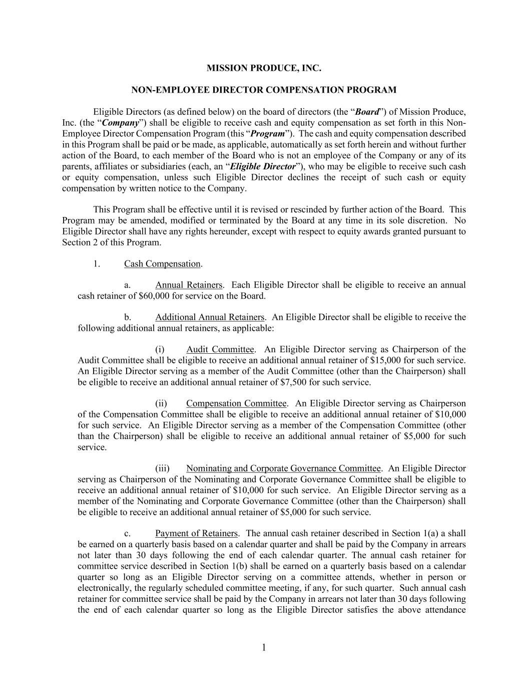
F-35
1 MISSION PRODUCE, INC. NON-EMPLOYEE DIRECTOR COMPENSATION PROGRAM Eligible Directors (as defined below) on the board of directors (the “Board”) of Mission Produce, Inc. (the “Company”) shall be eligible to receive cash and equity compensation as set forth in this Non- Employee Director Compensation Program (this “Program”). The cash and equity compensation described in this Program shall be paid or be made, as applicable, automatically as set forth herein and without further action of the Board, to each member of the Board who is not an employee of the Company or any of its parents, affiliates or subsidiaries (each, an “Eligible Director”), who may be eligible to receive such cash or equity compensation, unless such Eligible Director declines the receipt of such cash or equity compensation by written notice to the Company. This Program shall be effective until it is revised or rescinded by further action of the Board. This Program may be amended, modified or terminated by the Board at any time in its sole discretion. No Eligible Director shall have any rights hereunder, except with respect to equity awards granted pursuant to Section 2 of this Program. 1. Cash Compensation. a. Annual Retainers. Each Eligible Director shall be eligible to receive an annual cash retainer of $60,000 for service on the Board. b. Additional Annual Retainers. An Eligible Director shall be eligible to receive the following additional annual retainers, as applicable: (i) Audit Committee. An Eligible Director serving as Chairperson of the Audit Committee shall be eligible to receive an additional annual retainer of $15,000 for such service. An Eligible Director serving as a member of the Audit Committee (other than the Chairperson) shall be eligible to receive an additional annual retainer of $7,500 for such service. (ii) Compensation Committee. An Eligible Director serving as Chairperson of the Compensation Committee shall be eligible to receive an additional annual retainer of $10,000 for such service. An Eligible Director serving as a member of the Compensation Committee (other than the Chairperson) shall be eligible to receive an additional annual retainer of $5,000 for such service. (iii) Nominating and Corporate Governance Committee. An Eligible Director serving as Chairperson of the Nominating and Corporate Governance Committee shall be eligible to receive an additional annual retainer of $10,000 for such service. An Eligible Director serving as a member of the Nominating and Corporate Governance Committee (other than the Chairperson) shall be eligible to receive an additional annual retainer of $5,000 for such service. c. Payment of Retainers. The annual cash retainer described in Section 1(a) a shall be earned on a quarterly basis based on a calendar quarter and shall be paid by the Company in arrears not later than 30 days following the end of each calendar quarter. The annual cash retainer for committee service described in Section 1(b) shall be earned on a quarterly basis based on a calendar quarter so long as an Eligible Director serving on a committee attends, whether in person or electronically, the regularly scheduled committee meeting, if any, for such quarter. Such annual cash retainer for committee service shall be paid by the Company in arrears not later than 30 days following the end of each calendar quarter so long as the Eligible Director satisfies the above attendance

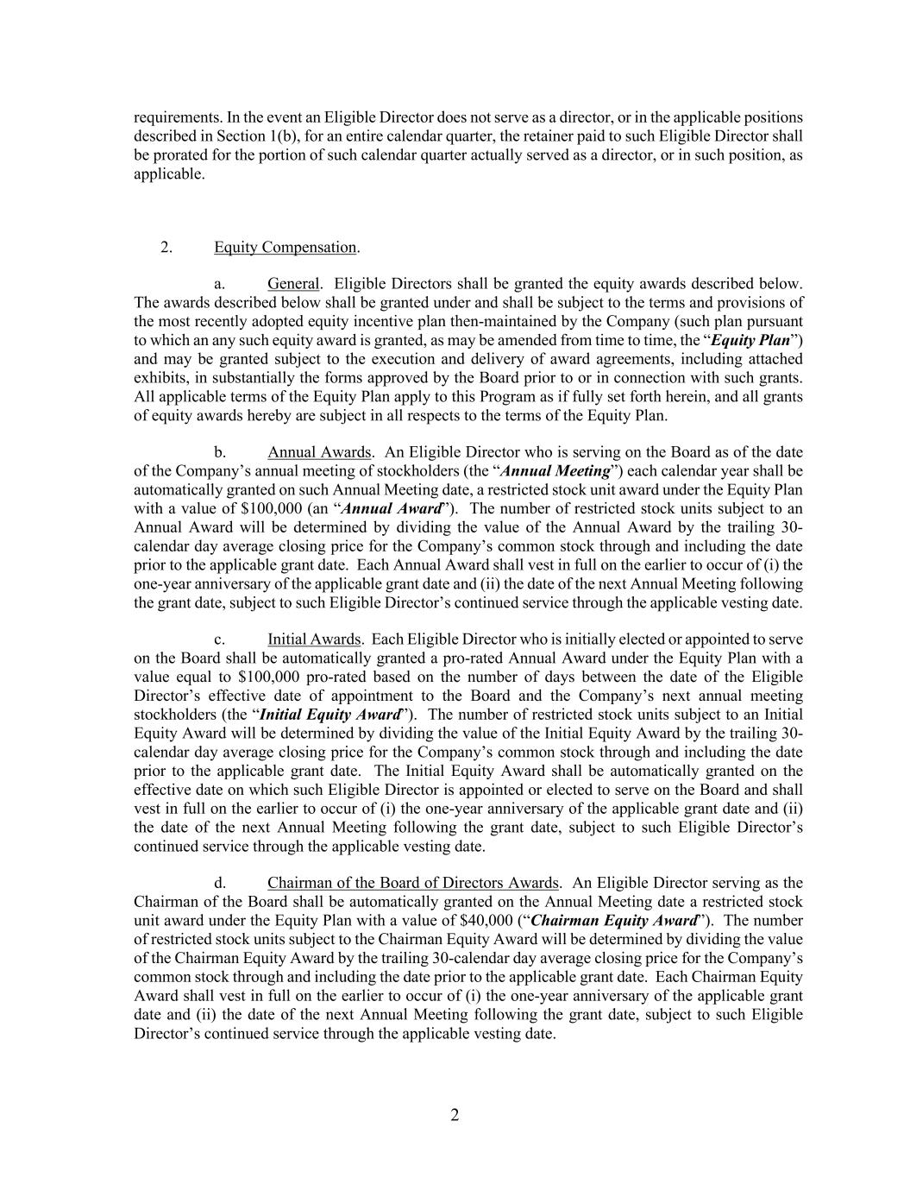
2 requirements. In the event an Eligible Director does not serve as a director, or in the applicable positions described in Section 1(b), for an entire calendar quarter, the retainer paid to such Eligible Director shall be prorated for the portion of such calendar quarter actually served as a director, or in such position, as applicable. 2. Equity Compensation. a. General. Eligible Directors shall be granted the equity awards described below. The awards described below shall be granted under and shall be subject to the terms and provisions of the most recently adopted equity incentive plan then-maintained by the Company (such plan pursuant to which an any such equity award is granted, as may be amended from time to time, the “Equity Plan”) and may be granted subject to the execution and delivery of award agreements, including attached exhibits, in substantially the forms approved by the Board prior to or in connection with such grants. All applicable terms of the Equity Plan apply to this Program as if fully set forth herein, and all grants of equity awards hereby are subject in all respects to the terms of the Equity Plan. b. Annual Awards. An Eligible Director who is serving on the Board as of the date of the Company’s annual meeting of stockholders (the “Annual Meeting”) each calendar year shall be automatically granted on such Annual Meeting date, a restricted stock unit award under the Equity Plan with a value of $100,000 (an “Annual Award”). The number of restricted stock units subject to an Annual Award will be determined by dividing the value of the Annual Award by the trailing 30- calendar day average closing price for the Company’s common stock through and including the date prior to the applicable grant date. Each Annual Award shall vest in full on the earlier to occur of (i) the one-year anniversary of the applicable grant date and (ii) the date of the next Annual Meeting following the grant date, subject to such Eligible Director’s continued service through the applicable vesting date. c. Initial Awards. Each Eligible Director who is initially elected or appointed to serve on the Board shall be automatically granted a pro-rated Annual Award under the Equity Plan with a value equal to $100,000 pro-rated based on the number of days between the date of the Eligible Director’s effective date of appointment to the Board and the Company’s next annual meeting stockholders (the “Initial Equity Award”). The number of restricted stock units subject to an Initial Equity Award will be determined by dividing the value of the Initial Equity Award by the trailing 30- calendar day average closing price for the Company’s common stock through and including the date prior to the applicable grant date. The Initial Equity Award shall be automatically granted on the effective date on which such Eligible Director is appointed or elected to serve on the Board and shall vest in full on the earlier to occur of (i) the one-year anniversary of the applicable grant date and (ii) the date of the next Annual Meeting following the grant date, subject to such Eligible Director’s continued service through the applicable vesting date. d. Chairman of the Board of Directors Awards. An Eligible Director serving as the Chairman of the Board shall be automatically granted on the Annual Meeting date a restricted stock unit award under the Equity Plan with a value of $40,000 (“Chairman Equity Award”). The number of restricted stock units subject to the Chairman Equity Award will be determined by dividing the value of the Chairman Equity Award by the trailing 30-calendar day average closing price for the Company’s common stock through and including the date prior to the applicable grant date. Each Chairman Equity Award shall vest in full on the earlier to occur of (i) the one-year anniversary of the applicable grant date and (ii) the date of the next Annual Meeting following the grant date, subject to such Eligible Director’s continued service through the applicable vesting date.


3 e. Accelerated Vesting Events. Notwithstanding the foregoing, an Eligible Director’s Annual Awards and/or Initial Awards shall vest in full immediately prior to the occurrence of a “change in control” (as defined in the Equity Plan) to the extent outstanding at such time. Last Approved by the Board of Directors on September 6, 2023

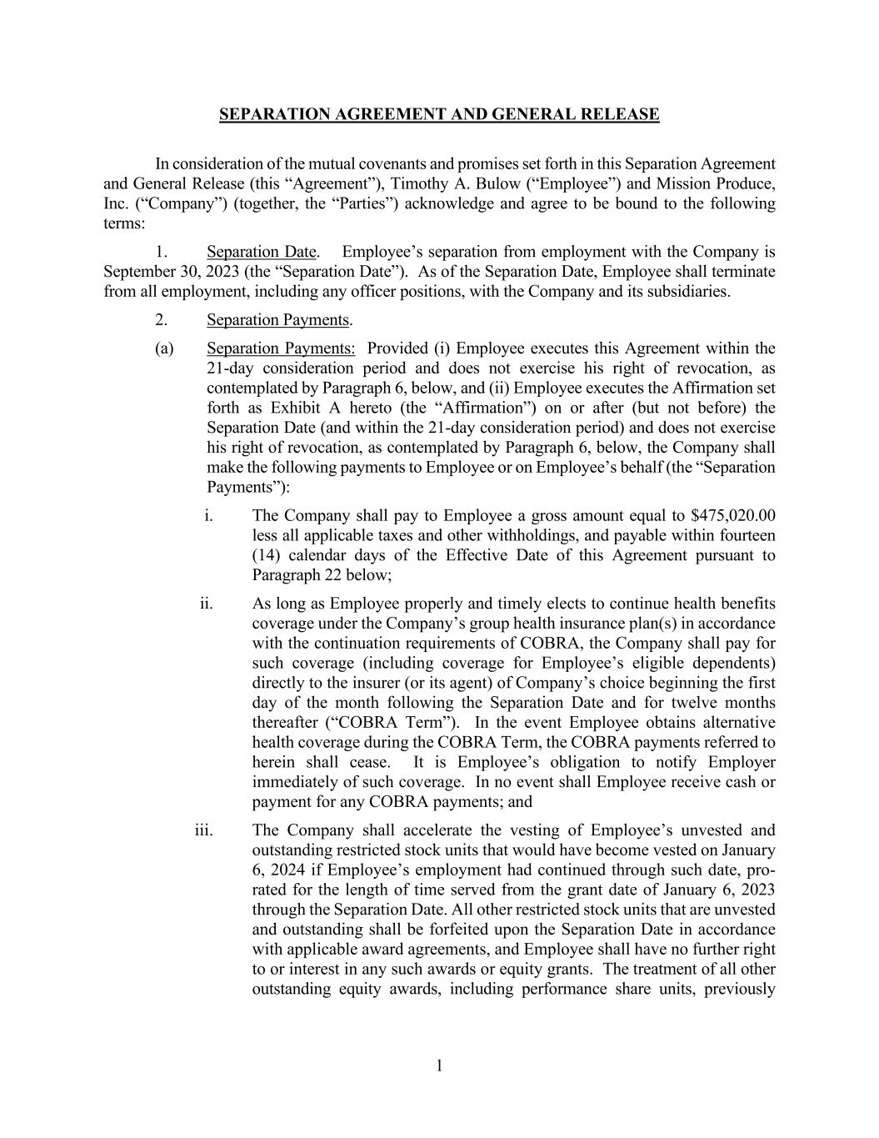
1 SEPARATION AGREEMENT AND GENERAL RELEASE In consideration of the mutual covenants and promises set forth in this Separation Agreement and General Release (this “Agreement”), Timothy A. Bulow (“Employee”) and Mission Produce, Inc. (“Company”) (together, the “Parties”) acknowledge and agree to be bound to the following terms: 1. Separation Date. Employee’s separation from employment with the Company is September 30, 2023 (the “Separation Date”). As of the Separation Date, Employee shall terminate from all employment, including any officer positions, with the Company and its subsidiaries. 2. Separation Payments. (a) Separation Payments: Provided (i) Employee executes this Agreement within the 21-day consideration period and does not exercise his right of revocation, as contemplated by Paragraph 6, below, and (ii) Employee executes the Affirmation set forth as Exhibit A hereto (the “Affirmation”) on or after (but not before) the Separation Date (and within the 21-day consideration period) and does not exercise his right of revocation, as contemplated by Paragraph 6, below, the Company shall make the following payments to Employee or on Employee’s behalf (the “Separation Payments”): i. The Company shall pay to Employee a gross amount equal to $475,020.00 less all applicable taxes and other withholdings, and payable within fourteen (14) calendar days of the Effective Date of this Agreement pursuant to Paragraph 22 below; ii. As long as Employee properly and timely elects to continue health benefits coverage under the Company’s group health insurance plan(s) in accordance with the continuation requirements of COBRA, the Company shall pay for such coverage (including coverage for Employee’s eligible dependents) directly to the insurer (or its agent) of Company’s choice beginning the first day of the month following the Separation Date and for twelve months thereafter (“COBRA Term”). In the event Employee obtains alternative health coverage during the COBRA Term, the COBRA payments referred to herein shall cease. It is Employee’s obligation to notify Employer immediately of such coverage. In no event shall Employee receive cash or payment for any COBRA payments; and iii. The Company shall accelerate the vesting of Employee’s unvested and outstanding restricted stock units that would have become vested on January 6, 2024 if Employee’s employment had continued through such date, pro- rated for the length of time served from the grant date of January 6, 2023 through the Separation Date. All other restricted stock units that are unvested and outstanding shall be forfeited upon the Separation Date in accordance with applicable award agreements, and Employee shall have no further right to or interest in any such awards or equity grants. The treatment of all other outstanding equity awards, including performance share units, previously

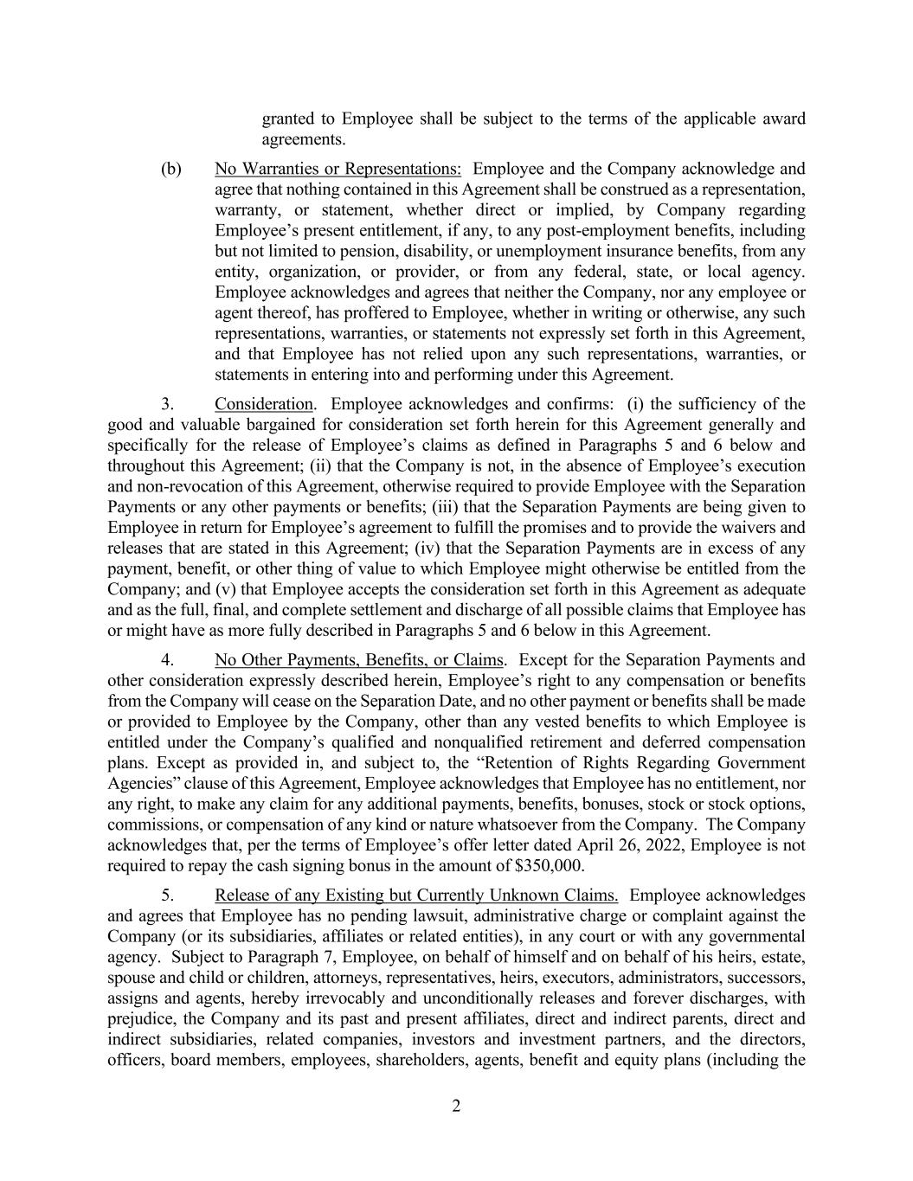
2 granted to Employee shall be subject to the terms of the applicable award agreements. (b) No Warranties or Representations: Employee and the Company acknowledge and agree that nothing contained in this Agreement shall be construed as a representation, warranty, or statement, whether direct or implied, by Company regarding Employee’s present entitlement, if any, to any post-employment benefits, including but not limited to pension, disability, or unemployment insurance benefits, from any entity, organization, or provider, or from any federal, state, or local agency. Employee acknowledges and agrees that neither the Company, nor any employee or agent thereof, has proffered to Employee, whether in writing or otherwise, any such representations, warranties, or statements not expressly set forth in this Agreement, and that Employee has not relied upon any such representations, warranties, or statements in entering into and performing under this Agreement. 3. Consideration. Employee acknowledges and confirms: (i) the sufficiency of the good and valuable bargained for consideration set forth herein for this Agreement generally and specifically for the release of Employee’s claims as defined in Paragraphs 5 and 6 below and throughout this Agreement; (ii) that the Company is not, in the absence of Employee’s execution and non-revocation of this Agreement, otherwise required to provide Employee with the Separation Payments or any other payments or benefits; (iii) that the Separation Payments are being given to Employee in return for Employee’s agreement to fulfill the promises and to provide the waivers and releases that are stated in this Agreement; (iv) that the Separation Payments are in excess of any payment, benefit, or other thing of value to which Employee might otherwise be entitled from the Company; and (v) that Employee accepts the consideration set forth in this Agreement as adequate and as the full, final, and complete settlement and discharge of all possible claims that Employee has or might have as more fully described in Paragraphs 5 and 6 below in this Agreement. 4. No Other Payments, Benefits, or Claims. Except for the Separation Payments and other consideration expressly described herein, Employee’s right to any compensation or benefits from the Company will cease on the Separation Date, and no other payment or benefits shall be made or provided to Employee by the Company, other than any vested benefits to which Employee is entitled under the Company’s qualified and nonqualified retirement and deferred compensation plans. Except as provided in, and subject to, the “Retention of Rights Regarding Government Agencies” clause of this Agreement, Employee acknowledges that Employee has no entitlement, nor any right, to make any claim for any additional payments, benefits, bonuses, stock or stock options, commissions, or compensation of any kind or nature whatsoever from the Company. The Company acknowledges that, per the terms of Employee’s offer letter dated April 26, 2022, Employee is not required to repay the cash signing bonus in the amount of $350,000. 5. Release of any Existing but Currently Unknown Claims. Employee acknowledges and agrees that Employee has no pending lawsuit, administrative charge or complaint against the Company (or its subsidiaries, affiliates or related entities), in any court or with any governmental agency. Subject to Paragraph 7, Employee, on behalf of himself and on behalf of his heirs, estate, spouse and child or children, attorneys, representatives, heirs, executors, administrators, successors, assigns and agents, hereby irrevocably and unconditionally releases and forever discharges, with prejudice, the Company and its past and present affiliates, direct and indirect parents, direct and indirect subsidiaries, related companies, investors and investment partners, and the directors, officers, board members, employees, shareholders, agents, benefit and equity plans (including the

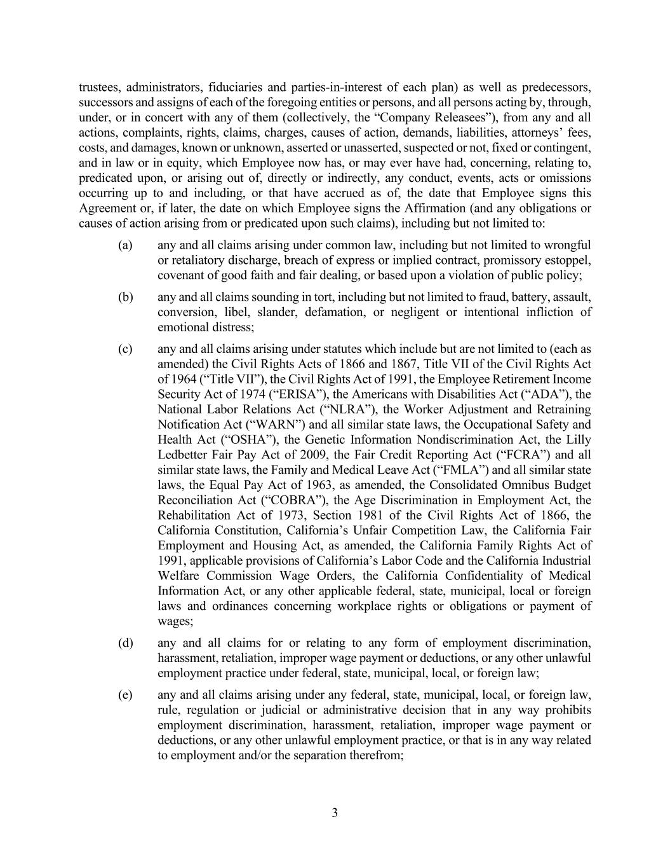
3 trustees, administrators, fiduciaries and parties-in-interest of each plan) as well as predecessors, successors and assigns of each of the foregoing entities or persons, and all persons acting by, through, under, or in concert with any of them (collectively, the “Company Releasees”), from any and all actions, complaints, rights, claims, charges, causes of action, demands, liabilities, attorneys’ fees, costs, and damages, known or unknown, asserted or unasserted, suspected or not, fixed or contingent, and in law or in equity, which Employee now has, or may ever have had, concerning, relating to, predicated upon, or arising out of, directly or indirectly, any conduct, events, acts or omissions occurring up to and including, or that have accrued as of, the date that Employee signs this Agreement or, if later, the date on which Employee signs the Affirmation (and any obligations or causes of action arising from or predicated upon such claims), including but not limited to: (a) any and all claims arising under common law, including but not limited to wrongful or retaliatory discharge, breach of express or implied contract, promissory estoppel, covenant of good faith and fair dealing, or based upon a violation of public policy; (b) any and all claims sounding in tort, including but not limited to fraud, battery, assault, conversion, libel, slander, defamation, or negligent or intentional infliction of emotional distress; (c) any and all claims arising under statutes which include but are not limited to (each as amended) the Civil Rights Acts of 1866 and 1867, Title VII of the Civil Rights Act of 1964 (“Title VII”), the Civil Rights Act of 1991, the Employee Retirement Income Security Act of 1974 (“ERISA”), the Americans with Disabilities Act (“ADA”), the National Labor Relations Act (“NLRA”), the Worker Adjustment and Retraining Notification Act (“WARN”) and all similar state laws, the Occupational Safety and Health Act (“OSHA”), the Genetic Information Nondiscrimination Act, the Lilly Ledbetter Fair Pay Act of 2009, the Fair Credit Reporting Act (“FCRA”) and all similar state laws, the Family and Medical Leave Act (“FMLA”) and all similar state laws, the Equal Pay Act of 1963, as amended, the Consolidated Omnibus Budget Reconciliation Act (“COBRA”), the Age Discrimination in Employment Act, the Rehabilitation Act of 1973, Section 1981 of the Civil Rights Act of 1866, the California Constitution, California’s Unfair Competition Law, the California Fair Employment and Housing Act, as amended, the California Family Rights Act of 1991, applicable provisions of California’s Labor Code and the California Industrial Welfare Commission Wage Orders, the California Confidentiality of Medical Information Act, or any other applicable federal, state, municipal, local or foreign laws and ordinances concerning workplace rights or obligations or payment of wages; (d) any and all claims for or relating to any form of employment discrimination, harassment, retaliation, improper wage payment or deductions, or any other unlawful employment practice under federal, state, municipal, local, or foreign law; (e) any and all claims arising under any federal, state, municipal, local, or foreign law, rule, regulation or judicial or administrative decision that in any way prohibits employment discrimination, harassment, retaliation, improper wage payment or deductions, or any other unlawful employment practice, or that is in any way related to employment and/or the separation therefrom;

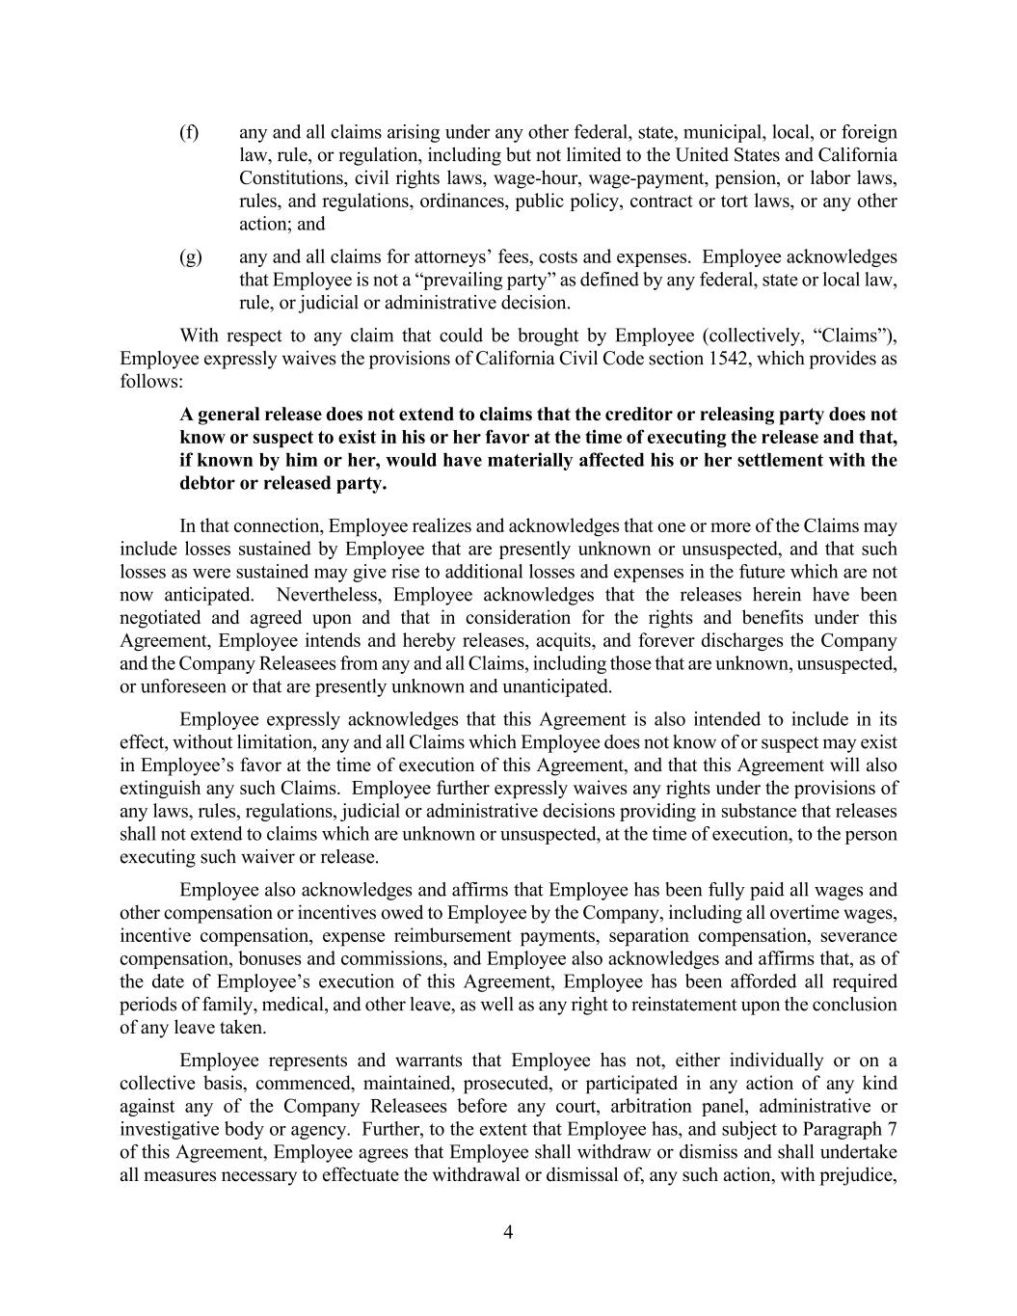
4 (f) any and all claims arising under any other federal, state, municipal, local, or foreign law, rule, or regulation, including but not limited to the United States and California Constitutions, civil rights laws, wage-hour, wage-payment, pension, or labor laws, rules, and regulations, ordinances, public policy, contract or tort laws, or any other action; and (g) any and all claims for attorneys’ fees, costs and expenses. Employee acknowledges that Employee is not a “prevailing party” as defined by any federal, state or local law, rule, or judicial or administrative decision. With respect to any claim that could be brought by Employee (collectively, “Claims”), Employee expressly waives the provisions of California Civil Code section 1542, which provides as follows: A general release does not extend to claims that the creditor or releasing party does not know or suspect to exist in his or her favor at the time of executing the release and that, if known by him or her, would have materially affected his or her settlement with the debtor or released party. In that connection, Employee realizes and acknowledges that one or more of the Claims may include losses sustained by Employee that are presently unknown or unsuspected, and that such losses as were sustained may give rise to additional losses and expenses in the future which are not now anticipated. Nevertheless, Employee acknowledges that the releases herein have been negotiated and agreed upon and that in consideration for the rights and benefits under this Agreement, Employee intends and hereby releases, acquits, and forever discharges the Company and the Company Releasees from any and all Claims, including those that are unknown, unsuspected, or unforeseen or that are presently unknown and unanticipated. Employee expressly acknowledges that this Agreement is also intended to include in its effect, without limitation, any and all Claims which Employee does not know of or suspect may exist in Employee’s favor at the time of execution of this Agreement, and that this Agreement will also extinguish any such Claims. Employee further expressly waives any rights under the provisions of any laws, rules, regulations, judicial or administrative decisions providing in substance that releases shall not extend to claims which are unknown or unsuspected, at the time of execution, to the person executing such waiver or release. Employee also acknowledges and affirms that Employee has been fully paid all wages and other compensation or incentives owed to Employee by the Company, including all overtime wages, incentive compensation, expense reimbursement payments, separation compensation, severance compensation, bonuses and commissions, and Employee also acknowledges and affirms that, as of the date of Employee’s execution of this Agreement, Employee has been afforded all required periods of family, medical, and other leave, as well as any right to reinstatement upon the conclusion of any leave taken. Employee represents and warrants that Employee has not, either individually or on a collective basis, commenced, maintained, prosecuted, or participated in any action of any kind against any of the Company Releasees before any court, arbitration panel, administrative or investigative body or agency. Further, to the extent that Employee has, and subject to Paragraph 7 of this Agreement, Employee agrees that Employee shall withdraw or dismiss and shall undertake all measures necessary to effectuate the withdrawal or dismissal of, any such action, with prejudice,

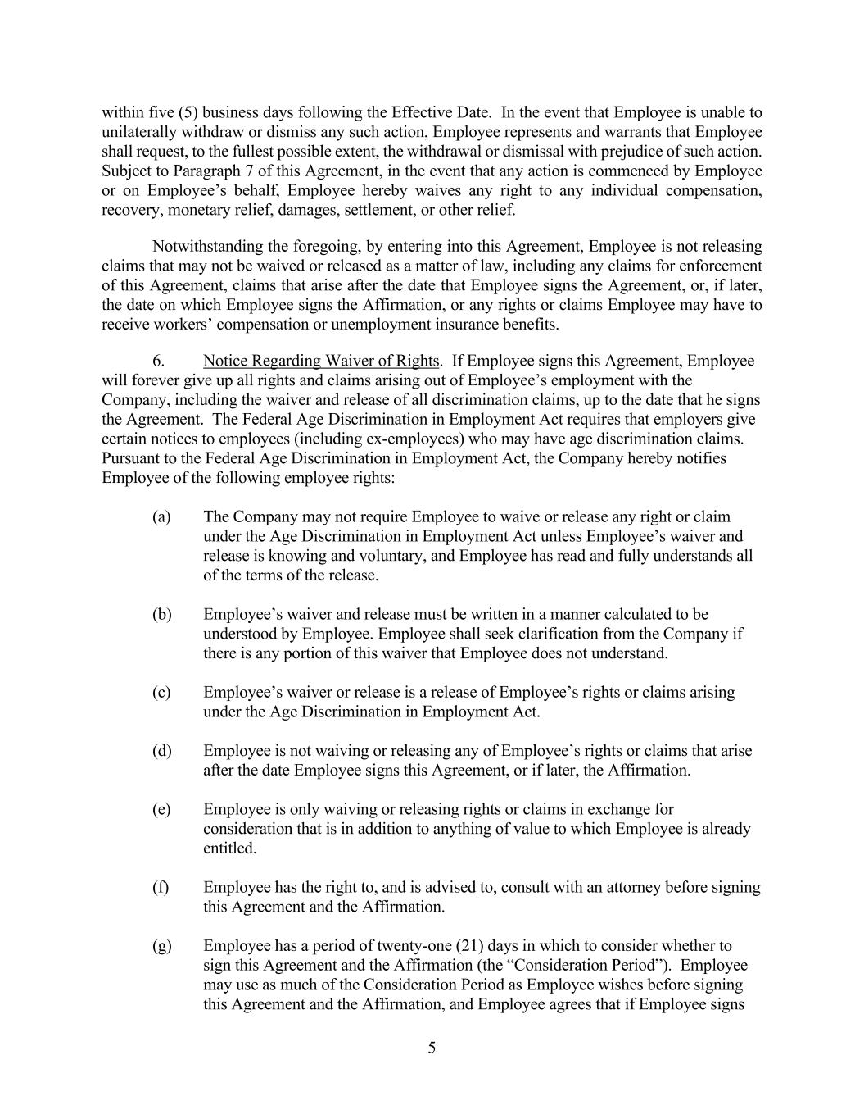
5 within five (5) business days following the Effective Date. In the event that Employee is unable to unilaterally withdraw or dismiss any such action, Employee represents and warrants that Employee shall request, to the fullest possible extent, the withdrawal or dismissal with prejudice of such action. Subject to Paragraph 7 of this Agreement, in the event that any action is commenced by Employee or on Employee’s behalf, Employee hereby waives any right to any individual compensation, recovery, monetary relief, damages, settlement, or other relief. Notwithstanding the foregoing, by entering into this Agreement, Employee is not releasing claims that may not be waived or released as a matter of law, including any claims for enforcement of this Agreement, claims that arise after the date that Employee signs the Agreement, or, if later, the date on which Employee signs the Affirmation, or any rights or claims Employee may have to receive workers’ compensation or unemployment insurance benefits. 6. Notice Regarding Waiver of Rights. If Employee signs this Agreement, Employee will forever give up all rights and claims arising out of Employee’s employment with the Company, including the waiver and release of all discrimination claims, up to the date that he signs the Agreement. The Federal Age Discrimination in Employment Act requires that employers give certain notices to employees (including ex-employees) who may have age discrimination claims. Pursuant to the Federal Age Discrimination in Employment Act, the Company hereby notifies Employee of the following employee rights: (a) The Company may not require Employee to waive or release any right or claim under the Age Discrimination in Employment Act unless Employee’s waiver and release is knowing and voluntary, and Employee has read and fully understands all of the terms of the release. (b) Employee’s waiver and release must be written in a manner calculated to be understood by Employee. Employee shall seek clarification from the Company if there is any portion of this waiver that Employee does not understand. (c) Employee’s waiver or release is a release of Employee’s rights or claims arising under the Age Discrimination in Employment Act. (d) Employee is not waiving or releasing any of Employee’s rights or claims that arise after the date Employee signs this Agreement, or if later, the Affirmation. (e) Employee is only waiving or releasing rights or claims in exchange for consideration that is in addition to anything of value to which Employee is already entitled. (f) Employee has the right to, and is advised to, consult with an attorney before signing this Agreement and the Affirmation. (g) Employee has a period of twenty-one (21) days in which to consider whether to sign this Agreement and the Affirmation (the “Consideration Period”). Employee may use as much of the Consideration Period as Employee wishes before signing this Agreement and the Affirmation, and Employee agrees that if Employee signs

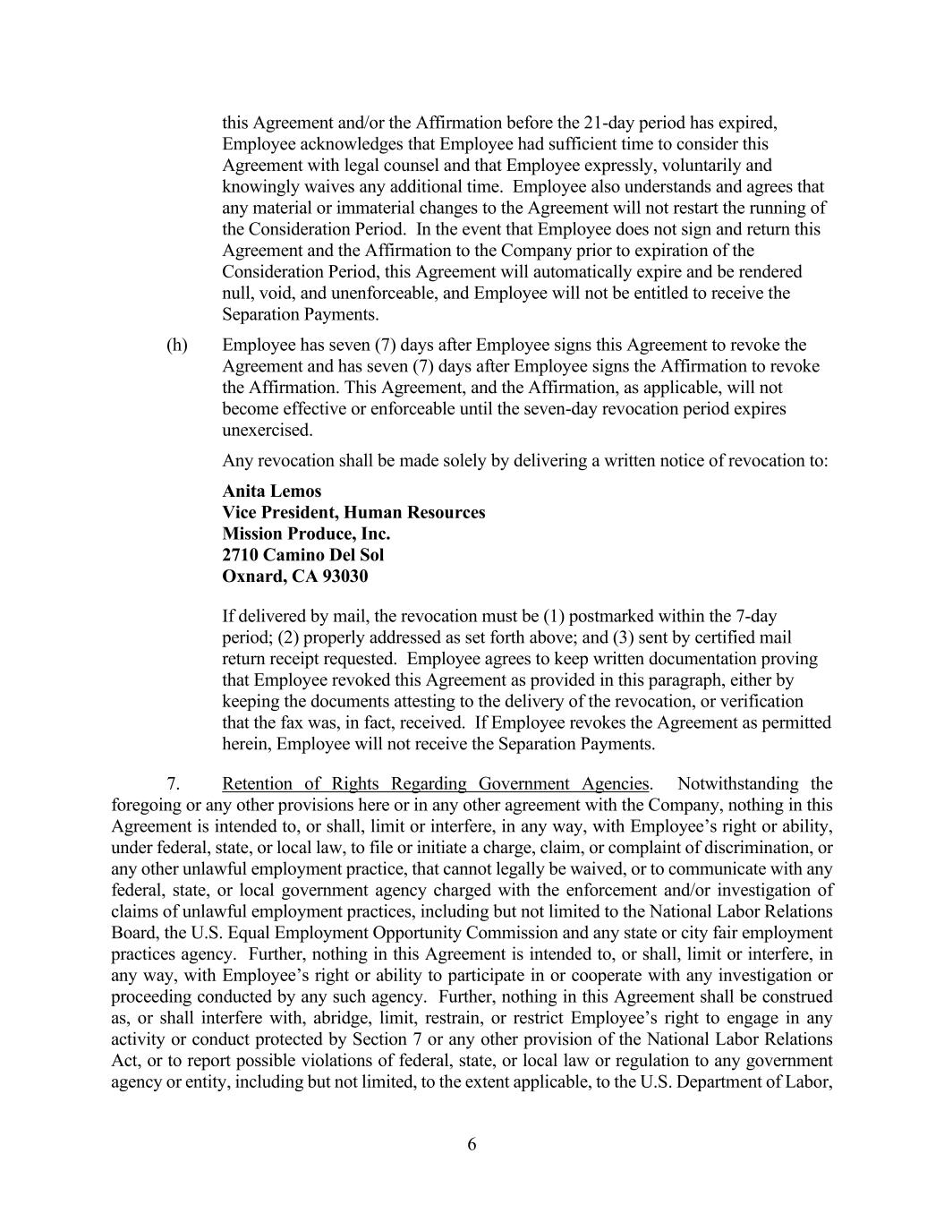
6 this Agreement and/or the Affirmation before the 21-day period has expired, Employee acknowledges that Employee had sufficient time to consider this Agreement with legal counsel and that Employee expressly, voluntarily and knowingly waives any additional time. Employee also understands and agrees that any material or immaterial changes to the Agreement will not restart the running of the Consideration Period. In the event that Employee does not sign and return this Agreement and the Affirmation to the Company prior to expiration of the Consideration Period, this Agreement will automatically expire and be rendered null, void, and unenforceable, and Employee will not be entitled to receive the Separation Payments. (h) Employee has seven (7) days after Employee signs this Agreement to revoke the Agreement and has seven (7) days after Employee signs the Affirmation to revoke the Affirmation. This Agreement, and the Affirmation, as applicable, will not become effective or enforceable until the seven-day revocation period expires unexercised. Any revocation shall be made solely by delivering a written notice of revocation to: Anita Lemos Vice President, Human Resources Mission Produce, Inc. 2710 Camino Del Sol Oxnard, CA 93030 If delivered by mail, the revocation must be (1) postmarked within the 7-day period; (2) properly addressed as set forth above; and (3) sent by certified mail return receipt requested. Employee agrees to keep written documentation proving that Employee revoked this Agreement as provided in this paragraph, either by keeping the documents attesting to the delivery of the revocation, or verification that the fax was, in fact, received. If Employee revokes the Agreement as permitted herein, Employee will not receive the Separation Payments. 7. Retention of Rights Regarding Government Agencies. Notwithstanding the foregoing or any other provisions here or in any other agreement with the Company, nothing in this Agreement is intended to, or shall, limit or interfere, in any way, with Employee’s right or ability, under federal, state, or local law, to file or initiate a charge, claim, or complaint of discrimination, or any other unlawful employment practice, that cannot legally be waived, or to communicate with any federal, state, or local government agency charged with the enforcement and/or investigation of claims of unlawful employment practices, including but not limited to the National Labor Relations Board, the U.S. Equal Employment Opportunity Commission and any state or city fair employment practices agency. Further, nothing in this Agreement is intended to, or shall, limit or interfere, in any way, with Employee’s right or ability to participate in or cooperate with any investigation or proceeding conducted by any such agency. Further, nothing in this Agreement shall be construed as, or shall interfere with, abridge, limit, restrain, or restrict Employee’s right to engage in any activity or conduct protected by Section 7 or any other provision of the National Labor Relations Act, or to report possible violations of federal, state, or local law or regulation to any government agency or entity, including but not limited, to the extent applicable, to the U.S. Department of Labor,

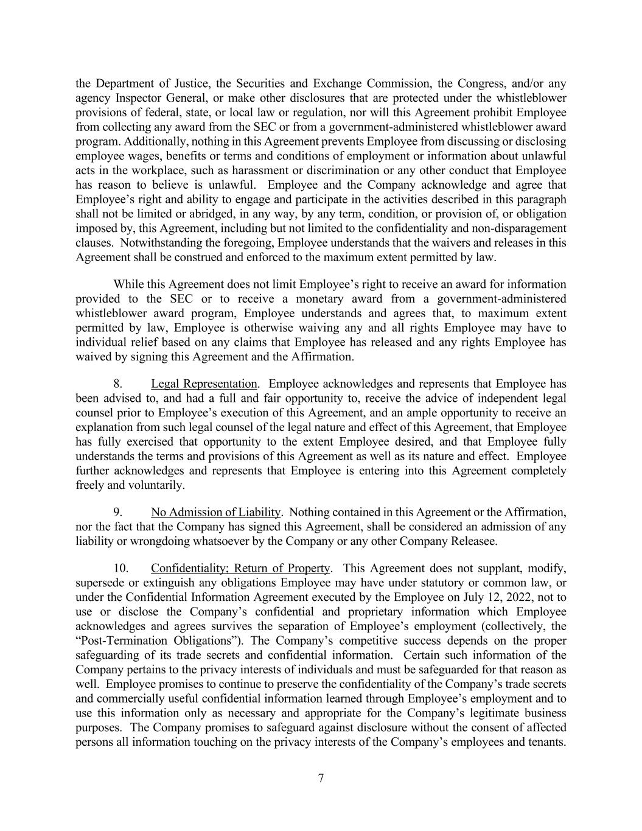
7 the Department of Justice, the Securities and Exchange Commission, the Congress, and/or any agency Inspector General, or make other disclosures that are protected under the whistleblower provisions of federal, state, or local law or regulation, nor will this Agreement prohibit Employee from collecting any award from the SEC or from a government-administered whistleblower award program. Additionally, nothing in this Agreement prevents Employee from discussing or disclosing employee wages, benefits or terms and conditions of employment or information about unlawful acts in the workplace, such as harassment or discrimination or any other conduct that Employee has reason to believe is unlawful. Employee and the Company acknowledge and agree that Employee’s right and ability to engage and participate in the activities described in this paragraph shall not be limited or abridged, in any way, by any term, condition, or provision of, or obligation imposed by, this Agreement, including but not limited to the confidentiality and non-disparagement clauses. Notwithstanding the foregoing, Employee understands that the waivers and releases in this Agreement shall be construed and enforced to the maximum extent permitted by law. While this Agreement does not limit Employee’s right to receive an award for information provided to the SEC or to receive a monetary award from a government-administered whistleblower award program, Employee understands and agrees that, to maximum extent permitted by law, Employee is otherwise waiving any and all rights Employee may have to individual relief based on any claims that Employee has released and any rights Employee has waived by signing this Agreement and the Affirmation. 8. Legal Representation. Employee acknowledges and represents that Employee has been advised to, and had a full and fair opportunity to, receive the advice of independent legal counsel prior to Employee’s execution of this Agreement, and an ample opportunity to receive an explanation from such legal counsel of the legal nature and effect of this Agreement, that Employee has fully exercised that opportunity to the extent Employee desired, and that Employee fully understands the terms and provisions of this Agreement as well as its nature and effect. Employee further acknowledges and represents that Employee is entering into this Agreement completely freely and voluntarily. 9. No Admission of Liability. Nothing contained in this Agreement or the Affirmation, nor the fact that the Company has signed this Agreement, shall be considered an admission of any liability or wrongdoing whatsoever by the Company or any other Company Releasee. 10. Confidentiality; Return of Property. This Agreement does not supplant, modify, supersede or extinguish any obligations Employee may have under statutory or common law, or under the Confidential Information Agreement executed by the Employee on July 12, 2022, not to use or disclose the Company’s confidential and proprietary information which Employee acknowledges and agrees survives the separation of Employee’s employment (collectively, the “Post-Termination Obligations”). The Company’s competitive success depends on the proper safeguarding of its trade secrets and confidential information. Certain such information of the Company pertains to the privacy interests of individuals and must be safeguarded for that reason as well. Employee promises to continue to preserve the confidentiality of the Company’s trade secrets and commercially useful confidential information learned through Employee’s employment and to use this information only as necessary and appropriate for the Company’s legitimate business purposes. The Company promises to safeguard against disclosure without the consent of affected persons all information touching on the privacy interests of the Company’s employees and tenants.

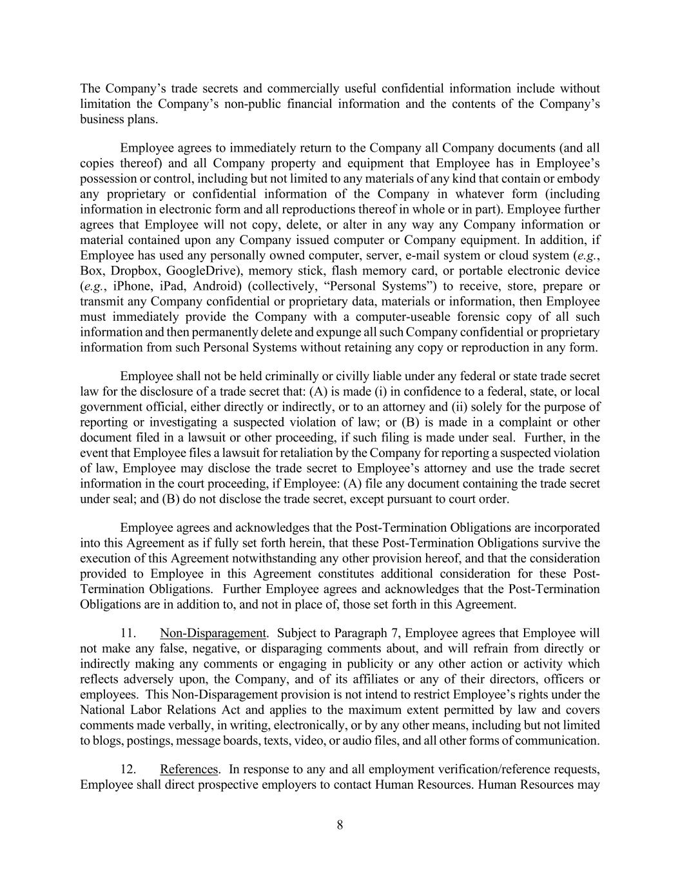
8 The Company’s trade secrets and commercially useful confidential information include without limitation the Company’s non-public financial information and the contents of the Company’s business plans. Employee agrees to immediately return to the Company all Company documents (and all copies thereof) and all Company property and equipment that Employee has in Employee’s possession or control, including but not limited to any materials of any kind that contain or embody any proprietary or confidential information of the Company in whatever form (including information in electronic form and all reproductions thereof in whole or in part). Employee further agrees that Employee will not copy, delete, or alter in any way any Company information or material contained upon any Company issued computer or Company equipment. In addition, if Employee has used any personally owned computer, server, e-mail system or cloud system (e.g., Box, Dropbox, GoogleDrive), memory stick, flash memory card, or portable electronic device (e.g., iPhone, iPad, Android) (collectively, “Personal Systems”) to receive, store, prepare or transmit any Company confidential or proprietary data, materials or information, then Employee must immediately provide the Company with a computer-useable forensic copy of all such information and then permanently delete and expunge all such Company confidential or proprietary information from such Personal Systems without retaining any copy or reproduction in any form. Employee shall not be held criminally or civilly liable under any federal or state trade secret law for the disclosure of a trade secret that: (A) is made (i) in confidence to a federal, state, or local government official, either directly or indirectly, or to an attorney and (ii) solely for the purpose of reporting or investigating a suspected violation of law; or (B) is made in a complaint or other document filed in a lawsuit or other proceeding, if such filing is made under seal. Further, in the event that Employee files a lawsuit for retaliation by the Company for reporting a suspected violation of law, Employee may disclose the trade secret to Employee’s attorney and use the trade secret information in the court proceeding, if Employee: (A) file any document containing the trade secret under seal; and (B) do not disclose the trade secret, except pursuant to court order. Employee agrees and acknowledges that the Post-Termination Obligations are incorporated into this Agreement as if fully set forth herein, that these Post-Termination Obligations survive the execution of this Agreement notwithstanding any other provision hereof, and that the consideration provided to Employee in this Agreement constitutes additional consideration for these Post- Termination Obligations. Further Employee agrees and acknowledges that the Post-Termination Obligations are in addition to, and not in place of, those set forth in this Agreement. 11. Non-Disparagement. Subject to Paragraph 7, Employee agrees that Employee will not make any false, negative, or disparaging comments about, and will refrain from directly or indirectly making any comments or engaging in publicity or any other action or activity which reflects adversely upon, the Company, and of its affiliates or any of their directors, officers or employees. This Non-Disparagement provision is not intend to restrict Employee’s rights under the National Labor Relations Act and applies to the maximum extent permitted by law and covers comments made verbally, in writing, electronically, or by any other means, including but not limited to blogs, postings, message boards, texts, video, or audio files, and all other forms of communication. 12. References. In response to any and all employment verification/reference requests, Employee shall direct prospective employers to contact Human Resources. Human Resources may

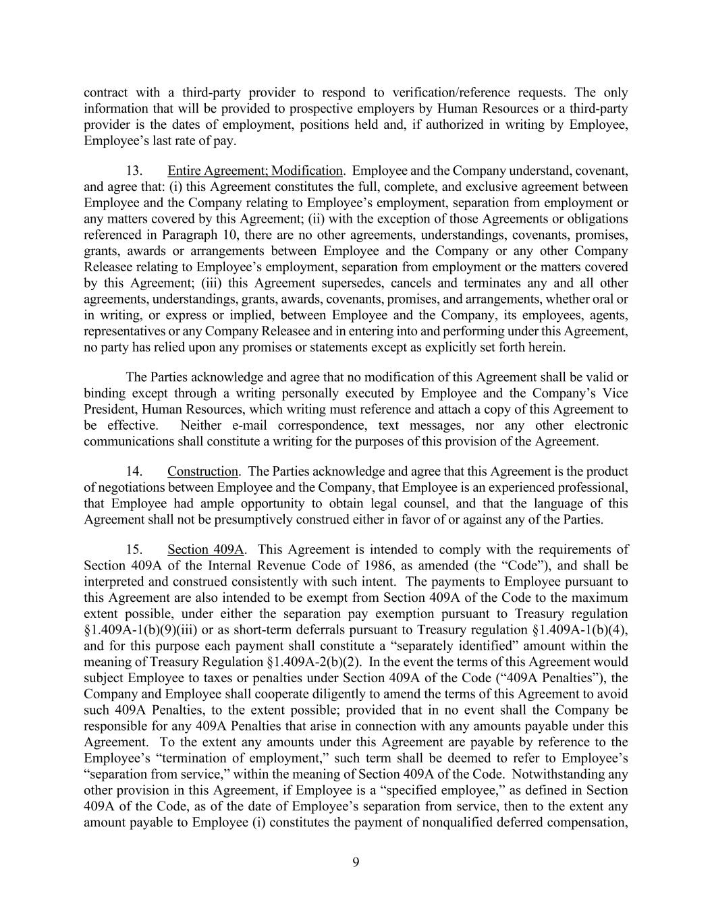
9 contract with a third-party provider to respond to verification/reference requests. The only information that will be provided to prospective employers by Human Resources or a third-party provider is the dates of employment, positions held and, if authorized in writing by Employee, Employee’s last rate of pay. 13. Entire Agreement; Modification. Employee and the Company understand, covenant, and agree that: (i) this Agreement constitutes the full, complete, and exclusive agreement between Employee and the Company relating to Employee’s employment, separation from employment or any matters covered by this Agreement; (ii) with the exception of those Agreements or obligations referenced in Paragraph 10, there are no other agreements, understandings, covenants, promises, grants, awards or arrangements between Employee and the Company or any other Company Releasee relating to Employee’s employment, separation from employment or the matters covered by this Agreement; (iii) this Agreement supersedes, cancels and terminates any and all other agreements, understandings, grants, awards, covenants, promises, and arrangements, whether oral or in writing, or express or implied, between Employee and the Company, its employees, agents, representatives or any Company Releasee and in entering into and performing under this Agreement, no party has relied upon any promises or statements except as explicitly set forth herein. The Parties acknowledge and agree that no modification of this Agreement shall be valid or binding except through a writing personally executed by Employee and the Company’s Vice President, Human Resources, which writing must reference and attach a copy of this Agreement to be effective. Neither e-mail correspondence, text messages, nor any other electronic communications shall constitute a writing for the purposes of this provision of the Agreement. 14. Construction. The Parties acknowledge and agree that this Agreement is the product of negotiations between Employee and the Company, that Employee is an experienced professional, that Employee had ample opportunity to obtain legal counsel, and that the language of this Agreement shall not be presumptively construed either in favor of or against any of the Parties. 15. Section 409A. This Agreement is intended to comply with the requirements of Section 409A of the Internal Revenue Code of 1986, as amended (the “Code”), and shall be interpreted and construed consistently with such intent. The payments to Employee pursuant to this Agreement are also intended to be exempt from Section 409A of the Code to the maximum extent possible, under either the separation pay exemption pursuant to Treasury regulation §1.409A-1(b)(9)(iii) or as short-term deferrals pursuant to Treasury regulation §1.409A-1(b)(4), and for this purpose each payment shall constitute a “separately identified” amount within the meaning of Treasury Regulation §1.409A-2(b)(2). In the event the terms of this Agreement would subject Employee to taxes or penalties under Section 409A of the Code (“409A Penalties”), the Company and Employee shall cooperate diligently to amend the terms of this Agreement to avoid such 409A Penalties, to the extent possible; provided that in no event shall the Company be responsible for any 409A Penalties that arise in connection with any amounts payable under this Agreement. To the extent any amounts under this Agreement are payable by reference to the Employee’s “termination of employment,” such term shall be deemed to refer to Employee’s “separation from service,” within the meaning of Section 409A of the Code. Notwithstanding any other provision in this Agreement, if Employee is a “specified employee,” as defined in Section 409A of the Code, as of the date of Employee’s separation from service, then to the extent any amount payable to Employee (i) constitutes the payment of nonqualified deferred compensation,

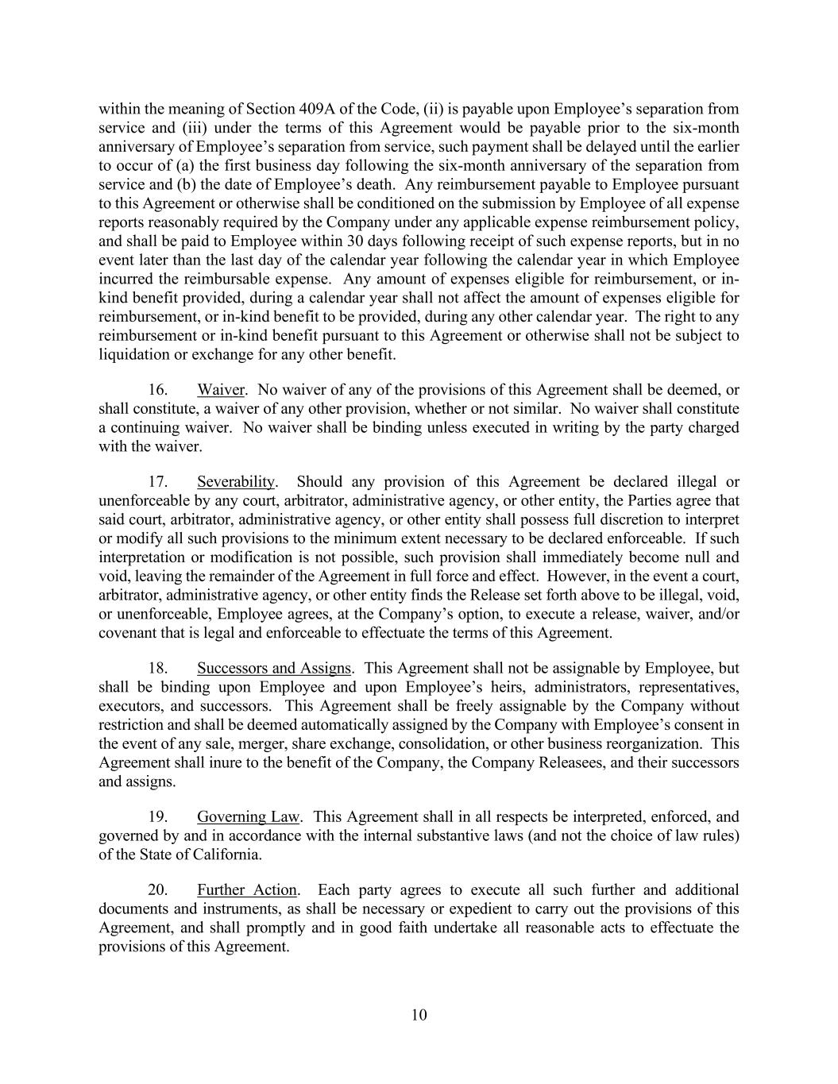
10 within the meaning of Section 409A of the Code, (ii) is payable upon Employee’s separation from service and (iii) under the terms of this Agreement would be payable prior to the six-month anniversary of Employee’s separation from service, such payment shall be delayed until the earlier to occur of (a) the first business day following the six-month anniversary of the separation from service and (b) the date of Employee’s death. Any reimbursement payable to Employee pursuant to this Agreement or otherwise shall be conditioned on the submission by Employee of all expense reports reasonably required by the Company under any applicable expense reimbursement policy, and shall be paid to Employee within 30 days following receipt of such expense reports, but in no event later than the last day of the calendar year following the calendar year in which Employee incurred the reimbursable expense. Any amount of expenses eligible for reimbursement, or in- kind benefit provided, during a calendar year shall not affect the amount of expenses eligible for reimbursement, or in-kind benefit to be provided, during any other calendar year. The right to any reimbursement or in-kind benefit pursuant to this Agreement or otherwise shall not be subject to liquidation or exchange for any other benefit. 16. Waiver. No waiver of any of the provisions of this Agreement shall be deemed, or shall constitute, a waiver of any other provision, whether or not similar. No waiver shall constitute a continuing waiver. No waiver shall be binding unless executed in writing by the party charged with the waiver. 17. Severability. Should any provision of this Agreement be declared illegal or unenforceable by any court, arbitrator, administrative agency, or other entity, the Parties agree that said court, arbitrator, administrative agency, or other entity shall possess full discretion to interpret or modify all such provisions to the minimum extent necessary to be declared enforceable. If such interpretation or modification is not possible, such provision shall immediately become null and void, leaving the remainder of the Agreement in full force and effect. However, in the event a court, arbitrator, administrative agency, or other entity finds the Release set forth above to be illegal, void, or unenforceable, Employee agrees, at the Company’s option, to execute a release, waiver, and/or covenant that is legal and enforceable to effectuate the terms of this Agreement. 18. Successors and Assigns. This Agreement shall not be assignable by Employee, but shall be binding upon Employee and upon Employee’s heirs, administrators, representatives, executors, and successors. This Agreement shall be freely assignable by the Company without restriction and shall be deemed automatically assigned by the Company with Employee’s consent in the event of any sale, merger, share exchange, consolidation, or other business reorganization. This Agreement shall inure to the benefit of the Company, the Company Releasees, and their successors and assigns. 19. Governing Law. This Agreement shall in all respects be interpreted, enforced, and governed by and in accordance with the internal substantive laws (and not the choice of law rules) of the State of California. 20. Further Action. Each party agrees to execute all such further and additional documents and instruments, as shall be necessary or expedient to carry out the provisions of this Agreement, and shall promptly and in good faith undertake all reasonable acts to effectuate the provisions of this Agreement.

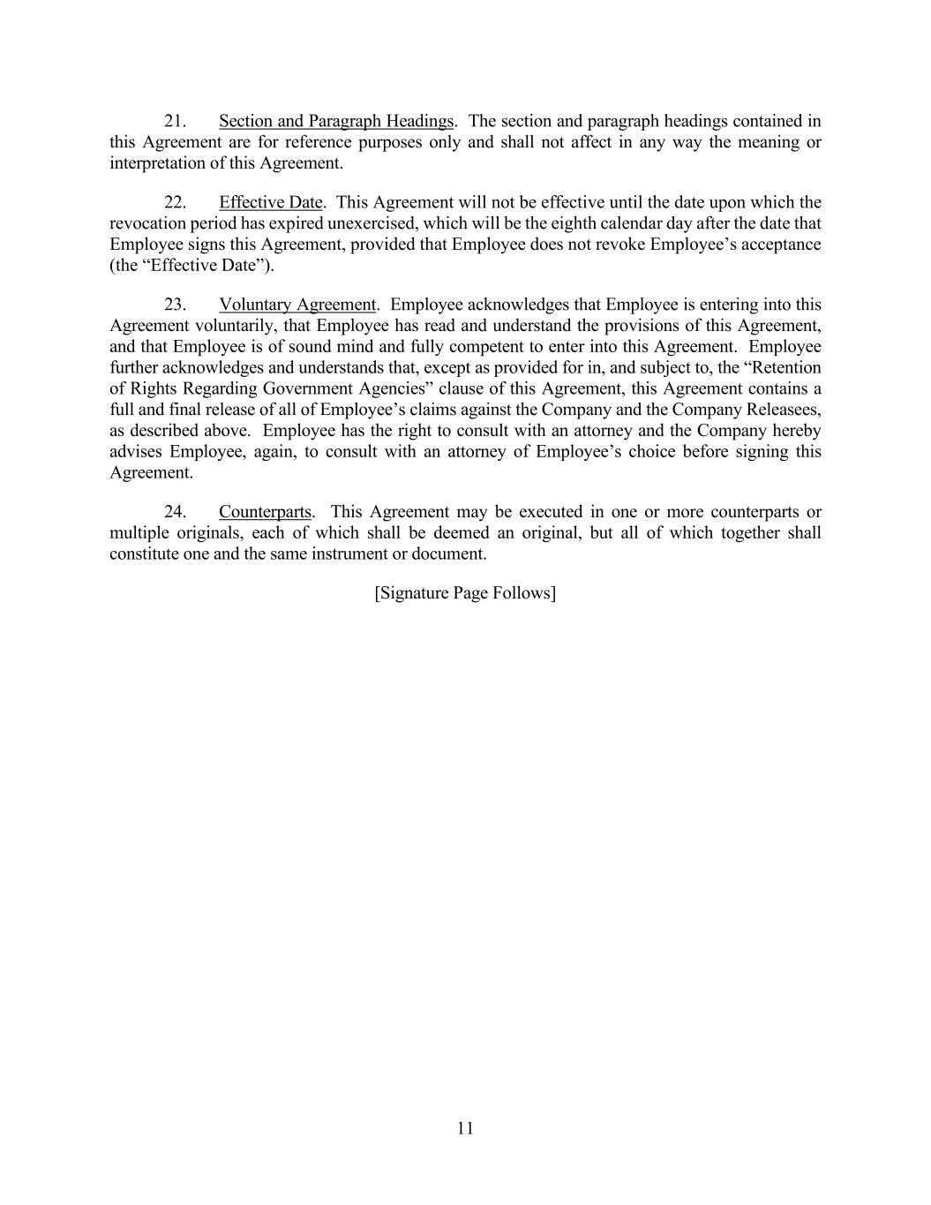
11 21. Section and Paragraph Headings. The section and paragraph headings contained in this Agreement are for reference purposes only and shall not affect in any way the meaning or interpretation of this Agreement. 22. Effective Date. This Agreement will not be effective until the date upon which the revocation period has expired unexercised, which will be the eighth calendar day after the date that Employee signs this Agreement, provided that Employee does not revoke Employee’s acceptance (the “Effective Date”). 23. Voluntary Agreement. Employee acknowledges that Employee is entering into this Agreement voluntarily, that Employee has read and understand the provisions of this Agreement, and that Employee is of sound mind and fully competent to enter into this Agreement. Employee further acknowledges and understands that, except as provided for in, and subject to, the “Retention of Rights Regarding Government Agencies” clause of this Agreement, this Agreement contains a full and final release of all of Employee’s claims against the Company and the Company Releasees, as described above. Employee has the right to consult with an attorney and the Company hereby advises Employee, again, to consult with an attorney of Employee’s choice before signing this Agreement. 24. Counterparts. This Agreement may be executed in one or more counterparts or multiple originals, each of which shall be deemed an original, but all of which together shall constitute one and the same instrument or document. [Signature Page Follows]

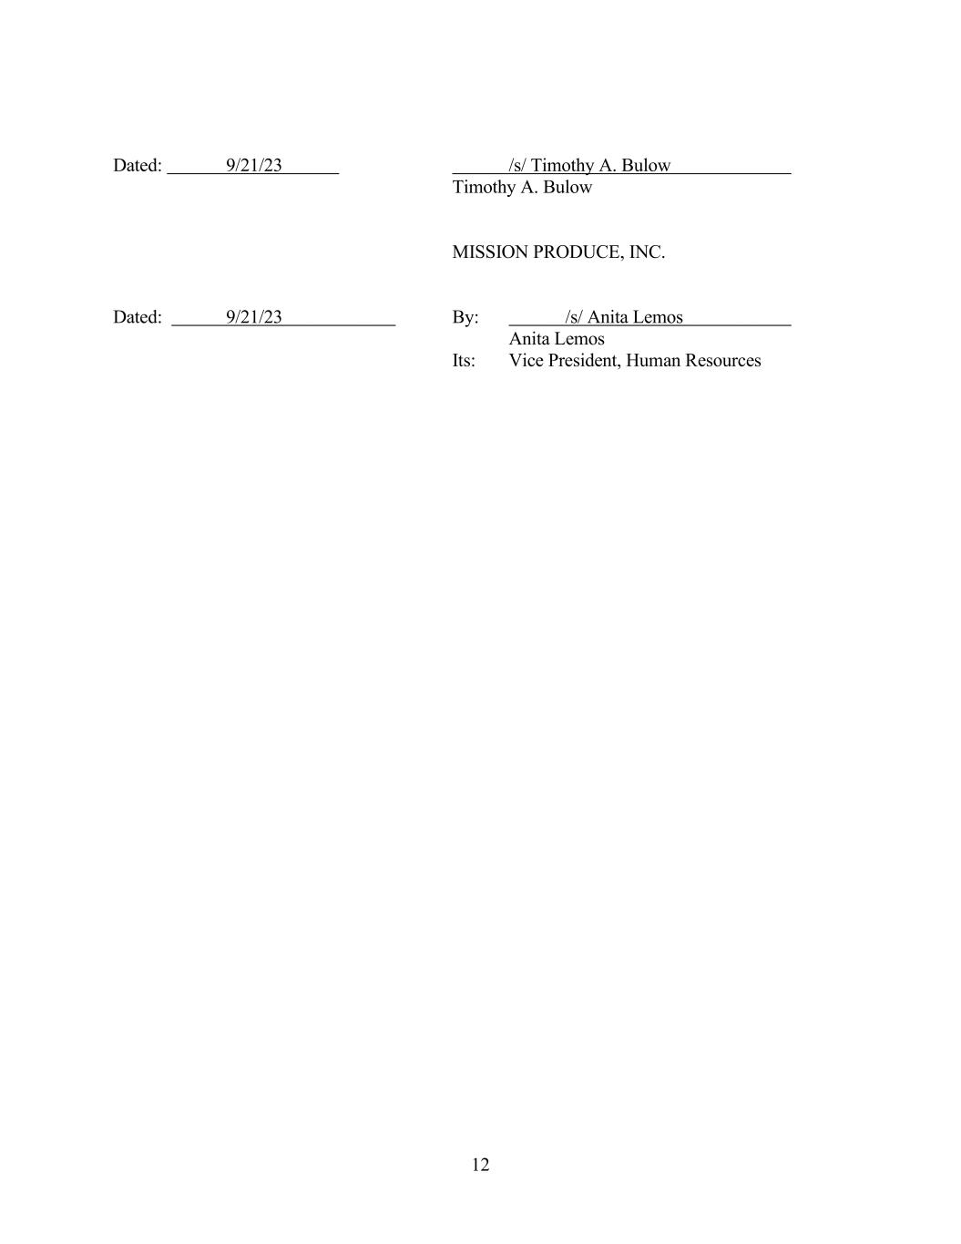
12 Dated: 9/21/23 /s/ Timothy A. Bulow Timothy A. Bulow MISSION PRODUCE, INC. Dated: 9/21/23 By: /s/ Anita Lemos Anita Lemos Its: Vice President, Human Resources

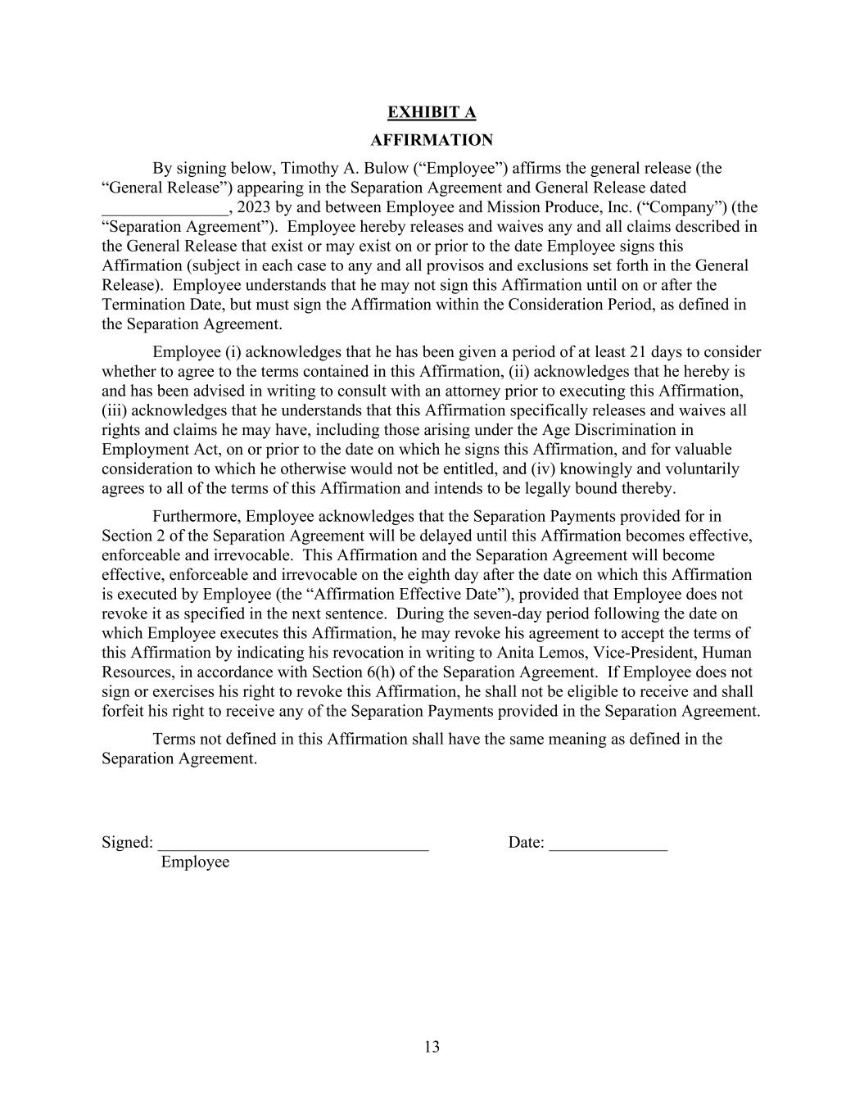
13 EXHIBIT A AFFIRMATION By signing below, Timothy A. Bulow (“Employee”) affirms the general release (the “General Release”) appearing in the Separation Agreement and General Release dated _______________, 2023 by and between Employee and Mission Produce, Inc. (“Company”) (the “Separation Agreement”). Employee hereby releases and waives any and all claims described in the General Release that exist or may exist on or prior to the date Employee signs this Affirmation (subject in each case to any and all provisos and exclusions set forth in the General Release). Employee understands that he may not sign this Affirmation until on or after the Termination Date, but must sign the Affirmation within the Consideration Period, as defined in the Separation Agreement. Employee (i) acknowledges that he has been given a period of at least 21 days to consider whether to agree to the terms contained in this Affirmation, (ii) acknowledges that he hereby is and has been advised in writing to consult with an attorney prior to executing this Affirmation, (iii) acknowledges that he understands that this Affirmation specifically releases and waives all rights and claims he may have, including those arising under the Age Discrimination in Employment Act, on or prior to the date on which he signs this Affirmation, and for valuable consideration to which he otherwise would not be entitled, and (iv) knowingly and voluntarily agrees to all of the terms of this Affirmation and intends to be legally bound thereby. Furthermore, Employee acknowledges that the Separation Payments provided for in Section 2 of the Separation Agreement will be delayed until this Affirmation becomes effective, enforceable and irrevocable. This Affirmation and the Separation Agreement will become effective, enforceable and irrevocable on the eighth day after the date on which this Affirmation is executed by Employee (the “Affirmation Effective Date”), provided that Employee does not revoke it as specified in the next sentence. During the seven-day period following the date on which Employee executes this Affirmation, he may revoke his agreement to accept the terms of this Affirmation by indicating his revocation in writing to Anita Lemos, Vice-President, Human Resources, in accordance with Section 6(h) of the Separation Agreement. If Employee does not sign or exercises his right to revoke this Affirmation, he shall not be eligible to receive and shall forfeit his right to receive any of the Separation Payments provided in the Separation Agreement. Terms not defined in this Affirmation shall have the same meaning as defined in the Separation Agreement. Signed: ________________________________ Date: ______________ Employee

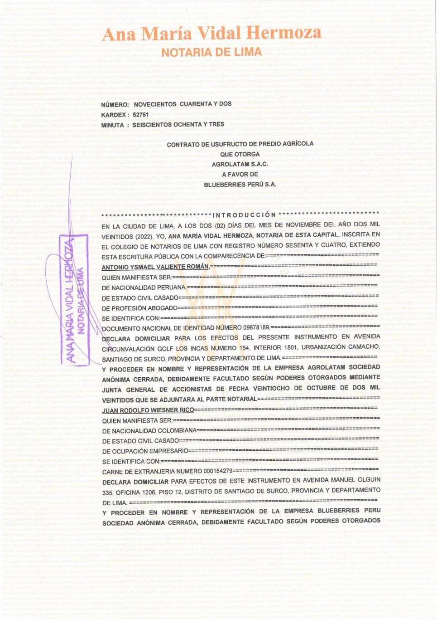

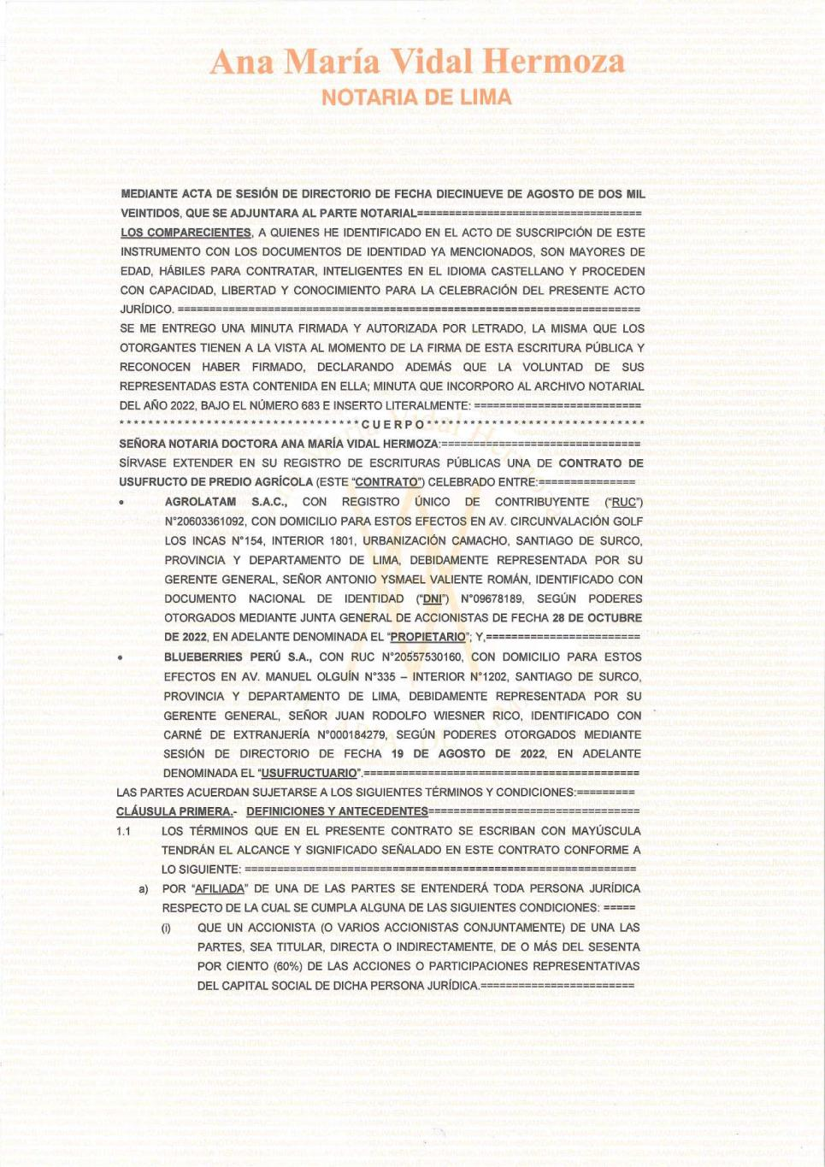

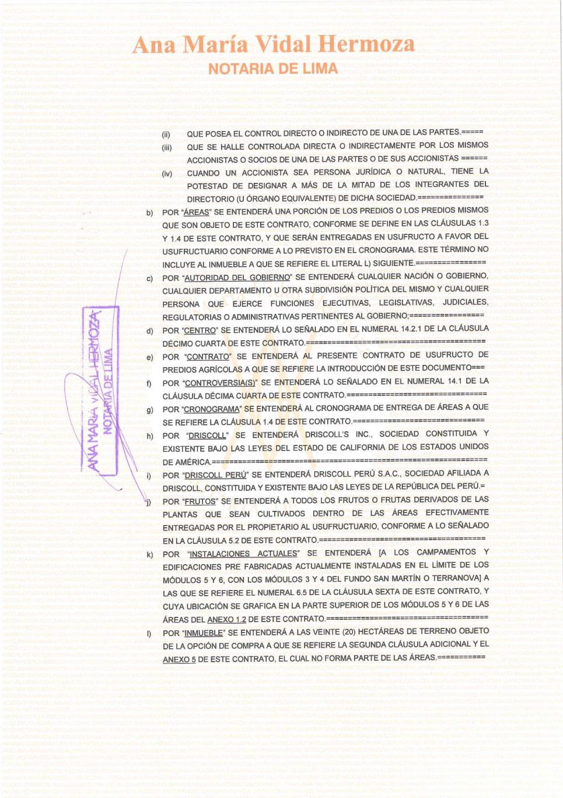

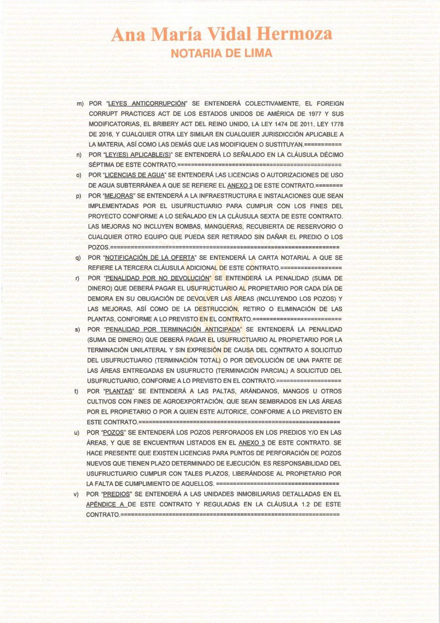

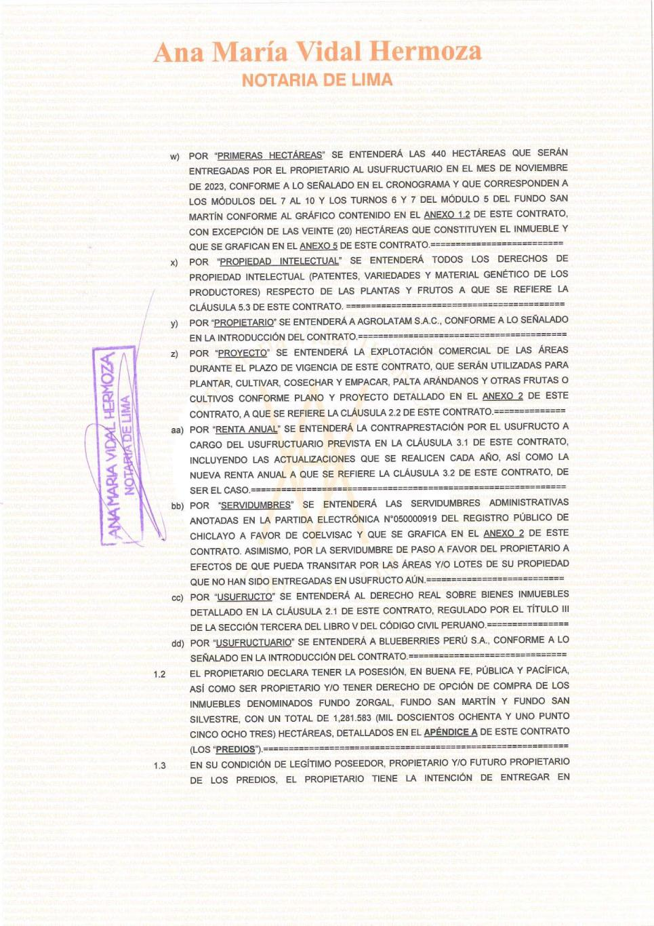

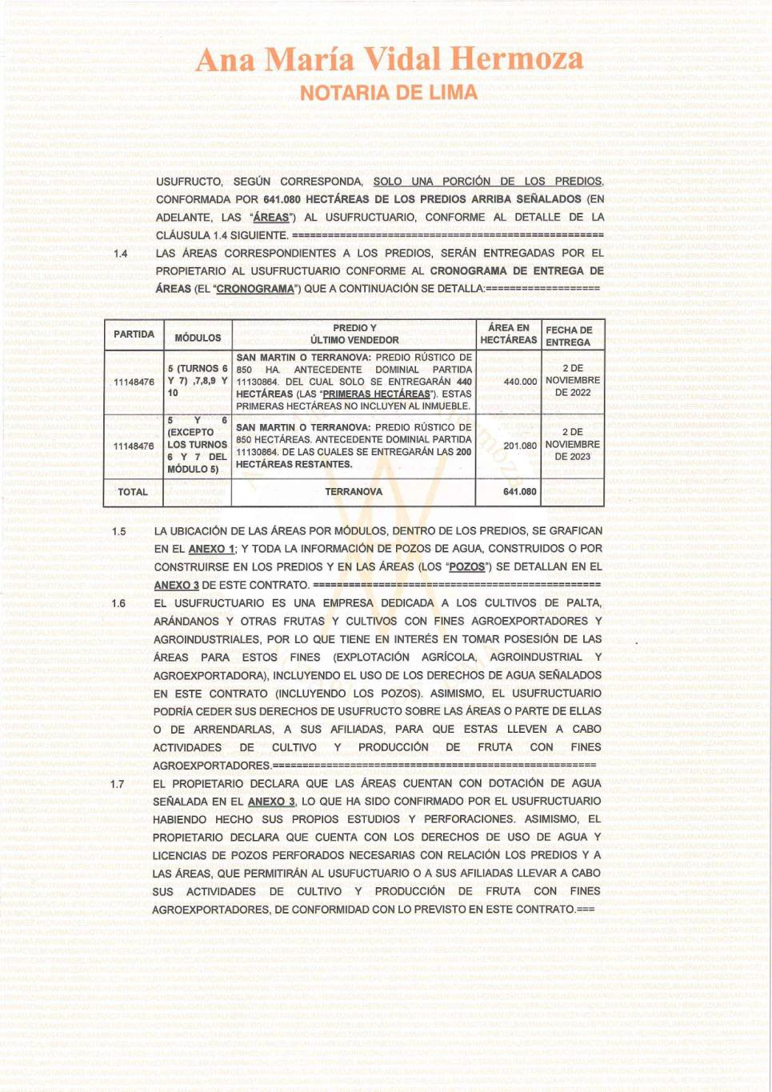

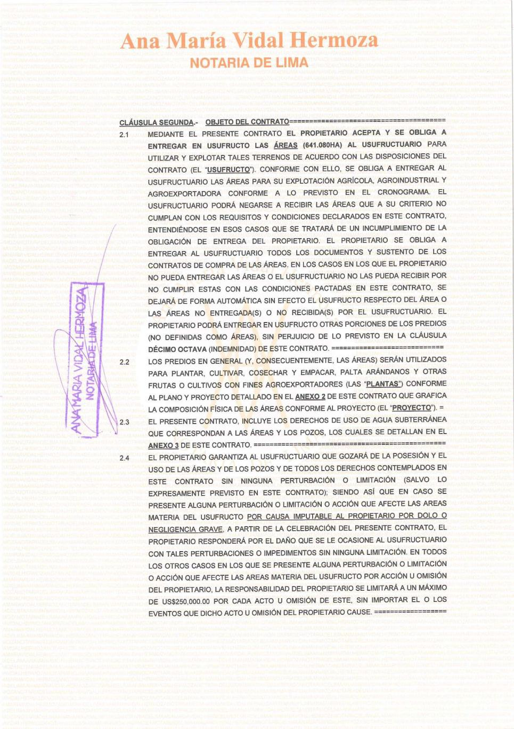

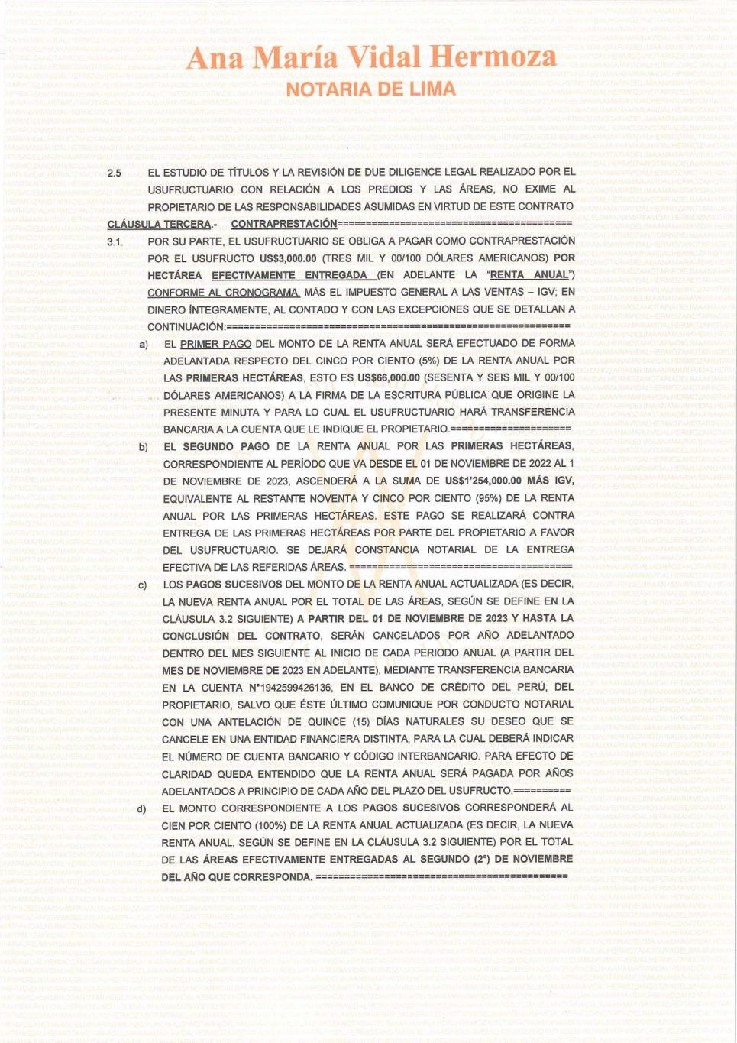

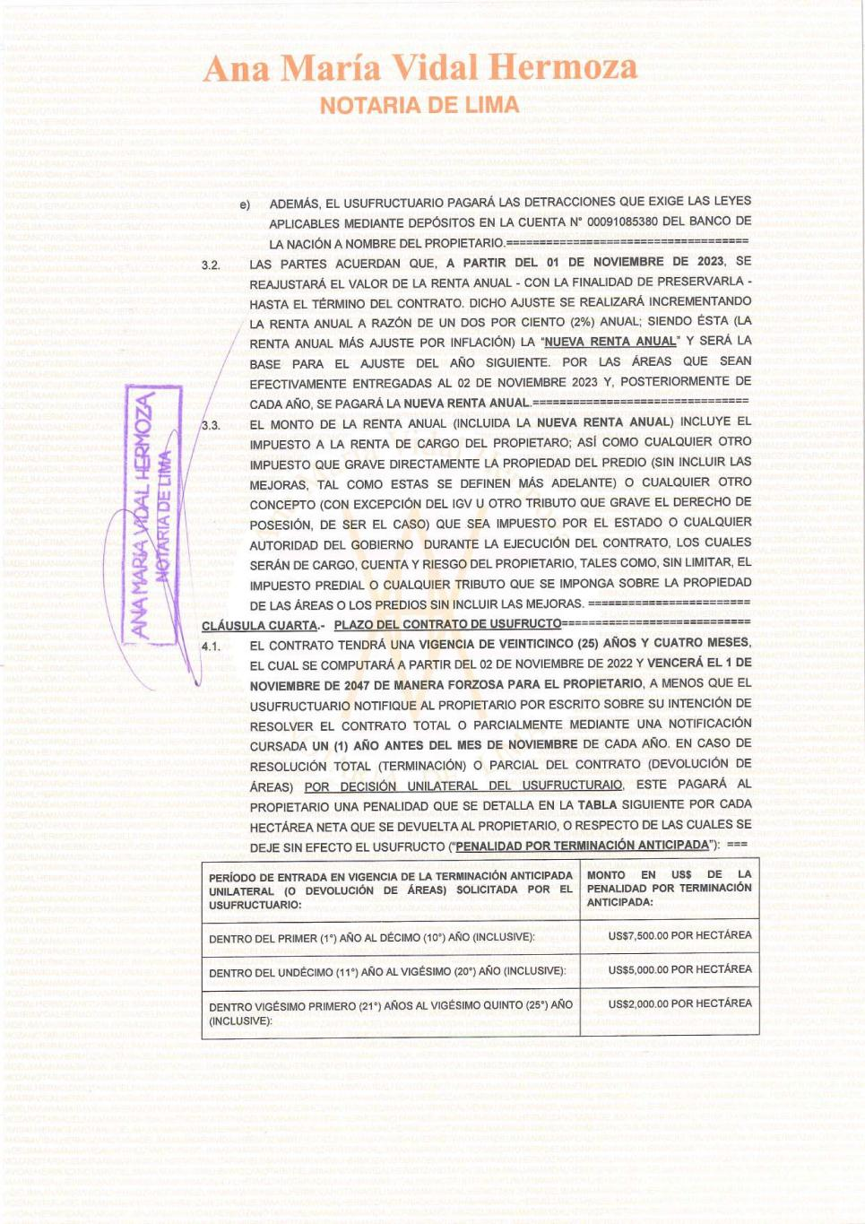

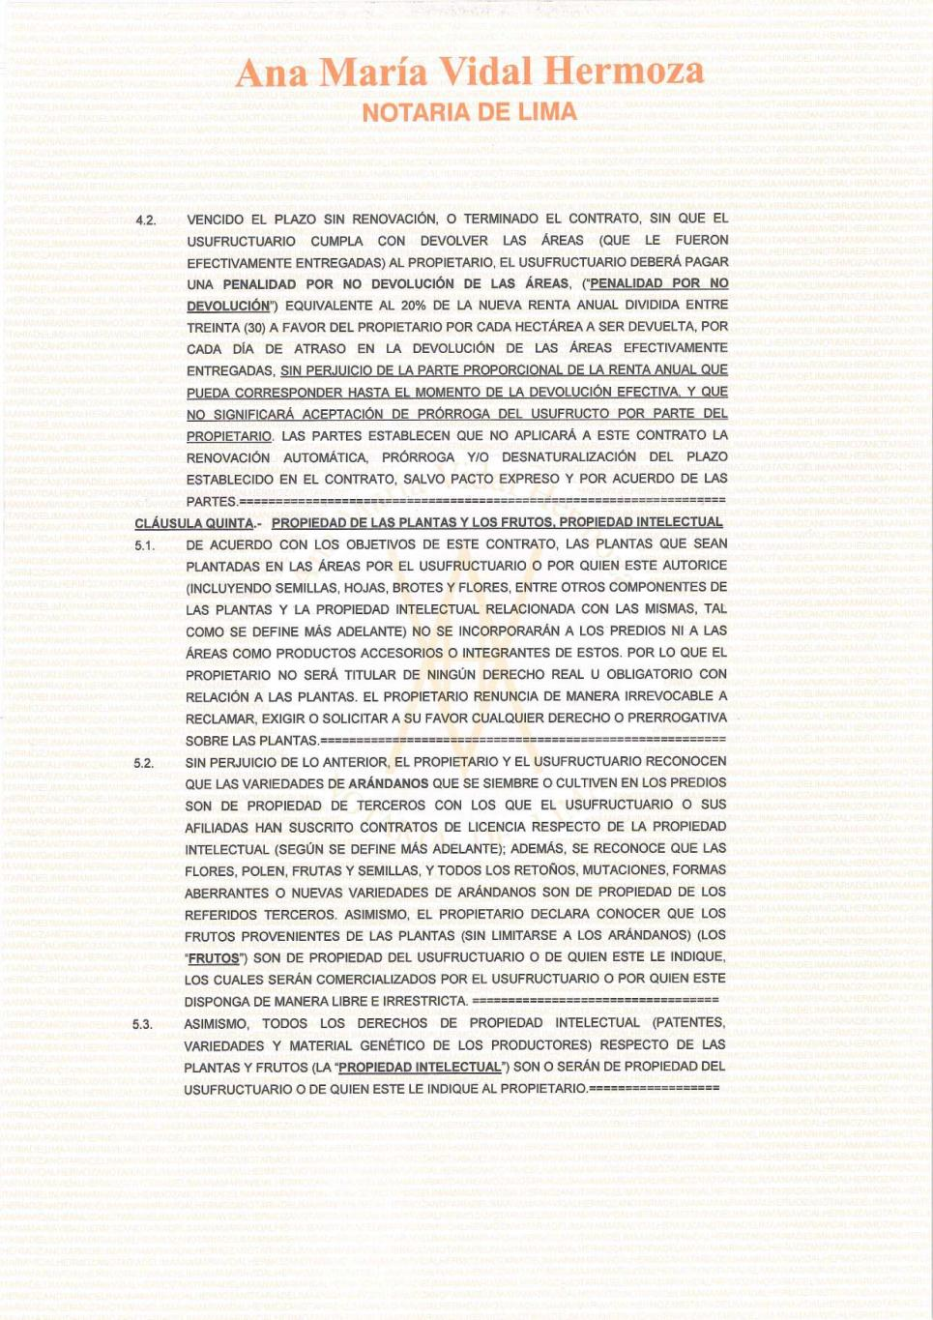

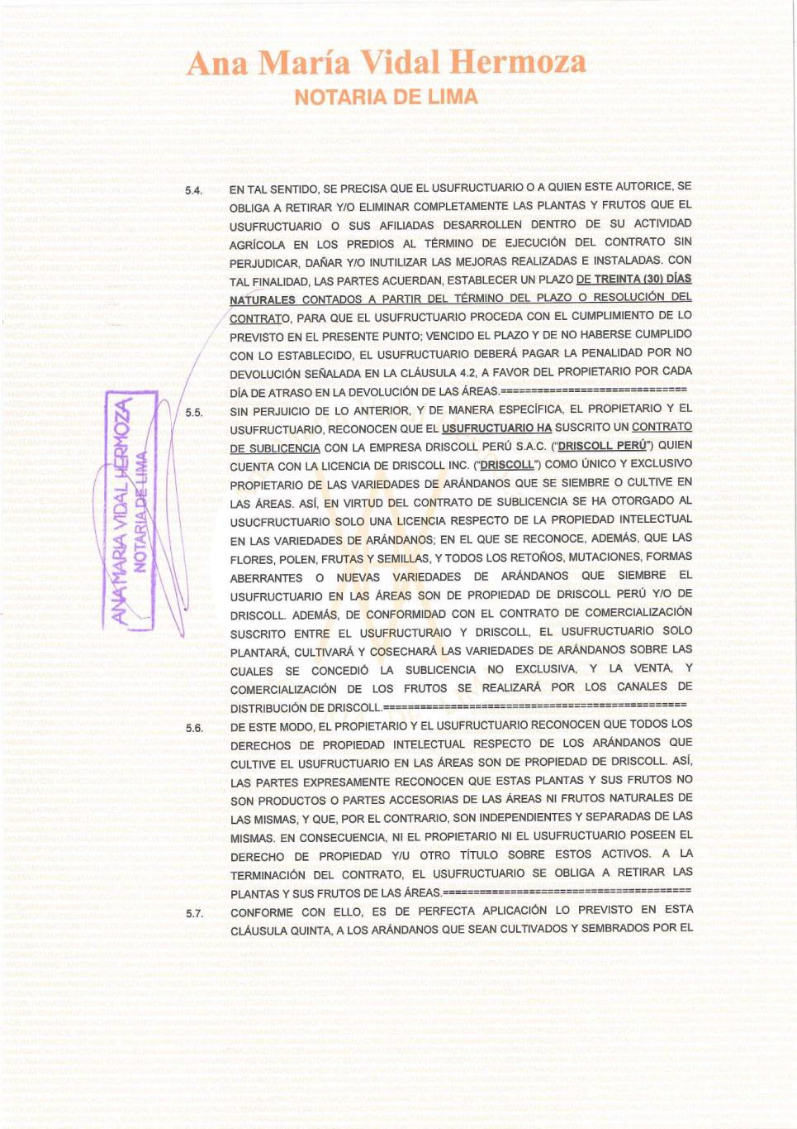

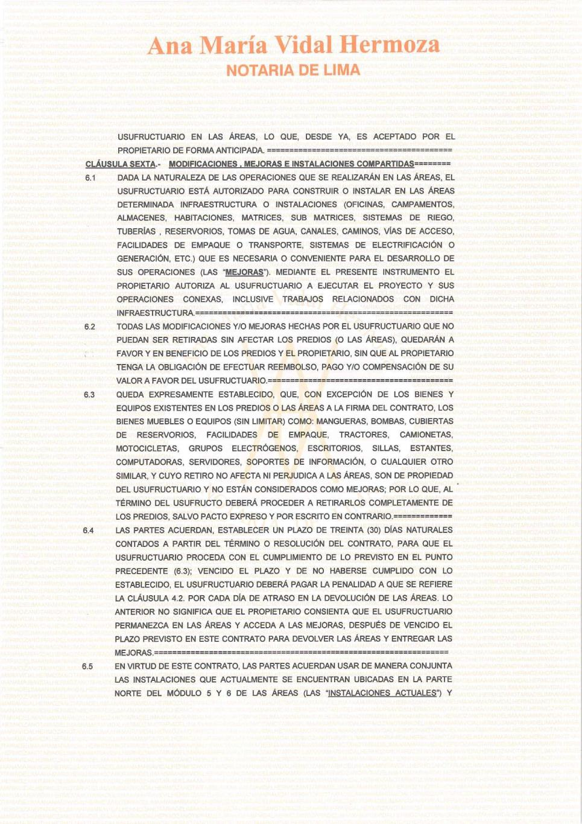

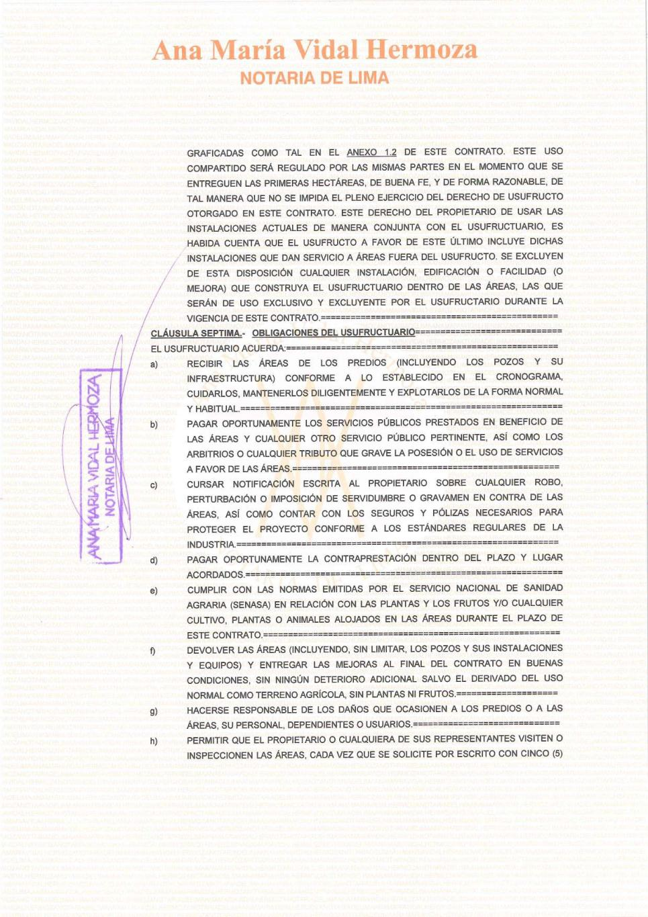

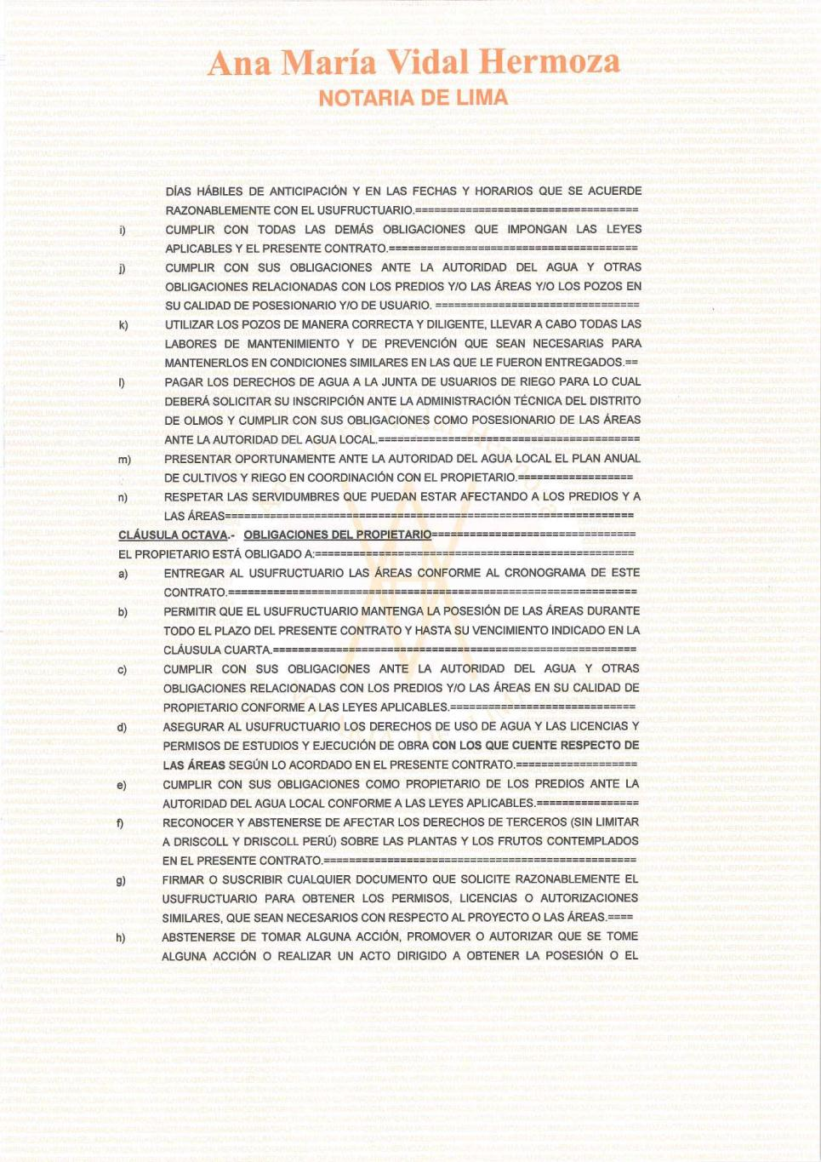

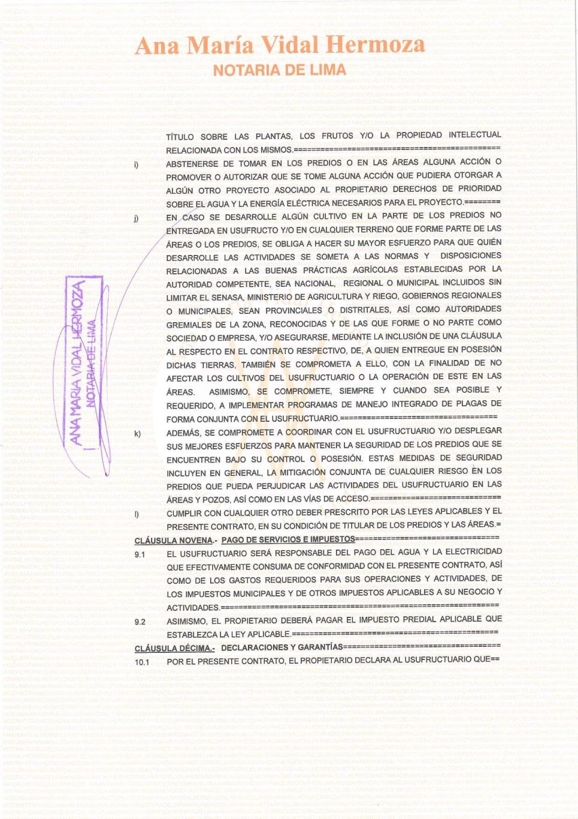

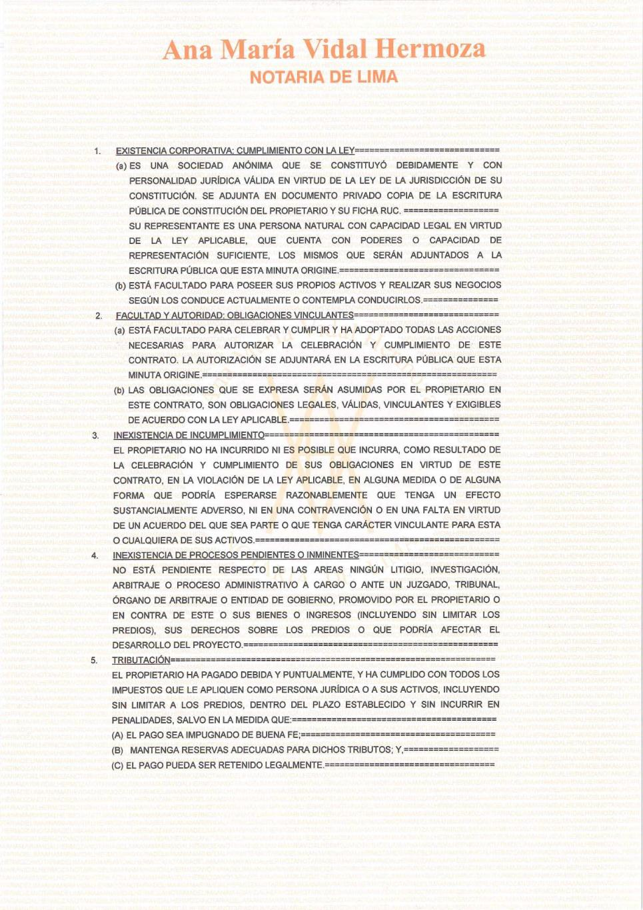

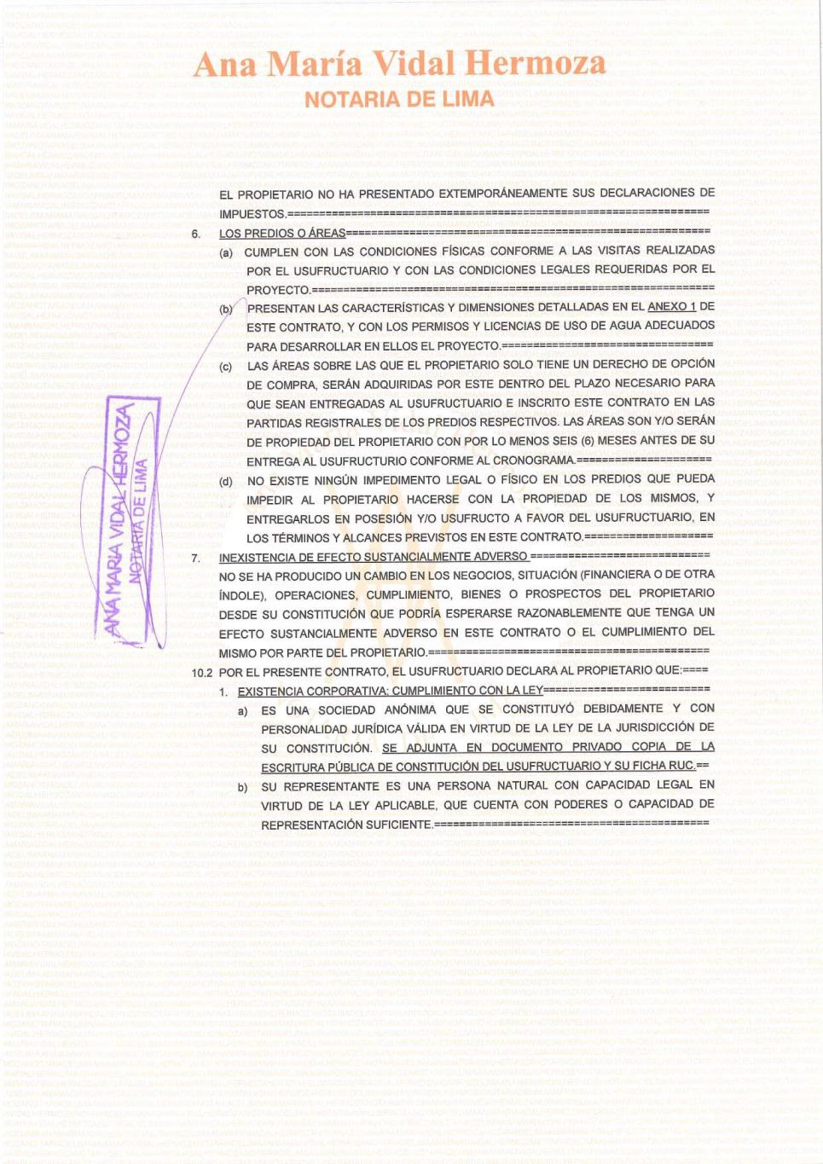

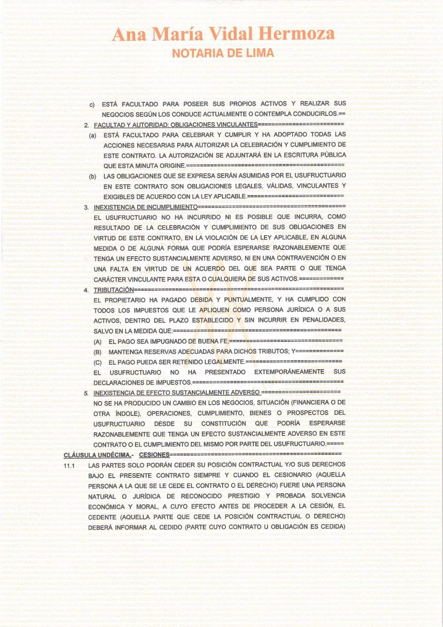

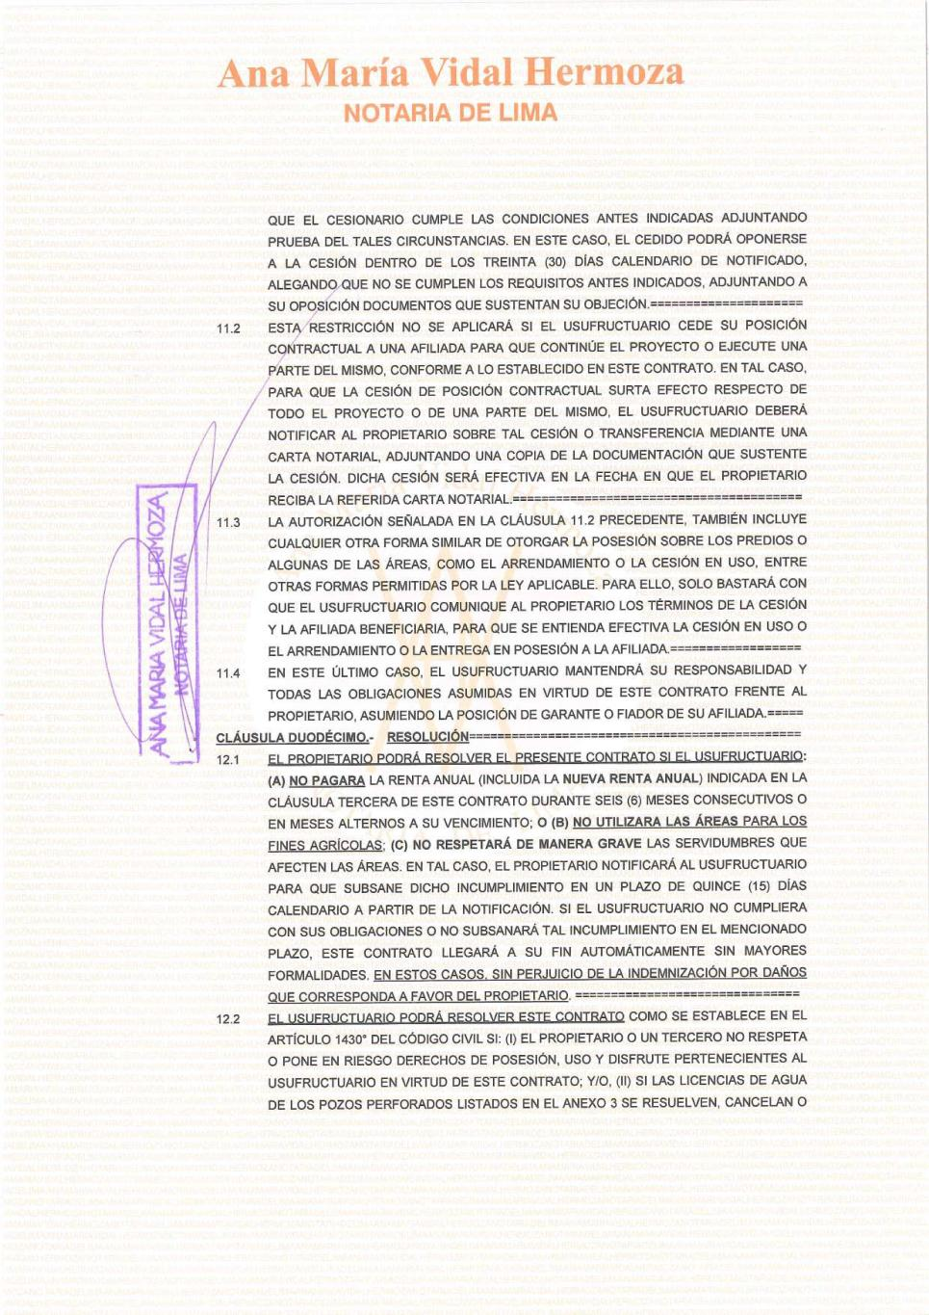

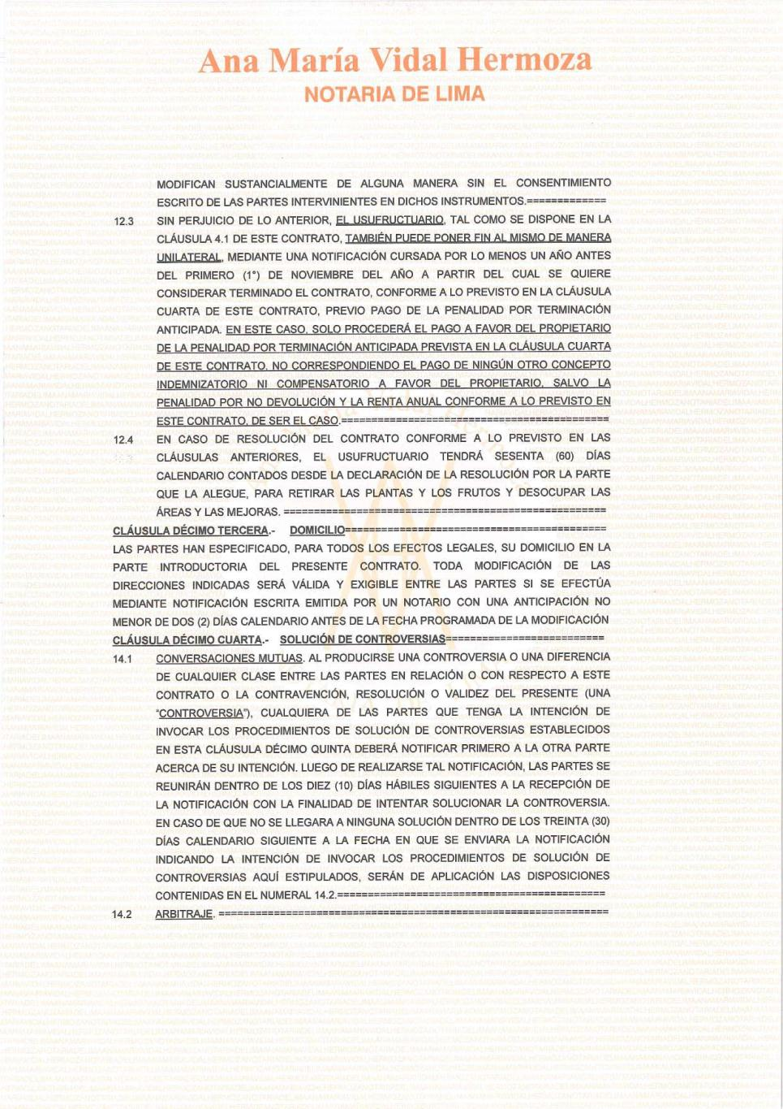

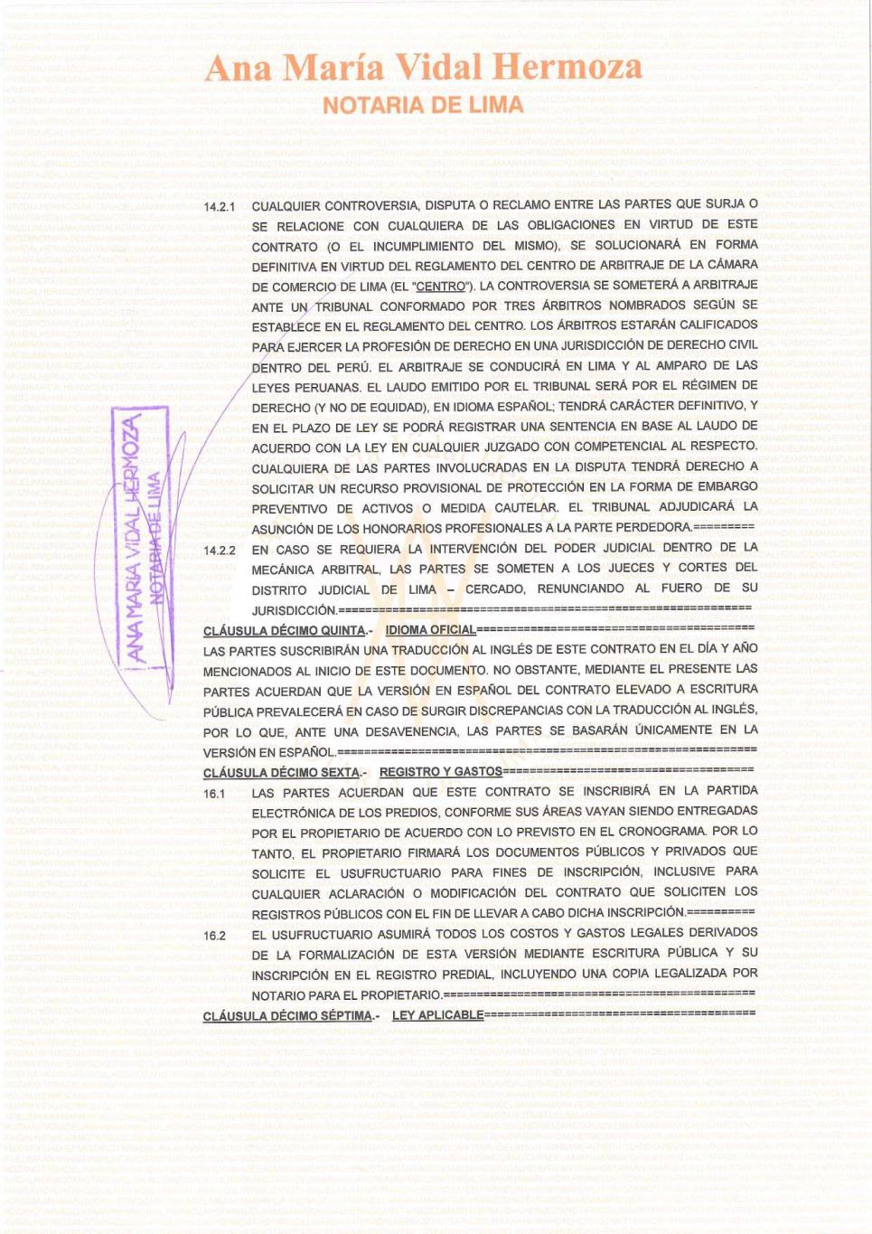

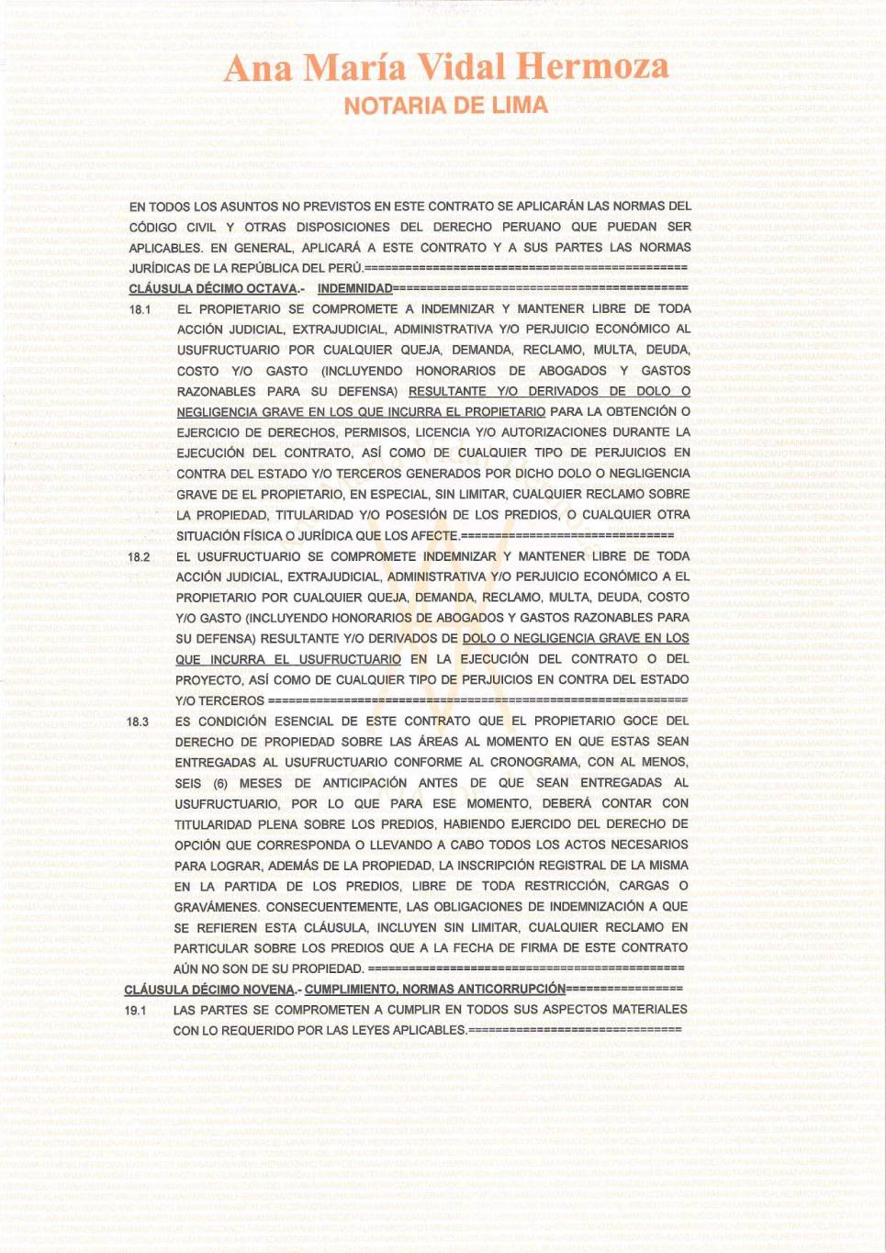

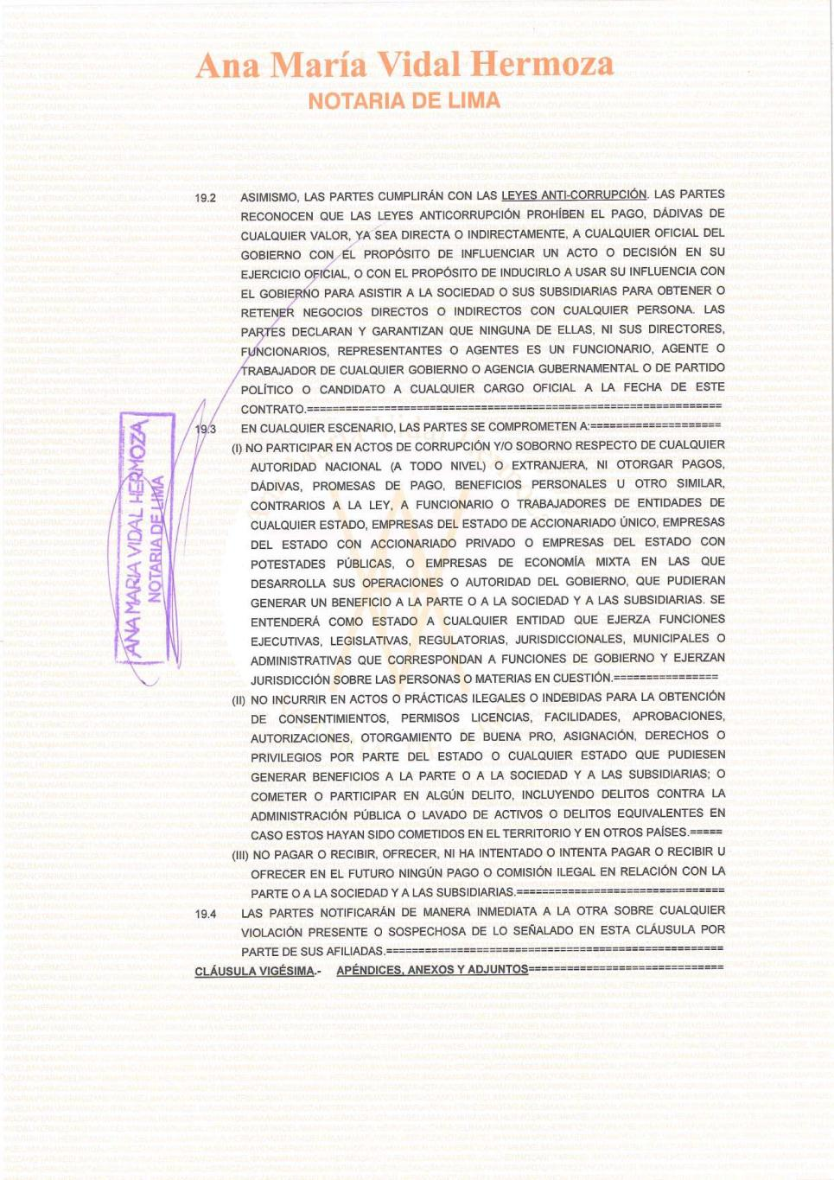

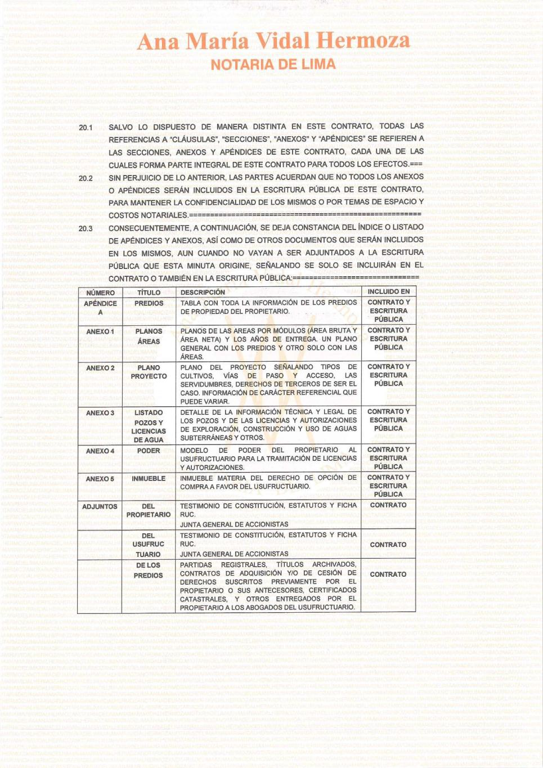

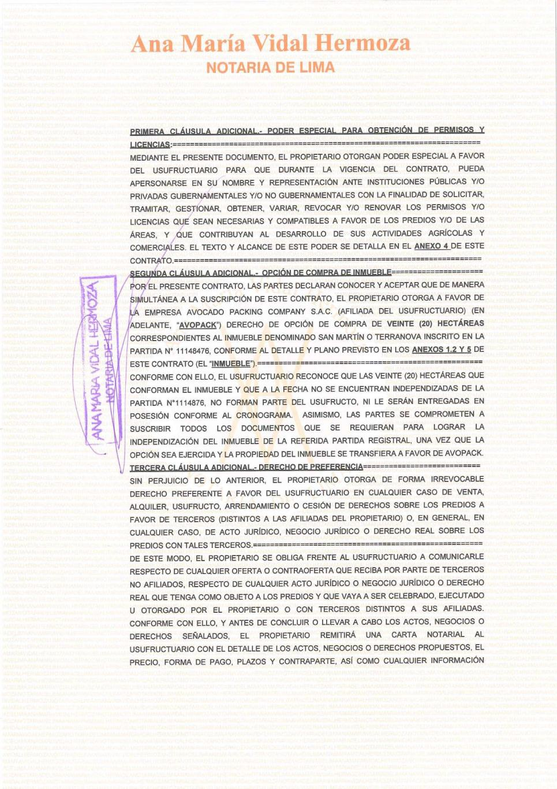

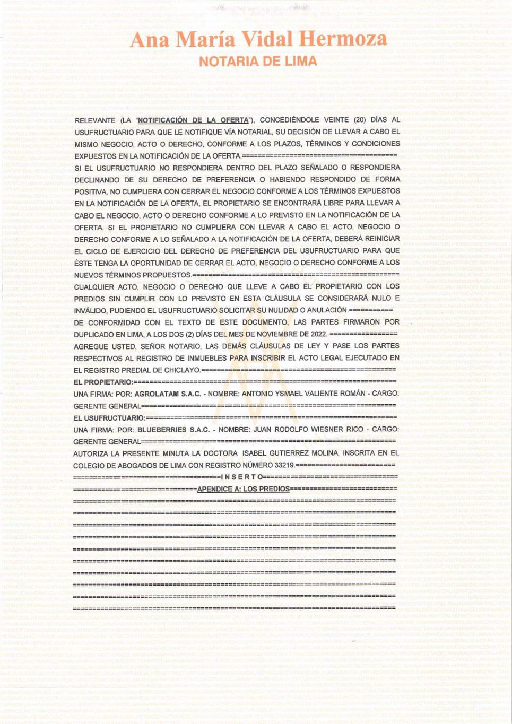

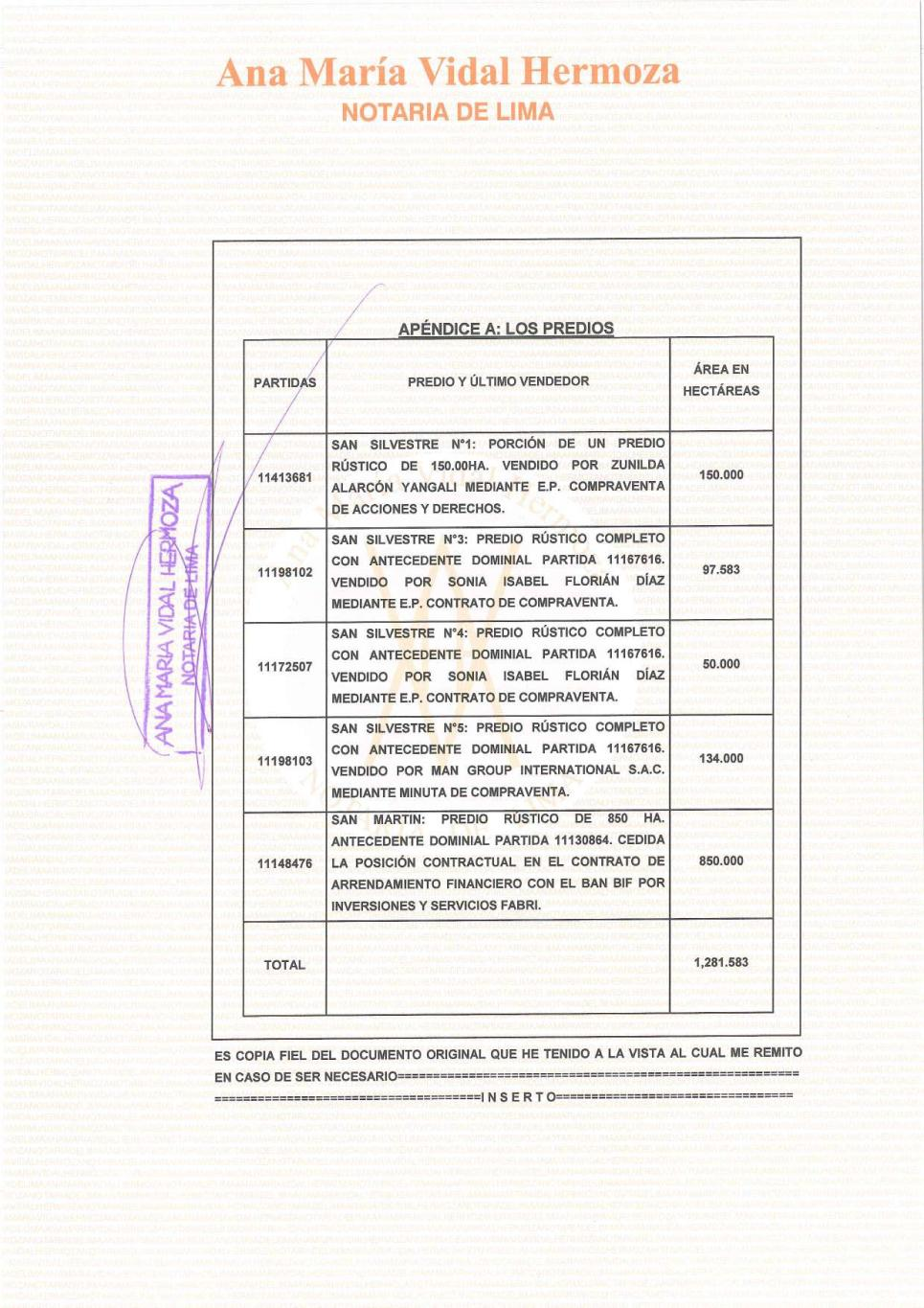

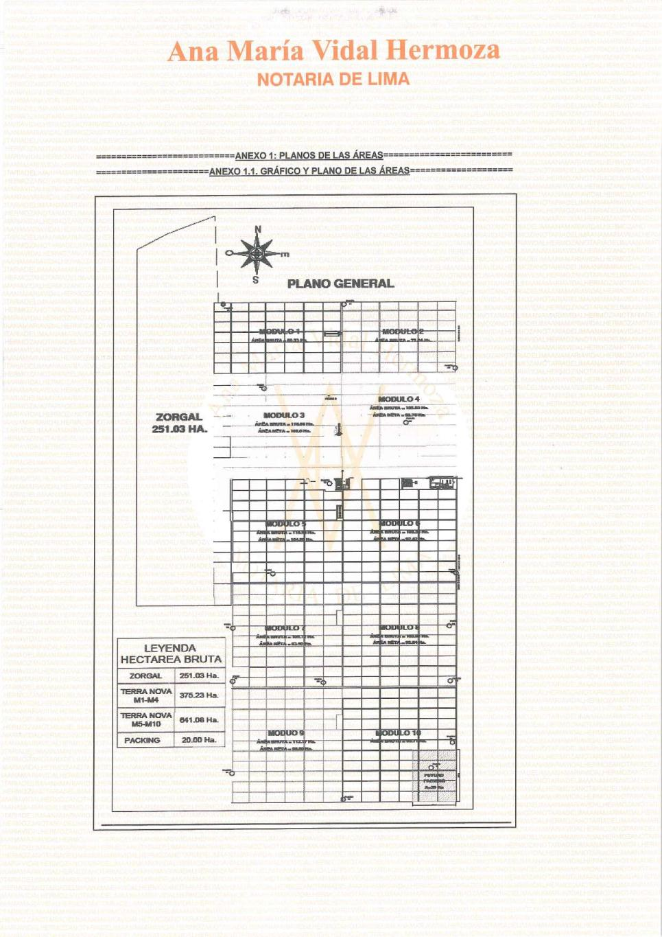

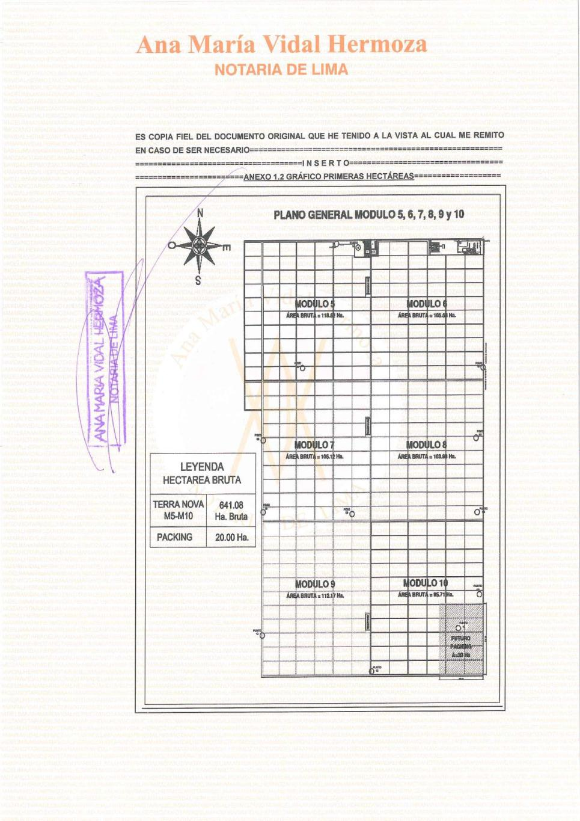

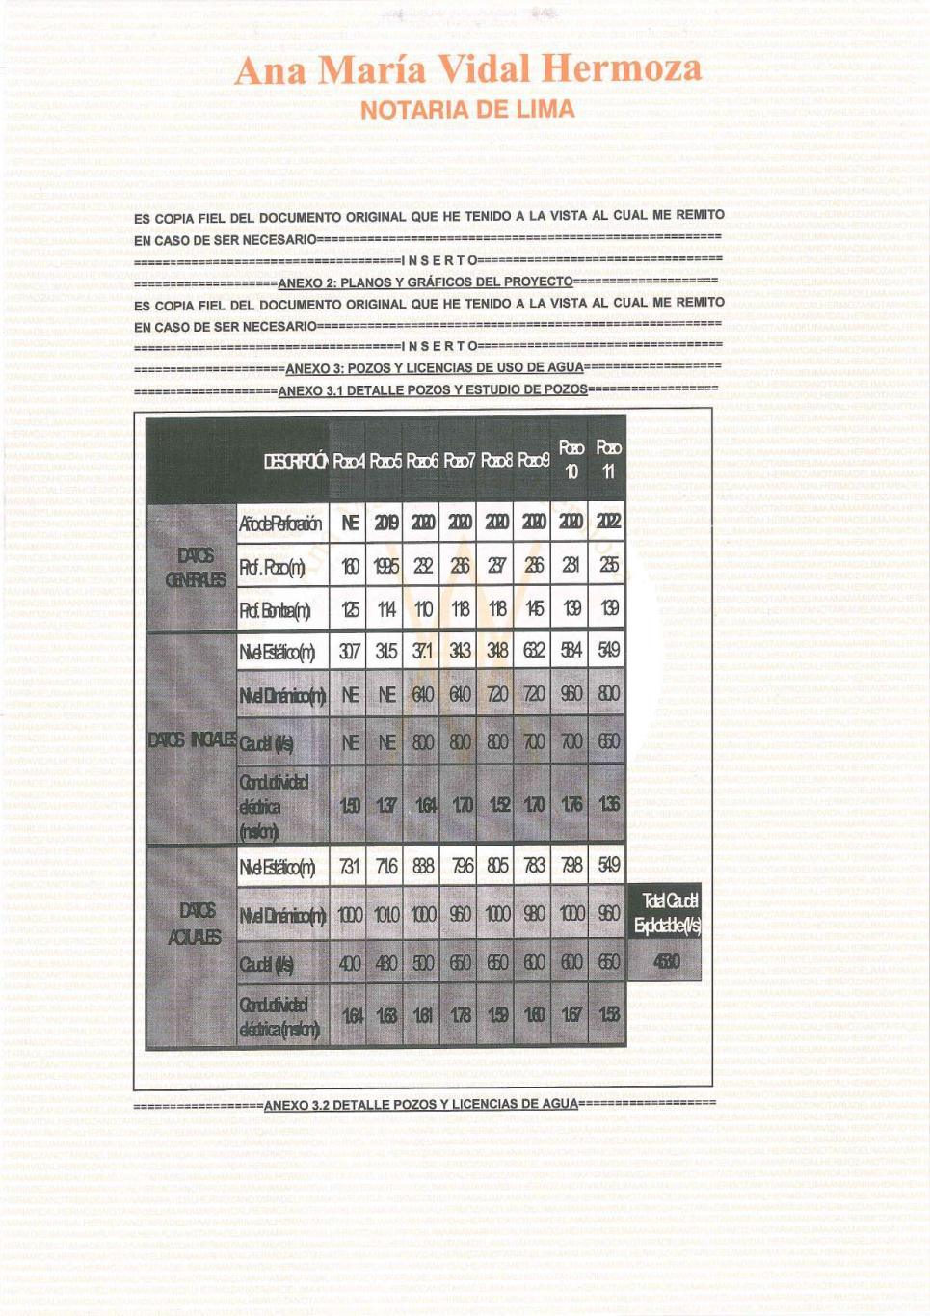

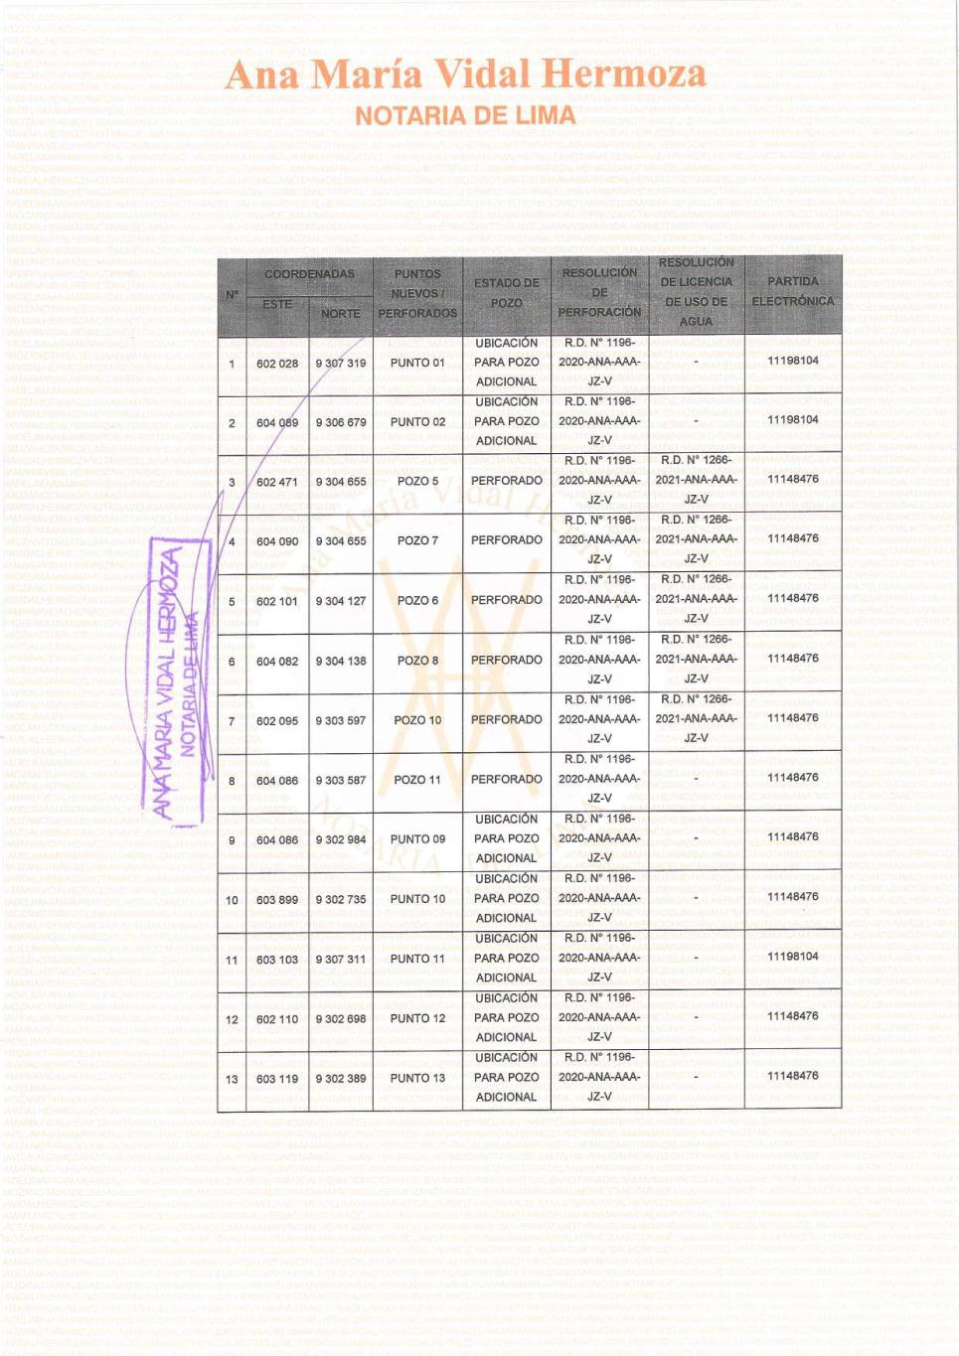

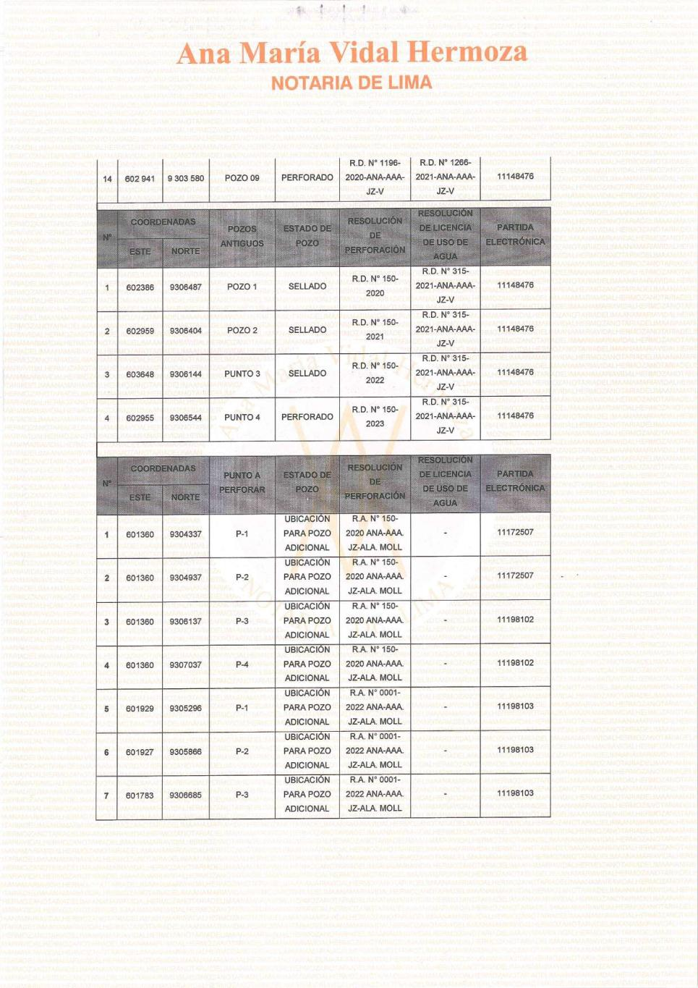

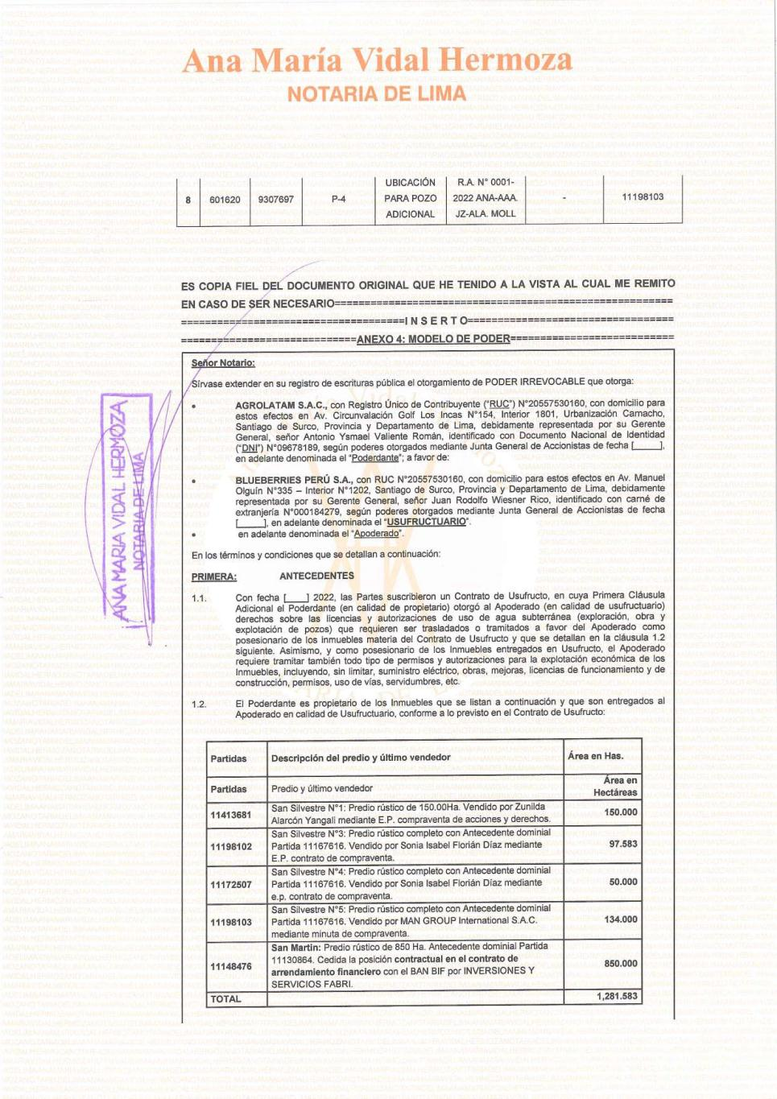

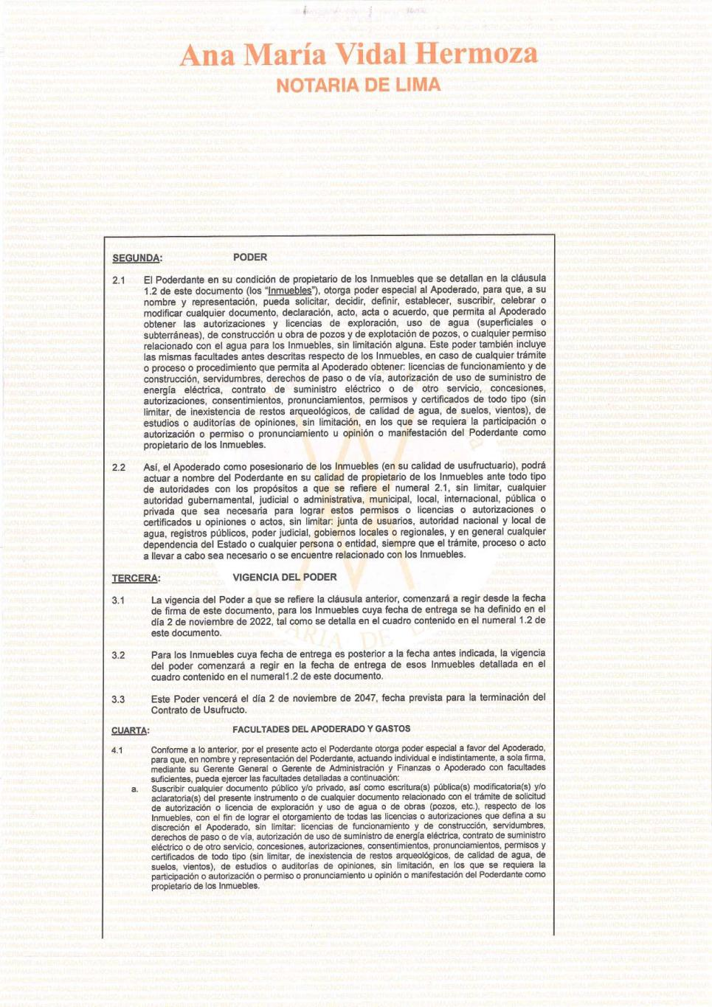

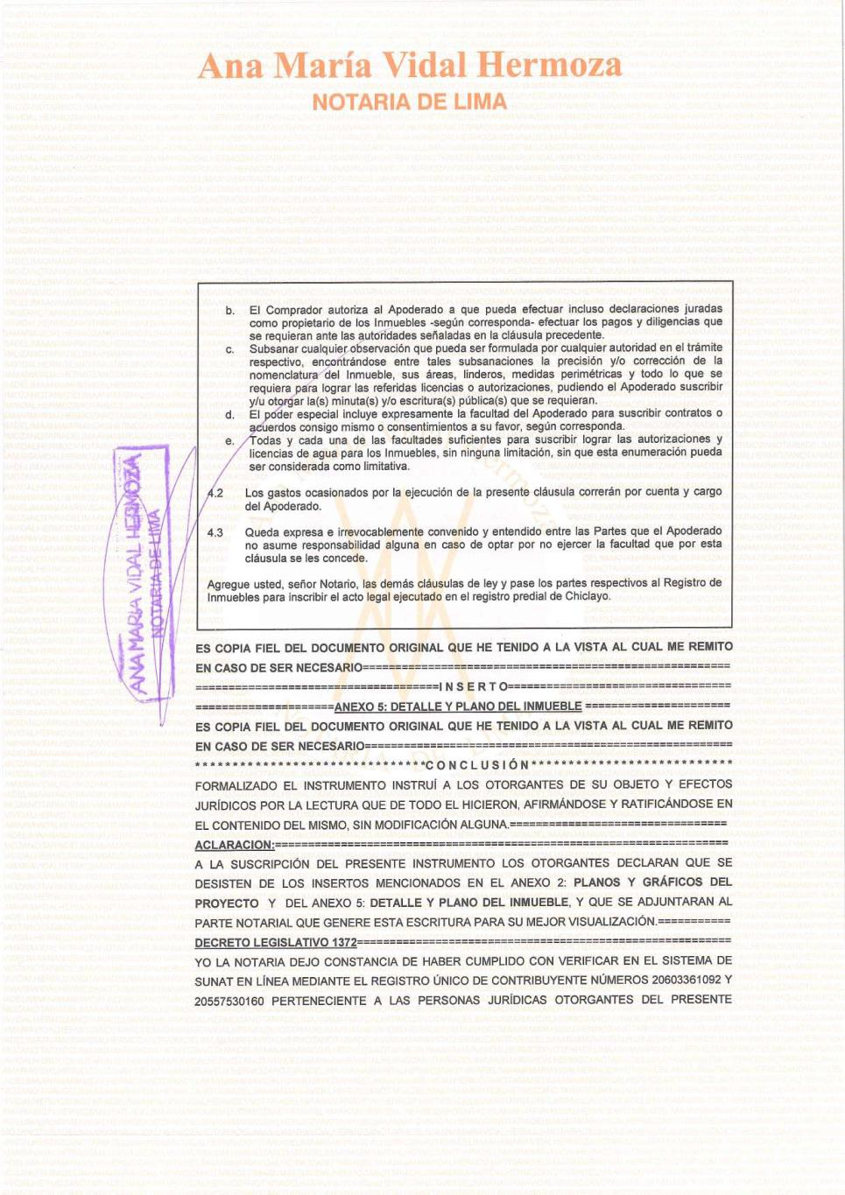

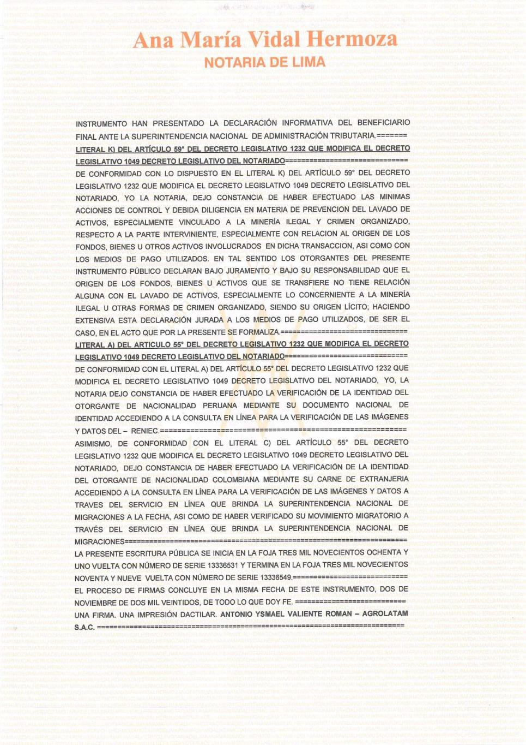





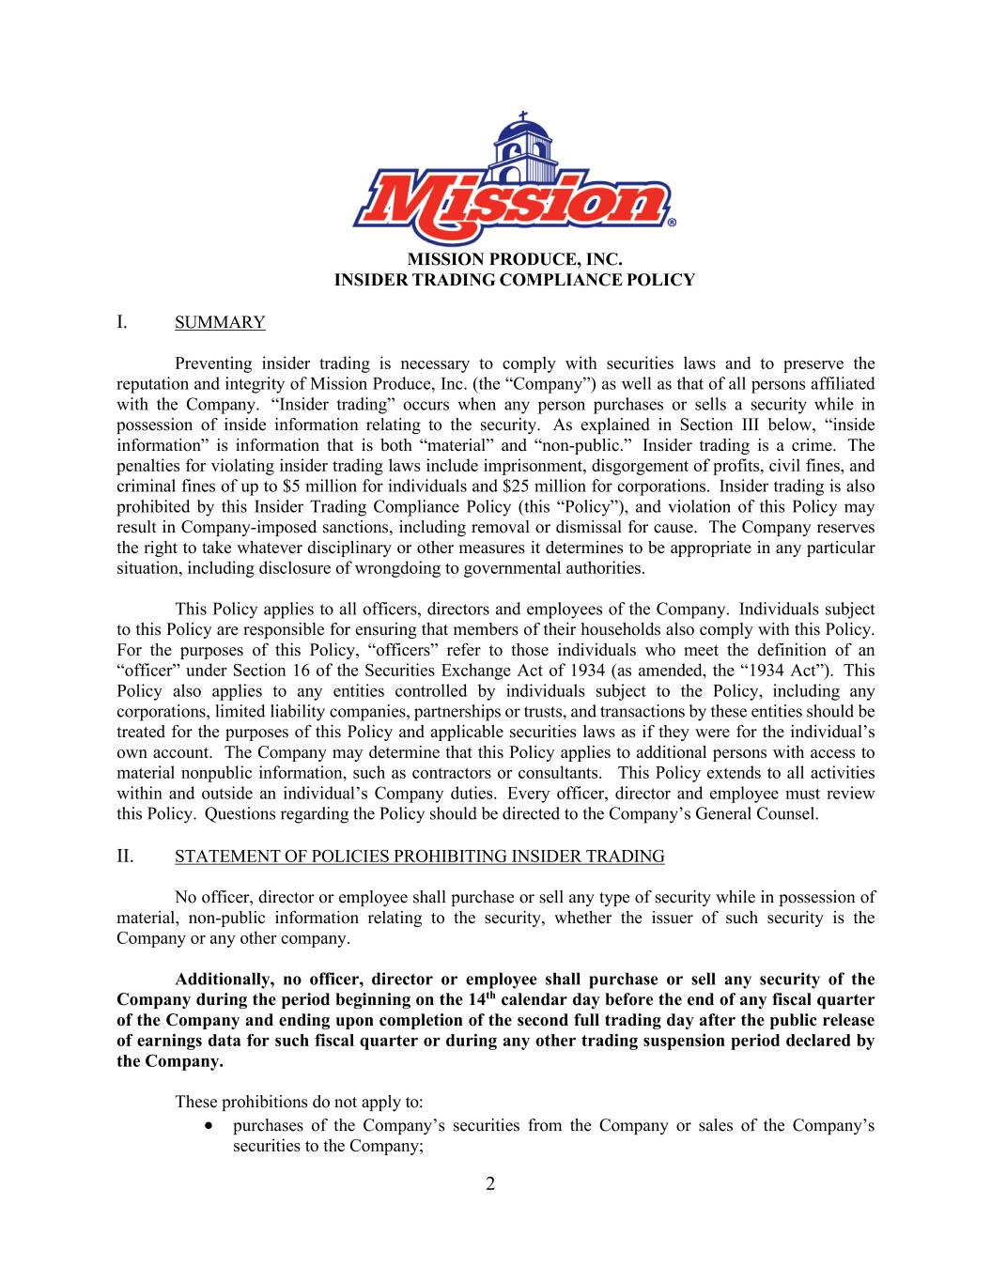
2 MISSION PRODUCE, INC. INSIDER TRADING COMPLIANCE POLICY I. SUMMARY Preventing insider trading is necessary to comply with securities laws and to preserve the reputation and integrity of Mission Produce, Inc. (the “Company”) as well as that of all persons affiliated with the Company. “Insider trading” occurs when any person purchases or sells a security while in possession of inside information relating to the security. As explained in Section III below, “inside information” is information that is both “material” and “non-public.” Insider trading is a crime. The penalties for violating insider trading laws include imprisonment, disgorgement of profits, civil fines, and criminal fines of up to $5 million for individuals and $25 million for corporations. Insider trading is also prohibited by this Insider Trading Compliance Policy (this “Policy”), and violation of this Policy may result in Company-imposed sanctions, including removal or dismissal for cause. The Company reserves the right to take whatever disciplinary or other measures it determines to be appropriate in any particular situation, including disclosure of wrongdoing to governmental authorities. This Policy applies to all officers, directors and employees of the Company. Individuals subject to this Policy are responsible for ensuring that members of their households also comply with this Policy. For the purposes of this Policy, “officers” refer to those individuals who meet the definition of an “officer” under Section 16 of the Securities Exchange Act of 1934 (as amended, the “1934 Act”). This Policy also applies to any entities controlled by individuals subject to the Policy, including any corporations, limited liability companies, partnerships or trusts, and transactions by these entities should be treated for the purposes of this Policy and applicable securities laws as if they were for the individual’s own account. The Company may determine that this Policy applies to additional persons with access to material nonpublic information, such as contractors or consultants. This Policy extends to all activities within and outside an individual’s Company duties. Every officer, director and employee must review this Policy. Questions regarding the Policy should be directed to the Company’s General Counsel. II. STATEMENT OF POLICIES PROHIBITING INSIDER TRADING No officer, director or employee shall purchase or sell any type of security while in possession of material, non-public information relating to the security, whether the issuer of such security is the Company or any other company. Additionally, no officer, director or employee shall purchase or sell any security of the Company during the period beginning on the 14th calendar day before the end of any fiscal quarter of the Company and ending upon completion of the second full trading day after the public release of earnings data for such fiscal quarter or during any other trading suspension period declared by the Company. These prohibitions do not apply to: • purchases of the Company’s securities from the Company or sales of the Company’s securities to the Company;

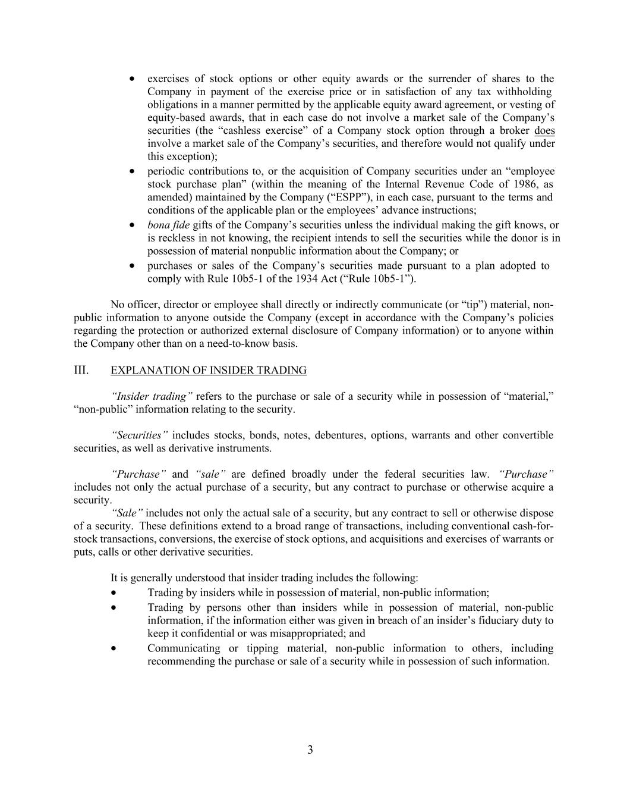
3 • exercises of stock options or other equity awards or the surrender of shares to the Company in payment of the exercise price or in satisfaction of any tax withholding obligations in a manner permitted by the applicable equity award agreement, or vesting of equity-based awards, that in each case do not involve a market sale of the Company’s securities (the “cashless exercise” of a Company stock option through a broker does involve a market sale of the Company’s securities, and therefore would not qualify under this exception); • periodic contributions to, or the acquisition of Company securities under an “employee stock purchase plan” (within the meaning of the Internal Revenue Code of 1986, as amended) maintained by the Company (“ESPP”), in each case, pursuant to the terms and conditions of the applicable plan or the employees’ advance instructions; • bona fide gifts of the Company’s securities unless the individual making the gift knows, or is reckless in not knowing, the recipient intends to sell the securities while the donor is in possession of material nonpublic information about the Company; or • purchases or sales of the Company’s securities made pursuant to a plan adopted to comply with Rule 10b5-1 of the 1934 Act (“Rule 10b5-1”). No officer, director or employee shall directly or indirectly communicate (or “tip”) material, non- public information to anyone outside the Company (except in accordance with the Company’s policies regarding the protection or authorized external disclosure of Company information) or to anyone within the Company other than on a need-to-know basis. III. EXPLANATION OF INSIDER TRADING “Insider trading” refers to the purchase or sale of a security while in possession of “material,” “non-public” information relating to the security. “Securities” includes stocks, bonds, notes, debentures, options, warrants and other convertible securities, as well as derivative instruments. “Purchase” and “sale” are defined broadly under the federal securities law. “Purchase” includes not only the actual purchase of a security, but any contract to purchase or otherwise acquire a security. “Sale” includes not only the actual sale of a security, but any contract to sell or otherwise dispose of a security. These definitions extend to a broad range of transactions, including conventional cash-for- stock transactions, conversions, the exercise of stock options, and acquisitions and exercises of warrants or puts, calls or other derivative securities. It is generally understood that insider trading includes the following: • Trading by insiders while in possession of material, non-public information; • Trading by persons other than insiders while in possession of material, non-public information, if the information either was given in breach of an insider’s fiduciary duty to keep it confidential or was misappropriated; and • Communicating or tipping material, non-public information to others, including recommending the purchase or sale of a security while in possession of such information.

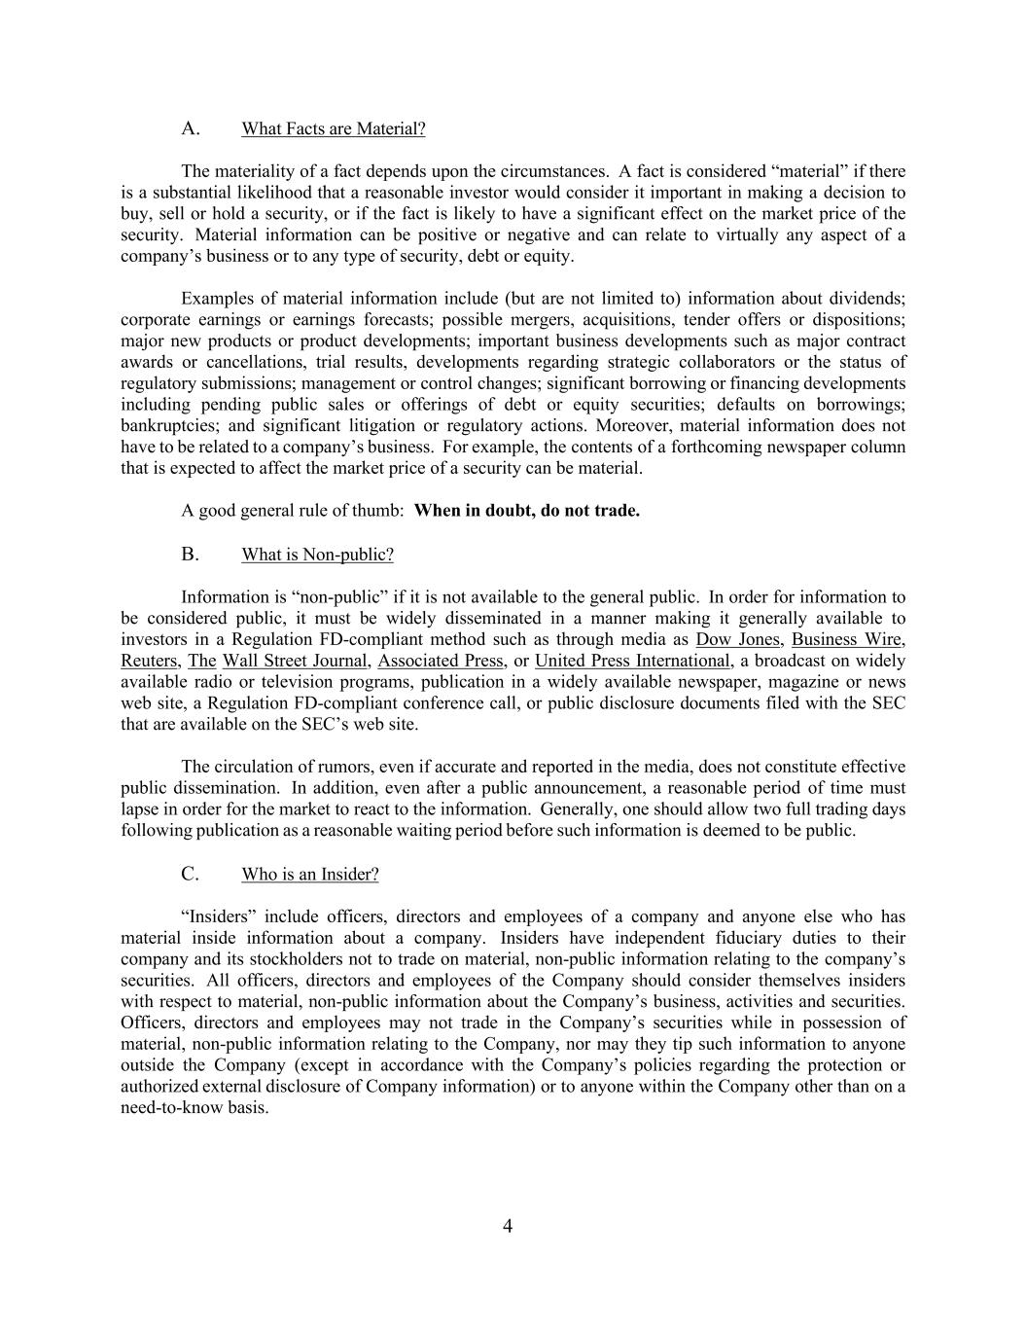
4 A. What Facts are Material? The materiality of a fact depends upon the circumstances. A fact is considered “material” if there is a substantial likelihood that a reasonable investor would consider it important in making a decision to buy, sell or hold a security, or if the fact is likely to have a significant effect on the market price of the security. Material information can be positive or negative and can relate to virtually any aspect of a company’s business or to any type of security, debt or equity. Examples of material information include (but are not limited to) information about dividends; corporate earnings or earnings forecasts; possible mergers, acquisitions, tender offers or dispositions; major new products or product developments; important business developments such as major contract awards or cancellations, trial results, developments regarding strategic collaborators or the status of regulatory submissions; management or control changes; significant borrowing or financing developments including pending public sales or offerings of debt or equity securities; defaults on borrowings; bankruptcies; and significant litigation or regulatory actions. Moreover, material information does not have to be related to a company’s business. For example, the contents of a forthcoming newspaper column that is expected to affect the market price of a security can be material. A good general rule of thumb: When in doubt, do not trade. B. What is Non-public? Information is “non-public” if it is not available to the general public. In order for information to be considered public, it must be widely disseminated in a manner making it generally available to investors in a Regulation FD-compliant method such as through media as Dow Jones, Business Wire, Reuters, The Wall Street Journal, Associated Press, or United Press International, a broadcast on widely available radio or television programs, publication in a widely available newspaper, magazine or news web site, a Regulation FD-compliant conference call, or public disclosure documents filed with the SEC that are available on the SEC’s web site. The circulation of rumors, even if accurate and reported in the media, does not constitute effective public dissemination. In addition, even after a public announcement, a reasonable period of time must lapse in order for the market to react to the information. Generally, one should allow two full trading days following publication as a reasonable waiting period before such information is deemed to be public. C. Who is an Insider? “Insiders” include officers, directors and employees of a company and anyone else who has material inside information about a company. Insiders have independent fiduciary duties to their company and its stockholders not to trade on material, non-public information relating to the company’s securities. All officers, directors and employees of the Company should consider themselves insiders with respect to material, non-public information about the Company’s business, activities and securities. Officers, directors and employees may not trade in the Company’s securities while in possession of material, non-public information relating to the Company, nor may they tip such information to anyone outside the Company (except in accordance with the Company’s policies regarding the protection or authorized external disclosure of Company information) or to anyone within the Company other than on a need-to-know basis.

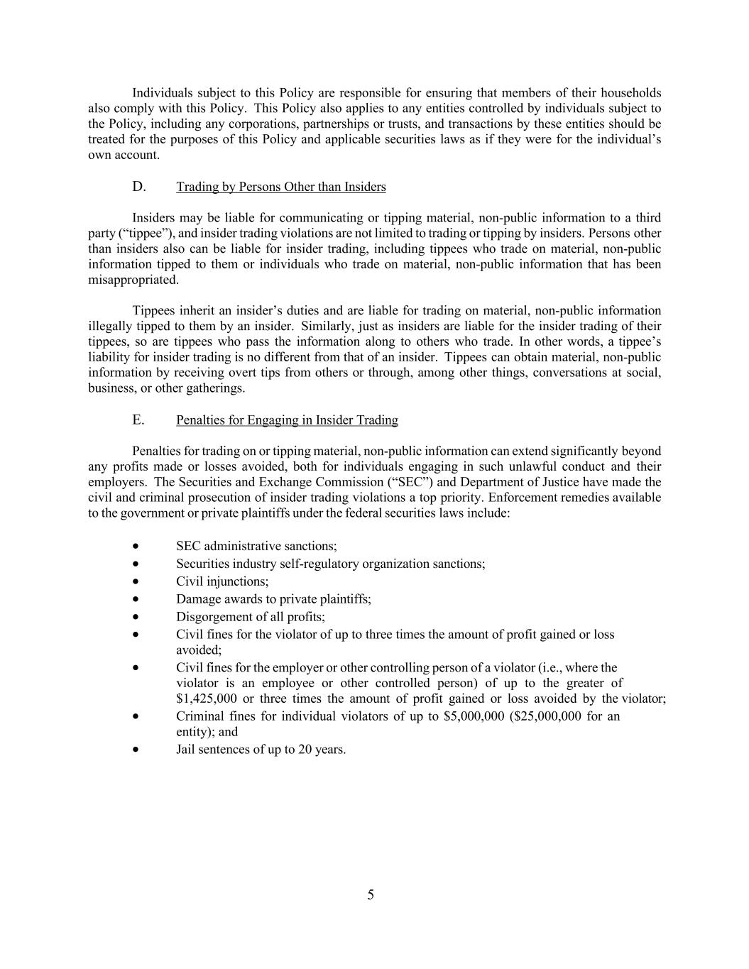
5 Individuals subject to this Policy are responsible for ensuring that members of their households also comply with this Policy. This Policy also applies to any entities controlled by individuals subject to the Policy, including any corporations, partnerships or trusts, and transactions by these entities should be treated for the purposes of this Policy and applicable securities laws as if they were for the individual’s own account. D. Trading by Persons Other than Insiders Insiders may be liable for communicating or tipping material, non-public information to a third party (“tippee”), and insider trading violations are not limited to trading or tipping by insiders. Persons other than insiders also can be liable for insider trading, including tippees who trade on material, non-public information tipped to them or individuals who trade on material, non-public information that has been misappropriated. Tippees inherit an insider’s duties and are liable for trading on material, non-public information illegally tipped to them by an insider. Similarly, just as insiders are liable for the insider trading of their tippees, so are tippees who pass the information along to others who trade. In other words, a tippee’s liability for insider trading is no different from that of an insider. Tippees can obtain material, non-public information by receiving overt tips from others or through, among other things, conversations at social, business, or other gatherings. E. Penalties for Engaging in Insider Trading Penalties for trading on or tipping material, non-public information can extend significantly beyond any profits made or losses avoided, both for individuals engaging in such unlawful conduct and their employers. The Securities and Exchange Commission (“SEC”) and Department of Justice have made the civil and criminal prosecution of insider trading violations a top priority. Enforcement remedies available to the government or private plaintiffs under the federal securities laws include: • SEC administrative sanctions; • Securities industry self-regulatory organization sanctions; • Civil injunctions; • Damage awards to private plaintiffs; • Disgorgement of all profits; • Civil fines for the violator of up to three times the amount of profit gained or loss avoided; • Civil fines for the employer or other controlling person of a violator (i.e., where the violator is an employee or other controlled person) of up to the greater of $1,425,000 or three times the amount of profit gained or loss avoided by the violator; • Criminal fines for individual violators of up to $5,000,000 ($25,000,000 for an entity); and • Jail sentences of up to 20 years.

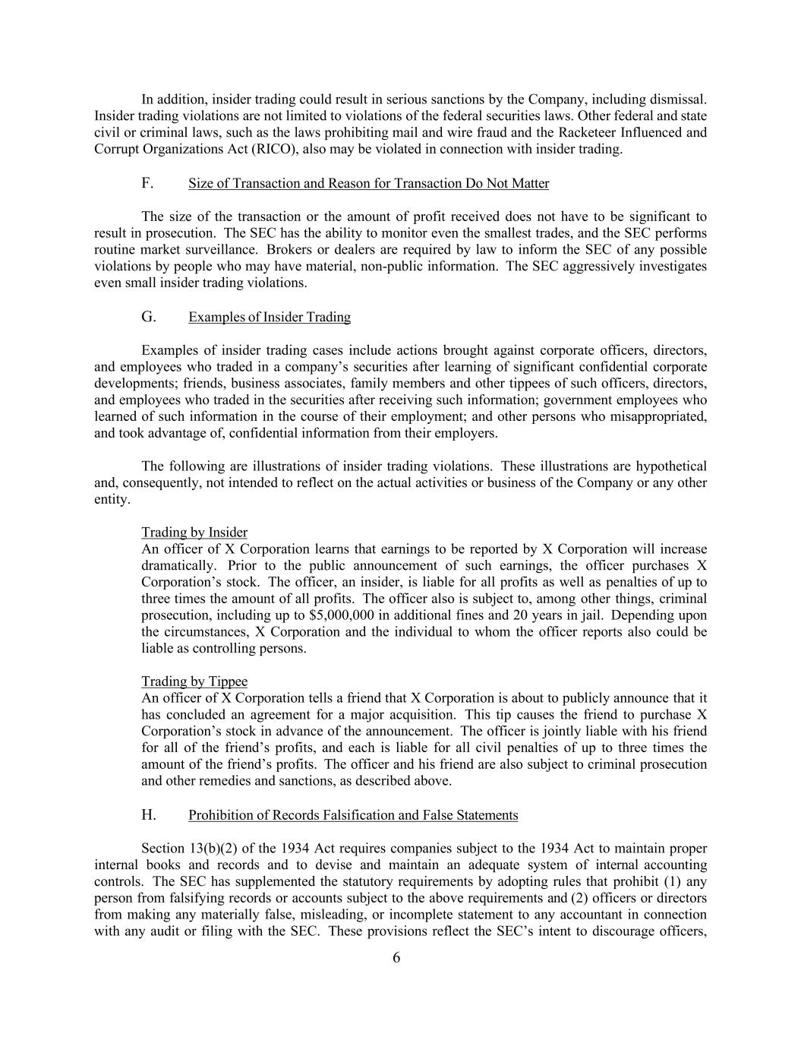
6 In addition, insider trading could result in serious sanctions by the Company, including dismissal. Insider trading violations are not limited to violations of the federal securities laws. Other federal and state civil or criminal laws, such as the laws prohibiting mail and wire fraud and the Racketeer Influenced and Corrupt Organizations Act (RICO), also may be violated in connection with insider trading. F. Size of Transaction and Reason for Transaction Do Not Matter The size of the transaction or the amount of profit received does not have to be significant to result in prosecution. The SEC has the ability to monitor even the smallest trades, and the SEC performs routine market surveillance. Brokers or dealers are required by law to inform the SEC of any possible violations by people who may have material, non-public information. The SEC aggressively investigates even small insider trading violations. G. Examples of Insider Trading Examples of insider trading cases include actions brought against corporate officers, directors, and employees who traded in a company’s securities after learning of significant confidential corporate developments; friends, business associates, family members and other tippees of such officers, directors, and employees who traded in the securities after receiving such information; government employees who learned of such information in the course of their employment; and other persons who misappropriated, and took advantage of, confidential information from their employers. The following are illustrations of insider trading violations. These illustrations are hypothetical and, consequently, not intended to reflect on the actual activities or business of the Company or any other entity. Trading by Insider An officer of X Corporation learns that earnings to be reported by X Corporation will increase dramatically. Prior to the public announcement of such earnings, the officer purchases X Corporation’s stock. The officer, an insider, is liable for all profits as well as penalties of up to three times the amount of all profits. The officer also is subject to, among other things, criminal prosecution, including up to $5,000,000 in additional fines and 20 years in jail. Depending upon the circumstances, X Corporation and the individual to whom the officer reports also could be liable as controlling persons. Trading by Tippee An officer of X Corporation tells a friend that X Corporation is about to publicly announce that it has concluded an agreement for a major acquisition. This tip causes the friend to purchase X Corporation’s stock in advance of the announcement. The officer is jointly liable with his friend for all of the friend’s profits, and each is liable for all civil penalties of up to three times the amount of the friend’s profits. The officer and his friend are also subject to criminal prosecution and other remedies and sanctions, as described above. H. Prohibition of Records Falsification and False Statements Section 13(b)(2) of the 1934 Act requires companies subject to the 1934 Act to maintain proper internal books and records and to devise and maintain an adequate system of internal accounting controls. The SEC has supplemented the statutory requirements by adopting rules that prohibit (1) any person from falsifying records or accounts subject to the above requirements and (2) officers or directors from making any materially false, misleading, or incomplete statement to any accountant in connection with any audit or filing with the SEC. These provisions reflect the SEC’s intent to discourage officers,

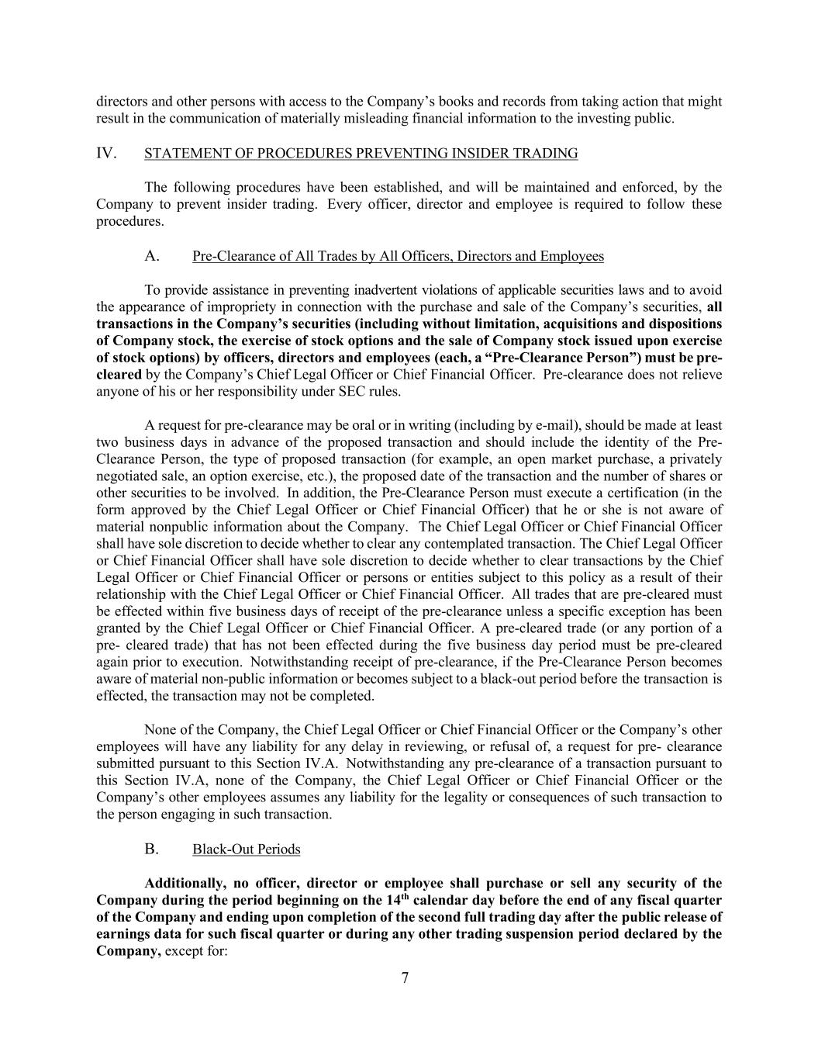
7 directors and other persons with access to the Company’s books and records from taking action that might result in the communication of materially misleading financial information to the investing public. IV. STATEMENT OF PROCEDURES PREVENTING INSIDER TRADING The following procedures have been established, and will be maintained and enforced, by the Company to prevent insider trading. Every officer, director and employee is required to follow these procedures. A. Pre-Clearance of All Trades by All Officers, Directors and Employees To provide assistance in preventing inadvertent violations of applicable securities laws and to avoid the appearance of impropriety in connection with the purchase and sale of the Company’s securities, all transactions in the Company’s securities (including without limitation, acquisitions and dispositions of Company stock, the exercise of stock options and the sale of Company stock issued upon exercise of stock options) by officers, directors and employees (each, a “Pre-Clearance Person”) must be pre- cleared by the Company’s Chief Legal Officer or Chief Financial Officer. Pre-clearance does not relieve anyone of his or her responsibility under SEC rules. A request for pre-clearance may be oral or in writing (including by e-mail), should be made at least two business days in advance of the proposed transaction and should include the identity of the Pre- Clearance Person, the type of proposed transaction (for example, an open market purchase, a privately negotiated sale, an option exercise, etc.), the proposed date of the transaction and the number of shares or other securities to be involved. In addition, the Pre-Clearance Person must execute a certification (in the form approved by the Chief Legal Officer or Chief Financial Officer) that he or she is not aware of material nonpublic information about the Company. The Chief Legal Officer or Chief Financial Officer shall have sole discretion to decide whether to clear any contemplated transaction. The Chief Legal Officer or Chief Financial Officer shall have sole discretion to decide whether to clear transactions by the Chief Legal Officer or Chief Financial Officer or persons or entities subject to this policy as a result of their relationship with the Chief Legal Officer or Chief Financial Officer. All trades that are pre-cleared must be effected within five business days of receipt of the pre-clearance unless a specific exception has been granted by the Chief Legal Officer or Chief Financial Officer. A pre-cleared trade (or any portion of a pre- cleared trade) that has not been effected during the five business day period must be pre-cleared again prior to execution. Notwithstanding receipt of pre-clearance, if the Pre-Clearance Person becomes aware of material non-public information or becomes subject to a black-out period before the transaction is effected, the transaction may not be completed. None of the Company, the Chief Legal Officer or Chief Financial Officer or the Company’s other employees will have any liability for any delay in reviewing, or refusal of, a request for pre- clearance submitted pursuant to this Section IV.A. Notwithstanding any pre-clearance of a transaction pursuant to this Section IV.A, none of the Company, the Chief Legal Officer or Chief Financial Officer or the Company’s other employees assumes any liability for the legality or consequences of such transaction to the person engaging in such transaction. B. Black-Out Periods Additionally, no officer, director or employee shall purchase or sell any security of the Company during the period beginning on the 14th calendar day before the end of any fiscal quarter of the Company and ending upon completion of the second full trading day after the public release of earnings data for such fiscal quarter or during any other trading suspension period declared by the Company, except for:

8 • purchases of the Company’s securities from the Company or sales of the Company’s securities to the Company; • exercises of stock options or other equity awards or the surrender of shares to the Company in payment of the exercise price or in satisfaction of any tax withholding obligations in a manner permitted by the applicable equity award agreement, or vesting of equity-based awards that do not involve a market sale of the Company’s securities (the “cashless exercise” of a Company stock option through a broker does involve a market sale of the Company’s securities, and therefore would not qualify under this exception); • periodic contributions to, or the acquisition of Company securities under an ESPP, in each case, pursuant to the terms and conditions of the applicable plan or the employees’ advance instructions; • bona fide gifts of the Company’s securities unless the individual making the gift knows, or is reckless in not knowing, the recipient intends to sell the securities while the donor is in possession of material nonpublic information about the Company; or • purchases or sales of the Company’s securities made pursuant to a plan adopted to comply with Rule 10b5-1. Exceptions to the black-out period policy may be approved only by the Company’s Chief Legal Officer or Chief Financial Officer or, in the case of exceptions for directors, the Board of Directors or Audit Committee of the Board of Directors. From time to time, the Company, through the Board of Directors or the Chief Legal Officer or Chief Financial Officer, may recommend that officers, directors, employees or others suspend trading in the Company’s securities because of developments that have not yet been disclosed to the public. Subject to the exceptions noted above, all those affected should not trade in our securities while the suspension is in effect, and should not disclose to others that we have suspended trading. C. Post-Termination Transactions With the exception of the pre-clearance requirement, this Policy continues to apply to transactions in the Company’s securities even after termination of service to the Company. If an individual is in possession of material, non-public information when his or her service terminates, that individual may not trade in the Company’s securities until that information has become public or is no longer material. D. Information Relating to the Company 1. Access to Information Access to material, non-public information about the Company, including the Company’s business, earnings or prospects, should be limited to officers, directors and employees of the Company on a need-to-know basis. In addition, such information should not be communicated to anyone outside the Company under any circumstances (except in accordance with the Company’s policies regarding the protection or authorized external disclosure of Company information) or to anyone within the Company on an other than need-to-know basis. In communicating material, non-public information to employees of the Company, all officers, directors and employees must take care to emphasize the need for confidential treatment of such information and adherence to the Company’s policies with regard to confidential information.

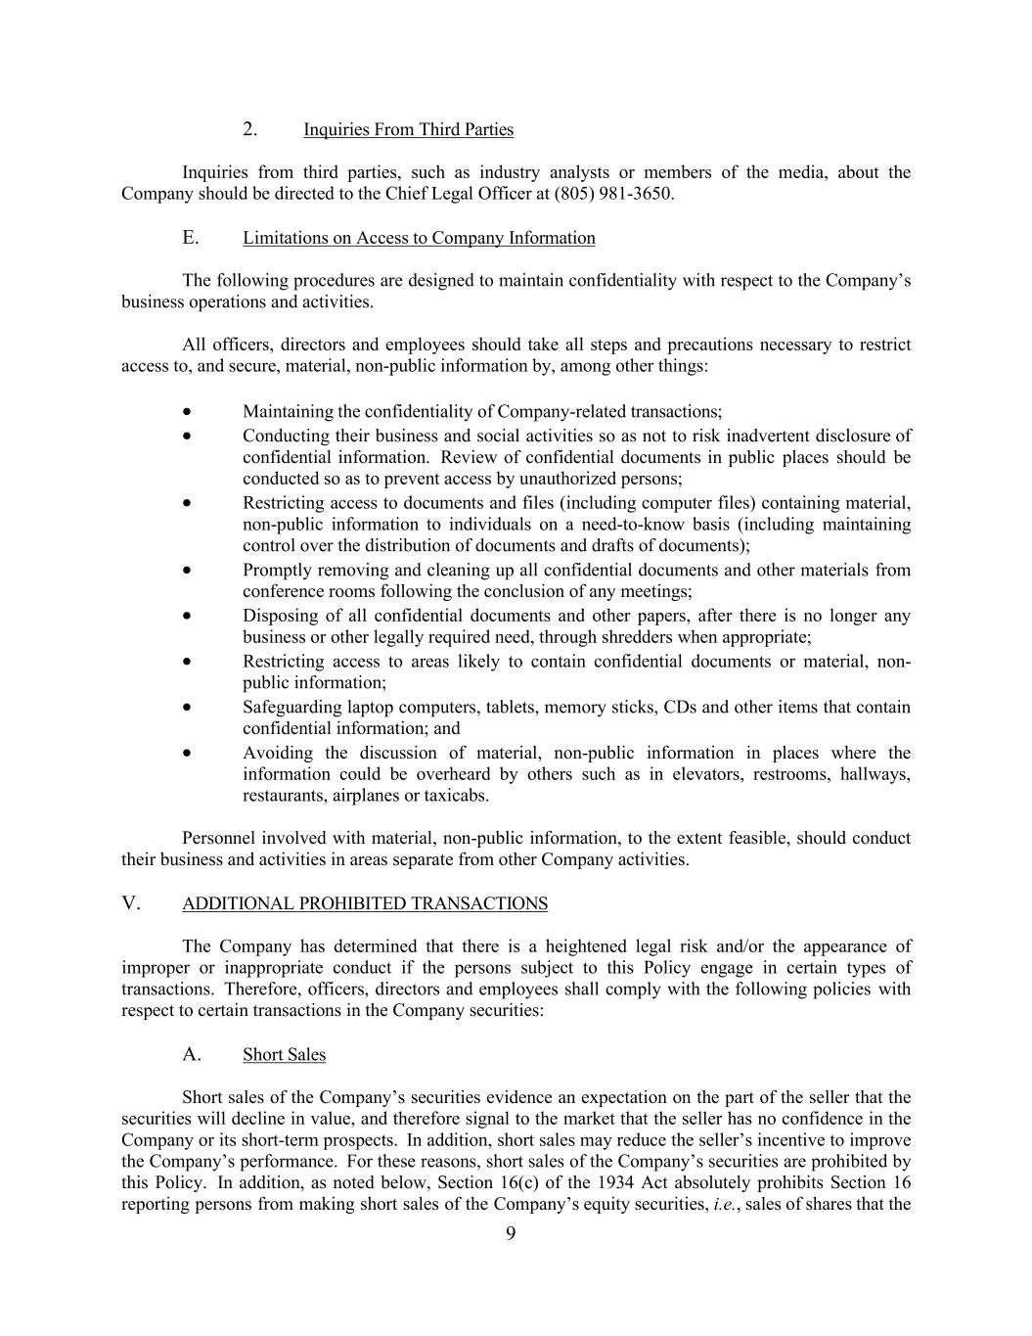
9 2. Inquiries From Third Parties Inquiries from third parties, such as industry analysts or members of the media, about the Company should be directed to the Chief Legal Officer at (805) 981-3650. E. Limitations on Access to Company Information The following procedures are designed to maintain confidentiality with respect to the Company’s business operations and activities. All officers, directors and employees should take all steps and precautions necessary to restrict access to, and secure, material, non-public information by, among other things: • Maintaining the confidentiality of Company-related transactions; • Conducting their business and social activities so as not to risk inadvertent disclosure of confidential information. Review of confidential documents in public places should be conducted so as to prevent access by unauthorized persons; • Restricting access to documents and files (including computer files) containing material, non-public information to individuals on a need-to-know basis (including maintaining control over the distribution of documents and drafts of documents); • Promptly removing and cleaning up all confidential documents and other materials from conference rooms following the conclusion of any meetings; • Disposing of all confidential documents and other papers, after there is no longer any business or other legally required need, through shredders when appropriate; • Restricting access to areas likely to contain confidential documents or material, non- public information; • Safeguarding laptop computers, tablets, memory sticks, CDs and other items that contain confidential information; and • Avoiding the discussion of material, non-public information in places where the information could be overheard by others such as in elevators, restrooms, hallways, restaurants, airplanes or taxicabs. Personnel involved with material, non-public information, to the extent feasible, should conduct their business and activities in areas separate from other Company activities. V. ADDITIONAL PROHIBITED TRANSACTIONS The Company has determined that there is a heightened legal risk and/or the appearance of improper or inappropriate conduct if the persons subject to this Policy engage in certain types of transactions. Therefore, officers, directors and employees shall comply with the following policies with respect to certain transactions in the Company securities: A. Short Sales Short sales of the Company’s securities evidence an expectation on the part of the seller that the securities will decline in value, and therefore signal to the market that the seller has no confidence in the Company or its short-term prospects. In addition, short sales may reduce the seller’s incentive to improve the Company’s performance. For these reasons, short sales of the Company’s securities are prohibited by this Policy. In addition, as noted below, Section 16(c) of the 1934 Act absolutely prohibits Section 16 reporting persons from making short sales of the Company’s equity securities, i.e., sales of shares that the

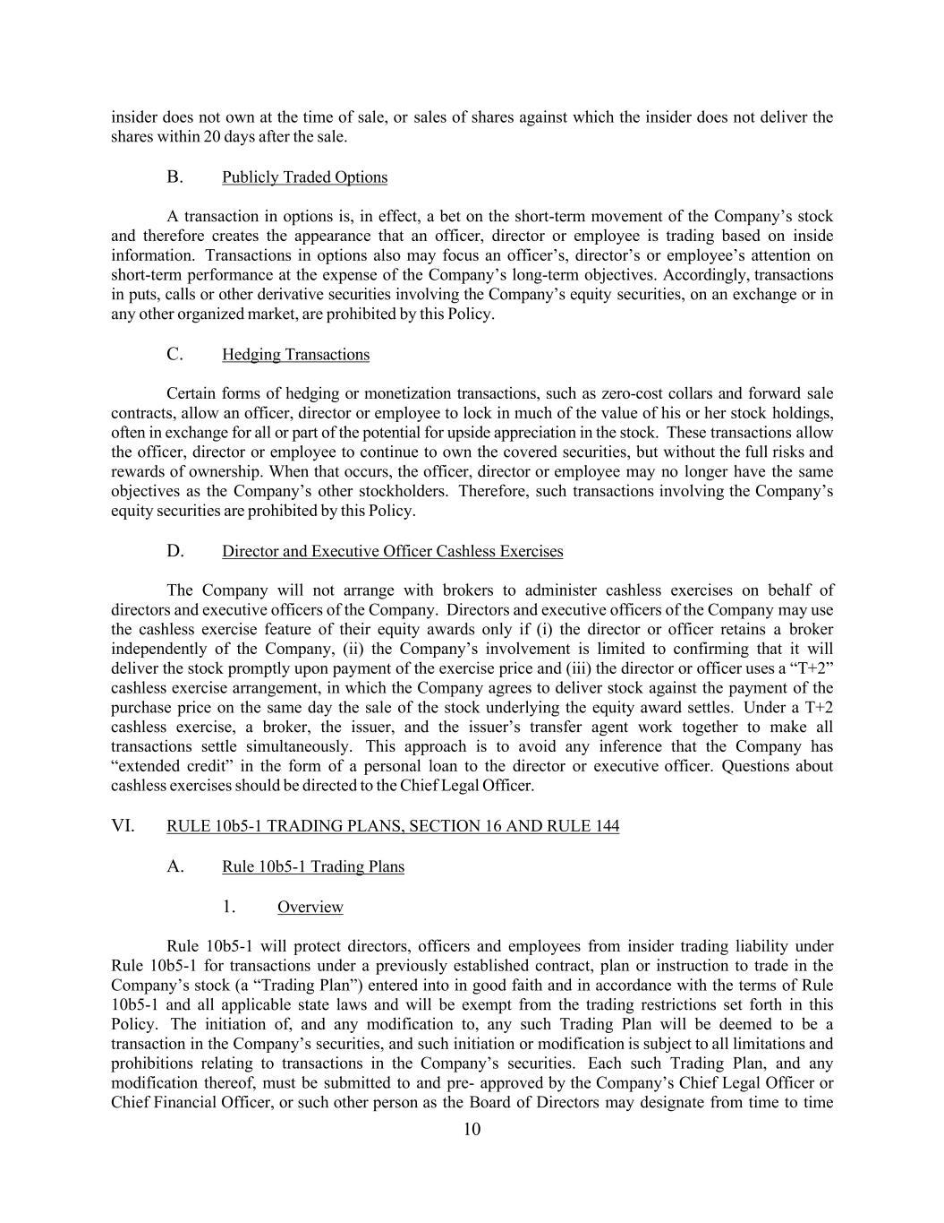
10 insider does not own at the time of sale, or sales of shares against which the insider does not deliver the shares within 20 days after the sale. B. Publicly Traded Options A transaction in options is, in effect, a bet on the short-term movement of the Company’s stock and therefore creates the appearance that an officer, director or employee is trading based on inside information. Transactions in options also may focus an officer’s, director’s or employee’s attention on short-term performance at the expense of the Company’s long-term objectives. Accordingly, transactions in puts, calls or other derivative securities involving the Company’s equity securities, on an exchange or in any other organized market, are prohibited by this Policy. C. Hedging Transactions Certain forms of hedging or monetization transactions, such as zero-cost collars and forward sale contracts, allow an officer, director or employee to lock in much of the value of his or her stock holdings, often in exchange for all or part of the potential for upside appreciation in the stock. These transactions allow the officer, director or employee to continue to own the covered securities, but without the full risks and rewards of ownership. When that occurs, the officer, director or employee may no longer have the same objectives as the Company’s other stockholders. Therefore, such transactions involving the Company’s equity securities are prohibited by this Policy. D. Director and Executive Officer Cashless Exercises The Company will not arrange with brokers to administer cashless exercises on behalf of directors and executive officers of the Company. Directors and executive officers of the Company may use the cashless exercise feature of their equity awards only if (i) the director or officer retains a broker independently of the Company, (ii) the Company’s involvement is limited to confirming that it will deliver the stock promptly upon payment of the exercise price and (iii) the director or officer uses a “T+2” cashless exercise arrangement, in which the Company agrees to deliver stock against the payment of the purchase price on the same day the sale of the stock underlying the equity award settles. Under a T+2 cashless exercise, a broker, the issuer, and the issuer’s transfer agent work together to make all transactions settle simultaneously. This approach is to avoid any inference that the Company has “extended credit” in the form of a personal loan to the director or executive officer. Questions about cashless exercises should be directed to the Chief Legal Officer. VI. RULE 10b5-1 TRADING PLANS, SECTION 16 AND RULE 144 A. Rule 10b5-1 Trading Plans 1. Overview Rule 10b5-1 will protect directors, officers and employees from insider trading liability under Rule 10b5-1 for transactions under a previously established contract, plan or instruction to trade in the Company’s stock (a “Trading Plan”) entered into in good faith and in accordance with the terms of Rule 10b5-1 and all applicable state laws and will be exempt from the trading restrictions set forth in this Policy. The initiation of, and any modification to, any such Trading Plan will be deemed to be a transaction in the Company’s securities, and such initiation or modification is subject to all limitations and prohibitions relating to transactions in the Company’s securities. Each such Trading Plan, and any modification thereof, must be submitted to and pre- approved by the Company’s Chief Legal Officer or Chief Financial Officer, or such other person as the Board of Directors may designate from time to time

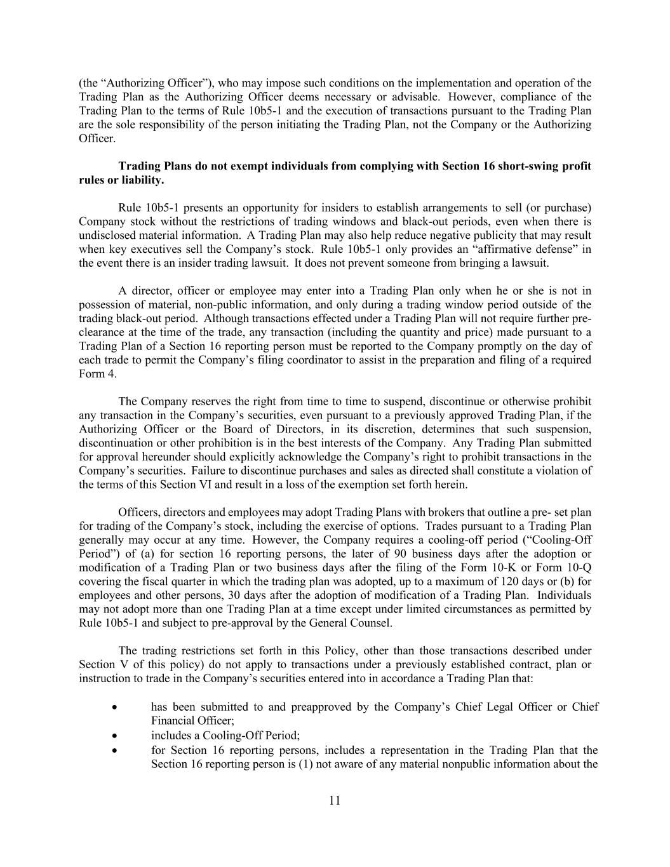
11 (the “Authorizing Officer”), who may impose such conditions on the implementation and operation of the Trading Plan as the Authorizing Officer deems necessary or advisable. However, compliance of the Trading Plan to the terms of Rule 10b5-1 and the execution of transactions pursuant to the Trading Plan are the sole responsibility of the person initiating the Trading Plan, not the Company or the Authorizing Officer. Trading Plans do not exempt individuals from complying with Section 16 short-swing profit rules or liability. Rule 10b5-1 presents an opportunity for insiders to establish arrangements to sell (or purchase) Company stock without the restrictions of trading windows and black-out periods, even when there is undisclosed material information. A Trading Plan may also help reduce negative publicity that may result when key executives sell the Company’s stock. Rule 10b5-1 only provides an “affirmative defense” in the event there is an insider trading lawsuit. It does not prevent someone from bringing a lawsuit. A director, officer or employee may enter into a Trading Plan only when he or she is not in possession of material, non-public information, and only during a trading window period outside of the trading black-out period. Although transactions effected under a Trading Plan will not require further pre- clearance at the time of the trade, any transaction (including the quantity and price) made pursuant to a Trading Plan of a Section 16 reporting person must be reported to the Company promptly on the day of each trade to permit the Company’s filing coordinator to assist in the preparation and filing of a required Form 4. The Company reserves the right from time to time to suspend, discontinue or otherwise prohibit any transaction in the Company’s securities, even pursuant to a previously approved Trading Plan, if the Authorizing Officer or the Board of Directors, in its discretion, determines that such suspension, discontinuation or other prohibition is in the best interests of the Company. Any Trading Plan submitted for approval hereunder should explicitly acknowledge the Company’s right to prohibit transactions in the Company’s securities. Failure to discontinue purchases and sales as directed shall constitute a violation of the terms of this Section VI and result in a loss of the exemption set forth herein. Officers, directors and employees may adopt Trading Plans with brokers that outline a pre- set plan for trading of the Company’s stock, including the exercise of options. Trades pursuant to a Trading Plan generally may occur at any time. However, the Company requires a cooling-off period (“Cooling-Off Period”) of (a) for section 16 reporting persons, the later of 90 business days after the adoption or modification of a Trading Plan or two business days after the filing of the Form 10-K or Form 10-Q covering the fiscal quarter in which the trading plan was adopted, up to a maximum of 120 days or (b) for employees and other persons, 30 days after the adoption of modification of a Trading Plan. Individuals may not adopt more than one Trading Plan at a time except under limited circumstances as permitted by Rule 10b5-1 and subject to pre-approval by the General Counsel. The trading restrictions set forth in this Policy, other than those transactions described under Section V of this policy) do not apply to transactions under a previously established contract, plan or instruction to trade in the Company’s securities entered into in accordance a Trading Plan that: • has been submitted to and preapproved by the Company’s Chief Legal Officer or Chief Financial Officer; • includes a Cooling-Off Period; • for Section 16 reporting persons, includes a representation in the Trading Plan that the Section 16 reporting person is (1) not aware of any material nonpublic information about the

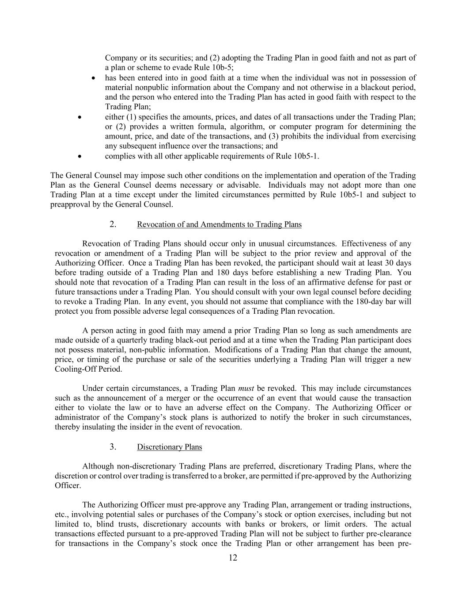
12 Company or its securities; and (2) adopting the Trading Plan in good faith and not as part of a plan or scheme to evade Rule 10b-5; • has been entered into in good faith at a time when the individual was not in possession of material nonpublic information about the Company and not otherwise in a blackout period, and the person who entered into the Trading Plan has acted in good faith with respect to the Trading Plan; • either (1) specifies the amounts, prices, and dates of all transactions under the Trading Plan; or (2) provides a written formula, algorithm, or computer program for determining the amount, price, and date of the transactions, and (3) prohibits the individual from exercising any subsequent influence over the transactions; and • complies with all other applicable requirements of Rule 10b5-1. The General Counsel may impose such other conditions on the implementation and operation of the Trading Plan as the General Counsel deems necessary or advisable. Individuals may not adopt more than one Trading Plan at a time except under the limited circumstances permitted by Rule 10b5-1 and subject to preapproval by the General Counsel. 2. Revocation of and Amendments to Trading Plans Revocation of Trading Plans should occur only in unusual circumstances. Effectiveness of any revocation or amendment of a Trading Plan will be subject to the prior review and approval of the Authorizing Officer. Once a Trading Plan has been revoked, the participant should wait at least 30 days before trading outside of a Trading Plan and 180 days before establishing a new Trading Plan. You should note that revocation of a Trading Plan can result in the loss of an affirmative defense for past or future transactions under a Trading Plan. You should consult with your own legal counsel before deciding to revoke a Trading Plan. In any event, you should not assume that compliance with the 180-day bar will protect you from possible adverse legal consequences of a Trading Plan revocation. A person acting in good faith may amend a prior Trading Plan so long as such amendments are made outside of a quarterly trading black-out period and at a time when the Trading Plan participant does not possess material, non-public information. Modifications of a Trading Plan that change the amount, price, or timing of the purchase or sale of the securities underlying a Trading Plan will trigger a new Cooling-Off Period. Under certain circumstances, a Trading Plan must be revoked. This may include circumstances such as the announcement of a merger or the occurrence of an event that would cause the transaction either to violate the law or to have an adverse effect on the Company. The Authorizing Officer or administrator of the Company’s stock plans is authorized to notify the broker in such circumstances, thereby insulating the insider in the event of revocation. 3. Discretionary Plans Although non-discretionary Trading Plans are preferred, discretionary Trading Plans, where the discretion or control over trading is transferred to a broker, are permitted if pre-approved by the Authorizing Officer. The Authorizing Officer must pre-approve any Trading Plan, arrangement or trading instructions, etc., involving potential sales or purchases of the Company’s stock or option exercises, including but not limited to, blind trusts, discretionary accounts with banks or brokers, or limit orders. The actual transactions effected pursuant to a pre-approved Trading Plan will not be subject to further pre-clearance for transactions in the Company’s stock once the Trading Plan or other arrangement has been pre-

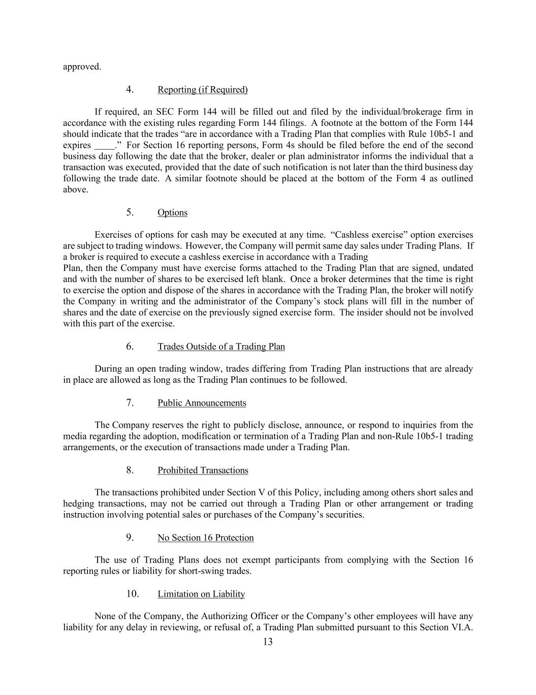
13 approved. 4. Reporting (if Required) If required, an SEC Form 144 will be filled out and filed by the individual/brokerage firm in accordance with the existing rules regarding Form 144 filings. A footnote at the bottom of the Form 144 should indicate that the trades “are in accordance with a Trading Plan that complies with Rule 10b5-1 and expires .” For Section 16 reporting persons, Form 4s should be filed before the end of the second business day following the date that the broker, dealer or plan administrator informs the individual that a transaction was executed, provided that the date of such notification is not later than the third business day following the trade date. A similar footnote should be placed at the bottom of the Form 4 as outlined above. 5. Options Exercises of options for cash may be executed at any time. “Cashless exercise” option exercises are subject to trading windows. However, the Company will permit same day sales under Trading Plans. If a broker is required to execute a cashless exercise in accordance with a Trading Plan, then the Company must have exercise forms attached to the Trading Plan that are signed, undated and with the number of shares to be exercised left blank. Once a broker determines that the time is right to exercise the option and dispose of the shares in accordance with the Trading Plan, the broker will notify the Company in writing and the administrator of the Company’s stock plans will fill in the number of shares and the date of exercise on the previously signed exercise form. The insider should not be involved with this part of the exercise. 6. Trades Outside of a Trading Plan During an open trading window, trades differing from Trading Plan instructions that are already in place are allowed as long as the Trading Plan continues to be followed. 7. Public Announcements The Company reserves the right to publicly disclose, announce, or respond to inquiries from the media regarding the adoption, modification or termination of a Trading Plan and non-Rule 10b5-1 trading arrangements, or the execution of transactions made under a Trading Plan. 8. Prohibited Transactions The transactions prohibited under Section V of this Policy, including among others short sales and hedging transactions, may not be carried out through a Trading Plan or other arrangement or trading instruction involving potential sales or purchases of the Company’s securities. 9. No Section 16 Protection The use of Trading Plans does not exempt participants from complying with the Section 16 reporting rules or liability for short-swing trades. 10. Limitation on Liability None of the Company, the Authorizing Officer or the Company’s other employees will have any liability for any delay in reviewing, or refusal of, a Trading Plan submitted pursuant to this Section VI.A.

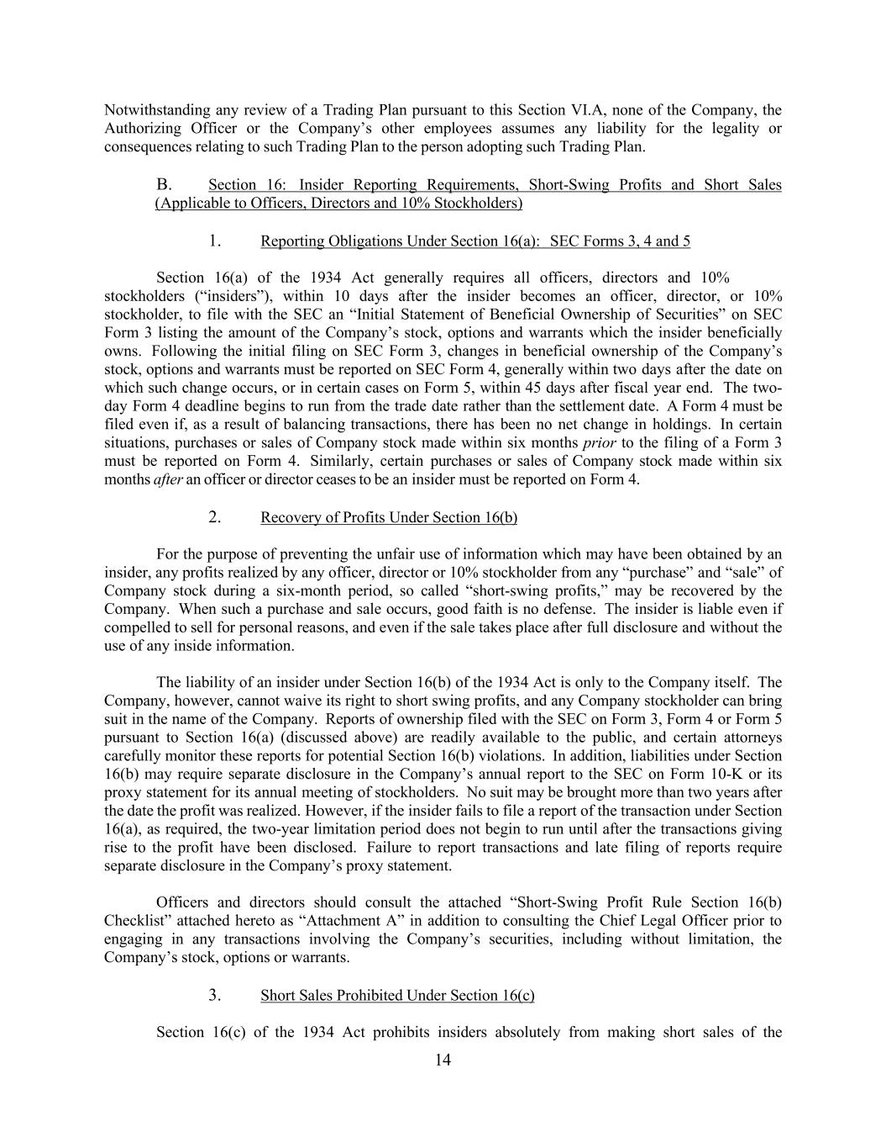
14 Notwithstanding any review of a Trading Plan pursuant to this Section VI.A, none of the Company, the Authorizing Officer or the Company’s other employees assumes any liability for the legality or consequences relating to such Trading Plan to the person adopting such Trading Plan. B. Section 16: Insider Reporting Requirements, Short-Swing Profits and Short Sales (Applicable to Officers, Directors and 10% Stockholders) 1. Reporting Obligations Under Section 16(a): SEC Forms 3, 4 and 5 Section 16(a) of the 1934 Act generally requires all officers, directors and 10% stockholders (“insiders”), within 10 days after the insider becomes an officer, director, or 10% stockholder, to file with the SEC an “Initial Statement of Beneficial Ownership of Securities” on SEC Form 3 listing the amount of the Company’s stock, options and warrants which the insider beneficially owns. Following the initial filing on SEC Form 3, changes in beneficial ownership of the Company’s stock, options and warrants must be reported on SEC Form 4, generally within two days after the date on which such change occurs, or in certain cases on Form 5, within 45 days after fiscal year end. The two- day Form 4 deadline begins to run from the trade date rather than the settlement date. A Form 4 must be filed even if, as a result of balancing transactions, there has been no net change in holdings. In certain situations, purchases or sales of Company stock made within six months prior to the filing of a Form 3 must be reported on Form 4. Similarly, certain purchases or sales of Company stock made within six months after an officer or director ceases to be an insider must be reported on Form 4. 2. Recovery of Profits Under Section 16(b) For the purpose of preventing the unfair use of information which may have been obtained by an insider, any profits realized by any officer, director or 10% stockholder from any “purchase” and “sale” of Company stock during a six-month period, so called “short-swing profits,” may be recovered by the Company. When such a purchase and sale occurs, good faith is no defense. The insider is liable even if compelled to sell for personal reasons, and even if the sale takes place after full disclosure and without the use of any inside information. The liability of an insider under Section 16(b) of the 1934 Act is only to the Company itself. The Company, however, cannot waive its right to short swing profits, and any Company stockholder can bring suit in the name of the Company. Reports of ownership filed with the SEC on Form 3, Form 4 or Form 5 pursuant to Section 16(a) (discussed above) are readily available to the public, and certain attorneys carefully monitor these reports for potential Section 16(b) violations. In addition, liabilities under Section 16(b) may require separate disclosure in the Company’s annual report to the SEC on Form 10-K or its proxy statement for its annual meeting of stockholders. No suit may be brought more than two years after the date the profit was realized. However, if the insider fails to file a report of the transaction under Section 16(a), as required, the two-year limitation period does not begin to run until after the transactions giving rise to the profit have been disclosed. Failure to report transactions and late filing of reports require separate disclosure in the Company’s proxy statement. Officers and directors should consult the attached “Short-Swing Profit Rule Section 16(b) Checklist” attached hereto as “Attachment A” in addition to consulting the Chief Legal Officer prior to engaging in any transactions involving the Company’s securities, including without limitation, the Company’s stock, options or warrants. 3. Short Sales Prohibited Under Section 16(c) Section 16(c) of the 1934 Act prohibits insiders absolutely from making short sales of the

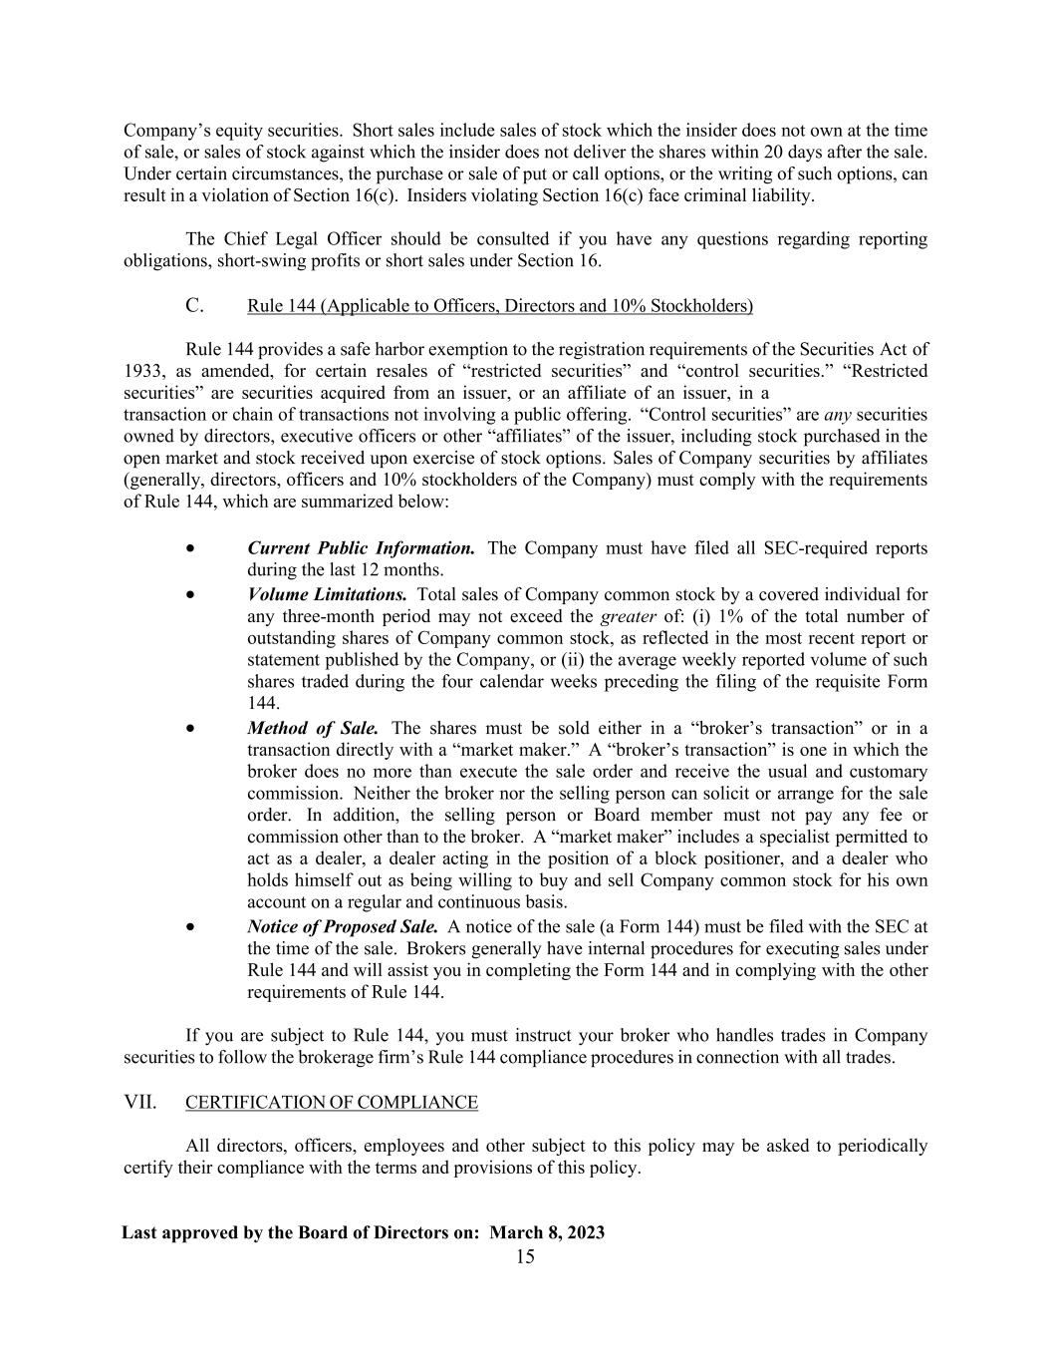
15 Company’s equity securities. Short sales include sales of stock which the insider does not own at the time of sale, or sales of stock against which the insider does not deliver the shares within 20 days after the sale. Under certain circumstances, the purchase or sale of put or call options, or the writing of such options, can result in a violation of Section 16(c). Insiders violating Section 16(c) face criminal liability. The Chief Legal Officer should be consulted if you have any questions regarding reporting obligations, short-swing profits or short sales under Section 16. C. Rule 144 (Applicable to Officers, Directors and 10% Stockholders) Rule 144 provides a safe harbor exemption to the registration requirements of the Securities Act of 1933, as amended, for certain resales of “restricted securities” and “control securities.” “Restricted securities” are securities acquired from an issuer, or an affiliate of an issuer, in a transaction or chain of transactions not involving a public offering. “Control securities” are any securities owned by directors, executive officers or other “affiliates” of the issuer, including stock purchased in the open market and stock received upon exercise of stock options. Sales of Company securities by affiliates (generally, directors, officers and 10% stockholders of the Company) must comply with the requirements of Rule 144, which are summarized below: • Current Public Information. The Company must have filed all SEC-required reports during the last 12 months. • Volume Limitations. Total sales of Company common stock by a covered individual for any three-month period may not exceed the greater of: (i) 1% of the total number of outstanding shares of Company common stock, as reflected in the most recent report or statement published by the Company, or (ii) the average weekly reported volume of such shares traded during the four calendar weeks preceding the filing of the requisite Form 144. • Method of Sale. The shares must be sold either in a “broker’s transaction” or in a transaction directly with a “market maker.” A “broker’s transaction” is one in which the broker does no more than execute the sale order and receive the usual and customary commission. Neither the broker nor the selling person can solicit or arrange for the sale order. In addition, the selling person or Board member must not pay any fee or commission other than to the broker. A “market maker” includes a specialist permitted to act as a dealer, a dealer acting in the position of a block positioner, and a dealer who holds himself out as being willing to buy and sell Company common stock for his own account on a regular and continuous basis. • Notice of Proposed Sale. A notice of the sale (a Form 144) must be filed with the SEC at the time of the sale. Brokers generally have internal procedures for executing sales under Rule 144 and will assist you in completing the Form 144 and in complying with the other requirements of Rule 144. If you are subject to Rule 144, you must instruct your broker who handles trades in Company securities to follow the brokerage firm’s Rule 144 compliance procedures in connection with all trades. VII. CERTIFICATION OF COMPLIANCE All directors, officers, employees and other subject to this policy may be asked to periodically certify their compliance with the terms and provisions of this policy. Last approved by the Board of Directors on: March 8, 2023

Exhibit 23.1
CONSENT OF INDEPENDENT REGISTERED PUBLIC ACCOUNTING FIRM
We consent to the incorporation by reference in Registration Statement No. 333-248596 on Form S-8 of our reports dated December 21, 2023, relating to the consolidated financial statements of Mission Produce, Inc. and subsidiaries (the “Company”) and the effectiveness of the Company’s internal control over financial reporting appearing in this Annual Report on Form 10-K of the Company for the year ended October 31, 2023.

/s/ Deloitte & Touche LLP

Los Angeles, California
December 21, 2023

Exhibit 31.1

CERTIFICATION OF CHIEF EXECUTIVE OFFICER
PURSUANT TO SECTION 302 OF THE SARBANES-OXLEY ACT OF 2002
I, Stephen J. Barnard, certify that:
1.I have reviewed this annual report on Form 10-K of Mission Produce, Inc.;
2.Based on my knowledge, this report does not contain any untrue statement of a material fact or omit to state a material fact necessary to make the statements made, in light of the circumstances under which such statements were made, not misleading with respect to the period covered by this report;
3.Based on my knowledge, the financial statements, and other financial information included in this report, fairly present in all material respects the financial condition, results of operations and cash flows of the registrant as of, and for, the periods presented in this report;
4.The registrant's other certifying officer(s) and I are responsible for establishing and maintaining disclosure controls and procedures (as defined in Exchange Act Rules 13a-15(e) and 15d-15(e)) and internal control over financial reporting (as defined in Exchange Act Rules 13a-15(f) and 15d-15(f)) for the registrant and have:
(a)Designed such disclosure controls and procedures, or caused such disclosure controls and procedures to be designed under our supervision, to ensure that material information relating to the registrant, including its consolidated subsidiaries, is made known to us by others within those entities, particularly during the period in which this report is being prepared;
(b)Designed such internal control over financial reporting, or caused such internal control over financial reporting to be designed under our supervision, to provide reasonable assurance regarding the reliability of financial reporting and the preparation of financial statements for external purposes in accordance with generally accepted accounting principles;
(c)Evaluated the effectiveness of the registrant's disclosure controls and procedures and presented in this report our conclusions about the effectiveness of the disclosure controls and procedures, as of the end of the period covered by this report based on such evaluation; and
(d)Disclosed in this report any change in the registrant's internal control over financial reporting that occurred during the registrant's most recent fiscal quarter (the registrant's fourth fiscal quarter in the case of an annual report) that has materially affected, or is reasonably likely to materially affect, the registrant's internal control over financial reporting; and
5.The registrant's other certifying officer(s) and I have disclosed, based on our most recent evaluation of internal control over financial reporting, to the registrant's auditors and the audit committee of the registrant's board of directors (or persons performing the equivalent functions):
(a)All significant deficiencies and material weaknesses in the design or operation of internal control over financial reporting which are reasonably likely to adversely affect the registrant's ability to record, process, summarize and report financial information; and
(b)Any fraud, whether or not material, that involves management or other employees who have a significant role in the registrant's internal control over financial reporting.

/s/ Stephen J. Barnard
Stephen J. Barnard
Chief Executive Officer and Director
Date: December 21, 2023

Exhibit 31.2

CERTIFICATION OF CHIEF FINANCIAL OFFICER
PURSUANT TO SECTION 302 OF THE SARBANES-OXLEY ACT OF 2002
I, Bryan E. Giles, certify that:
1.I have reviewed this annual report on Form 10-K of Mission Produce, Inc.;
2.Based on my knowledge, this report does not contain any untrue statement of a material fact or omit to state a material fact necessary to make the statements made, in light of the circumstances under which such statements were made, not misleading with respect to the period covered by this report;
3.Based on my knowledge, the financial statements, and other financial information included in this report, fairly present in all material respects the financial condition, results of operations and cash flows of the registrant as of, and for, the periods presented in this report;
4.The registrant's other certifying officer(s) and I are responsible for establishing and maintaining disclosure controls and procedures (as defined in Exchange Act Rules 13a-15(e) and 15d-15(e)) and internal control over financial reporting (as defined in Exchange Act Rules 13a-15(f) and 15d-15(f)) for the registrant and have:
(a)Designed such disclosure controls and procedures, or caused such disclosure controls and procedures to be designed under our supervision, to ensure that material information relating to the registrant, including its consolidated subsidiaries, is made known to us by others within those entities, particularly during the period in which this report is being prepared;
(b)Designed such internal control over financial reporting, or caused such internal control over financial reporting to be designed under our supervision, to provide reasonable assurance regarding the reliability of financial reporting and the preparation of financial statements for external purposes in accordance with generally accepted accounting principles;
(c)Evaluated the effectiveness of the registrant's disclosure controls and procedures and presented in this report our conclusions about the effectiveness of the disclosure controls and procedures, as of the end of the period covered by this report based on such evaluation; and
(d)Disclosed in this report any change in the registrant's internal control over financial reporting that occurred during the registrant's most recent fiscal quarter (the registrant's fourth fiscal quarter in the case of an annual report) that has materially affected, or is reasonably likely to materially affect, the registrant's internal control over financial reporting; and
5.The registrant's other certifying officer(s) and I have disclosed, based on our most recent evaluation of internal control over financial reporting, to the registrant's auditors and the audit committee of the registrant's board of directors (or persons performing the equivalent functions):
(a)All significant deficiencies and material weaknesses in the design or operation of internal control over financial reporting which are reasonably likely to adversely affect the registrant's ability to record, process, summarize and report financial information; and
(b)Any fraud, whether or not material, that involves management or other employees who have a significant role in the registrant's internal control over financial reporting.

/s/ Bryan E. Giles
Bryan E. Giles
Chief Financial Officer
Date: December 21, 2023

Exhibit 32.1

CERTIFICATION OF CHIEF EXECUTIVE OFFICER
PURSUANT TO SECTION 906 OF THE SARBANES-OXLEY ACT OF 2002

Pursuant to 18 U.S.C. Section 1350, as created by Section 906 of the Sarbanes-Oxley Act of 2002, the undersigned officer of Mission Produce, Inc. (the “Company”) hereby certifies, to the best of his knowledge, that:
(i)the Annual Report on Form 10-K of the Company for the fiscal year ended October 31, 2023 (the “Report”) fully complies with the requirements of Section 13(a) or Section 15(d), as applicable, of the Securities Exchange Act of 1934, as amended; and
(ii)the information contained in the Report fairly presents, in all material respects, the financial condition and results of operations of the Company.

/s/ Stephen J. Barnard
Stephen J. Barnard
Chief Executive Officer and Director
Date: December 21, 2023

Exhibit 32.2

CERTIFICATION OF CHIEF FINANCIAL OFFICER
PURSUANT TO SECTION 906 OF THE SARBANES-OXLEY ACT OF 2002
Pursuant to 18 U.S.C. Section 1350, as created by Section 906 of the Sarbanes-Oxley Act of 2002, the undersigned officer of Mission Produce, Inc. (the “Company”) hereby certifies, to the best of his knowledge, that:
(i)the Annual Report on Form 10-K of the Company for the fiscal year ended October 31, 2023 (the “Report”) fully complies with the requirements of Section 13(a) or Section 15(d), as applicable, of the Securities Exchange Act of 1934, as amended; and
(ii)the information contained in the Report fairly presents, in all material respects, the financial condition and results of operations of the Company.

/s/ Bryan E. Giles
Bryan E. Giles
Chief Financial Officer
Date: December 21, 2023
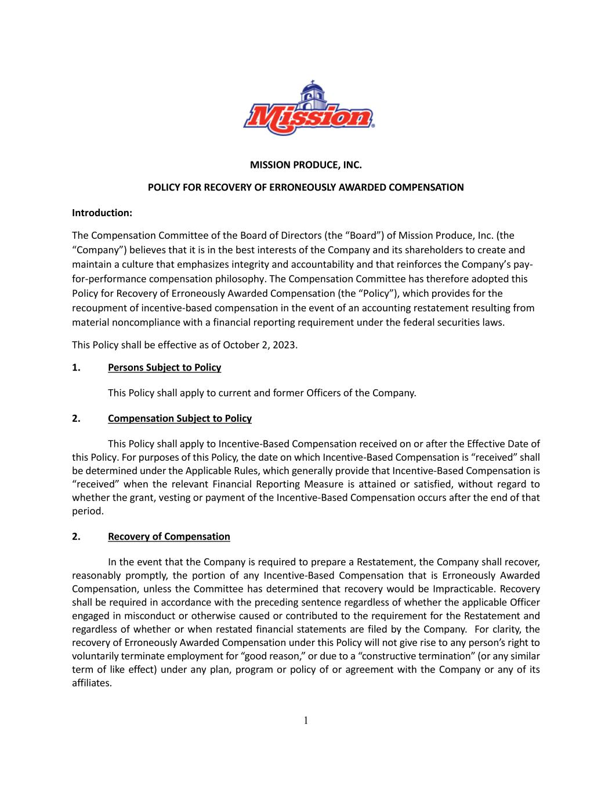

1 MISSION PRODUCE, INC. POLICY FOR RECOVERY OF ERRONEOUSLY AWARDED COMPENSATION Introduction: The Compensation Committee of the Board of Directors (the “Board”) of Mission Produce, Inc. (the “Company”) believes that it is in the best interests of the Company and its shareholders to create and maintain a culture that emphasizes integrity and accountability and that reinforces the Company’s pay- for-performance compensation philosophy. The Compensation Committee has therefore adopted this Policy for Recovery of Erroneously Awarded Compensation (the “Policy”), which provides for the recoupment of incentive-based compensation in the event of an accounting restatement resulting from material noncompliance with a financial reporting requirement under the federal securities laws. This Policy shall be effective as of October 2, 2023. 1. Persons Subject to Policy This Policy shall apply to current and former Officers of the Company. 2. Compensation Subject to Policy This Policy shall apply to Incentive-Based Compensation received on or after the Effective Date of this Policy. For purposes of this Policy, the date on which Incentive-Based Compensation is “received” shall be determined under the Applicable Rules, which generally provide that Incentive-Based Compensation is “received” when the relevant Financial Reporting Measure is attained or satisfied, without regard to whether the grant, vesting or payment of the Incentive-Based Compensation occurs after the end of that period. 2. Recovery of Compensation In the event that the Company is required to prepare a Restatement, the Company shall recover, reasonably promptly, the portion of any Incentive-Based Compensation that is Erroneously Awarded Compensation, unless the Committee has determined that recovery would be Impracticable. Recovery shall be required in accordance with the preceding sentence regardless of whether the applicable Officer engaged in misconduct or otherwise caused or contributed to the requirement for the Restatement and regardless of whether or when restated financial statements are filed by the Company. For clarity, the recovery of Erroneously Awarded Compensation under this Policy will not give rise to any person’s right to voluntarily terminate employment for “good reason,” or due to a “constructive termination” (or any similar term of like effect) under any plan, program or policy of or agreement with the Company or any of its affiliates.

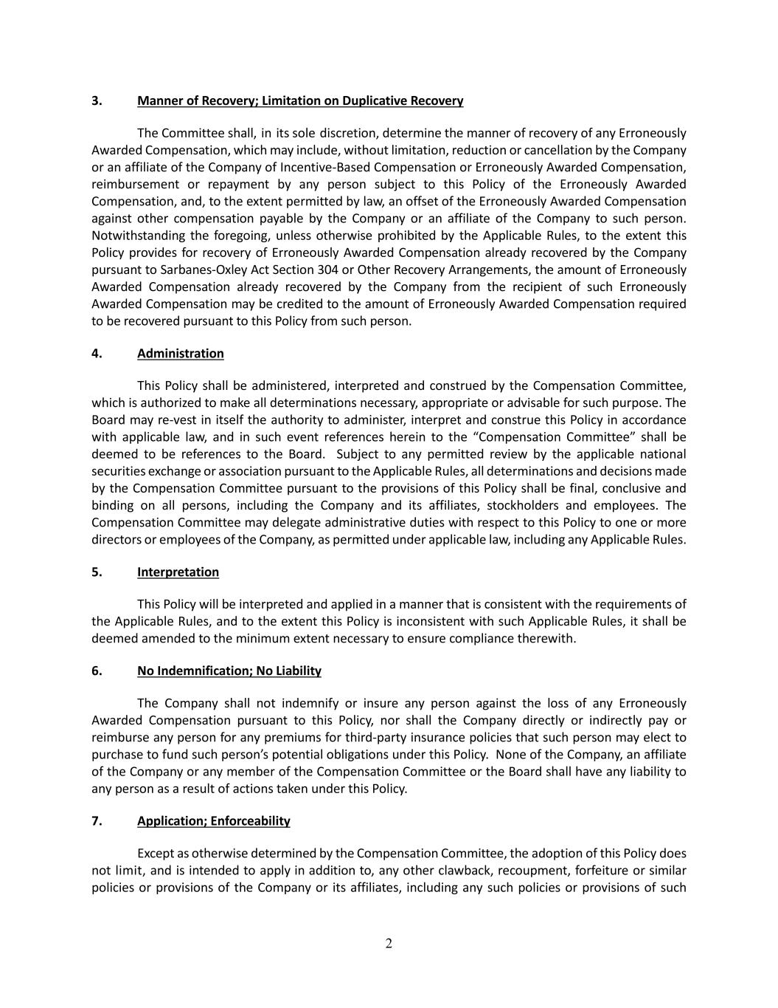
2 3. Manner of Recovery; Limitation on Duplicative Recovery The Committee shall, in its sole discretion, determine the manner of recovery of any Erroneously Awarded Compensation, which may include, without limitation, reduction or cancellation by the Company or an affiliate of the Company of Incentive-Based Compensation or Erroneously Awarded Compensation, reimbursement or repayment by any person subject to this Policy of the Erroneously Awarded Compensation, and, to the extent permitted by law, an offset of the Erroneously Awarded Compensation against other compensation payable by the Company or an affiliate of the Company to such person. Notwithstanding the foregoing, unless otherwise prohibited by the Applicable Rules, to the extent this Policy provides for recovery of Erroneously Awarded Compensation already recovered by the Company pursuant to Sarbanes-Oxley Act Section 304 or Other Recovery Arrangements, the amount of Erroneously Awarded Compensation already recovered by the Company from the recipient of such Erroneously Awarded Compensation may be credited to the amount of Erroneously Awarded Compensation required to be recovered pursuant to this Policy from such person. 4. Administration This Policy shall be administered, interpreted and construed by the Compensation Committee, which is authorized to make all determinations necessary, appropriate or advisable for such purpose. The Board may re-vest in itself the authority to administer, interpret and construe this Policy in accordance with applicable law, and in such event references herein to the “Compensation Committee” shall be deemed to be references to the Board. Subject to any permitted review by the applicable national securities exchange or association pursuant to the Applicable Rules, all determinations and decisions made by the Compensation Committee pursuant to the provisions of this Policy shall be final, conclusive and binding on all persons, including the Company and its affiliates, stockholders and employees. The Compensation Committee may delegate administrative duties with respect to this Policy to one or more directors or employees of the Company, as permitted under applicable law, including any Applicable Rules. 5. Interpretation This Policy will be interpreted and applied in a manner that is consistent with the requirements of the Applicable Rules, and to the extent this Policy is inconsistent with such Applicable Rules, it shall be deemed amended to the minimum extent necessary to ensure compliance therewith. 6. No Indemnification; No Liability The Company shall not indemnify or insure any person against the loss of any Erroneously Awarded Compensation pursuant to this Policy, nor shall the Company directly or indirectly pay or reimburse any person for any premiums for third-party insurance policies that such person may elect to purchase to fund such person’s potential obligations under this Policy. None of the Company, an affiliate of the Company or any member of the Compensation Committee or the Board shall have any liability to any person as a result of actions taken under this Policy. 7. Application; Enforceability Except as otherwise determined by the Compensation Committee, the adoption of this Policy does not limit, and is intended to apply in addition to, any other clawback, recoupment, forfeiture or similar policies or provisions of the Company or its affiliates, including any such policies or provisions of such

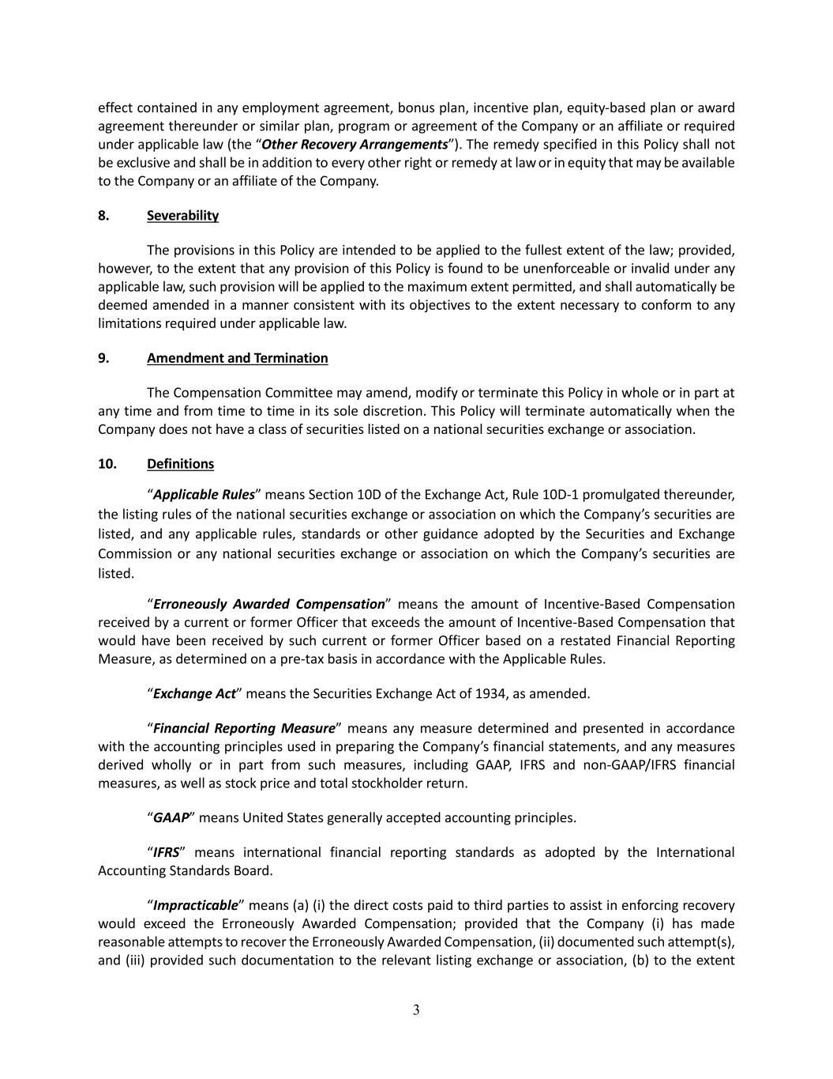
3 effect contained in any employment agreement, bonus plan, incentive plan, equity-based plan or award agreement thereunder or similar plan, program or agreement of the Company or an affiliate or required under applicable law (the “Other Recovery Arrangements”). The remedy specified in this Policy shall not be exclusive and shall be in addition to every other right or remedy at law or in equity that may be available to the Company or an affiliate of the Company. 8. Severability The provisions in this Policy are intended to be applied to the fullest extent of the law; provided, however, to the extent that any provision of this Policy is found to be unenforceable or invalid under any applicable law, such provision will be applied to the maximum extent permitted, and shall automatically be deemed amended in a manner consistent with its objectives to the extent necessary to conform to any limitations required under applicable law. 9. Amendment and Termination The Compensation Committee may amend, modify or terminate this Policy in whole or in part at any time and from time to time in its sole discretion. This Policy will terminate automatically when the Company does not have a class of securities listed on a national securities exchange or association. 10. Definitions “Applicable Rules” means Section 10D of the Exchange Act, Rule 10D-1 promulgated thereunder, the listing rules of the national securities exchange or association on which the Company’s securities are listed, and any applicable rules, standards or other guidance adopted by the Securities and Exchange Commission or any national securities exchange or association on which the Company’s securities are listed. “Erroneously Awarded Compensation” means the amount of Incentive-Based Compensation received by a current or former Officer that exceeds the amount of Incentive-Based Compensation that would have been received by such current or former Officer based on a restated Financial Reporting Measure, as determined on a pre-tax basis in accordance with the Applicable Rules. “Exchange Act” means the Securities Exchange Act of 1934, as amended. “Financial Reporting Measure” means any measure determined and presented in accordance with the accounting principles used in preparing the Company’s financial statements, and any measures derived wholly or in part from such measures, including GAAP, IFRS and non-GAAP/IFRS financial measures, as well as stock price and total stockholder return. “GAAP” means United States generally accepted accounting principles. “IFRS” means international financial reporting standards as adopted by the International Accounting Standards Board. “Impracticable” means (a) (i) the direct costs paid to third parties to assist in enforcing recovery would exceed the Erroneously Awarded Compensation; provided that the Company (i) has made reasonable attempts to recover the Erroneously Awarded Compensation, (ii) documented such attempt(s), and (iii) provided such documentation to the relevant listing exchange or association, (b) to the extent

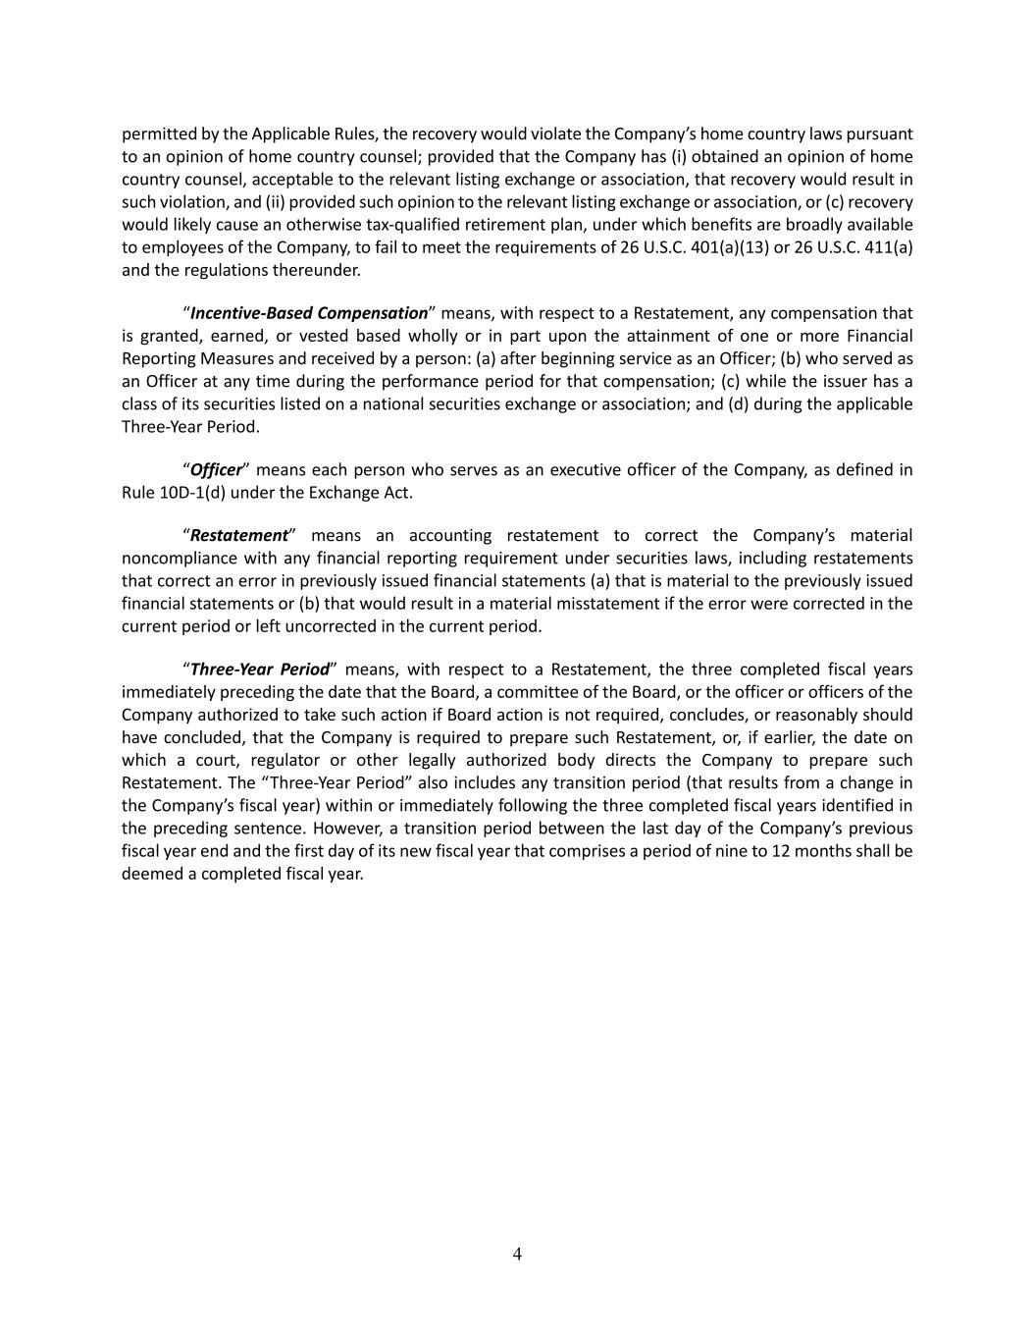
4 permitted by the Applicable Rules, the recovery would violate the Company’s home country laws pursuant to an opinion of home country counsel; provided that the Company has (i) obtained an opinion of home country counsel, acceptable to the relevant listing exchange or association, that recovery would result in such violation, and (ii) provided such opinion to the relevant listing exchange or association, or (c) recovery would likely cause an otherwise tax-qualified retirement plan, under which benefits are broadly available to employees of the Company, to fail to meet the requirements of 26 U.S.C. 401(a)(13) or 26 U.S.C. 411(a) and the regulations thereunder. “Incentive-Based Compensation” means, with respect to a Restatement, any compensation that is granted, earned, or vested based wholly or in part upon the attainment of one or more Financial Reporting Measures and received by a person: (a) after beginning service as an Officer; (b) who served as an Officer at any time during the performance period for that compensation; (c) while the issuer has a class of its securities listed on a national securities exchange or association; and (d) during the applicable Three-Year Period. “Officer” means each person who serves as an executive officer of the Company, as defined in Rule 10D-1(d) under the Exchange Act. “Restatement” means an accounting restatement to correct the Company’s material noncompliance with any financial reporting requirement under securities laws, including restatements that correct an error in previously issued financial statements (a) that is material to the previously issued financial statements or (b) that would result in a material misstatement if the error were corrected in the current period or left uncorrected in the current period. “Three-Year Period” means, with respect to a Restatement, the three completed fiscal years immediately preceding the date that the Board, a committee of the Board, or the officer or officers of the Company authorized to take such action if Board action is not required, concludes, or reasonably should have concluded, that the Company is required to prepare such Restatement, or, if earlier, the date on which a court, regulator or other legally authorized body directs the Company to prepare such Restatement. The “Three-Year Period” also includes any transition period (that results from a change in the Company’s fiscal year) within or immediately following the three completed fiscal years identified in the preceding sentence. However, a transition period between the last day of the Company’s previous fiscal year end and the first day of its new fiscal year that comprises a period of nine to 12 months shall be deemed a completed fiscal year.

