UNITED STATES
SECURITIES AND EXCHANGE COMMISSION
WASHINGTON, D.C. 20549
_____________
FORM 8-K
_____________

CURRENT REPORT
Pursuant to Section 13 OR 15(d) of The Securities Exchange Act of 1934

Date of Report (Date of earliest event reported): October 8, 2026

MISSION PRODUCE, INC.
(Exact name of Registrant as specified in its charter)
_____________

Delaware |  |  |  |  |  | 001-39561 |  |  |  |  |  | 95-3847744
(State or Other Jurisdiction of Incorporation or Organization) |  |  |  |  |  | (Commission file number) |  |  |  |  |  | (IRS Employer Identification No.)
2710 Camino Del Sol, Oxnard, CA |  |  |  |  |  |  |  |  |  |  |  | 93030
(Address of Principal Executive Offices) |  |  |  |  |  |  |  |  |  |  |  | (Zip code)
Registrant’s telephone number, including area code: (805) 981-3650

(Former name or former address, if changed since last report.)

Securities registered pursuant to Section 12(b) of the Act:

Title of each class |  |  |  |  |  | Trading Symbol(s) |  |  |  |  |  | Name of each exchange on which registered
Common Stock, par value $0.001 per share |  |  |  |  |  | AVO |  |  |  |  |  | NASDAQ Global Select Market
Series A Junior Participating Preferred Stock, par value $0.001 per share

Check the appropriate box below if the Form 8-K ﬁling is intended to simultaneously satisfy the ﬁling obligation of the registrant under any of the following provisions (see General Instruction A.2. below):

☐ |  |  | Written communications pursuant to Rule 425 under the Securities Act (17 CFR 230.425)
☐ |  |  | Soliciting material pursuant to Rule 14a-12 under the Exchange Act (17 CFR 240.14a-12)
☐ |  |  | Pre-commencement communications pursuant to Rule 14d-2(b) under the Exchange Act (17 CFR 240.14d-2(b))
☐ |  |  | Pre-commencement communications pursuant to Rule 13e-4(c) under the Exchange Act (17 CFR 240.13e-4(c))

Indicate by check mark whether the registrant is an emerging growth company as defined in Rule 405 of the Securities Act of 1933 (§230.405 of this chapter) or Rule 12b-2 of the Securities Exchange Act of 1934 (§240.12b-2 of this chapter).

Emerging growth company |  |  | ☐
If an emerging growth company, indicate by check mark if the registrant has elected not to use the extended transition period for complying with any new or revised financial accounting standards provided pursuant to Section 13(a) of the Exchange Act. |  |  | ☐

Item 8.01 Other Events
As previously announced on June 8, 2026, the Board of Directors of Mission Produce, Inc. (the “Company”) authorized a $100 million stock repurchase program. During the fiscal fourth quarter to-date, the Company has repurchased 290,994 shares at an average purchase price of $12.94.
Item 7.01 Regulation FD Disclosure
On October 8, 2026, the Company issued a press release and posted an updated copy of its investor presentation on its website at www.missionproduce.com. The presentation will be used at the Company’s 2026 Investor Day on October 8, 2026, where certain members of senior management of the Company are scheduled to participate. Copies of the press release and investor presentation are attached to this Current Report on Form 8-K as Exhibits 99.1 and 99.2, respectively.
The information contained in this Item 7.01, including the information set forth in the press release and updated investor presentation attached hereto as Exhibits 99.1 and 99.2, respectively, and incorporated by reference herein, are being “furnished” and shall not be deemed “filed” for the purposes of Section 18 of the Securities Exchange Act of 1934, as amended (the “Exchange Act”), or otherwise subject to the liabilities of that section. The information in this Item 7.01, including the information in Exhibits 99.1 and 99.2 attached to this report, shall not be incorporated by reference into any Company filing pursuant to the Securities Act of 1933, as amended, or the Exchange Act, except as otherwise expressly stated in any such filing.
Item 9.01 Financial Statements and Exhibits

(d) Exhibits

Exhibit No. |  |  |  |  |  | Description
99.1 |  |  |  |  |  | Press Release dated October 8, 2026
99.2 |  |  |  |  |  | Investor Presentation dated October 8, 2026
104 |  |  |  |  |  | Cover Page Interactive Data File (embedded within the Inline XBRL document)

SIGNATURES
Pursuant to the requirements of the Securities Exchange Act of 1934, the registrant has duly caused this report to be signed on its behalf by the undersigned hereunto duly authorized.

MISSION PRODUCE, INC.
/s/ John M. Pawlowski
John M. Pawlowski
President and Chief Executive Officer
Date: October 8, 2026



Mission Produce Unveils Five-Year Financial Targets and Strategies at 2026 Investor Day
Targets mid-single-digit organic sales growth and 300 basis points of margin expansion over the next five years
Introduces 2035 ambition to double sales and triple Adjusted EBITDA
Strategy designed to support high-single-digit to double-digit annual shareholder returns over time

OXNARD, Calif., Oct. 8, 2026 (GLOBE NEWSWIRE) -- Mission Produce, Inc. (NASDAQ: AVO) (“Mission” or “the Company”), a world leader in sourcing, producing, and distributing fresh Hass avocados, today is hosting its 2026 Investor Day in New York City. Management is presenting the Company’s five-year growth strategy and its ambition to double sales and triple profit by 2035.
After more than four decades of building the global supply network, infrastructure and customer capabilities behind its category leadership, Mission is entering a new chapter focused on generating more growth, earnings and cash flow from its platform. The Company’s largest value-creation initiatives are already underway, including the integration of Calavo Growers, expansion of higher-margin Prepared Foods, and improved utilization of Mission’s asset base.
Management Comments
John Pawlowski, President and Chief Executive Officer of Mission, stated, “Mission was built to lead. Over more than 40 years, we built the modern avocado category and created a platform that would be difficult to replicate. Our next chapter is about fully leveraging that platform and compounding the value we deliver to shareholders by growing faster than our markets, expanding margins, converting more earnings into cash and deploying that cash with discipline.”
“Our growth opportunity is broad and compelling. U.S. avocado remains one of the most durable growth stories in food. International markets offer substantial consumption headroom. Prepared Foods extends our avocado leadership into a higher-margin, growing category, and mango gives us a capital-efficient path to develop the next fresh platform. With Calavo synergies and better utilization of the assets already in place, we believe Mission can become a larger, more productive and higher-return company.”
A Financial Framework Built to Compound
Mission’s five-year plan is built around four connected goals for long-term shareholder value creation:

Organic sales growth: Grow faster than the markets the Company serves, supporting mid-single-digit organic sales growth over the five-year period.
Margin expansion: Expand margins by approximately 300 basis points over five years through improved portfolio mix, Calavo synergies, SG&A leverage and greater asset utilization.
Cash conversion: Convert more than 90% of Adjusted Net Income into free cash flow over time.
Disciplined capital allocation: Invest in the core business, reduce net leverage (total debt less cash) below 1.5 times Adjusted EBITDA, pursue disciplined M&A and execute opportunistic share repurchases.
Together, these initiatives are expected to support high-single-digit organic Adjusted EBITDA growth over the five-year period. Combined with disciplined M&A and opportunistic share repurchases, the framework is designed to support high-single-digit to double-digit annual shareholder returns over time.
Calavo Integration Progressing
Mission has pooled supply, closed the Temecula operation and established its future-state U.S. distribution footprint. The Company is now advancing network and systems transitions, and will be followed by the integration of remaining operations, including Mexico packing and Prepared Foods.
As announced in its fiscal third quarter 2026 earnings release, Mission increased its annualized synergy target from at least $25 million to more than $30 million. The Company expects a small contribution in the fourth quarter of fiscal 2026 and continues to target the full annualized run rate within 18 months of closing.
Disciplined Capital Allocation
Mission’s capital-allocation priorities are to invest in the core business, reduce net leverage below 1.5 times Adjusted EBITDA, pursue M&A where strategic fit and returns are compelling, and repurchase shares opportunistically. The Company currently has a $100 million share-repurchase authorization, which provides meaningful flexibility.
Bryan Giles, Chief Financial Officer of Mission, stated, “Mission is entering a financially compelling stage, with the majority of the heavy investment required to build our platform behind us and the Calavo acquisition adding scale, new capabilities and a meaningful synergy opportunity.”
“Our five-year framework is designed to grow earnings faster than sales and convert more of those earnings into cash. That should give us greater capacity to reduce leverage, fund high-return growth and return capital when it creates attractive value for shareholders.”
Fiscal 2026 Outlook Reaffirmed
Mission is reaffirming its previously provided outlook for the second half and fourth quarter of fiscal 2026:

Second-half fiscal 2026 Adjusted EBITDA of $84 million to $88 million, including fourth-quarter Adjusted EBITDA of $52 million to $55 million; and
Mission Peru exportable volume of 120 million to 130 million pounds in the second half, including 67 million to 77 million pounds in the fourth quarter.
Webcast Information
The 2026 Investor Day will be webcast live beginning at 10:00 a.m. ET today. The webcast, along with the presentation materials, will be accessible in the News & Events section of the Company’s investor relations website at https://investors.missionproduce.com. A replay will be available on the same site following the event.
Non-GAAP Financial Measures
This press release contains the non-GAAP financial measures “Adjusted EBITDA,” “Adjusted Net Income” and “Free Cash Flow.” Management believes these measures provide useful information for analyzing the underlying business results. These measures are not in accordance with, nor are they a substitute for or superior to, the comparable financial measures by generally accepted accounting principles.
Adjusted EBITDA refers to net income before interest expense, income taxes, depreciation and amortization expense, stock-based compensation expense, other income (expense), and income (loss) from equity method investees, further adjusted by asset impairment and disposals, farming costs for nonproductive orchards (which represents land lease costs), recognition of deferred ERP costs, transaction advisory costs, and any special, non-recurring, or one-time items such as remeasurements or impairments, and any portion of these items attributable to the noncontrolling interest. Segment adjusted EBITDA refers to, with respect to the applicable segment, net income (loss), before interest expense, income taxes, depreciation and amortization expense, stock-based compensation expense, other income (expense), and income (loss) from equity method investees, further adjusted by asset impairment and disposals, farming costs for nonproductive orchards (which represents land lease costs), recognition of deferred ERP costs, transaction advisory and integration costs, amortization of inventory adjustments recognized from business combinations, and any special, non-recurring, or one-time items such as remeasurements or impairments, and any portion of these items attributable to the noncontrolling interest.
Adjusted Net Income refers to net income attributable to Mission Produce, before stock-based compensation expense, unrealized gain (loss) on derivative financial instruments, foreign currency gain (loss), farming costs for nonproductive orchards (which represents land lease costs), recognition of deferred ERP costs, transaction advisory and integration costs, amortization of inventory adjustments and intangible asset recognized from business combinations, further adjusted by any special, non-recurring, or one-time items such as remeasurement, impairment or discrete tax charges that are distortive to results, and tax effects of these items, if any, and the tax-effected impact of these non-GAAP adjustments attributable to noncontrolling interest, allocable to the noncontrolling owners based on their percentage of ownership interest.
Free cash flow refers to cash flow from operations minus capital expenditures.

We have not reconciled our forward-looking non-GAAP financial measures to the most directly comparable GAAP measures in reliance on the "unreasonable efforts" exception in Item 10(e)(1)(i)(B) of Regulation S-K. These measures include our fiscal 2026 Adjusted EBITDA outlook, our fiscal 2035 Adjusted EBITDA ambition, our Adjusted EBITDA growth target, our Free Cash Flow Conversion target and our Net Debt to Adjusted EBITDA target. We cannot provide these reconciliations without unreasonable efforts because we cannot predict with reasonable certainty the amount or timing of certain items. These items include stock-based compensation, unrealized gains and losses on derivative financial instruments, foreign currency gains and losses, asset impairments and disposals, transaction advisory and integration costs and income taxes. They are inherently uncertain, depend on factors outside our control and could be material, individually or in the aggregate, to our GAAP results.
About Mission Produce, Inc.
Mission Produce is a global leader in the worldwide fresh produce industry and the world’s premier supplier of fresh Hass avocados, serving retail, wholesale, and foodservice customers in more than 25 countries. Since 1983, Mission has been dedicated to sourcing, producing, and distributing avocados, building one of the most integrated and diversified avocado supply networks in the world. While avocados remain at the core of its business, Mission also markets and distributes mangos, tomatoes, papayas, value-added prepared foods, including guacamole, and grows blueberries as part of its diversified portfolio. The Company is vertically integrated and has sourcing capabilities across 20+ premium growing regions. With a global distribution network spanning North America, Europe, the United Kingdom, and China, Mission provides a reliable year-round supply of premium products and value-added services, including ripening, bagging, custom packing, and logistics management. For more information, visit www.missionproduce.com.
Forward-Looking Statements
Statements in this press release that are not historical in nature are forward-looking statements that, within the meaning of the federal securities laws, including the safe harbor provisions of the Private Securities Litigation Reform Act of 1995, involve known and unknown risks and uncertainties. Words such as "may", "will", "expect", "intend", "plan", "believe", "seek", "could", "estimate", "judgment", "targeting", "should", "anticipate", "goal" and variations of these words and similar expressions, are also intended to identify forward-looking statements. The forward-looking statements in this press release address a variety of subjects, including statements about our anticipated future performance, anticipated synergies related our completed acquisition of Calavo, the anticipated future performance of Calavo, and our short-term and long-term assumptions, goals and targets. Many of these assumptions relate to matters that are beyond our control and changing rapidly. Although we believe the expectations reflected in such forward-looking statements are based upon reasonable assumptions, we can give no assurances that our expectations will be attained. Readers are cautioned that actual results could differ materially from those implied by such forward-looking statements due to a variety of factors, including: reliance on primarily one main product, limitations regarding the supply of fruit, either through purchasing or growing; ; the risks that the businesses of Mission Produce and Calavo will not be integrated successfully or that the integration will be more costly or difficult than expected; the risk that the cost savings and any other synergies from the completed acquisition of Calavo may not be fully realized or may take longer to realize than expected; the risk of underperformance of Calavo’s business; the risk that the credit ratings of

the combined company or its subsidiaries may be different from what the companies expect; the risk of adverse reactions or changes to business or employee relationships resulting from the completion of the acquisition of Calavo; fluctuations in the market price of fruit; increasing competition; risks associated with doing business internationally, including Mexican and Peruvian economic, political and/or societal conditions; inflationary pressures; establishment of sales channels and geographic markets; loss of one or more of our largest customers; general economic conditions or downturns; supply chain failures or disruptions; disruption to the supply of reliable and cost-effective transportation; failure to recruit or retain employees, poor employee relations, and/or ineffective organizational structure; inherent farming risks, including climate change; seasonality in operating results; failures associated with information technology infrastructure, system security and cyber risks; new and changing privacy laws and our compliance with such laws; food safety events and recalls; failure to comply with laws and regulations; changes to trade policy and/or export/import laws and regulations; risks from business acquisitions, if any; lack of or failure of infrastructure; material litigation or governmental inquiries/actions; failure to maintain or protect our brand; changes in tax rates or international tax legislation; risks associated with global conflicts; inability to accurately forecast future performance; the viability of an active, liquid, and orderly market for our common stock; volatility in the trading price of our common stock; concentration of control in our executive officers, and directors over matters submitted to stockholders for approval; limited sources of capital appreciation; significant costs associated with being a public company and the allocation of significant management resources thereto; reliance on analyst reports; failure to maintain proper and effective internal control over financial reporting; restrictions on takeover attempts in our charter documents and under Delaware law; the selection of Delaware as the exclusive forum for substantially all disputes between us and our stockholders; risks related to restrictive covenants under our credit facility, which could affect our flexibility to fund ongoing operations, uses of capital and strategic initiatives, and, if we are unable to maintain compliance with such covenants, lead to significant challenges in meeting our liquidity requirements and acceleration of our debt; and other risks and factors discussed from time to time in our Annual and Quarterly Reports on Forms 10-K and 10-Q, the “Risk Factors” in our Proxy Statement/Prospectus dated March 20, 2026 (the “Proxy Statement/Prospectus”), and in our other filings with the Securities and Exchange Commission. You can obtain copies of our SEC filings on the SEC’s website at www.sec.gov. The forward-looking statements contained in this press release are made as of the date hereof and the Corporation does not intend to, nor does it assume any obligation to, update or supplement any forward-looking statements after the date hereof to reflect actual results or future events or circumstances.
Contacts
Investor Relations
Andrew Pearson
Vice President Investor Relations and Strategy
Mission Produce, Inc.
apearson@missionproduce.com

Media
Jenna Aguilera
Director of Communications
Mission Produce, Inc.
press@missionproduce.com
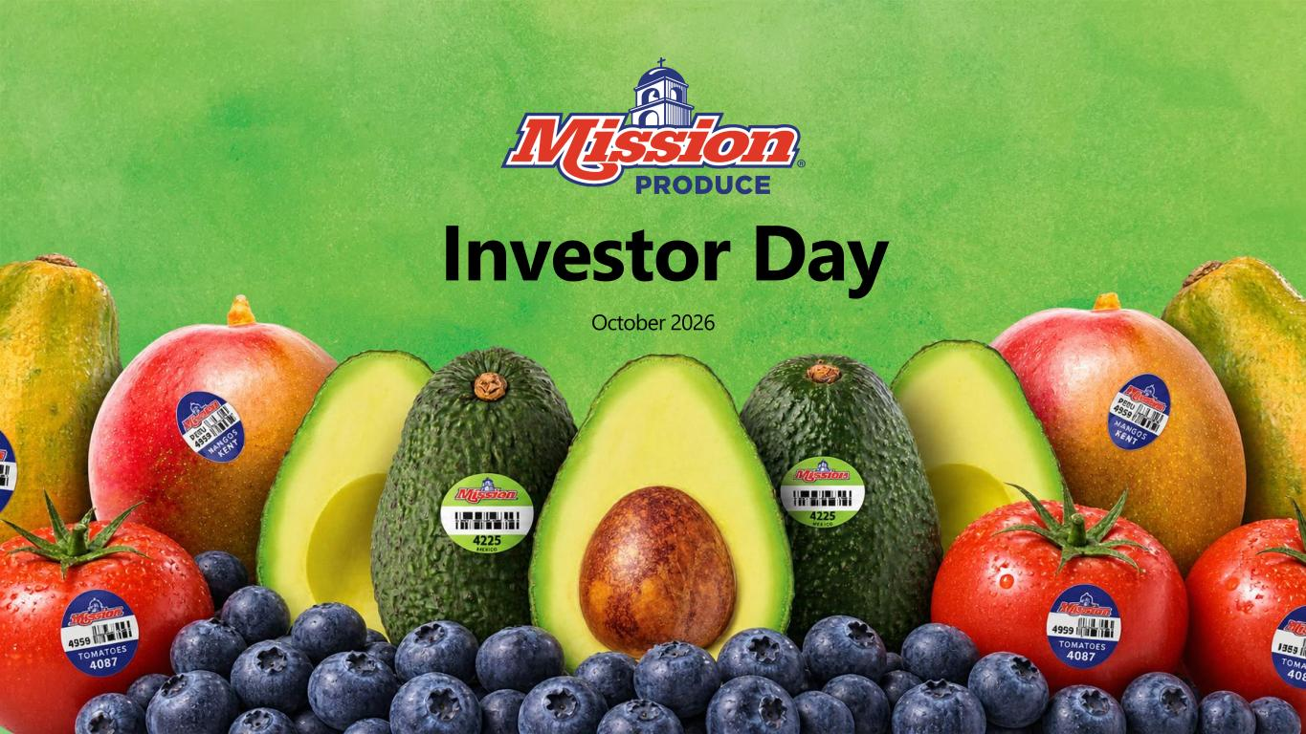

Investor Day October 2026

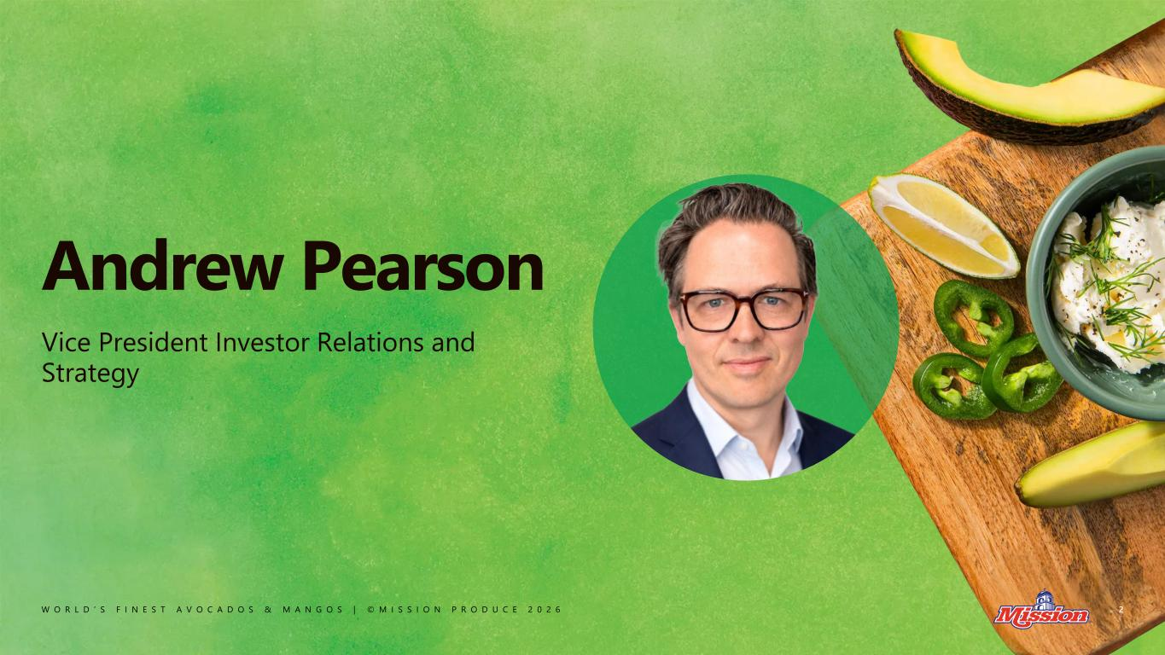
W O R L D ’ S F I N E S T A V O C A D O S & M A N G O S | © M I S S I O N P R O D U C E 2 0 2 6 Andrew Pearson 2 Vice President Investor Relations and Strategy

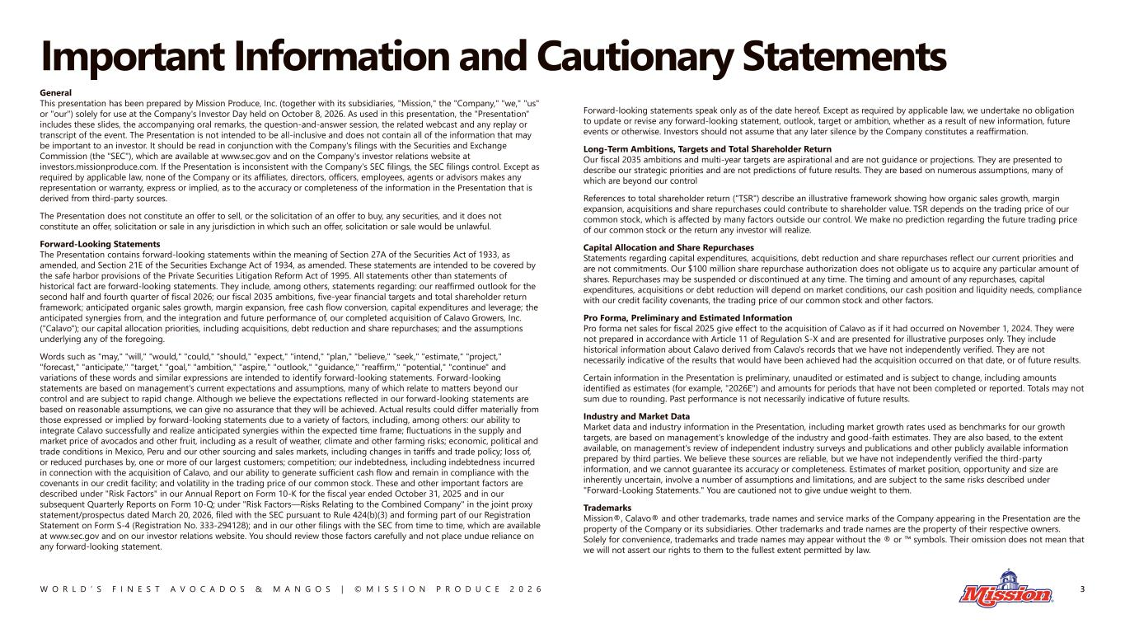
W O R L D ’ S F I N E S T A V O C A D O S & M A N G O S | © M I S S I O N P R O D U C E 2 0 2 6 Important Information and Cautionary Statements General This presentation has been prepared by Mission Produce, Inc. (together with its subsidiaries, "Mission," the "Company," "we," "us" or "our") solely for use at the Company's Investor Day held on October 8, 2026. As used in this presentation, the "Presentation" includes these slides, the accompanying oral remarks, the question-and-answer session, the related webcast and any replay or transcript of the event. The Presentation is not intended to be all-inclusive and does not contain all of the information that may be important to an investor. It should be read in conjunction with the Company's filings with the Securities and Exchange Commission (the "SEC"), which are available at www.sec.gov and on the Company's investor relations website at investors.missionproduce.com. If the Presentation is inconsistent with the Company's SEC filings, the SEC filings control. Except as required by applicable law, none of the Company or its affiliates, directors, officers, employees, agents or advisors makes any representation or warranty, express or implied, as to the accuracy or completeness of the information in the Presentation that is derived from third-party sources. The Presentation does not constitute an offer to sell, or the solicitation of an offer to buy, any securities, and it does not constitute an offer, solicitation or sale in any jurisdiction in which such an offer, solicitation or sale would be unlawful. Forward-Looking Statements The Presentation contains forward-looking statements within the meaning of Section 27A of the Securities Act of 1933, as amended, and Section 21E of the Securities Exchange Act of 1934, as amended. These statements are intended to be covered by the safe harbor provisions of the Private Securities Litigation Reform Act of 1995. All statements other than statements of historical fact are forward-looking statements. They include, among others, statements regarding: our reaffirmed outlook for the second half and fourth quarter of fiscal 2026; our fiscal 2035 ambitions, five-year financial targets and total shareholder return framework; anticipated organic sales growth, margin expansion, free cash flow conversion, capital expenditures and leverage; the anticipated synergies from, and the integration and future performance of, our completed acquisition of Calavo Growers, Inc. ("Calavo"); our capital allocation priorities, including acquisitions, debt reduction and share repurchases; and the assumptions underlying any of the foregoing. Words such as "may," "will," "would," "could," "should," "expect," "intend," "plan," "believe," "seek," "estimate," "project," "forecast," "anticipate," "target," "goal," "ambition," "aspire," "outlook," "guidance," "reaffirm," "potential," "continue" and variations of these words and similar expressions are intended to identify forward-looking statements. Forward-looking statements are based on management's current expectations and assumptions, many of which relate to matters beyond our control and are subject to rapid change. Although we believe the expectations reflected in our forward-looking statements are based on reasonable assumptions, we can give no assurance that they will be achieved. Actual results could differ materially from those expressed or implied by forward-looking statements due to a variety of factors, including, among others: our ability to integrate Calavo successfully and realize anticipated synergies within the expected time frame; fluctuations in the supply and market price of avocados and other fruit, including as a result of weather, climate and other farming risks; economic, political and trade conditions in Mexico, Peru and our other sourcing and sales markets, including changes in tariffs and trade policy; loss of, or reduced purchases by, one or more of our largest customers; competition; our indebtedness, including indebtedness incurred in connection with the acquisition of Calavo, and our ability to generate sufficient cash flow and remain in compliance with the covenants in our credit facility; and volatility in the trading price of our common stock. These and other important factors are described under "Risk Factors" in our Annual Report on Form 10-K for the fiscal year ended October 31, 2025 and in our subsequent Quarterly Reports on Form 10-Q; under "Risk Factors—Risks Relating to the Combined Company" in the joint proxy statement/prospectus dated March 20, 2026, filed with the SEC pursuant to Rule 424(b)(3) and forming part of our Registration Statement on Form S-4 (Registration No. 333-294128); and in our other filings with the SEC from time to time, which are available at www.sec.gov and on our investor relations website. You should review those factors carefully and not place undue reliance on any forward-looking statement. Forward-looking statements speak only as of the date hereof. Except as required by applicable law, we undertake no obligation to update or revise any forward-looking statement, outlook, target or ambition, whether as a result of new information, future events or otherwise. Investors should not assume that any later silence by the Company constitutes a reaffirmation. Long-Term Ambitions, Targets and Total Shareholder Return Our fiscal 2035 ambitions and multi-year targets are aspirational and are not guidance or projections. They are presented to describe our strategic priorities and are not predictions of future results. They are based on numerous assumptions, many of which are beyond our control References to total shareholder return ("TSR") describe an illustrative framework showing how organic sales growth, margin expansion, acquisitions and share repurchases could contribute to shareholder value. TSR depends on the trading price of our common stock, which is affected by many factors outside our control. We make no prediction regarding the future trading price of our common stock or the return any investor will realize. Capital Allocation and Share Repurchases Statements regarding capital expenditures, acquisitions, debt reduction and share repurchases reflect our current priorities and are not commitments. Our $100 million share repurchase authorization does not obligate us to acquire any particular amount of shares. Repurchases may be suspended or discontinued at any time. The timing and amount of any repurchases, capital expenditures, acquisitions or debt reduction will depend on market conditions, our cash position and liquidity needs, compliance with our credit facility covenants, the trading price of our common stock and other factors. Pro Forma, Preliminary and Estimated Information Pro forma net sales for fiscal 2025 give effect to the acquisition of Calavo as if it had occurred on November 1, 2024. They were not prepared in accordance with Article 11 of Regulation S-X and are presented for illustrative purposes only. They include historical information about Calavo derived from Calavo's records that we have not independently verified. They are not necessarily indicative of the results that would have been achieved had the acquisition occurred on that date, or of future results. Certain information in the Presentation is preliminary, unaudited or estimated and is subject to change, including amounts identified as estimates (for example, "2026E") and amounts for periods that have not been completed or reported. Totals may not sum due to rounding. Past performance is not necessarily indicative of future results. Industry and Market Data Market data and industry information in the Presentation, including market growth rates used as benchmarks for our growth targets, are based on management's knowledge of the industry and good-faith estimates. They are also based, to the extent available, on management's review of independent industry surveys and publications and other publicly available information prepared by third parties. We believe these sources are reliable, but we have not independently verified the third-party information, and we cannot guarantee its accuracy or completeness. Estimates of market position, opportunity and size are inherently uncertain, involve a number of assumptions and limitations, and are subject to the same risks described under "Forward-Looking Statements." You are cautioned not to give undue weight to them. Trademarks Mission®, Calavo® and other trademarks, trade names and service marks of the Company appearing in the Presentation are the property of the Company or its subsidiaries. Other trademarks and trade names are the property of their respective owners. Solely for convenience, trademarks and trade names may appear without the ® or symbols. Their omission does not mean that we will not assert our rights to them to the fullest extent permitted by law. 3

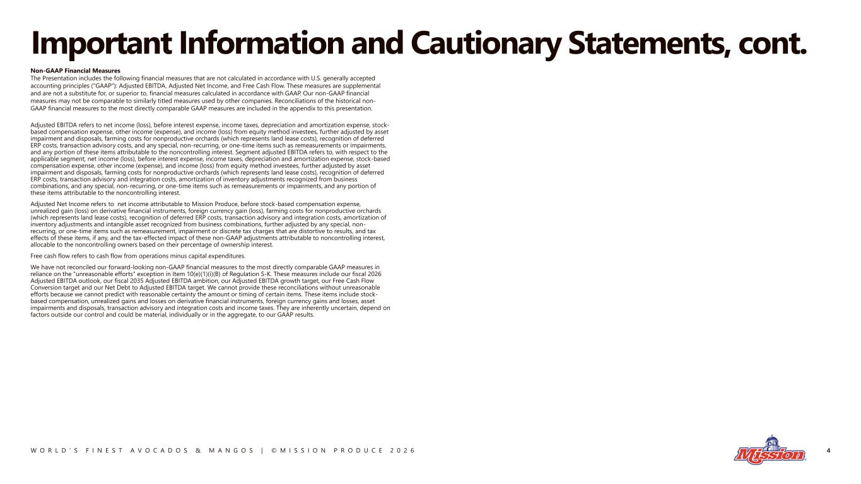
W O R L D ’ S F I N E S T A V O C A D O S & M A N G O S | © M I S S I O N P R O D U C E 2 0 2 6 Important Information and Cautionary Statements, cont. Non-GAAP Financial Measures The Presentation includes the following financial measures that are not calculated in accordance with U.S. generally accepted accounting principles ("GAAP"): Adjusted EBITDA, Adjusted Net Income, and Free Cash Flow. These measures are supplemental and are not a substitute for, or superior to, financial measures calculated in accordance with GAAP. Our non-GAAP financial measures may not be comparable to similarly titled measures used by other companies. Reconciliations of the historical non- GAAP financial measures to the most directly comparable GAAP measures are included in the appendix to this presentation. Adjusted EBITDA refers to net income (loss), before interest expense, income taxes, depreciation and amortization expense, stock- based compensation expense, other income (expense), and income (loss) from equity method investees, further adjusted by asset impairment and disposals, farming costs for nonproductive orchards (which represents land lease costs), recognition of deferred ERP costs, transaction advisory costs, and any special, non-recurring, or one-time items such as remeasurements or impairments, and any portion of these items attributable to the noncontrolling interest. Segment adjusted EBITDA refers to, with respect to the applicable segment, net income (loss), before interest expense, income taxes, depreciation and amortization expense, stock-based compensation expense, other income (expense), and income (loss) from equity method investees, further adjusted by asset impairment and disposals, farming costs for nonproductive orchards (which represents land lease costs), recognition of deferred ERP costs, transaction advisory and integration costs, amortization of inventory adjustments recognized from business combinations, and any special, non-recurring, or one-time items such as remeasurements or impairments, and any portion of these items attributable to the noncontrolling interest. Adjusted Net Income refers to net income attributable to Mission Produce, before stock-based compensation expense, unrealized gain (loss) on derivative financial instruments, foreign currency gain (loss), farming costs for nonproductive orchards (which represents land lease costs), recognition of deferred ERP costs, transaction advisory and integration costs, amortization of inventory adjustments and intangible asset recognized from business combinations, further adjusted by any special, non- recurring, or one-time items such as remeasurement, impairment or discrete tax charges that are distortive to results, and tax effects of these items, if any, and the tax-effected impact of these non-GAAP adjustments attributable to noncontrolling interest, allocable to the noncontrolling owners based on their percentage of ownership interest. Free cash flow refers to cash flow from operations minus capital expenditures. We have not reconciled our forward-looking non-GAAP financial measures to the most directly comparable GAAP measures in reliance on the "unreasonable efforts" exception in Item 10(e)(1)(i)(B) of Regulation S-K. These measures include our fiscal 2026 Adjusted EBITDA outlook, our fiscal 2035 Adjusted EBITDA ambition, our Adjusted EBITDA growth target, our Free Cash Flow Conversion target and our Net Debt to Adjusted EBITDA target. We cannot provide these reconciliations without unreasonable efforts because we cannot predict with reasonable certainty the amount or timing of certain items. These items include stock- based compensation, unrealized gains and losses on derivative financial instruments, foreign currency gains and losses, asset impairments and disposals, transaction advisory and integration costs and income taxes. They are inherently uncertain, depend on factors outside our control and could be material, individually or in the aggregate, to our GAAP results. 4

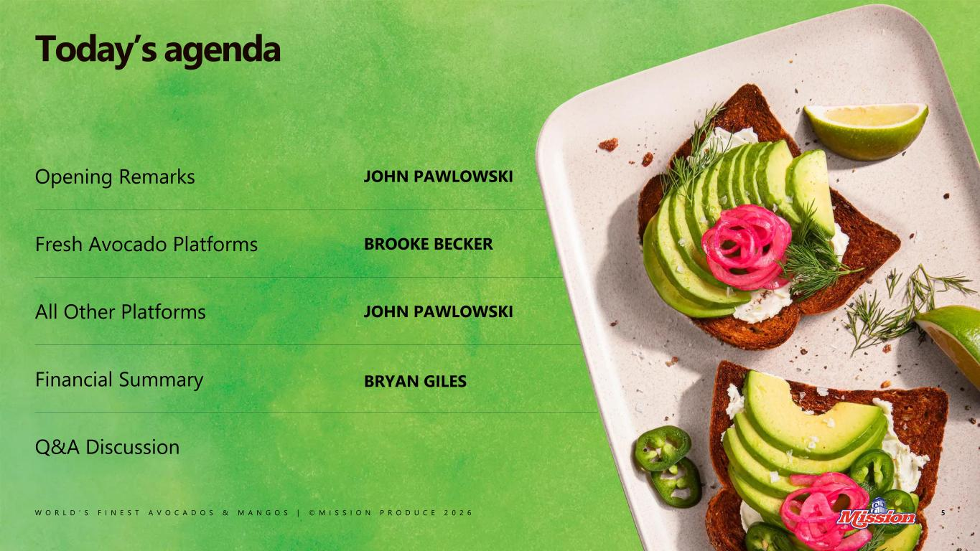
W O R L D ’ S F I N E S T A V O C A D O S & M A N G O S | © M I S S I O N P R O D U C E 2 0 2 6 Opening Remarks JOHN PAWLOWSKI Fresh Avocado Platforms BROOKE BECKER All Other Platforms JOHN PAWLOWSKI Financial Summary BRYAN GILES Q&A Discussion 5 Today’s agenda

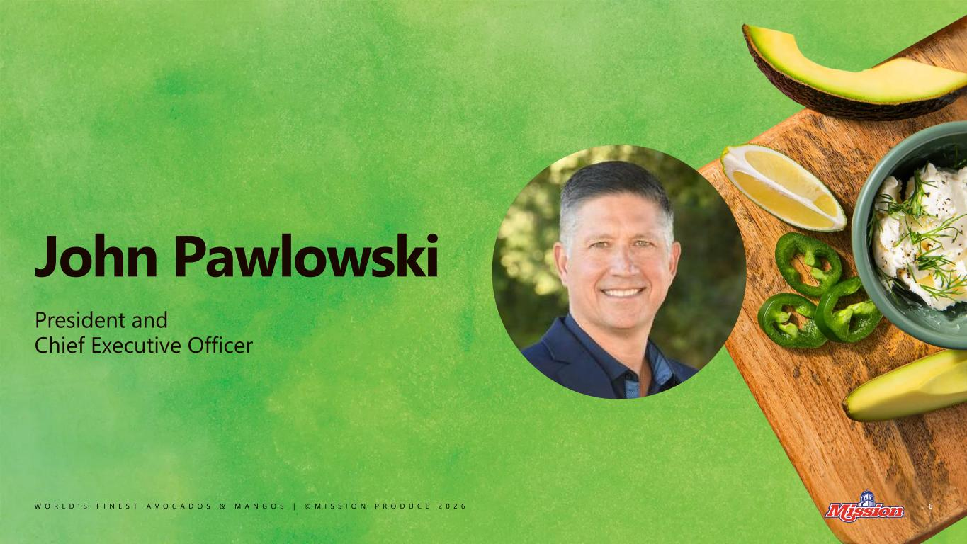
W O R L D ’ S F I N E S T A V O C A D O S & M A N G O S | © M I S S I O N P R O D U C E 2 0 2 6 John Pawlowski 6 President and Chief Executive Officer

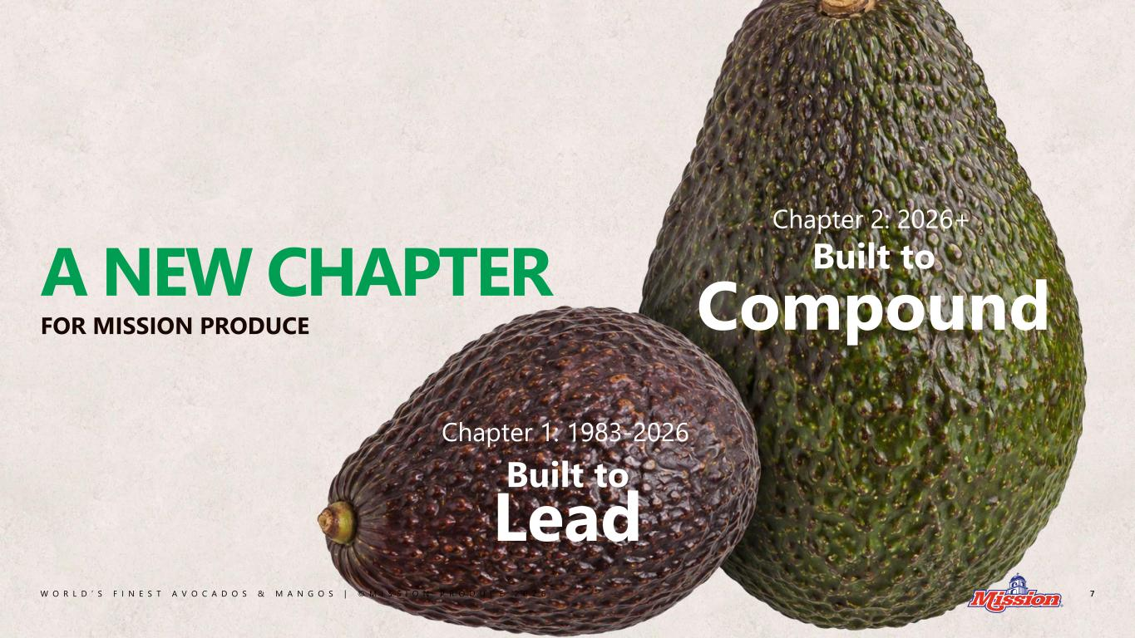
W O R L D ’ S F I N E S T A V O C A D O S & M A N G O S | © M I S S I O N P R O D U C E 2 0 2 6 7 A NEW CHAPTER FOR MISSION PRODUCE Built to Compound Chapter 2: 2026+ Built to Lead Chapter 1: 1983-2026


W O R L D ’ S F I N E S T A V O C A D O S & M A N G O S | © M I S S I O N P R O D U C E 2 0 2 6 CHAPTER 1 Built to Lead 8

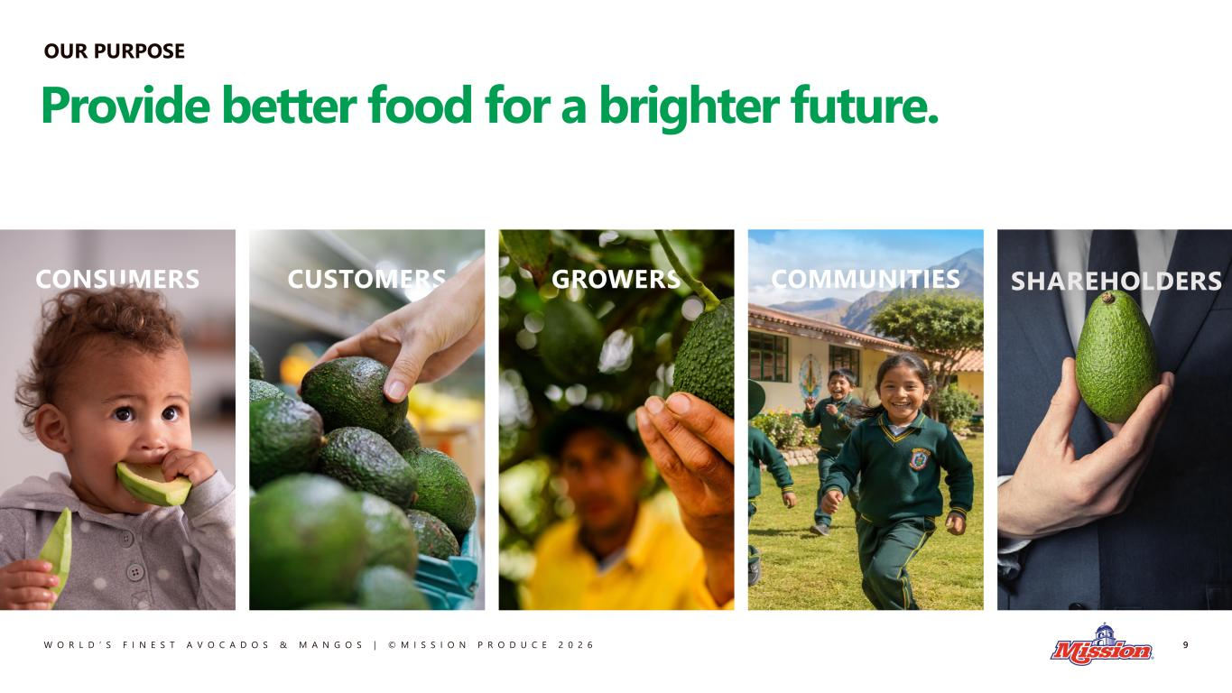
W O R L D ’ S F I N E S T A V O C A D O S & M A N G O S | © M I S S I O N P R O D U C E 2 0 2 6 OUR PURPOSE 9 Provide better food for a brighter future.

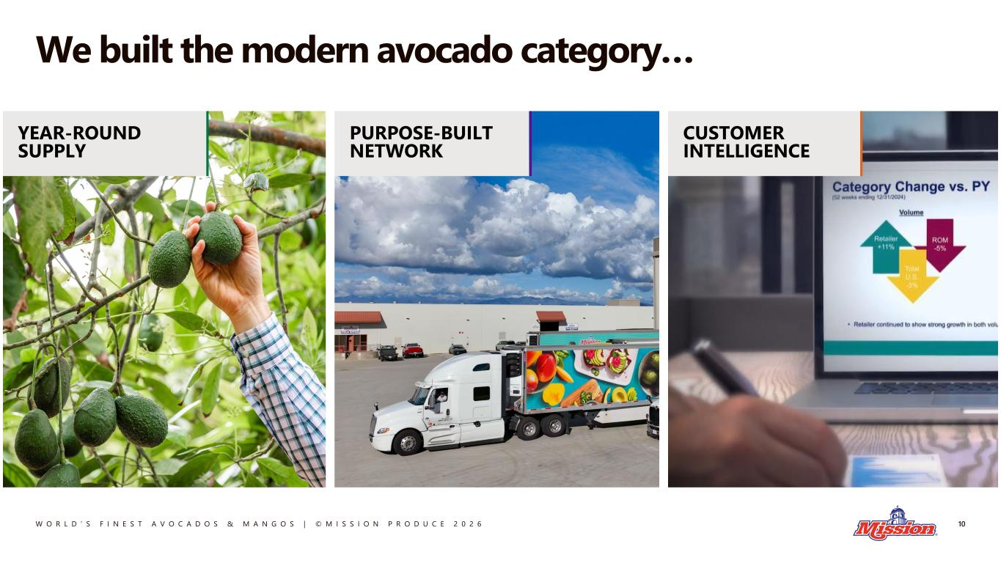
W O R L D ’ S F I N E S T A V O C A D O S & M A N G O S | © M I S S I O N P R O D U C E 2 0 2 6 We built the modern avocado category… 10 YEAR-ROUND SUPPLY PURPOSE-BUILT NETWORK CUSTOMER INTELLIGENCE

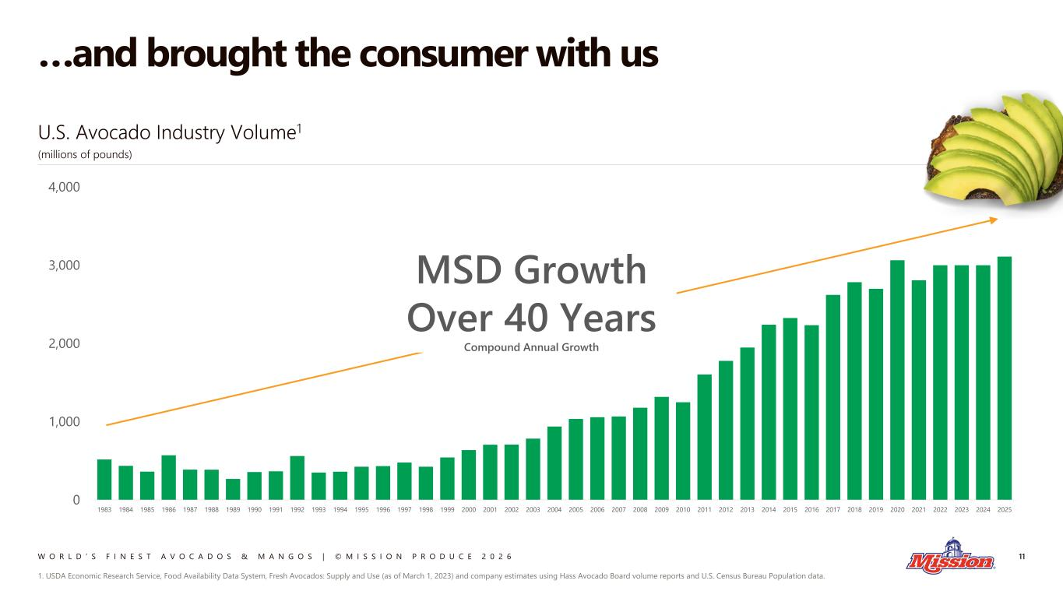
W O R L D ’ S F I N E S T A V O C A D O S & M A N G O S | © M I S S I O N P R O D U C E 2 0 2 6 …and brought the consumer with us 11 0 1,000 2,000 3,000 4,000 1983 1984 1985 1986 1987 1988 1989 1990 1991 1992 1993 1994 1995 1996 1997 1998 1999 2000 2001 2002 2003 2004 2005 2006 2007 2008 2009 2010 2011 2012 2013 2014 2015 2016 2017 2018 2019 2020 2021 2022 2023 2024 2025 U.S. Avocado Industry Volume1 (millions of pounds) MSD Growth Over 40 Years Compound Annual Growth 1. USDA Economic Research Service, Food Availability Data System, Fresh Avocados: Supply and Use (as of March 1, 2023) and company estimates using Hass Avocado Board volume reports and U.S. Census Bureau Population data.

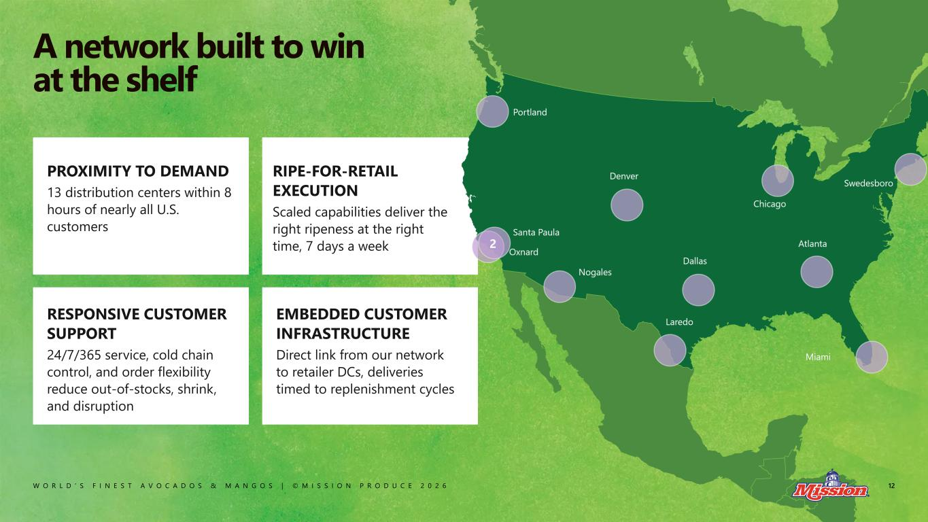
W O R L D ’ S F I N E S T A V O C A D O S & M A N G O S | © M I S S I O N P R O D U C E 2 0 2 6 PROXIMITY TO DEMAND 13 distribution centers within 8 hours of nearly all U.S. customers RIPE-FOR-RETAIL EXECUTION Scaled capabilities deliver the right ripeness at the right time, 7 days a week RESPONSIVE CUSTOMER SUPPORT 24/7/365 service, cold chain control, and order flexibility reduce out-of-stocks, shrink, and disruption EMBEDDED CUSTOMER INFRASTRUCTURE Direct link from our network to retailer DCs, deliveries timed to replenishment cycles 12 A network built to win at the shelf

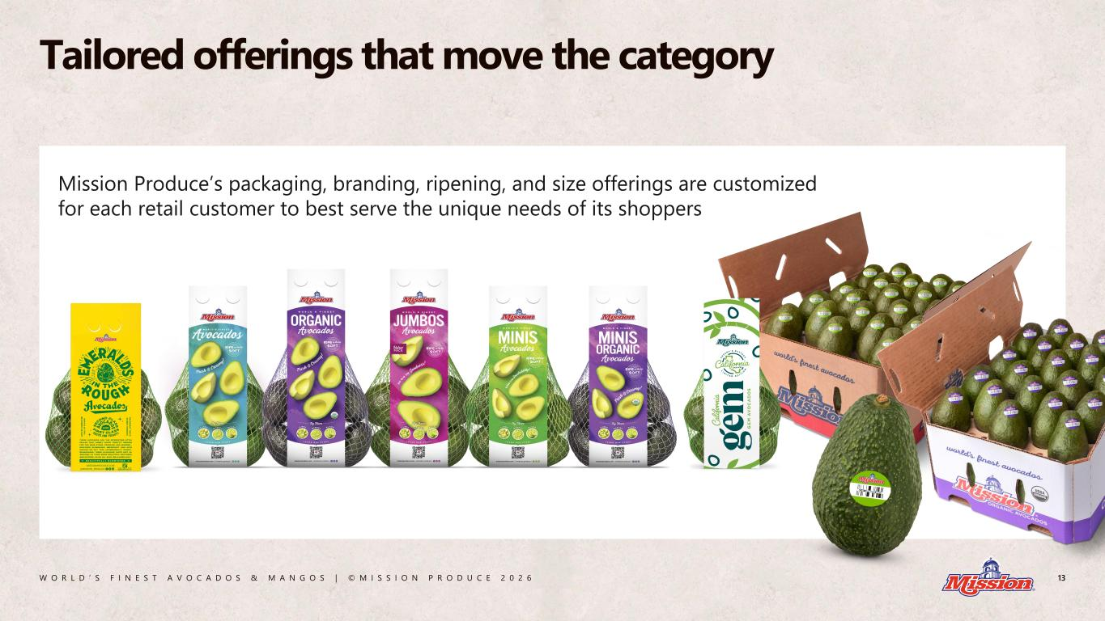
W O R L D ’ S F I N E S T A V O C A D O S & M A N G O S | © M I S S I O N P R O D U C E 2 0 2 6 13 Tailored offerings that move the category Mission Produce’s packaging, branding, ripening, and size offerings are customized for each retail customer to best serve the unique needs of its shoppers

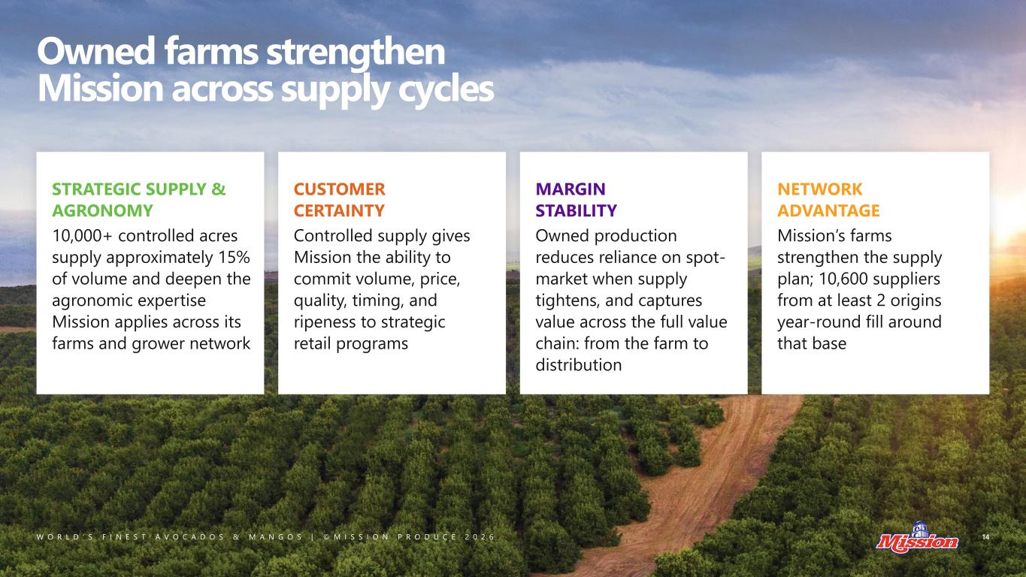
W O R L D ’ S F I N E S T A V O C A D O S & M A N G O S | © M I S S I O N P R O D U C E 2 0 2 6 14 Owned farms strengthen Mission across supply cycles STRATEGIC SUPPLY & AGRONOMY 10,000+ controlled acres supply approximately 15% of volume and deepen the agronomic expertise Mission applies across its farms and grower network CUSTOMER CERTAINTY Controlled supply gives Mission the ability to commit volume, price, quality, timing, and ripeness to strategic retail programs MARGIN STABILITY Owned production reduces reliance on spot- market when supply tightens, and captures value across the full value chain: from the farm to distribution NETWORK ADVANTAGE Mission’s farms strengthen the supply plan; 10,600 suppliers from at least 2 origins year-round fill around that base

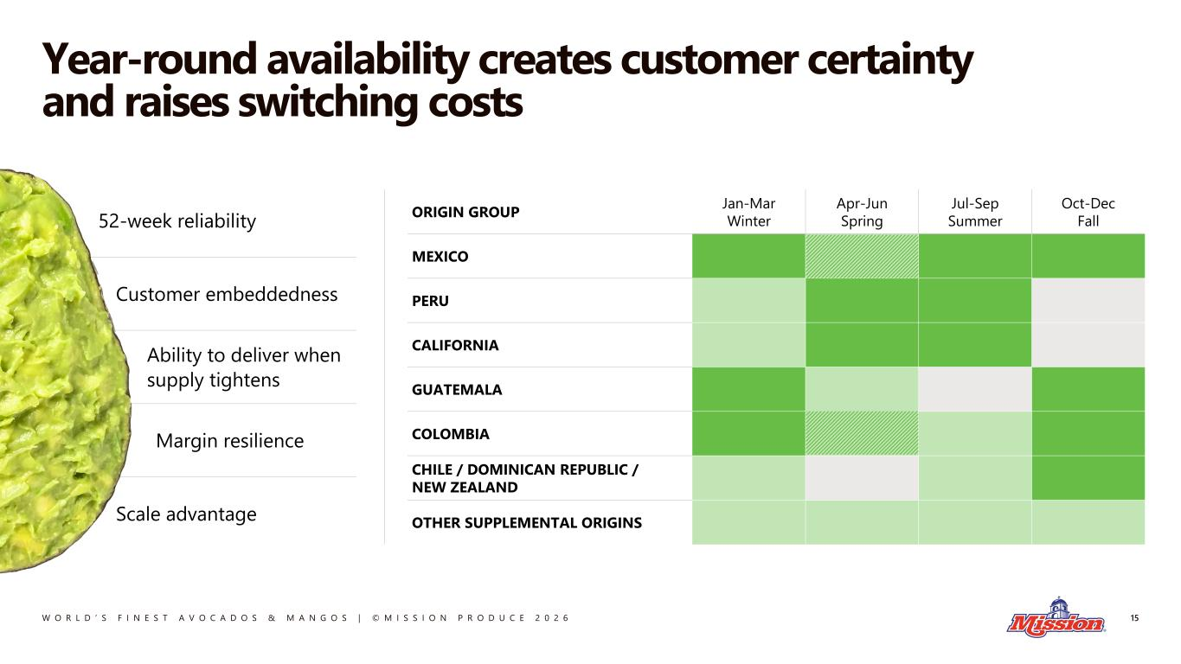
W O R L D ’ S F I N E S T A V O C A D O S & M A N G O S | © M I S S I O N P R O D U C E 2 0 2 6 52-week reliability Customer embeddedness Ability to deliver when supply tightens Margin resilience Scale advantage Year-round availability creates customer certainty and raises switching costs 15 ORIGIN GROUP Jan-Mar Winter Apr-Jun Spring Jul-Sep Summer Oct-Dec Fall MEXICO PERU CALIFORNIA GUATEMALA COLOMBIA CHILE / DOMINICAN REPUBLIC / NEW ZEALAND OTHER SUPPLEMENTAL ORIGINS

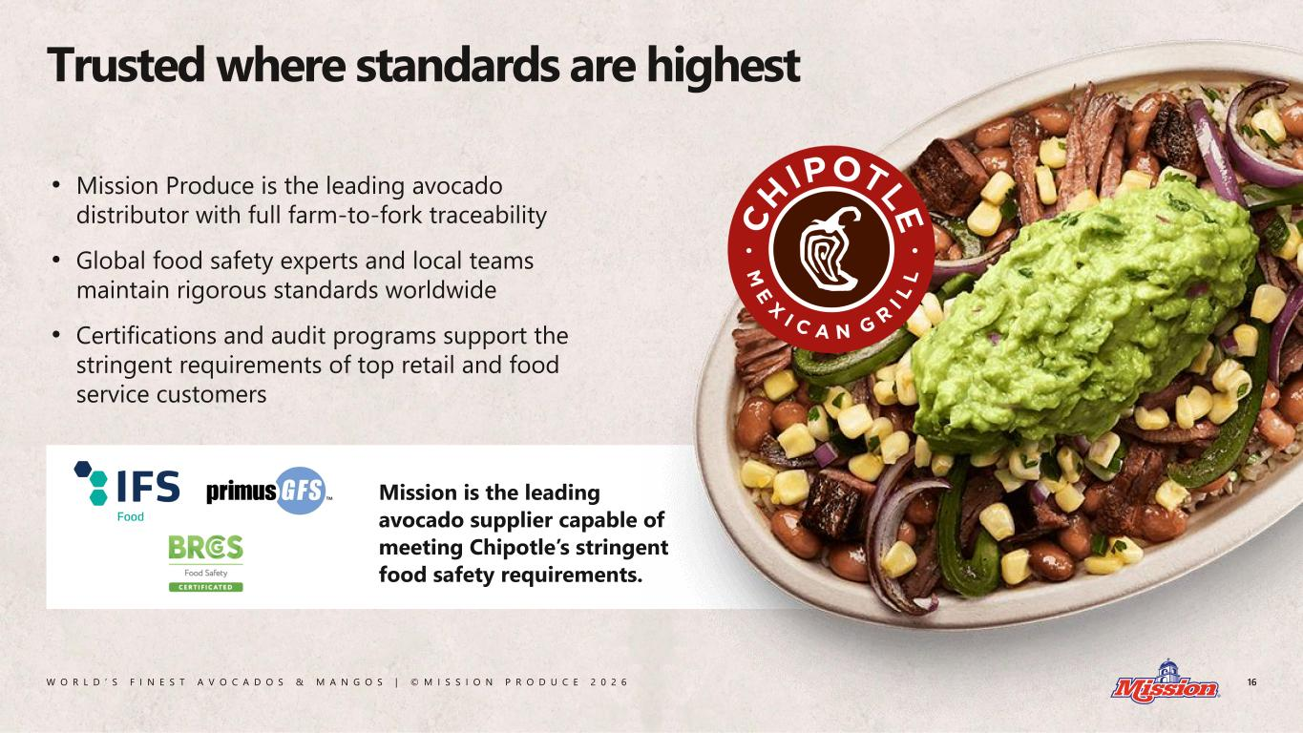
W O R L D ’ S F I N E S T A V O C A D O S & M A N G O S | © M I S S I O N P R O D U C E 2 0 2 6 Mission is the leading avocado supplier capable of meeting Chipotle’s stringent food safety requirements. Trusted where standards are highest 16 • Mission Produce is the leading avocado distributor with full farm-to-fork traceability • Global food safety experts and local teams maintain rigorous standards worldwide • Certifications and audit programs support the stringent requirements of top retail and food service customers

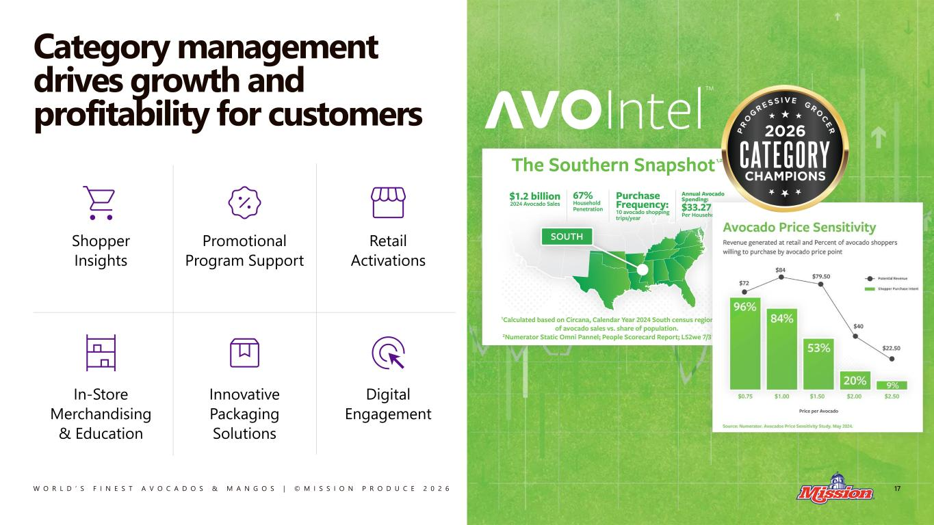
W O R L D ’ S F I N E S T A V O C A D O S & M A N G O S | © M I S S I O N P R O D U C E 2 0 2 6 Category management drives growth and profitability for customers 17 Shopper Insights Promotional Program Support Retail Activations In-Store Merchandising & Education Innovative Packaging Solutions Digital Engagement

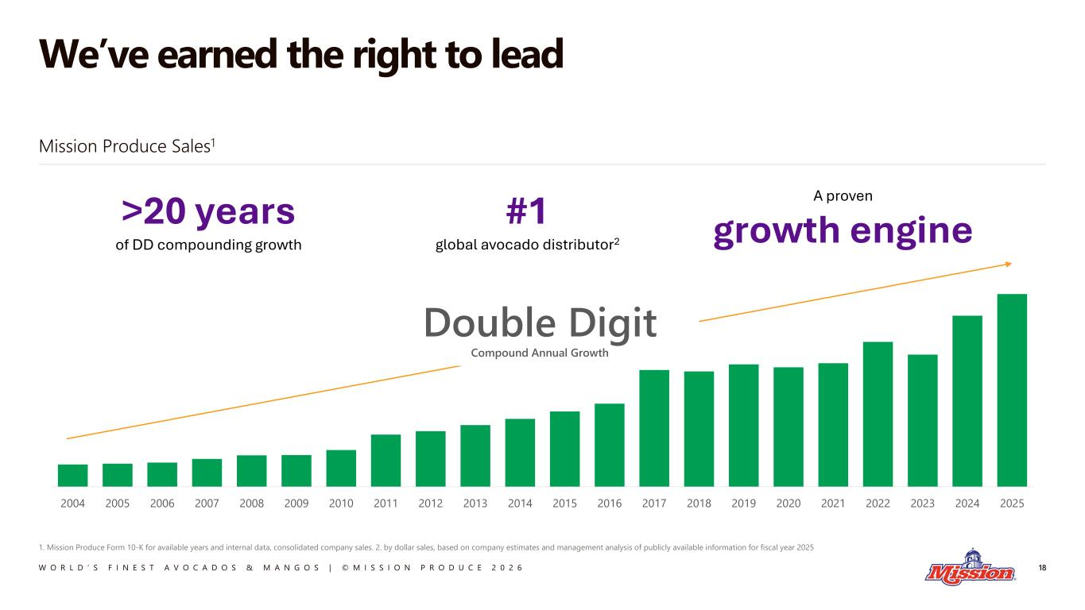
W O R L D ’ S F I N E S T A V O C A D O S & M A N G O S | © M I S S I O N P R O D U C E 2 0 2 6 We’ve earned the right to lead 18 2004 2005 2006 2007 2008 2009 2010 2011 2012 2013 2014 2015 2016 2017 2018 2019 2020 2021 2022 2023 2024 2025 Double Digit Compound Annual Growth >20 years of DD compounding growth #1 global avocado distributor2 A proven growth engine Mission Produce Sales1 1. Mission Produce Form 10-K for available years and internal data, consolidated company sales. 2. by dollar sales, based on company estimates and management analysis of publicly available information for fiscal year 2025


W O R L D ’ S F I N E S T A V O C A D O S & M A N G O S | © M I S S I O N P R O D U C E 2 0 2 6 19 Built to Compound Chapter 2

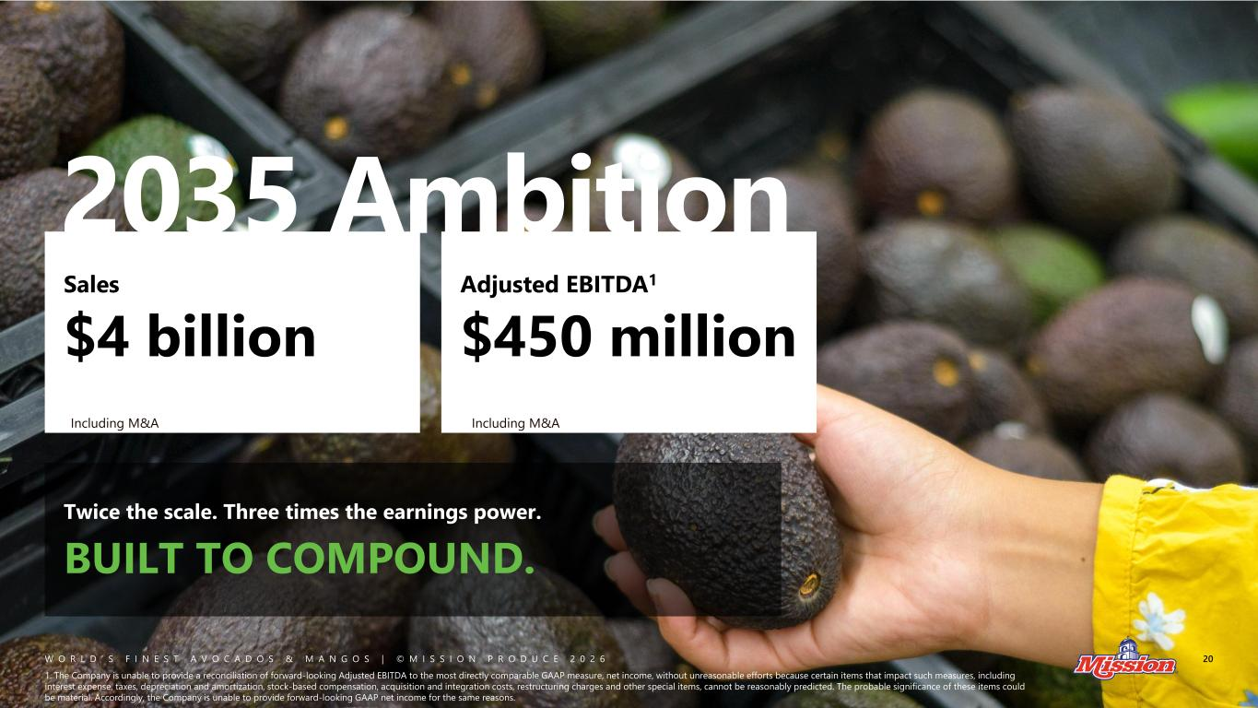
W O R L D ’ S F I N E S T A V O C A D O S & M A N G O S | © M I S S I O N P R O D U C E 2 0 2 6 Twice the scale. Three times the earnings power. BUILT TO COMPOUND. 2035 Ambition Sales $4 billion Adjusted EBITDA1 $450 million 20 1. The Company is unable to provide a reconciliation of forward-looking Adjusted EBITDA to the most directly comparable GAAP measure, net income, without unreasonable efforts because certain items that impact such measures, including interest expense, taxes, depreciation and amortization, stock-based compensation, acquisition and integration costs, restructuring charges and other special items, cannot be reasonably predicted. The probable significance of these items could be material. Accordingly, the Company is unable to provide forward-looking GAAP net income for the same reasons. Including M&A Including M&A

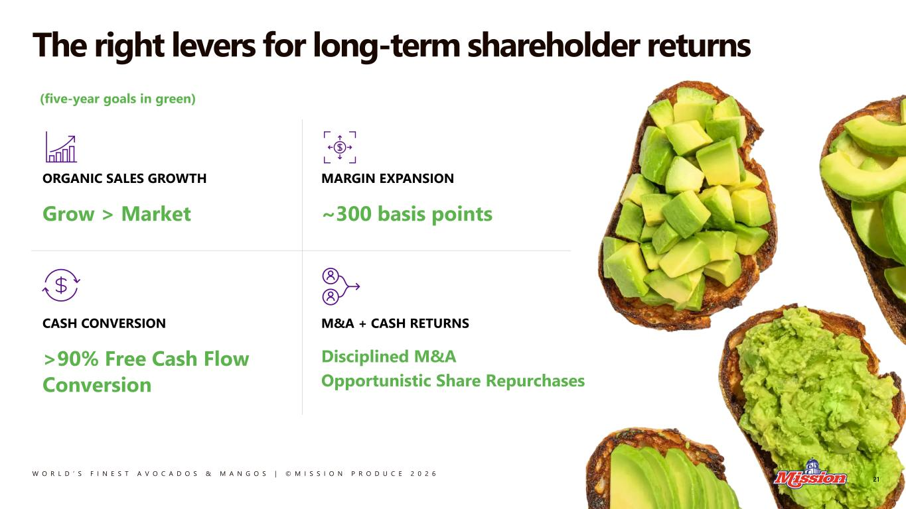
W O R L D ’ S F I N E S T A V O C A D O S & M A N G O S | © M I S S I O N P R O D U C E 2 0 2 6 ORGANIC SALES GROWTH Grow > Market MARGIN EXPANSION ~300 basis points CASH CONVERSION >90% Free Cash Flow Conversion M&A + CASH RETURNS Disciplined M&A Opportunistic Share Repurchases The right levers for long-term shareholder returns 21 (five-year goals in green) 21


W O R L D ’ S F I N E S T A V O C A D O S & M A N G O S | © M I S S I O N P R O D U C E 2 0 2 6 22 The right team is in place Andrew Pearson VP, IR & Strategy Joanne Wu Chief Legal Officer Bryan Giles CFO Damian Ricketts CAO Keith Barnard SVP, Global Sourcing Brooke Becker SVP, Sales & Marketing Simón Gonzales SVP, International Farming Anita Lemos Chief of Staff Frank Briseño VP, Operations Paul Frowde Managing Director, UK & Europe Ani Khachatoorian VP, HR John Pawlowski President & CEO

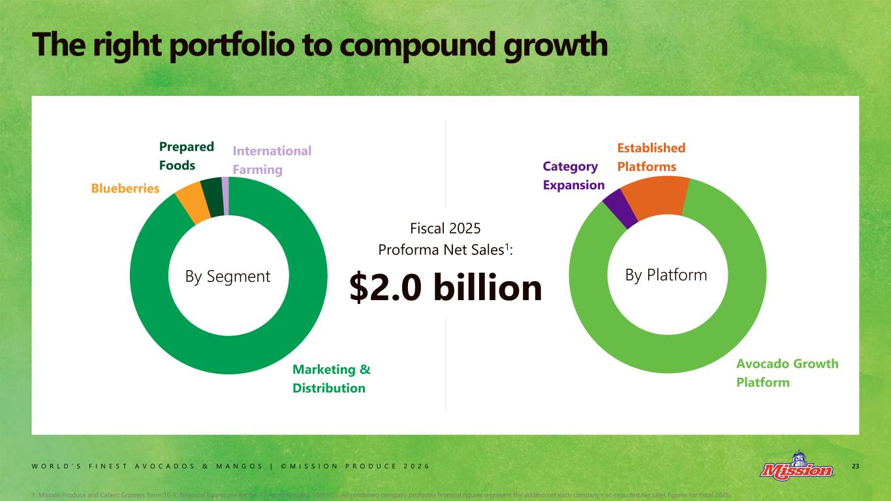
W O R L D ’ S F I N E S T A V O C A D O S & M A N G O S | © M I S S I O N P R O D U C E 2 0 2 6 23 The right portfolio to compound growth By Segment Fiscal 2025 Proforma Net Sales1: $2.0 billion Marketing & Distribution Blueberries Prepared Foods International Farming Avocado Growth Platform Category Expansion Established Platforms By Platform 1. Mission Produce and Calavo Growers Form 10-K; Financial figures are for the 12 months ended 10/31/25. All combined company proforma financial figures represent the addition of each company's as-reported net sales figures for fiscal 2025.

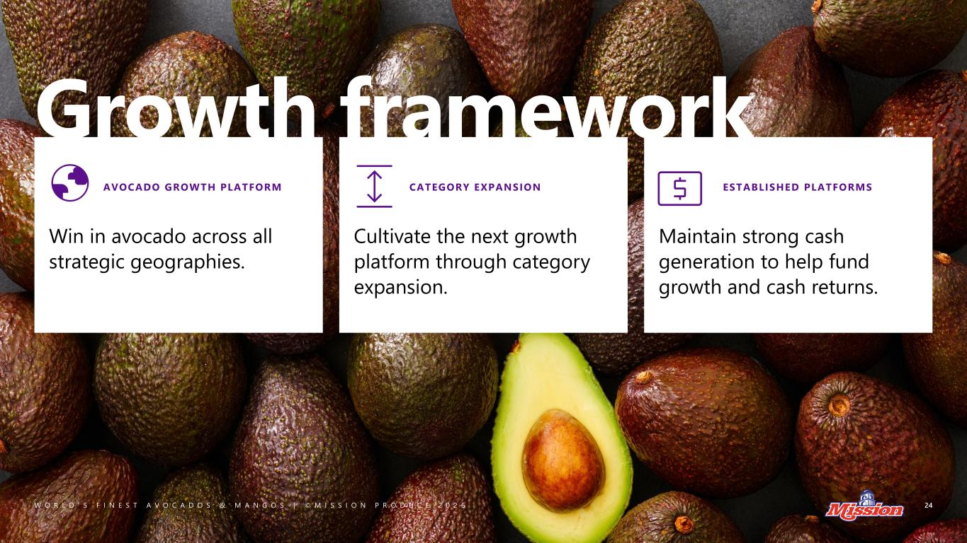
W O R L D ’ S F I N E S T A V O C A D O S & M A N G O S | © M I S S I O N P R O D U C E 2 0 2 6 Growth framework 24 Win in avocado across all strategic geographies. Cultivate the next growth platform through category expansion. Maintain strong cash generation to help fund growth and cash returns. AVOCADO GROWTH PLATFORM CATEGORY EXPANSION ESTABLISHED PLATFORMS

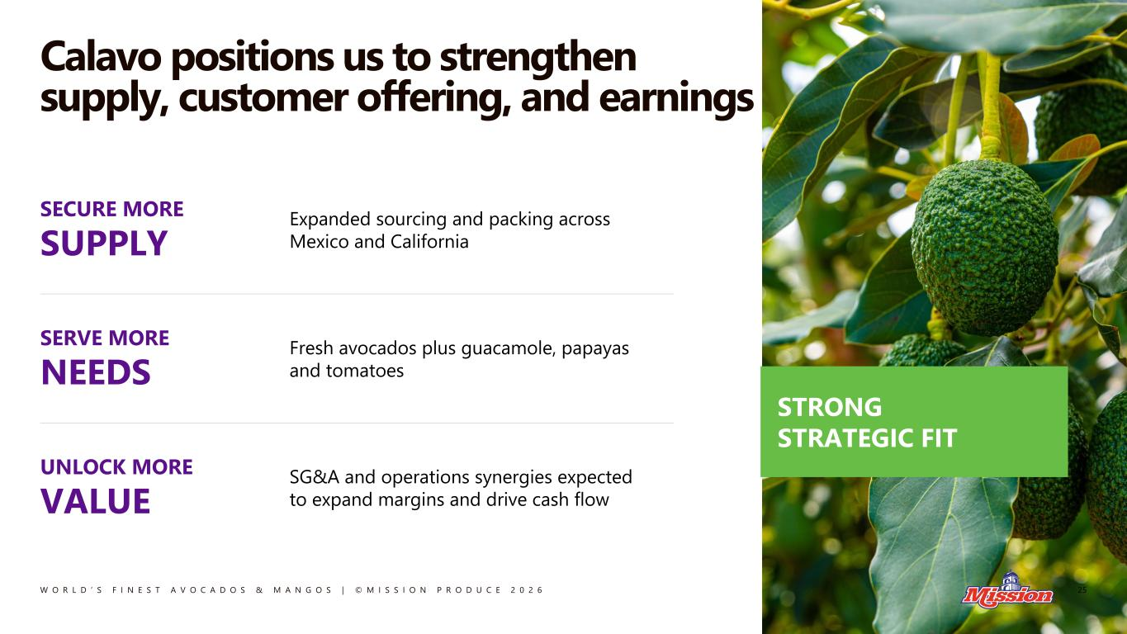
W O R L D ’ S F I N E S T A V O C A D O S & M A N G O S | © M I S S I O N P R O D U C E 2 0 2 6 Calavo positions us to strengthen supply, customer offering, and earnings 25 STRONG STRATEGIC FIT SECURE MORE SUPPLY Expanded sourcing and packing across Mexico and California SERVE MORE NEEDS Fresh avocados plus guacamole, papayas and tomatoes UNLOCK MORE VALUE SG&A and operations synergies expected to expand margins and drive cash flow

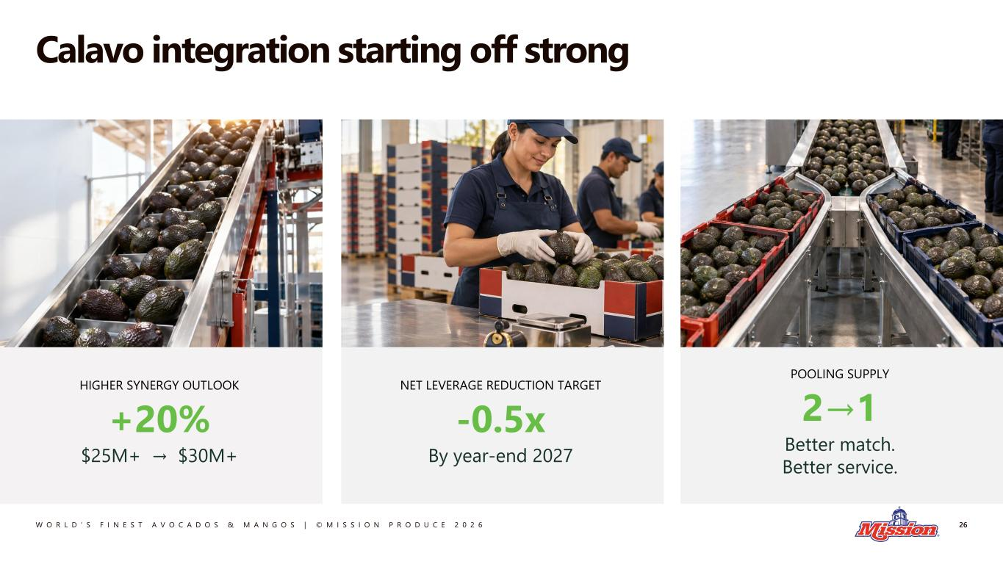
W O R L D ’ S F I N E S T A V O C A D O S & M A N G O S | © M I S S I O N P R O D U C E 2 0 2 6 Calavo integration starting off strong 26 POOLING SUPPLY 2→1 Better match. Better service. HIGHER SYNERGY OUTLOOK +20% $25M+ → $30M+ NET LEVERAGE REDUCTION TARGET -0.5x By year-end 2027

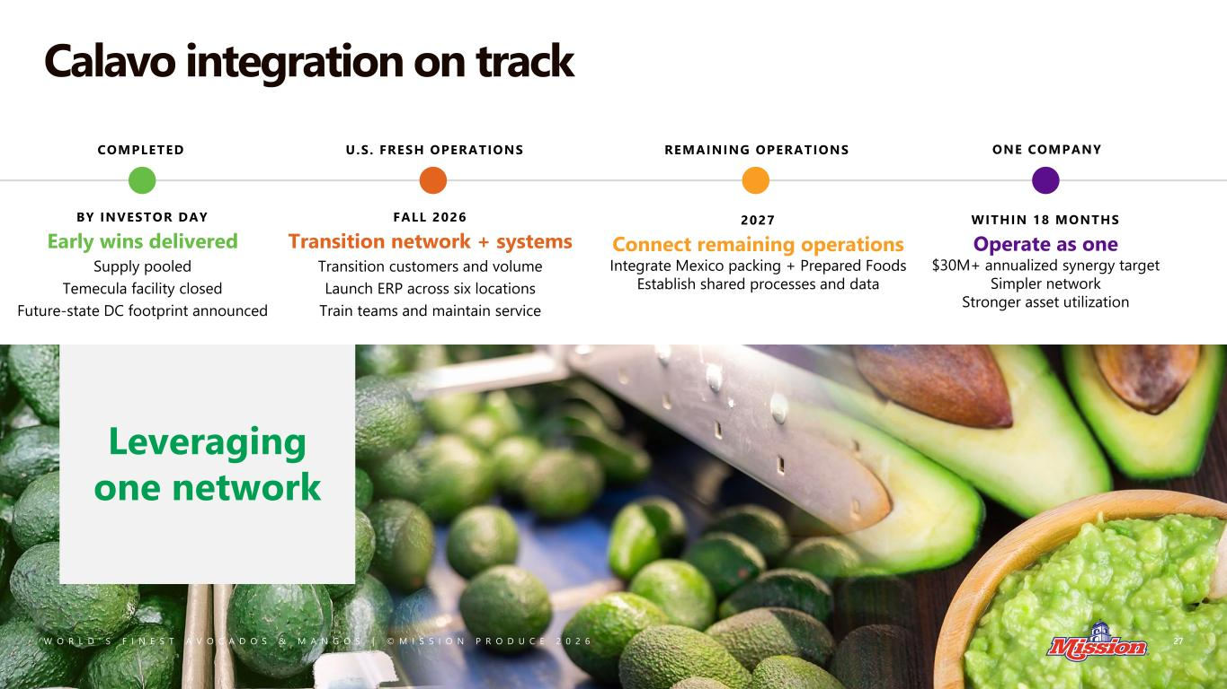
W O R L D ’ S F I N E S T A V O C A D O S & M A N G O S | © M I S S I O N P R O D U C E 2 0 2 6 Calavo integration on track 27 \ COMPLETED BY INVESTOR DAY Early wins delivered Supply pooled Temecula facility closed Future-state DC footprint announced Leveraging one network U.S. FRESH OPERATIONS FALL 2026 Transition network + systems Transition customers and volume Launch ERP across six locations Train teams and maintain service REMAINING OPERATIONS 2027 Connect remaining operations Integrate Mexico packing + Prepared Foods Establish shared processes and data ONE COMPANY WITHIN 18 MONTHS Operate as one $30M+ annualized synergy target Simpler network Stronger asset utilization

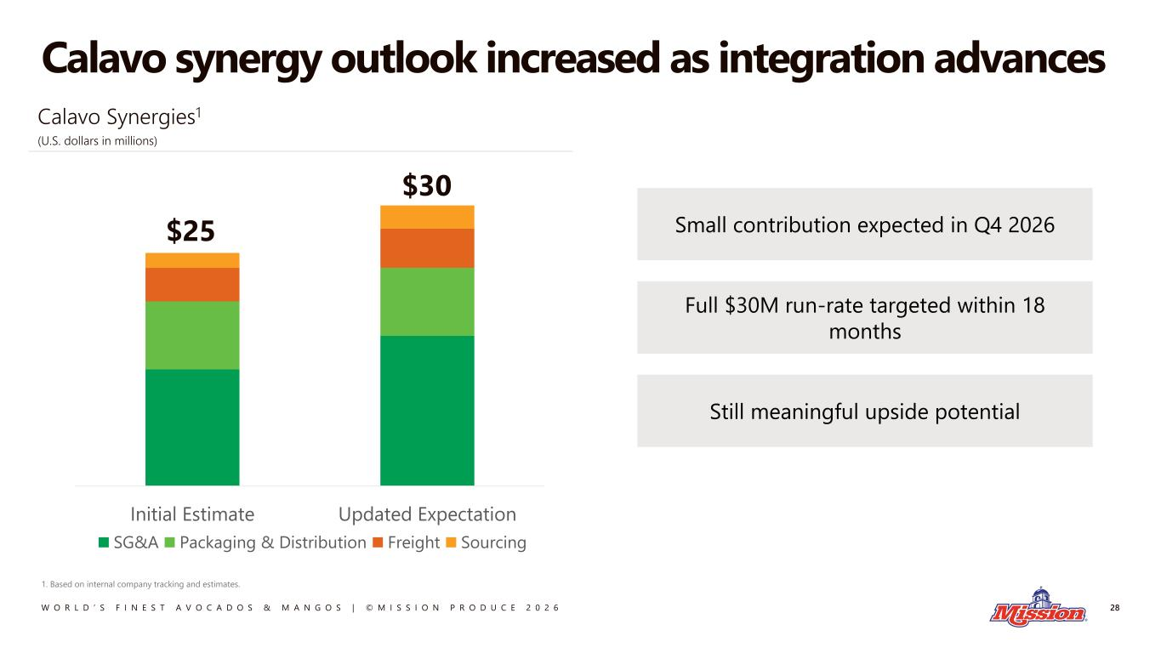
W O R L D ’ S F I N E S T A V O C A D O S & M A N G O S | © M I S S I O N P R O D U C E 2 0 2 6 Calavo synergy outlook increased as integration advances 28 1. Based on internal company tracking and estimates. $25 $30 Initial Estimate Updated Expectation SG&A Packaging & Distribution Freight Sourcing Small contribution expected in Q4 2026 Full $30M run-rate targeted within 18 months Still meaningful upside potential Calavo Synergies1 (U.S. dollars in millions)

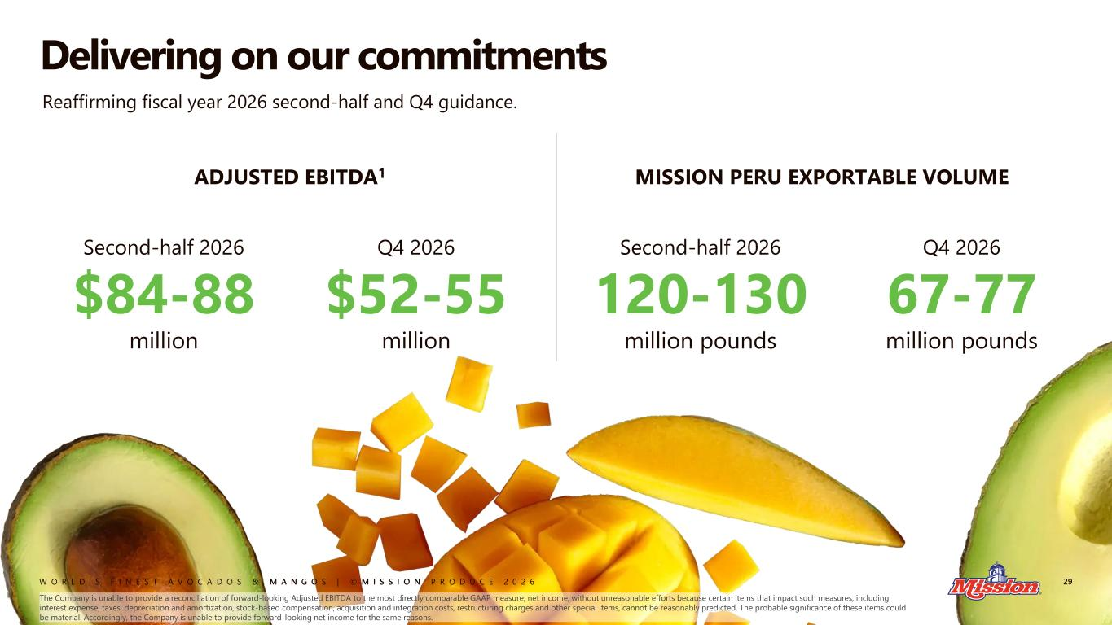
W O R L D ’ S F I N E S T A V O C A D O S & M A N G O S | © M I S S I O N P R O D U C E 2 0 2 6 ADJUSTED EBITDA1 Delivering on our commitments 29 Second-half 2026 $84-88 million Q4 2026 $52-55 million MISSION PERU EXPORTABLE VOLUME Second-half 2026 120-130 million pounds Q4 2026 67-77 million pounds The Company is unable to provide a reconciliation of forward-looking Adjusted EBITDA to the most directly comparable GAAP measure, net income, without unreasonable efforts because certain items that impact such measures, including interest expense, taxes, depreciation and amortization, stock-based compensation, acquisition and integration costs, restructuring charges and other special items, cannot be reasonably predicted. The probable significance of these items could be material. Accordingly, the Company is unable to provide forward-looking net income for the same reasons. Reaffirming fiscal year 2026 second-half and Q4 guidance.


W O R L D ’ S F I N E S T A V O C A D O S & M A N G O S | © M I S S I O N P R O D U C E 2 0 2 6 Brooke Becker 30 Senior Vice President Sales and Marketing

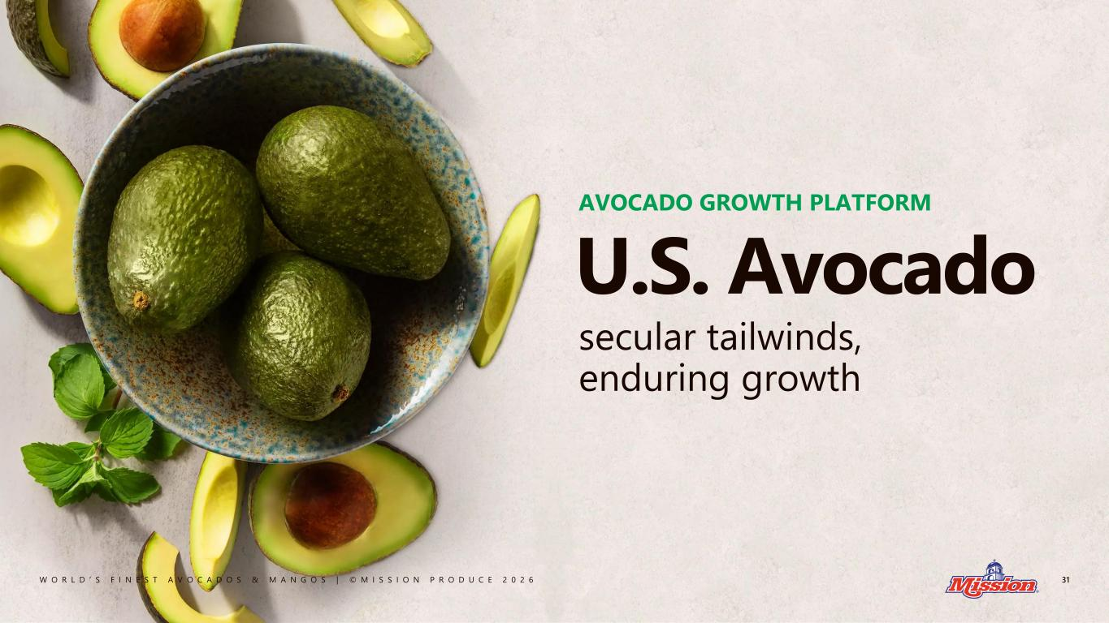
W O R L D ’ S F I N E S T A V O C A D O S & M A N G O S | © M I S S I O N P R O D U C E 2 0 2 6 31 U.S. Avocado AVOCADO GROWTH PLATFORM secular tailwinds, enduring growth

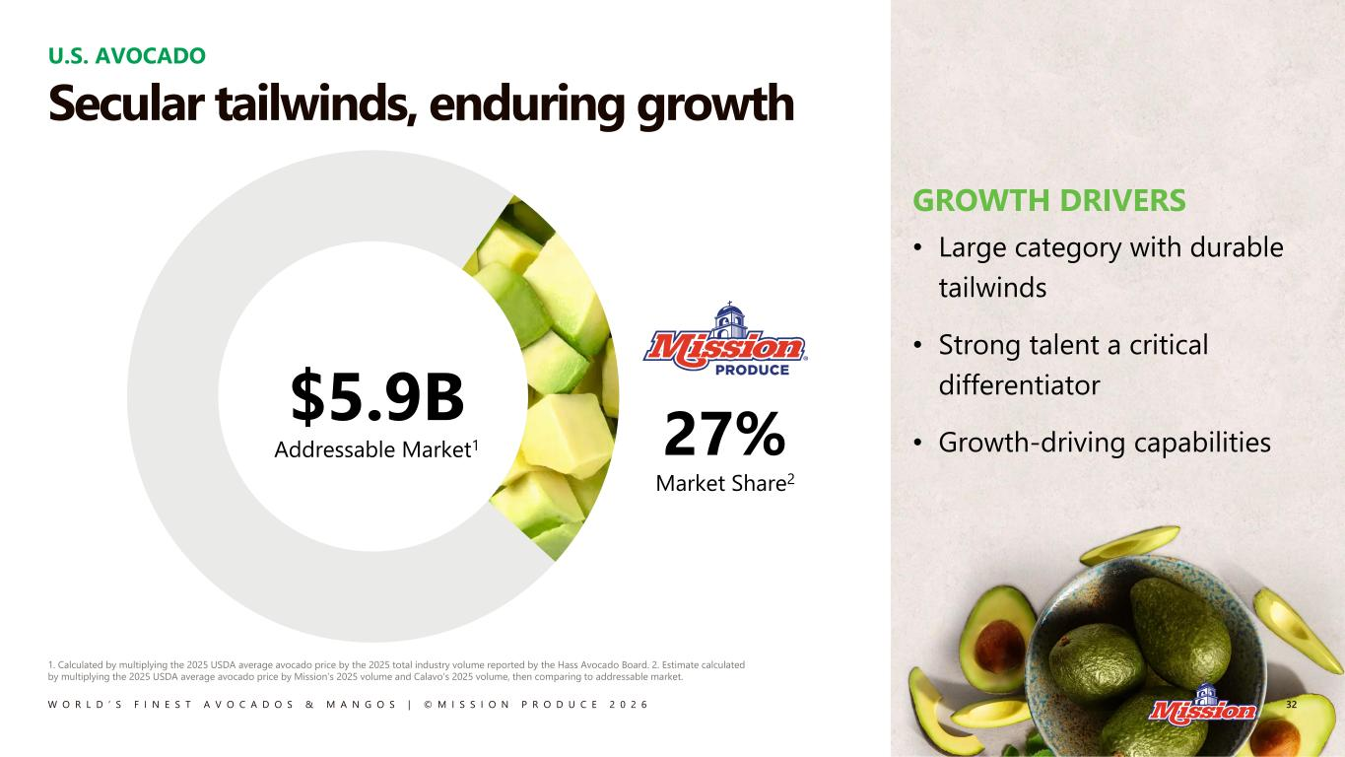
W O R L D ’ S F I N E S T A V O C A D O S & M A N G O S | © M I S S I O N P R O D U C E 2 0 2 6 U.S. AVOCADO 1. Calculated by multiplying the 2025 USDA average avocado price by the 2025 total industry volume reported by the Hass Avocado Board. 2. Estimate calculated by multiplying the 2025 USDA average avocado price by Mission’s 2025 volume and Calavo’s 2025 volume, then comparing to addressable market. GROWTH DRIVERS • Large category with durable tailwinds • Strong talent a critical differentiator • Growth-driving capabilities27% Market Share2 32 Secular tailwinds, enduring growth $5.9B Addressable Market1

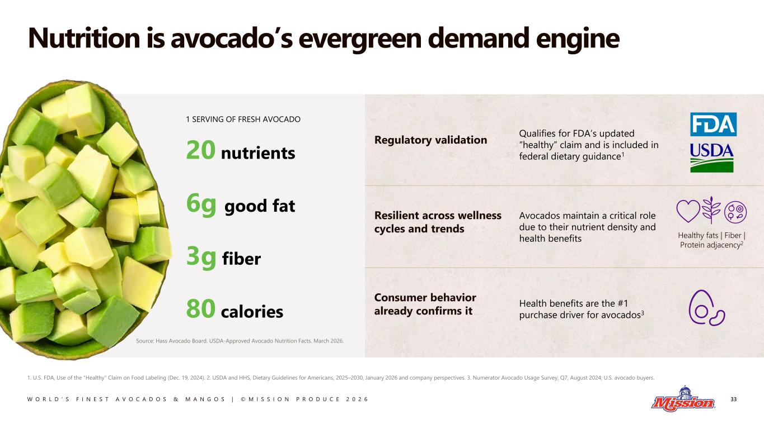
W O R L D ’ S F I N E S T A V O C A D O S & M A N G O S | © M I S S I O N P R O D U C E 2 0 2 6 Regulatory validation Qualifies for FDA’s updated “healthy” claim and is included in federal dietary guidance1 Resilient across wellness cycles and trends Avocados maintain a critical role due to their nutrient density and health benefits Consumer behavior already confirms it Health benefits are the #1 purchase driver for avocados3 Nutrition is avocado’s evergreen demand engine 33 1. U.S. FDA, Use of the "Healthy" Claim on Food Labeling (Dec. 19, 2024). 2. USDA and HHS, Dietary Guidelines for Americans, 2025–2030, January 2026 and company perspectives. 3. Numerator Avocado Usage Survey, Q7, August 2024; U.S. avocado buyers. 1 SERVING OF FRESH AVOCADO 20 nutrients 6g good fat 3g fiber 80 calories Healthy fats | Fiber | Protein adjacency2 Source: Hass Avocado Board. USDA-Approved Avocado Nutrition Facts. March 2026.

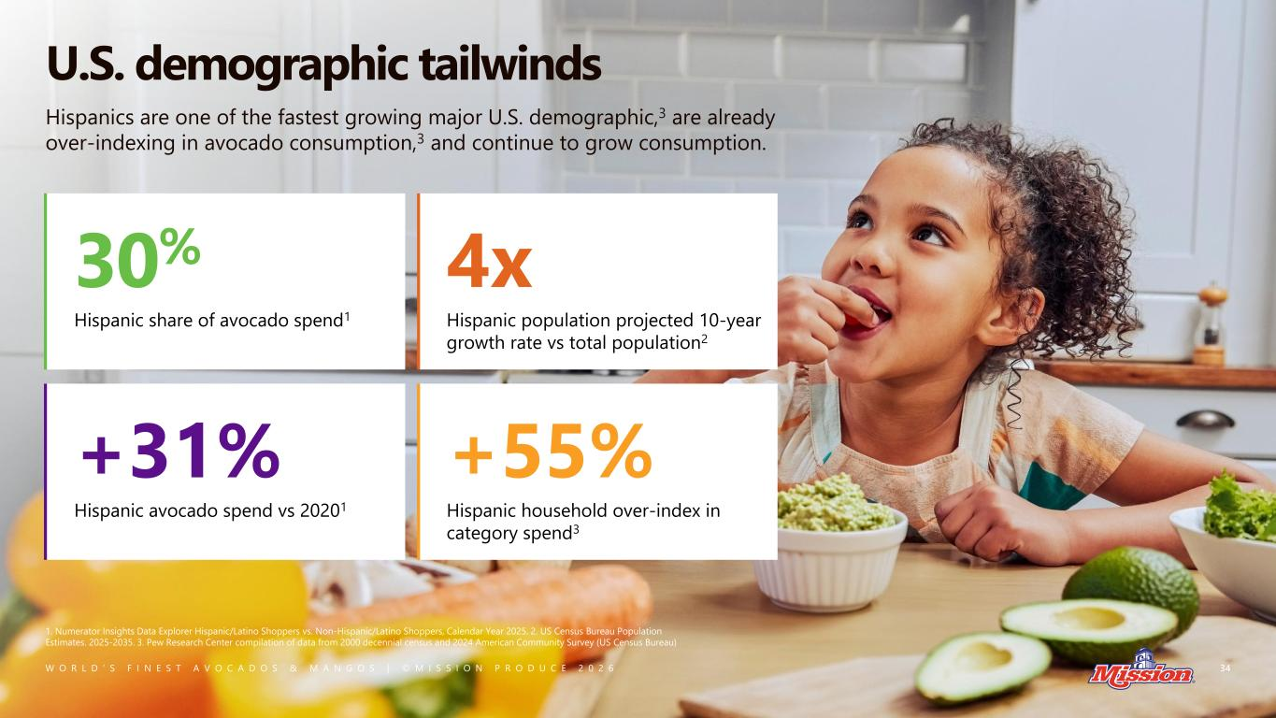
W O R L D ’ S F I N E S T A V O C A D O S & M A N G O S | © M I S S I O N P R O D U C E 2 0 2 6 U.S. demographic tailwinds 34 1. Numerator Insights Data Explorer Hispanic/Latino Shoppers vs. Non-Hispanic/Latino Shoppers, Calendar Year 2025. 2. US Census Bureau Population Estimates. 2025-2035. 3. Pew Research Center compilation of data from 2000 decennial census and 2024 American Community Survey (US Census Bureau) 30% Hispanic share of avocado spend1 4x Hispanic population projected 10-year growth rate vs total population2 +31% Hispanic avocado spend vs 20201 +55% Hispanic household over-index in category spend3 Hispanics are one of the fastest growing major U.S. demographic,3 are already over-indexing in avocado consumption,3 and continue to grow consumption.

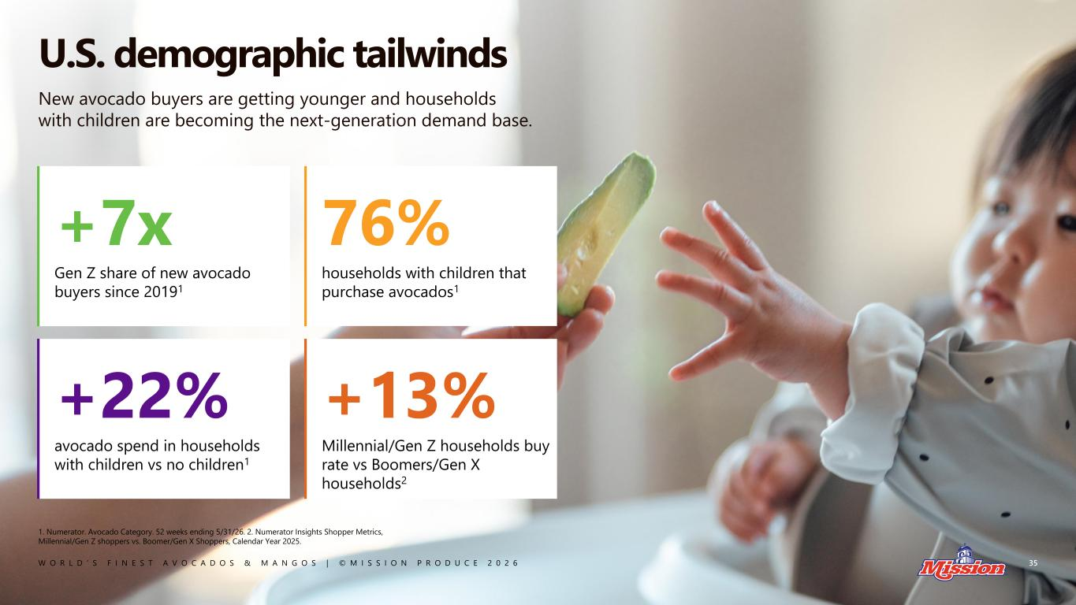
W O R L D ’ S F I N E S T A V O C A D O S & M A N G O S | © M I S S I O N P R O D U C E 2 0 2 6 U.S. demographic tailwinds 35 1. Numerator. Avocado Category. 52 weeks ending 5/31/26. 2. Numerator Insights Shopper Metrics, Millennial/Gen Z shoppers vs. Boomer/Gen X Shoppers, Calendar Year 2025. New avocado buyers are getting younger and households with children are becoming the next-generation demand base. +7x Gen Z share of new avocado buyers since 20191 76% households with children that purchase avocados1 +22% avocado spend in households with children vs no children1 +13% Millennial/Gen Z households buy rate vs Boomers/Gen X households2

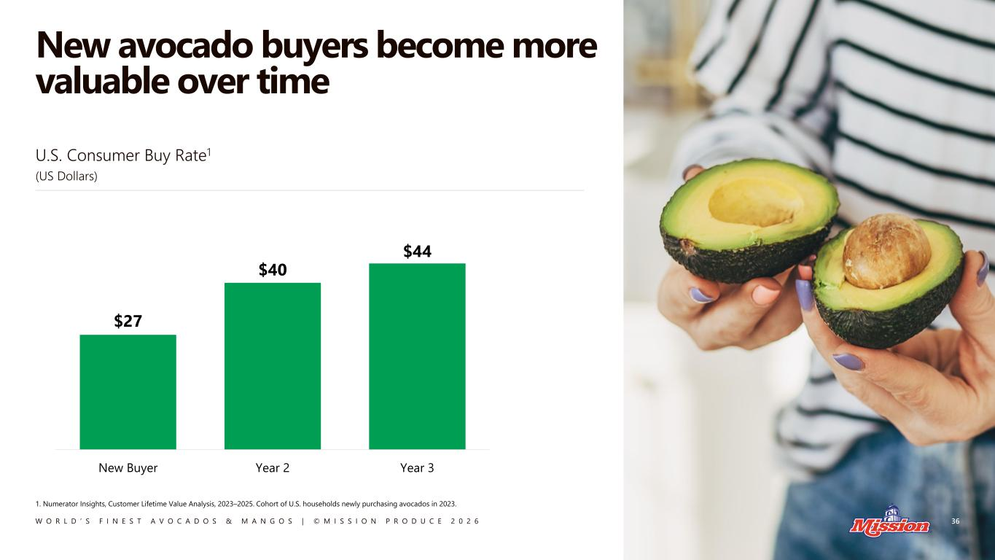
W O R L D ’ S F I N E S T A V O C A D O S & M A N G O S | © M I S S I O N P R O D U C E 2 0 2 6 New avocado buyers become more valuable over time 36 U.S. Consumer Buy Rate1 (US Dollars) $27 $40 $44 New Buyer Year 2 Year 3 1. Numerator Insights, Customer Lifetime Value Analysis, 2023–2025. Cohort of U.S. households newly purchasing avocados in 2023.

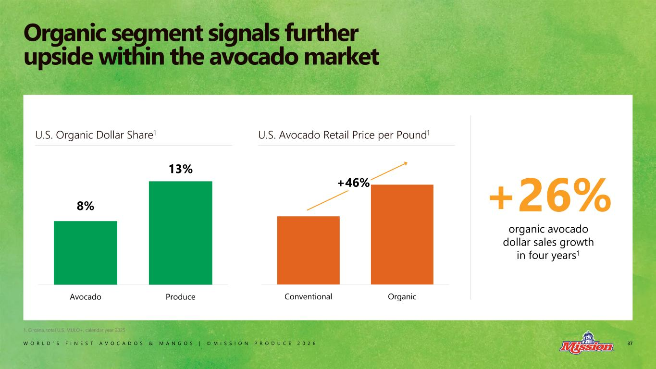
W O R L D ’ S F I N E S T A V O C A D O S & M A N G O S | © M I S S I O N P R O D U C E 2 0 2 6 37 Organic segment signals further upside within the avocado market +26% organic avocado dollar sales growth in four years1 8% 13% Avocado Produce Conventional Organic U.S. Organic Dollar Share1 U.S. Avocado Retail Price per Pound1 +46% 1. Circana, total U.S. MULO+, calendar year 2025

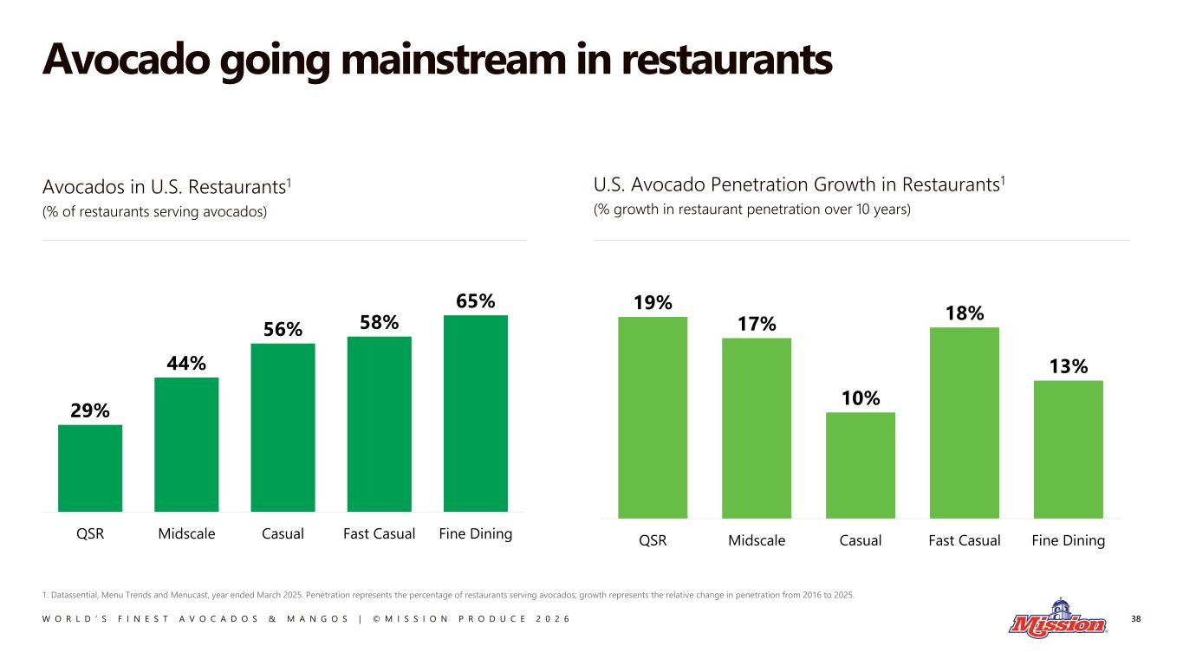
W O R L D ’ S F I N E S T A V O C A D O S & M A N G O S | © M I S S I O N P R O D U C E 2 0 2 6 Avocados in U.S. Restaurants1 (% of restaurants serving avocados) U.S. Avocado Penetration Growth in Restaurants1 (% growth in restaurant penetration over 10 years) Avocado going mainstream in restaurants 38 1. Datassential, Menu Trends and Menucast, year ended March 2025. Penetration represents the percentage of restaurants serving avocados; growth represents the relative change in penetration from 2016 to 2025. 29% 44% 56% 58% 65% QSR Midscale Casual Fast Casual Fine Dining 19% 17% 10% 18% 13% QSR Midscale Casual Fast Casual Fine Dining

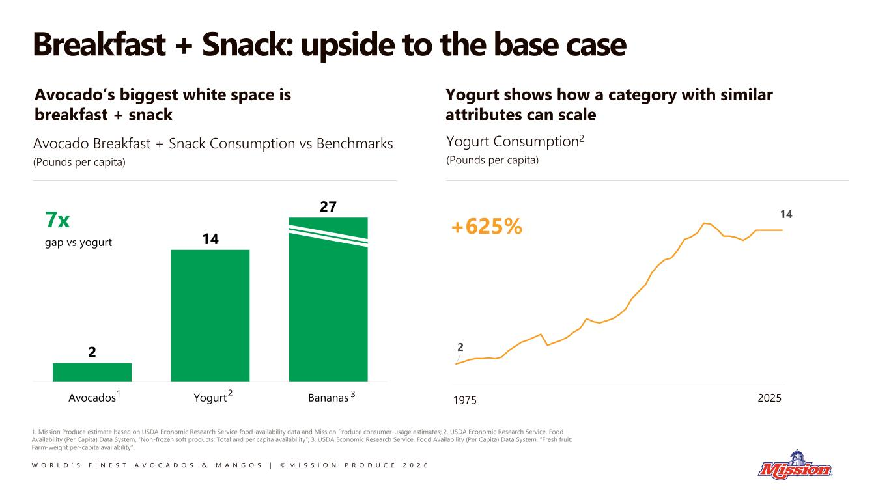
W O R L D ’ S F I N E S T A V O C A D O S & M A N G O S | © M I S S I O N P R O D U C E 2 0 2 6 2 14 Avocado’s biggest white space is breakfast + snack Yogurt shows how a category with similar attributes can scale Breakfast + Snack: upside to the base case 1. Mission Produce estimate based on USDA Economic Research Service food-availability data and Mission Produce consumer-usage estimates; 2. USDA Economic Research Service, Food Availability (Per Capita) Data System, “Non-frozen soft products: Total and per capita availability”; 3. USDA Economic Research Service, Food Availability (Per Capita) Data System, “Fresh fruit: Farm-weight per-capita availability”. 1975 2025 Avocado Breakfast + Snack Consumption vs Benchmarks (Pounds per capita) 2 14 27 Avocados Yogurt Bananas 7x gap vs yogurt Yogurt Consumption2 (Pounds per capita) +625% 1 2 3

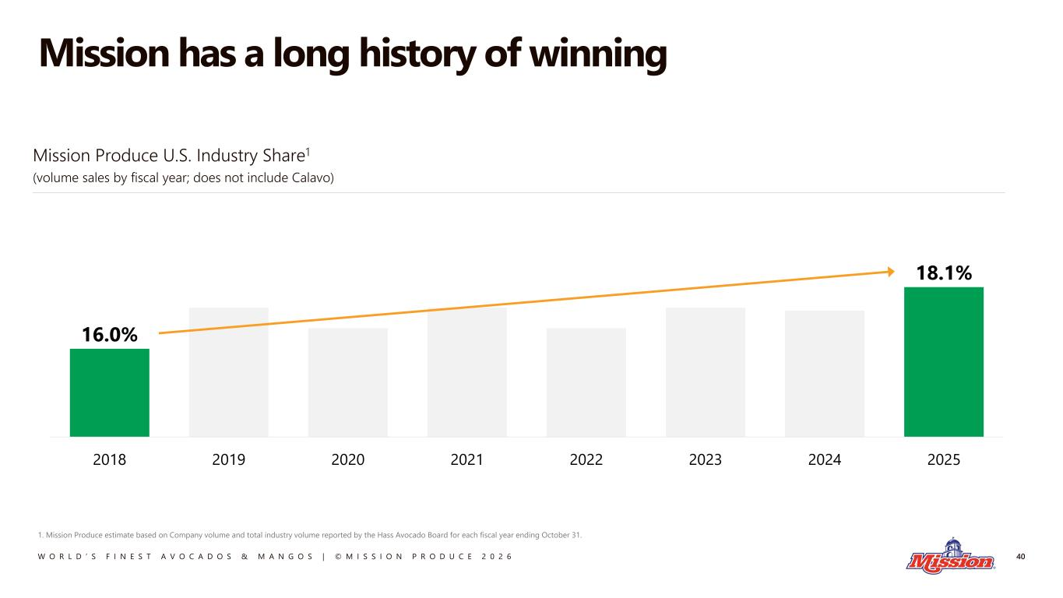
W O R L D ’ S F I N E S T A V O C A D O S & M A N G O S | © M I S S I O N P R O D U C E 2 0 2 6 Mission has a long history of winning 40 1. Mission Produce estimate based on Company volume and total industry volume reported by the Hass Avocado Board for each fiscal year ending October 31. 16.0% 18.1% 2018 2019 2020 2021 2022 2023 2024 2025 Mission Produce U.S. Industry Share1 (volume sales by fiscal year; does not include Calavo)

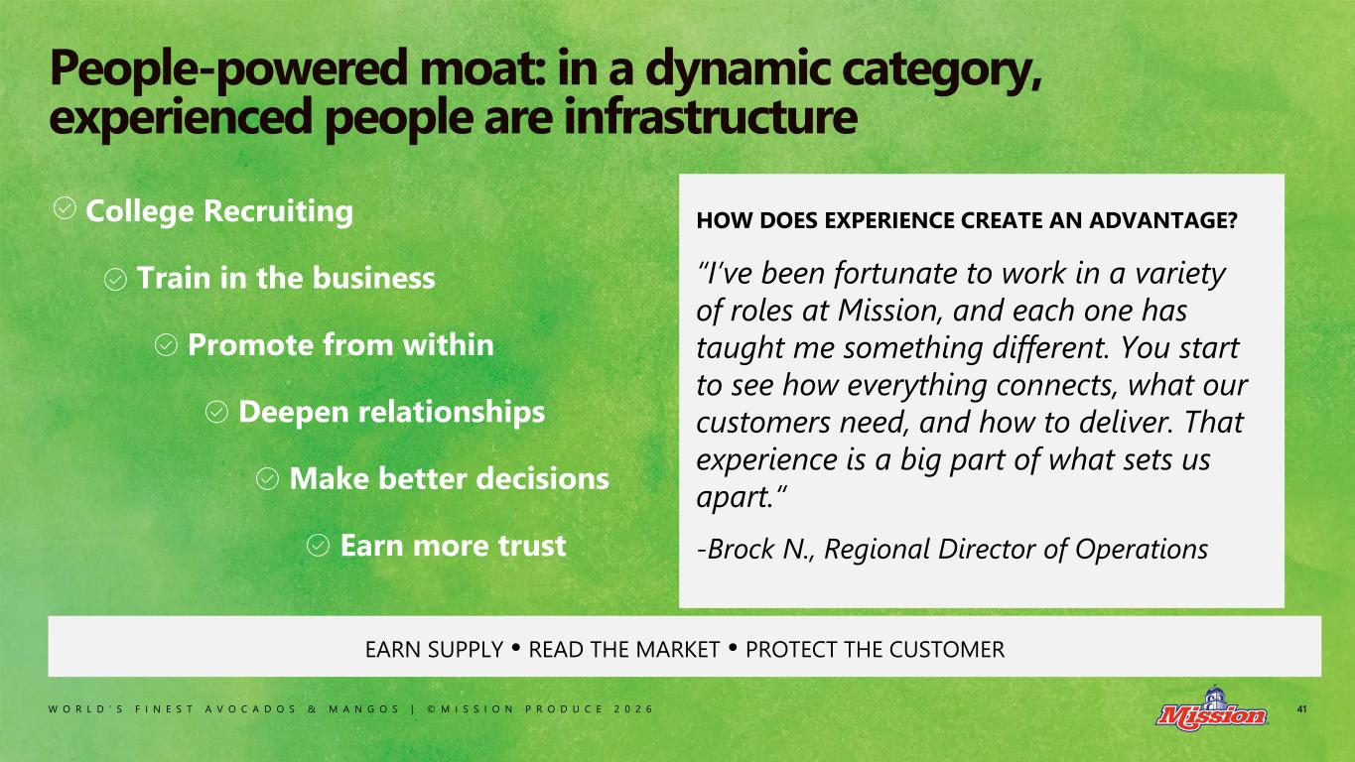
W O R L D ’ S F I N E S T A V O C A D O S & M A N G O S | © M I S S I O N P R O D U C E 2 0 2 6 41 People-powered moat: in a dynamic category, experienced people are infrastructure College Recruiting Train in the business Promote from within Deepen relationships Make better decisions Earn more trust EARN SUPPLY • READ THE MARKET • PROTECT THE CUSTOMER HOW DOES EXPERIENCE CREATE AN ADVANTAGE? “I’ve been fortunate to work in a variety of roles at Mission, and each one has taught me something different. You start to see how everything connects, what our customers need, and how to deliver. That experience is a big part of what sets us apart.“ -Brock N., Regional Director of Operations

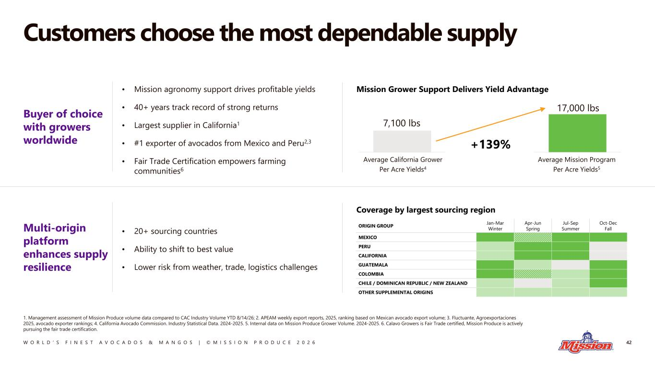
W O R L D ’ S F I N E S T A V O C A D O S & M A N G O S | © M I S S I O N P R O D U C E 2 0 2 6 Customers choose the most dependable supply 42 1. Management assessment of Mission Produce volume data compared to CAC Industry Volume YTD 8/14/26; 2. APEAM weekly export reports, 2025, ranking based on Mexican avocado export volume; 3. Fluctuante, Agroexportaciones 2025, avocado exporter rankings; 4. California Avocado Commission. Industry Statistical Data. 2024-2025. 5. Internal data on Mission Produce Grower Volume. 2024-2025. 6. Calavo Growers is Fair Trade certified, Mission Produce is actively pursuing the fair trade certification. Mission Grower Support Delivers Yield Advantage Buyer of choice with growers worldwide • Mission agronomy support drives profitable yields • 40+ years track record of strong returns • Largest supplier in California1 • #1 exporter of avocados from Mexico and Peru2,3 • Fair Trade Certification empowers farming communities6 7,100 lbs Average California Grower Per Acre Yields4 Average Mission Program Per Acre Yields5 17,000 lbs +139% Coverage by largest sourcing region Multi-origin platform enhances supply resilience • 20+ sourcing countries • Ability to shift to best value • Lower risk from weather, trade, logistics challenges ORIGIN GROUP Jan-Mar Winter Apr-Jun Spring Jul-Sep Summer Oct-Dec Fall MEXICO PERU CALIFORNIA GUATEMALA COLOMBIA CHILE / DOMINICAN REPUBLIC / NEW ZEALAND OTHER SUPPLEMENTAL ORIGINS

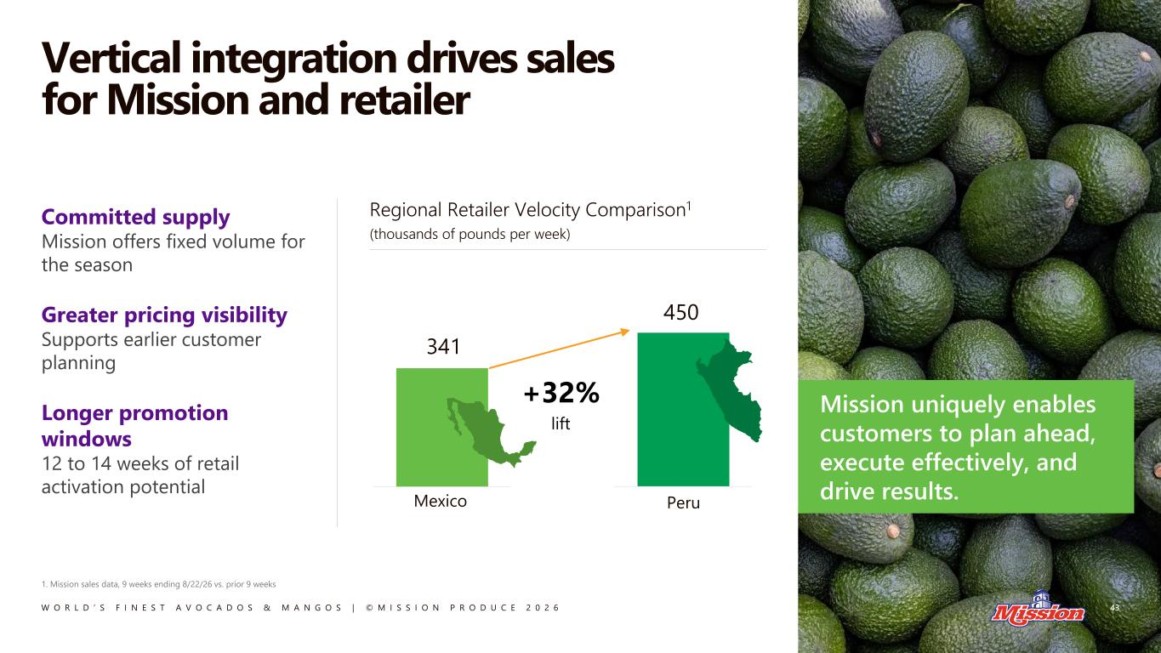
W O R L D ’ S F I N E S T A V O C A D O S & M A N G O S | © M I S S I O N P R O D U C E 2 0 2 6 Vertical integration drives sales for Mission and retailer 43 1. Mission sales data, 9 weeks ending 8/22/26 vs. prior 9 weeks Mission uniquely enables customers to plan ahead, execute effectively, and drive results. Committed supply Mission offers fixed volume for the season Greater pricing visibility Supports earlier customer planning Longer promotion windows 12 to 14 weeks of retail activation potential Regional Retailer Velocity Comparison1 (thousands of pounds per week) 341 Mexico Peru 450 +32% lift

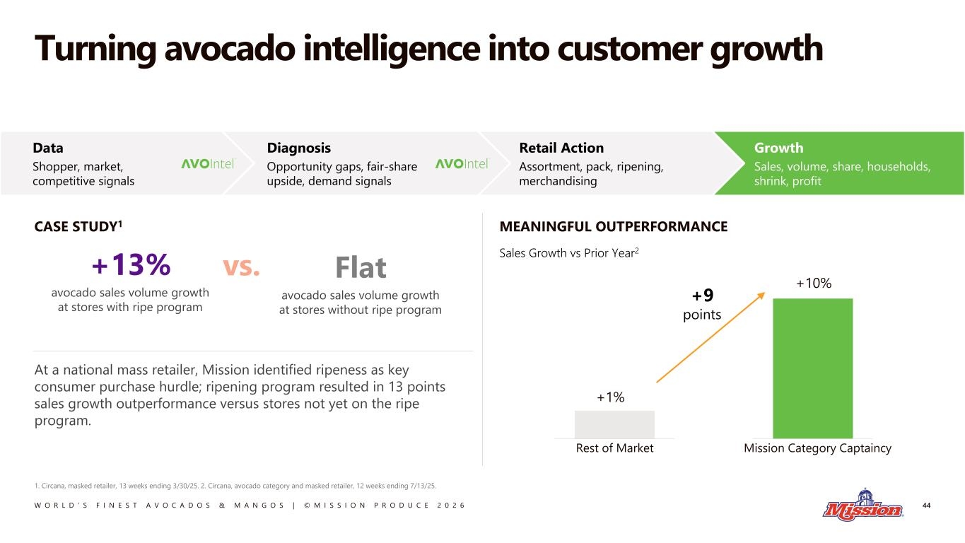
W O R L D ’ S F I N E S T A V O C A D O S & M A N G O S | © M I S S I O N P R O D U C E 2 0 2 6 Turning avocado intelligence into customer growth 44 1. Circana, masked retailer, 13 weeks ending 3/30/25. 2. Circana, avocado category and masked retailer, 12 weeks ending 7/13/25. MEANINGFUL OUTPERFORMANCE +13% avocado sales volume growth at stores with ripe program Flat avocado sales volume growth at stores without ripe program At a national mass retailer, Mission identified ripeness as key consumer purchase hurdle; ripening program resulted in 13 points sales growth outperformance versus stores not yet on the ripe program. Sales Growth vs Prior Year2 Growth Sales, volume, share, households, shrink, profit Retail Action Assortment, pack, ripening, merchandising Diagnosis Opportunity gaps, fair-share upside, demand signals Data Shopper, market, competitive signals CASE STUDY1 +1% Rest of Market Mission Category Captaincy +10% +9 points vs.

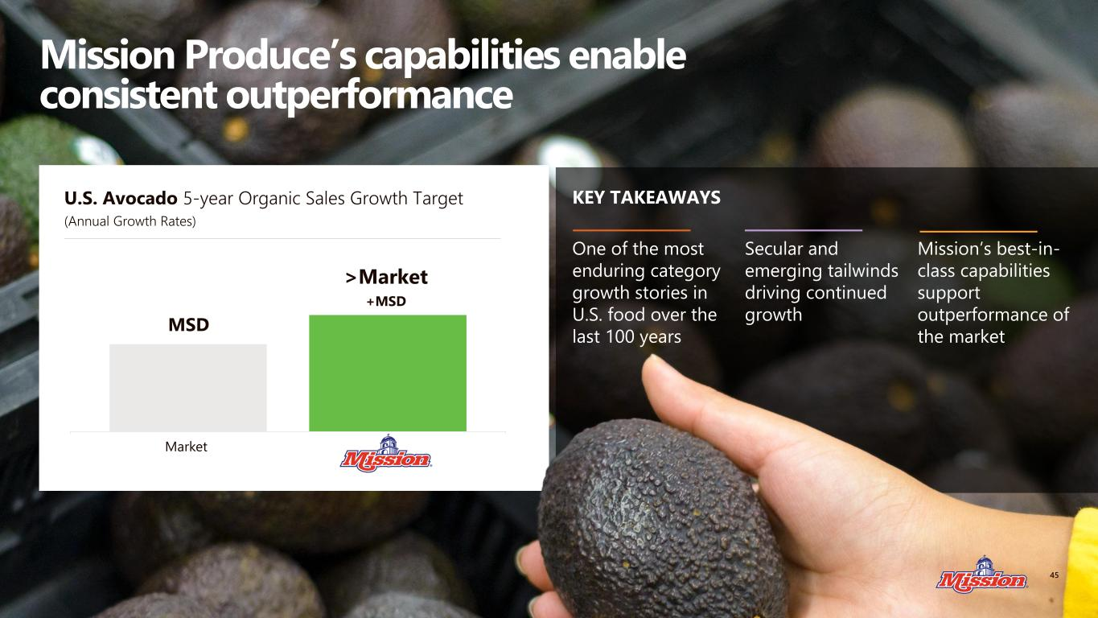
W O R L D ’ S F I N E S T A V O C A D O S & M A N G O S | © M I S S I O N P R O D U C E 2 0 2 6 Mission Produce’s capabilities enable consistent outperformance U.S. Avocado 5-year Organic Sales Growth Target (Annual Growth Rates) MSD >Market +MSD Market KEY TAKEAWAYS 45 One of the most enduring category growth stories in U.S. food over the last 100 years Secular and emerging tailwinds driving continued growth Mission’s best-in- class capabilities support outperformance of the market

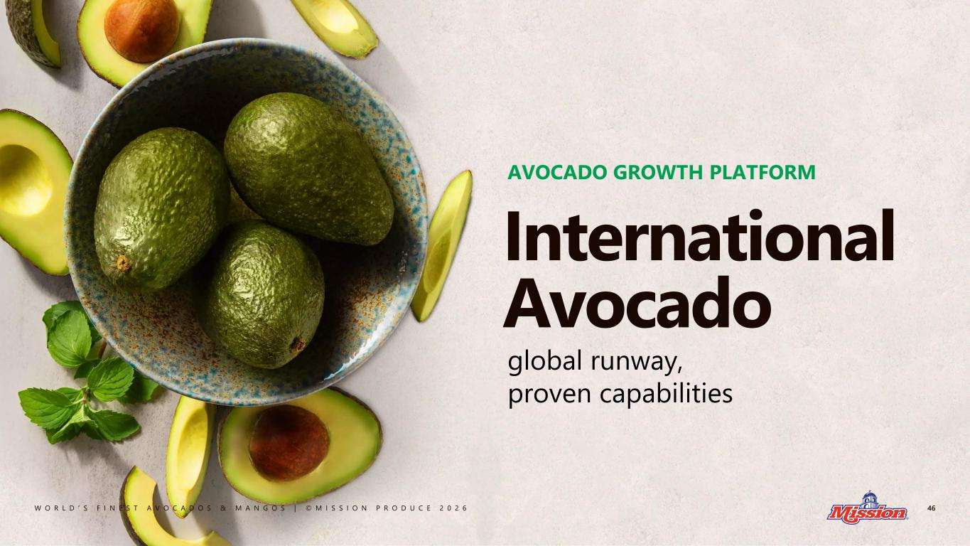
W O R L D ’ S F I N E S T A V O C A D O S & M A N G O S | © M I S S I O N P R O D U C E 2 0 2 6 46 International Avocado global runway, proven capabilities AVOCADO GROWTH PLATFORM

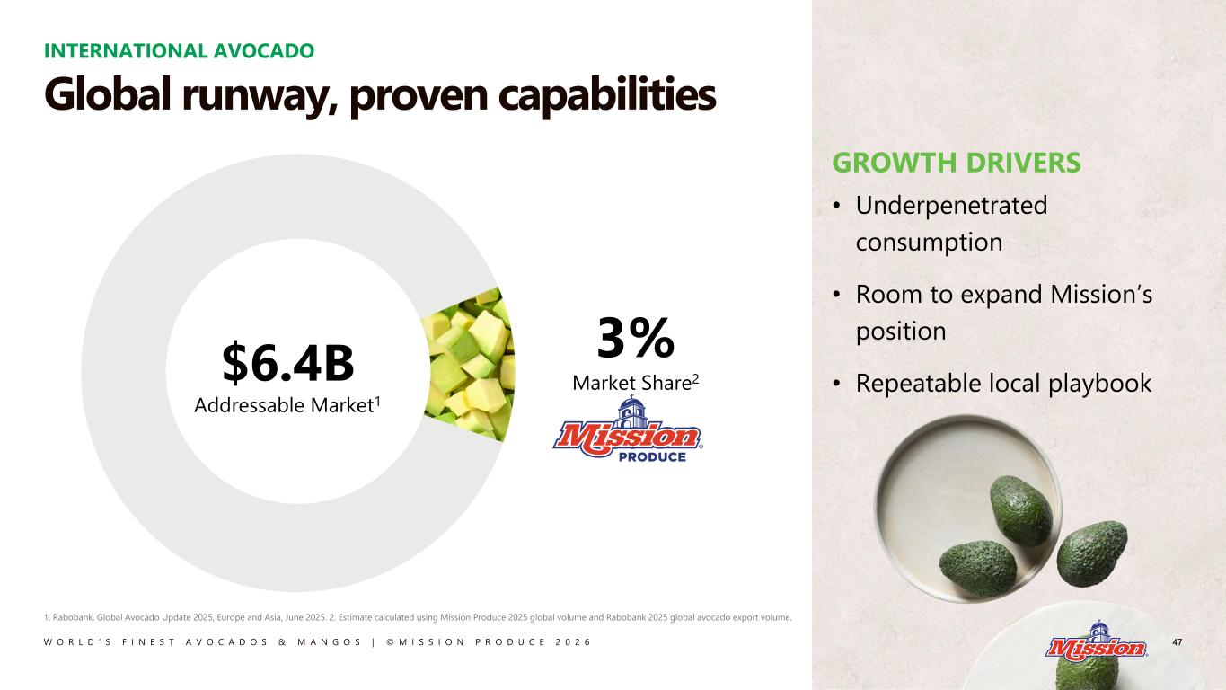
W O R L D ’ S F I N E S T A V O C A D O S & M A N G O S | © M I S S I O N P R O D U C E 2 0 2 6 INTERNATIONAL AVOCADO 47 1. Rabobank. Global Avocado Update 2025, Europe and Asia, June 2025. 2. Estimate calculated using Mission Produce 2025 global volume and Rabobank 2025 global avocado export volume. GROWTH DRIVERS • Underpenetrated consumption • Room to expand Mission’s position • Repeatable local playbook Global runway, proven capabilities 3% Market Share2$6.4B Addressable Market1

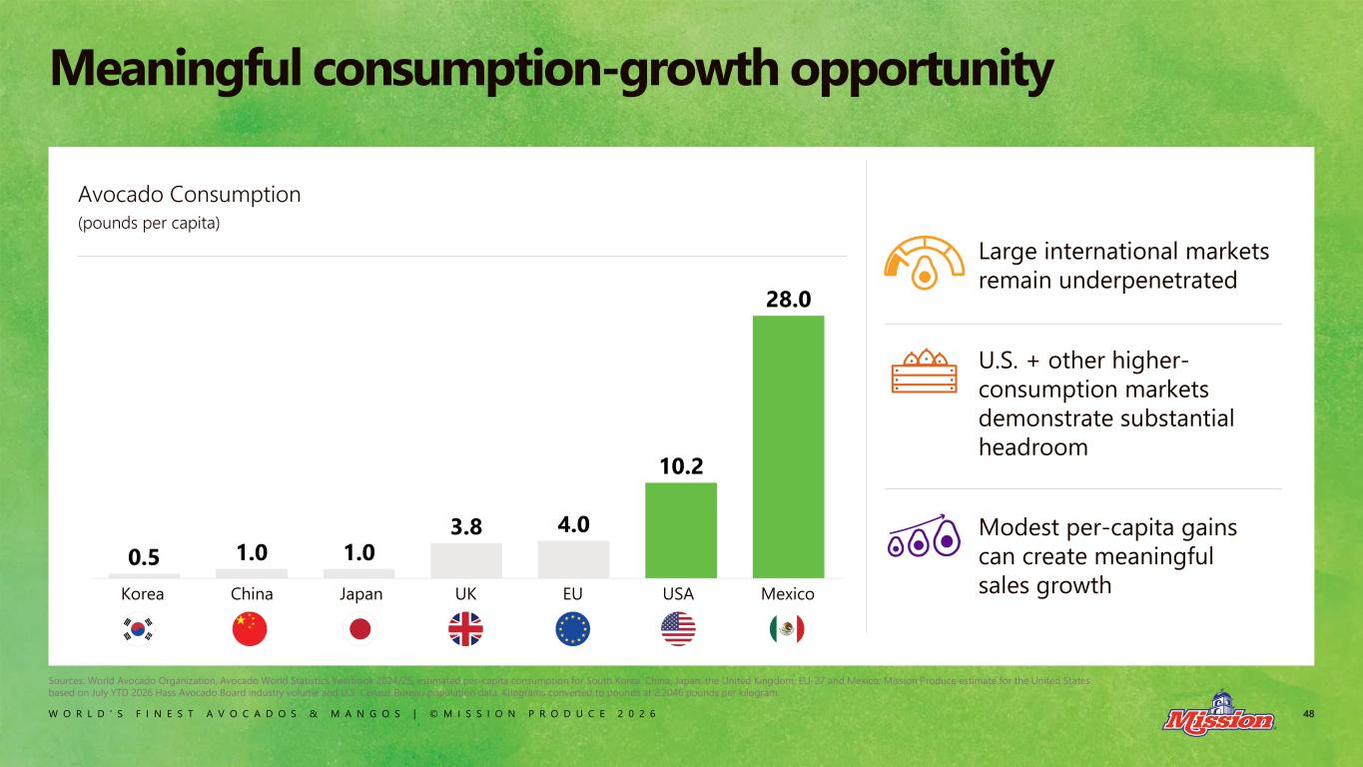
W O R L D ’ S F I N E S T A V O C A D O S & M A N G O S | © M I S S I O N P R O D U C E 2 0 2 6 48 Meaningful consumption-growth opportunity 0.5 1.0 1.0 3.8 4.0 10.2 28.0 Avocado Consumption (pounds per capita) Korea China Japan UK EU USA Mexico Large international markets remain underpenetrated U.S. + other higher- consumption markets demonstrate substantial headroom Modest per-capita gains can create meaningful sales growth Sources: World Avocado Organization, Avocado World Statistics Yearbook 2024/25, estimated per-capita consumption for South Korea, China, Japan, the United Kingdom, EU-27 and Mexico; Mission Produce estimate for the United States based on July YTD 2026 Hass Avocado Board industry volume and U.S. Census Bureau population data. Kilograms converted to pounds at 2.2046 pounds per kilogram.

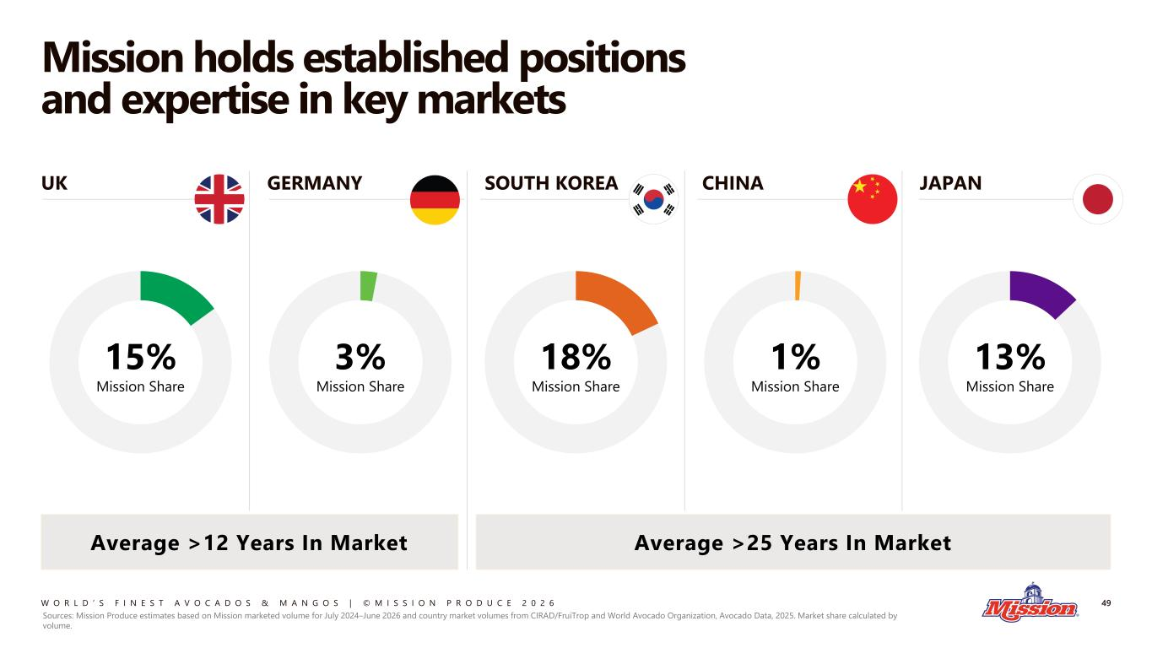
W O R L D ’ S F I N E S T A V O C A D O S & M A N G O S | © M I S S I O N P R O D U C E 2 0 2 6 Mission holds established positions and expertise in key markets 49 Average >25 Years In Market UK GERMANY SOUTH KOREA CHINA JAPAN Average >12 Years In Market 13% Mission Share 1% Mission Share 18% Mission Share 3% Mission Share 15% Mission Share Sources: Mission Produce estimates based on Mission marketed volume for July 2024–June 2026 and country market volumes from CIRAD/FruiTrop and World Avocado Organization, Avocado Data, 2025. Market share calculated by volume.

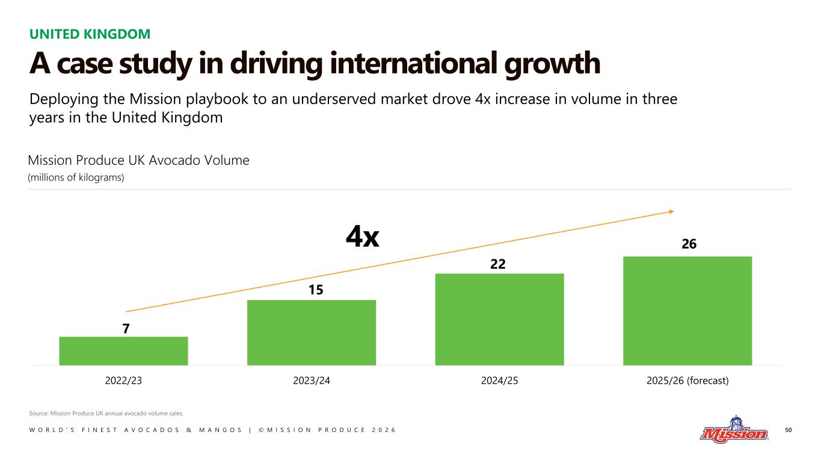
W O R L D ’ S F I N E S T A V O C A D O S & M A N G O S | © M I S S I O N P R O D U C E 2 0 2 6 50 Deploying the Mission playbook to an underserved market drove 4x increase in volume in three years in the United Kingdom 2022/23 2023/24 2024/25 2025/26 (forecast) 22 4x 26 7 15 UNITED KINGDOM A case study in driving international growth Mission Produce UK Avocado Volume (millions of kilograms) Source: Mission Produce UK annual avocado volume sales.

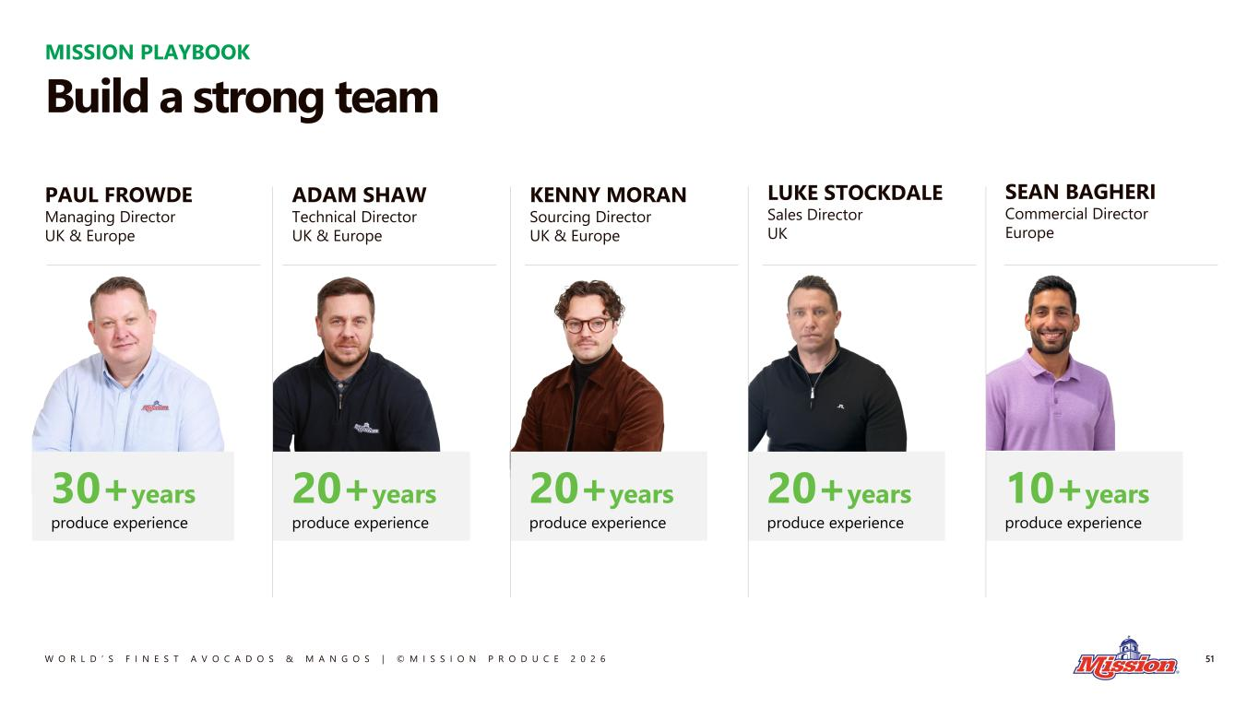
W O R L D ’ S F I N E S T A V O C A D O S & M A N G O S | © M I S S I O N P R O D U C E 2 0 2 6 20+years produce experience 20+years produce experience 20+years produce experience 10+years produce experience 51 PAUL FROWDE Managing Director UK & Europe ADAM SHAW Technical Director UK & Europe KENNY MORAN Sourcing Director UK & Europe LUKE STOCKDALE Sales Director UK SEAN BAGHERI Commercial Director Europe 30+years produce experience MISSION PLAYBOOK Build a strong team

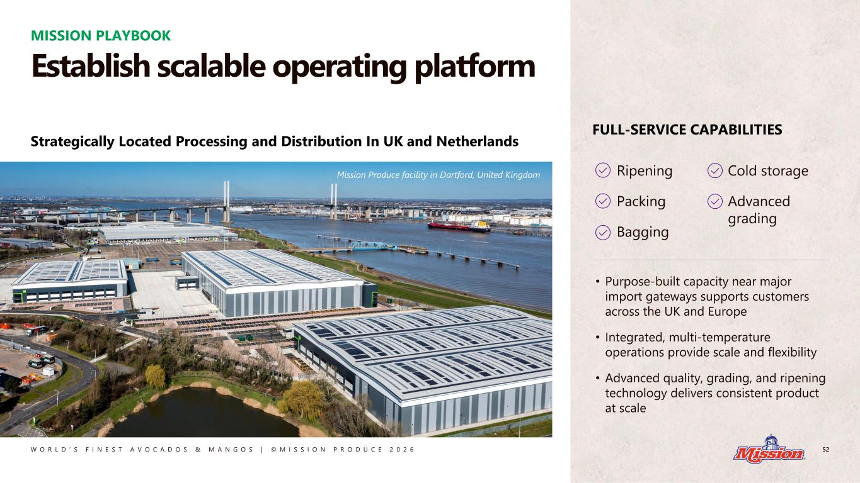
W O R L D ’ S F I N E S T A V O C A D O S & M A N G O S | © M I S S I O N P R O D U C E 2 0 2 6 52 • Purpose-built capacity near major import gateways supports customers across the UK and Europe • Integrated, multi-temperature operations provide scale and flexibility • Advanced quality, grading, and ripening technology delivers consistent product at scale Ripening Packing Bagging Cold storage Advanced grading FULL-SERVICE CAPABILITIES Strategically Located Processing and Distribution In UK and Netherlands Mission Produce facility in Dartford, United Kingdom MISSION PLAYBOOK Establish scalable operating platform

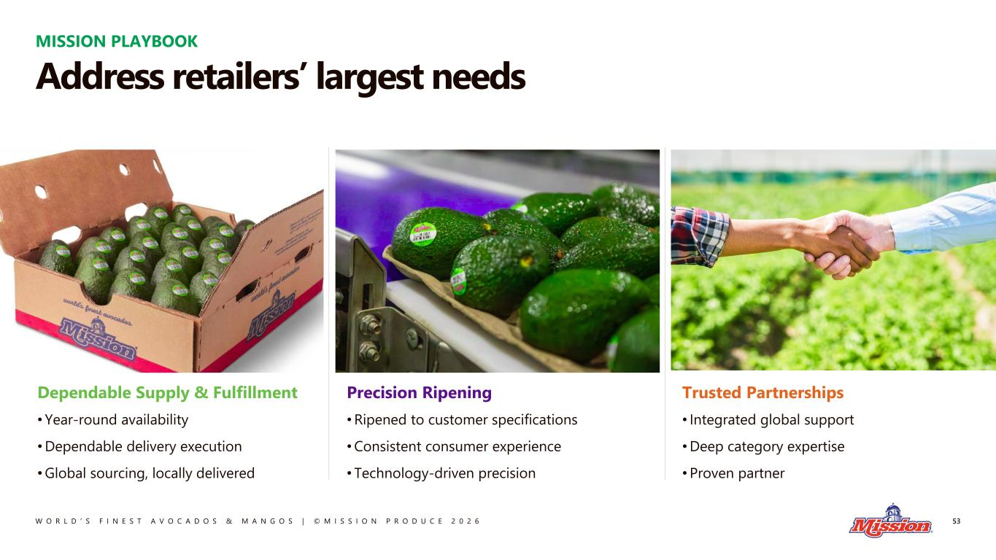
W O R L D ’ S F I N E S T A V O C A D O S & M A N G O S | © M I S S I O N P R O D U C E 2 0 2 6 MISSION PLAYBOOK 53 Address retailers’ largest needs Precision Ripening •Ripened to customer specifications •Consistent consumer experience • Technology-driven precision Dependable Supply & Fulfillment •Year-round availability •Dependable delivery execution •Global sourcing, locally delivered Trusted Partnerships • Integrated global support •Deep category expertise •Proven partner

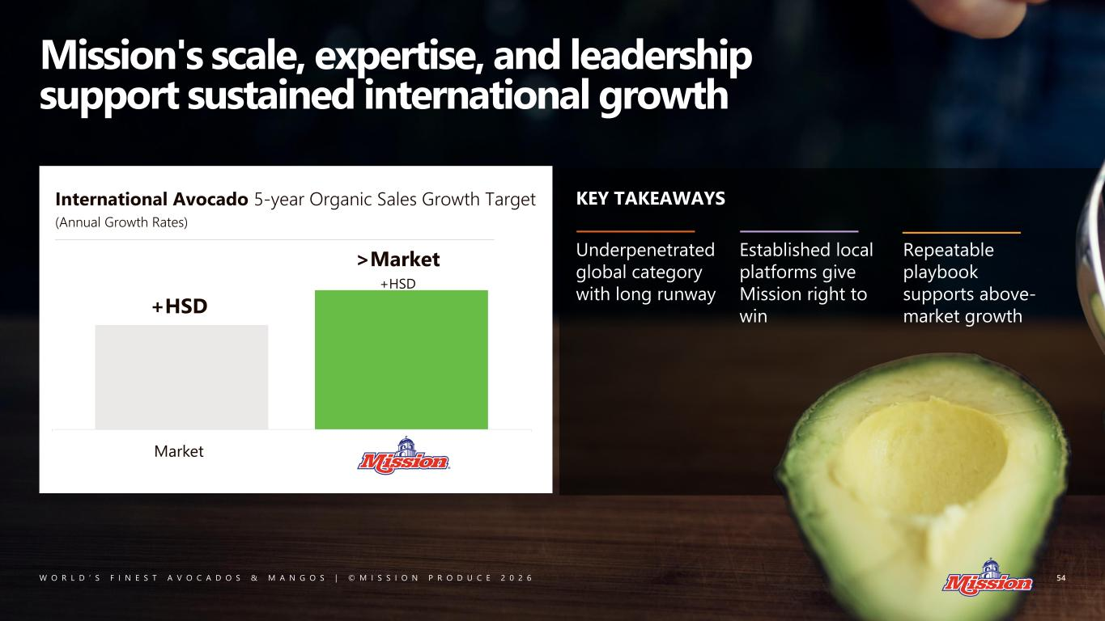
W O R L D ’ S F I N E S T A V O C A D O S & M A N G O S | © M I S S I O N P R O D U C E 2 0 2 6 Mission's scale, expertise, and leadership support sustained international growth Provide bridge? At least share where we are today Once we show what our market shares are it will be easier to understand how we can outpace. Paul for Europe/nolan for asia International Avocado 5-year Organic Sales Growth Target (Annual Growth Rates) KEY TAKEAWAYS Market +HSD >Market +HSD 54 Underpenetrated global category with long runway Established local platforms give Mission right to win Repeatable playbook supports above- market growth

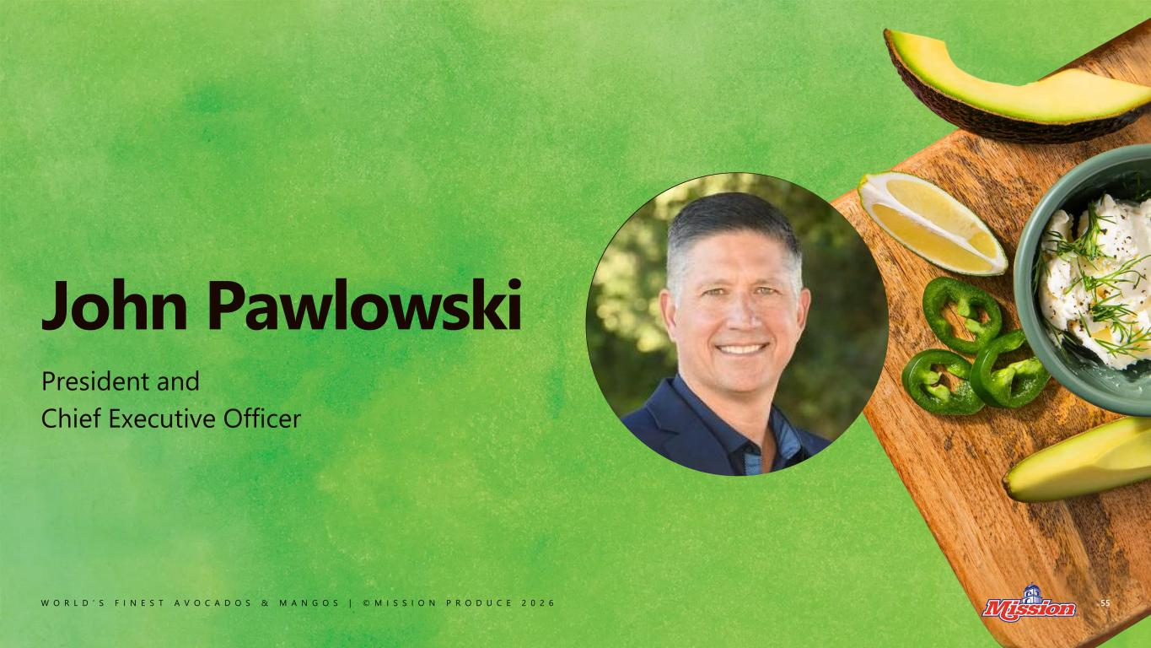
W O R L D ’ S F I N E S T A V O C A D O S & M A N G O S | © M I S S I O N P R O D U C E 2 0 2 6 John Pawlowski President and Chief Executive Officer 55

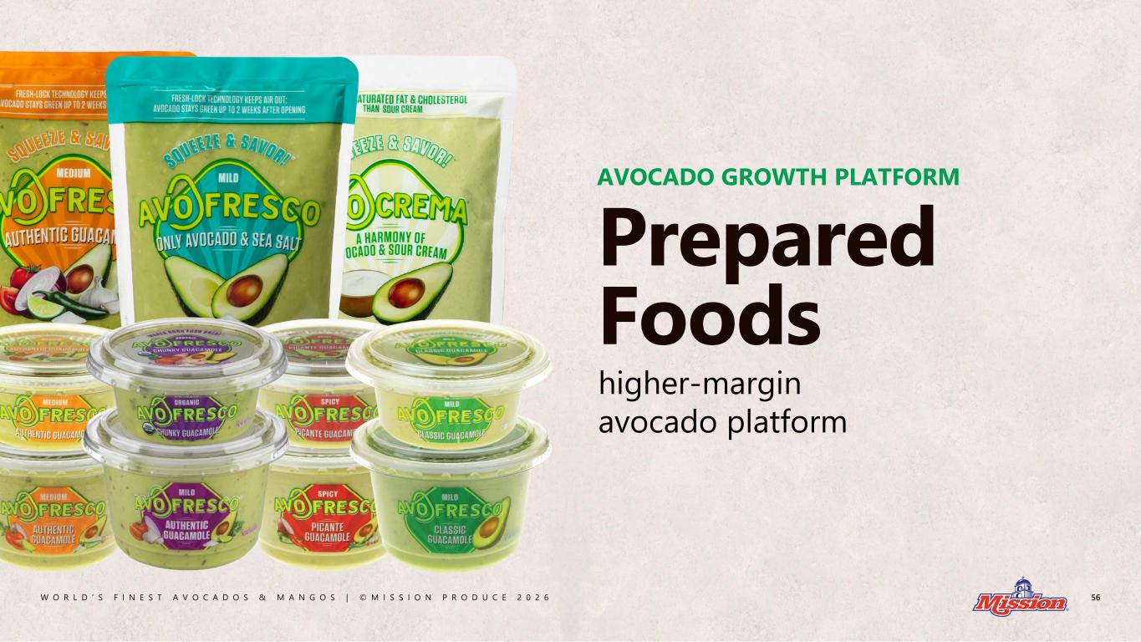
W O R L D ’ S F I N E S T A V O C A D O S & M A N G O S | © M I S S I O N P R O D U C E 2 0 2 6 higher-margin avocado platform AVOCADO GROWTH PLATFORM 56 Prepared Foods

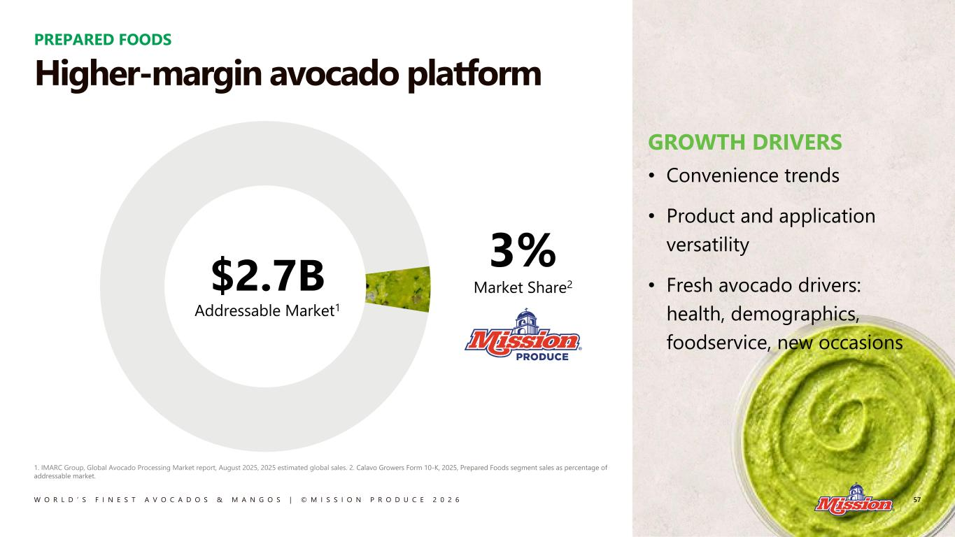
W O R L D ’ S F I N E S T A V O C A D O S & M A N G O S | © M I S S I O N P R O D U C E 2 0 2 6 PREPARED FOODS 3% Market Share2$2.7B Addressable Market1 GROWTH DRIVERS • Convenience trends • Product and application versatility • Fresh avocado drivers: health, demographics, foodservice, new occasions Higher-margin avocado platform 1. IMARC Group, Global Avocado Processing Market report, August 2025, 2025 estimated global sales. 2. Calavo Growers Form 10-K, 2025, Prepared Foods segment sales as percentage of addressable market. 57

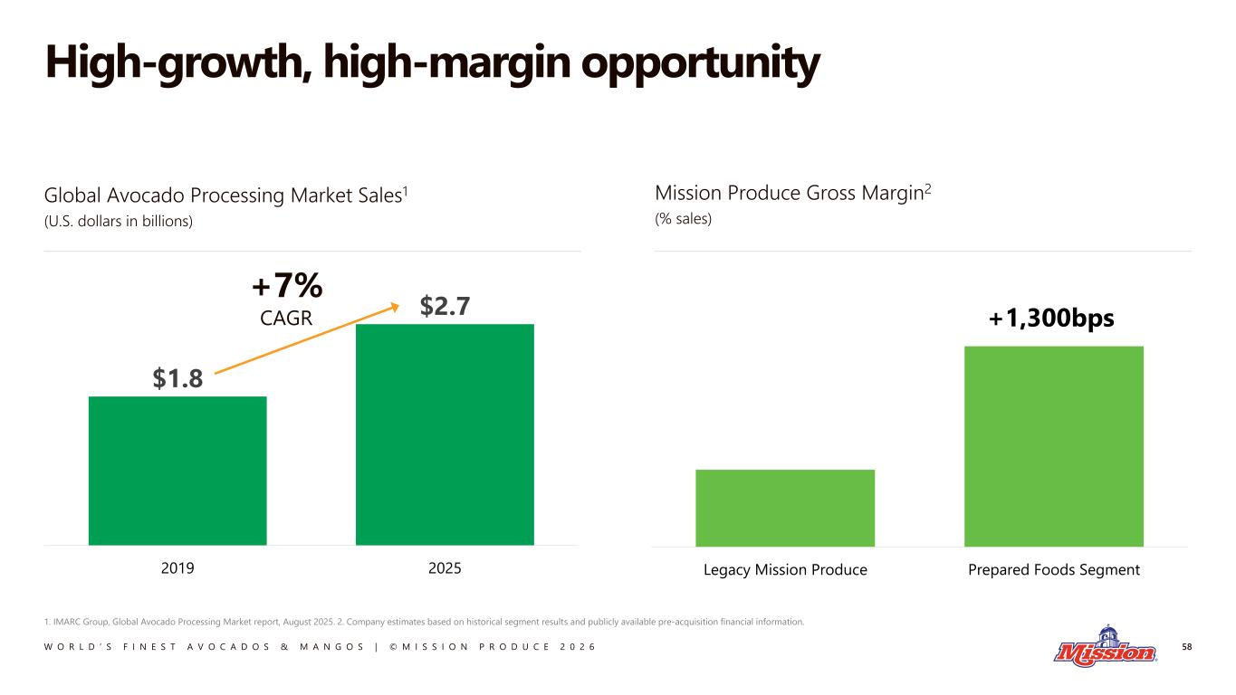
W O R L D ’ S F I N E S T A V O C A D O S & M A N G O S | © M I S S I O N P R O D U C E 2 0 2 6 High-growth, high-margin opportunity 58 1. IMARC Group, Global Avocado Processing Market report, August 2025. 2. Company estimates based on historical segment results and publicly available pre-acquisition financial information. $1.8 $2.7 2019 2025 Legacy Mission Produce Prepared Foods Segment +1,300bps Global Avocado Processing Market Sales1 (U.S. dollars in billions) Mission Produce Gross Margin2 (% sales) +7% CAGR

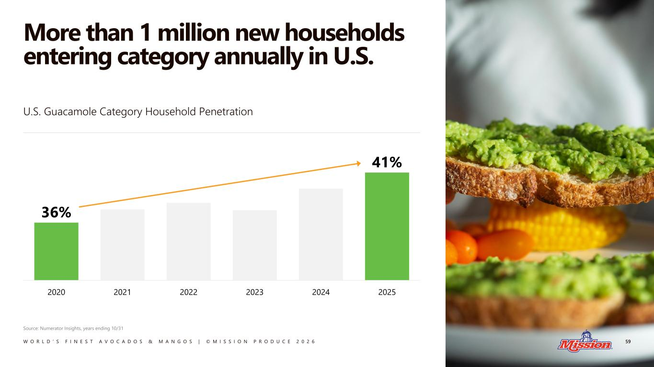
W O R L D ’ S F I N E S T A V O C A D O S & M A N G O S | © M I S S I O N P R O D U C E 2 0 2 6 More than 1 million new households entering category annually in U.S. 59 36% 41% 2020 2021 2022 2023 2024 2025 U.S. Guacamole Category Household Penetration Source: Numerator Insights, years ending 10/31

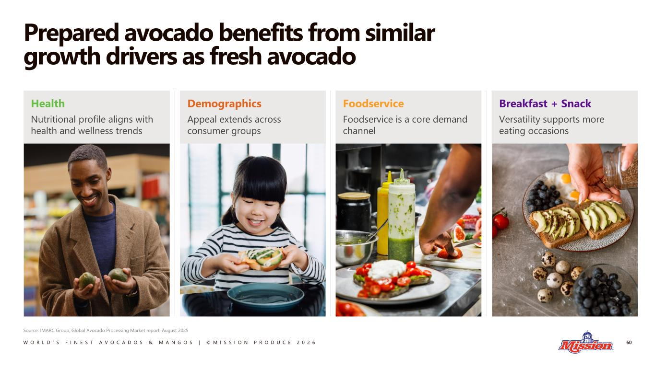
W O R L D ’ S F I N E S T A V O C A D O S & M A N G O S | © M I S S I O N P R O D U C E 2 0 2 6 Prepared avocado benefits from similar growth drivers as fresh avocado 60 Source: IMARC Group, Global Avocado Processing Market report, August 2025 Health Nutritional profile aligns with health and wellness trends Breakfast + Snack Versatility supports more eating occasions Foodservice Foodservice is a core demand channel Demographics Appeal extends across consumer groups

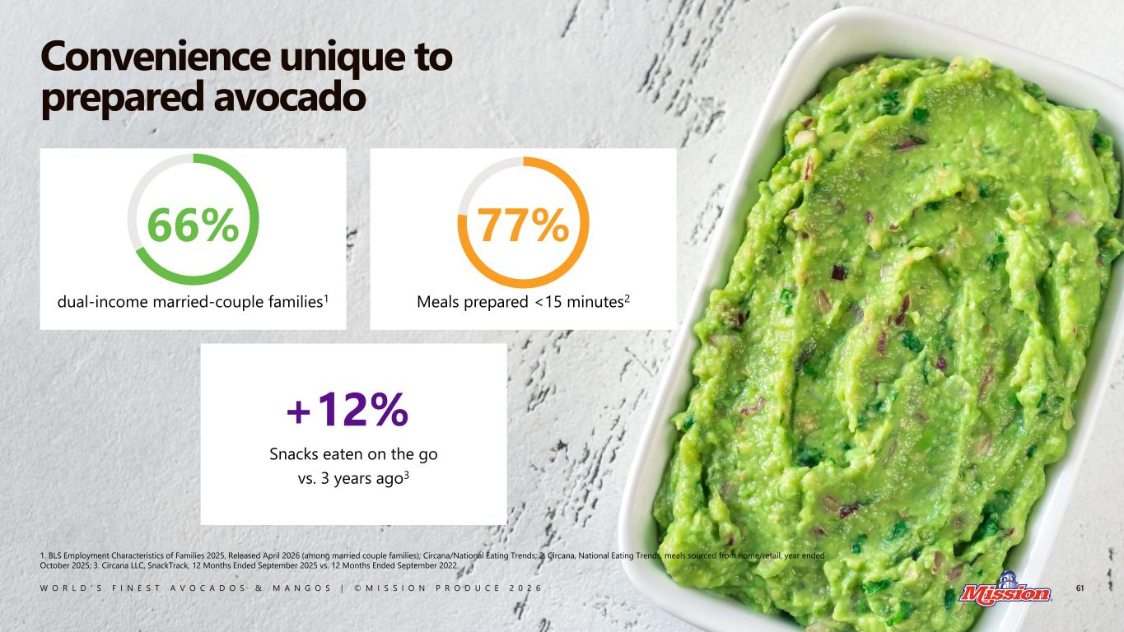
W O R L D ’ S F I N E S T A V O C A D O S & M A N G O S | © M I S S I O N P R O D U C E 2 0 2 6 dual-income married-couple families1 Meals prepared <15 minutes2 +12%% Snacks eaten on the go vs. 3 years ago3 Convenience unique to prepared avocado 61 1. BLS Employment Characteristics of Families 2025, Released April 2026 (among married couple families); Circana/National Eating Trends; 2. Circana, National Eating Trends, meals sourced from home/retail, year ended October 2025; 3. Circana LLC, SnackTrack, 12 Months Ended September 2025 vs. 12 Months Ended September 2022. 77%66%

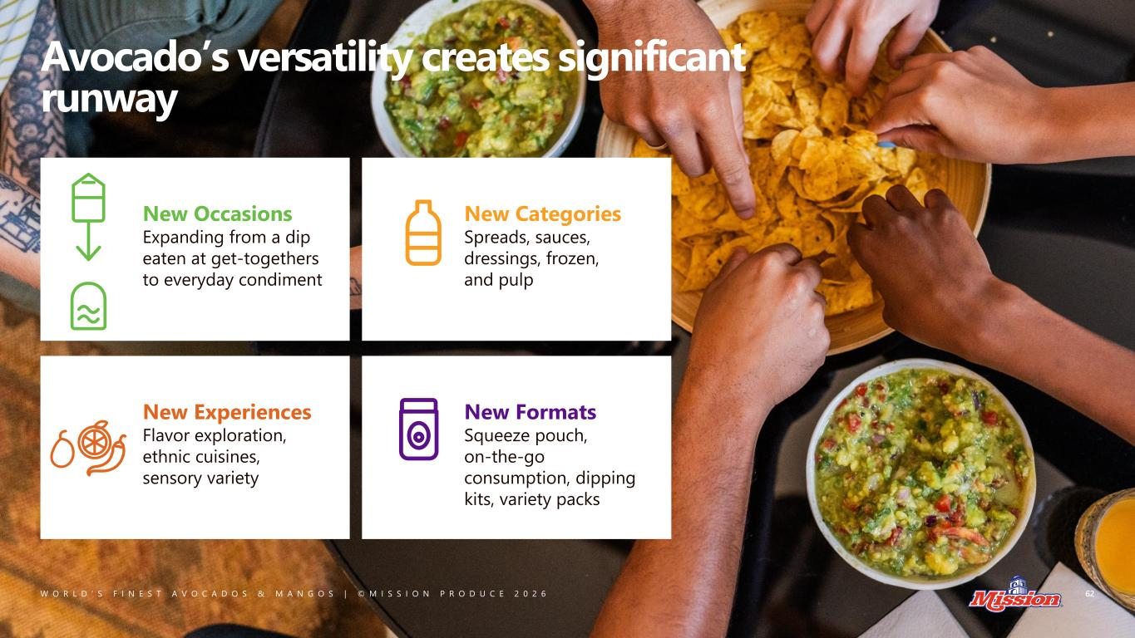
W O R L D ’ S F I N E S T A V O C A D O S & M A N G O S | © M I S S I O N P R O D U C E 2 0 2 6 Avocado’s versatility creates significant runway 62 New Occasions Expanding from a dip eaten at get-togethers to everyday condiment New Categories Spreads, sauces, dressings, frozen, and pulp New Experiences Flavor exploration, ethnic cuisines, sensory variety New Formats Squeeze pouch, on-the-go consumption, dipping kits, variety packs

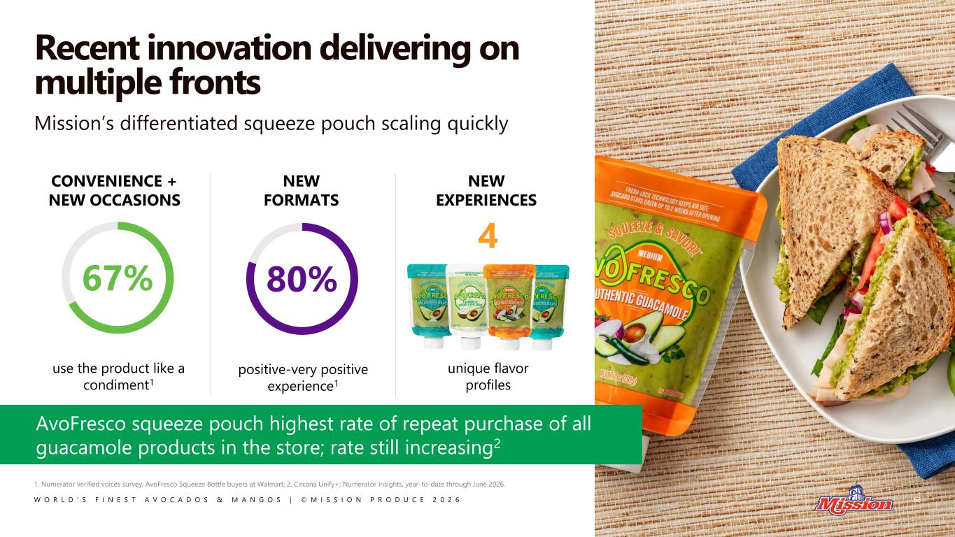
W O R L D ’ S F I N E S T A V O C A D O S & M A N G O S | © M I S S I O N P R O D U C E 2 0 2 6 Recent innovation delivering on multiple fronts 63 CONVENIENCE + NEW OCCASIONS NEW FORMATS NEW EXPERIENCES Mission’s differentiated squeeze pouch scaling quickly AvoFresco squeeze pouch highest rate of repeat purchase of all guacamole products in the store; rate still increasing2 use the product like a condiment1 67% positive-very positive experience1 80% unique flavor profiles 4 1. Numerator verified voices survey, AvoFresco Squeeze Bottle buyers at Walmart; 2. Circana Unify+; Numerator Insights, year-to-date through June 2026.

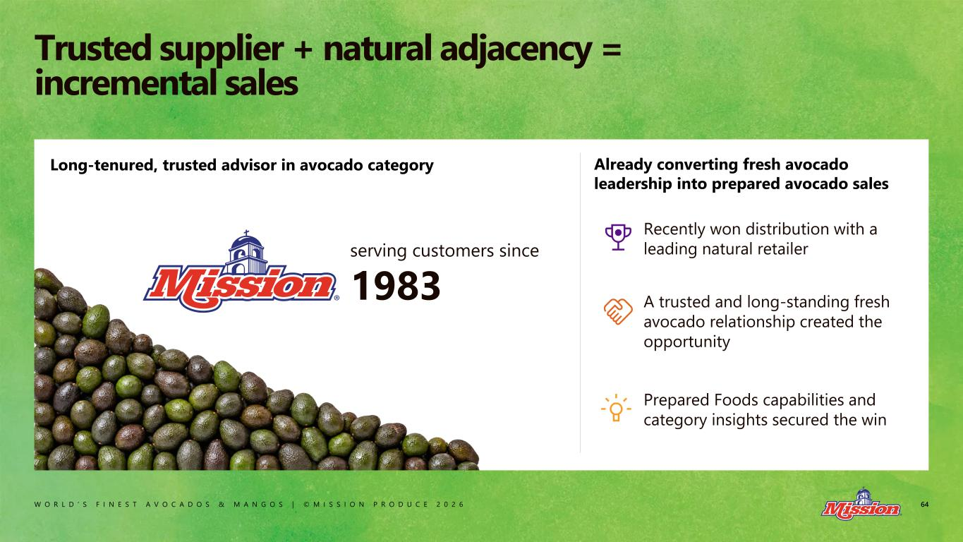
W O R L D ’ S F I N E S T A V O C A D O S & M A N G O S | © M I S S I O N P R O D U C E 2 0 2 6 64 Trusted supplier + natural adjacency = incremental sales Already converting fresh avocado leadership into prepared avocado sales Long-tenured, trusted advisor in avocado category Recently won distribution with a leading natural retailer A trusted and long-standing fresh avocado relationship created the opportunity Prepared Foods capabilities and category insights secured the win serving customers since 1983

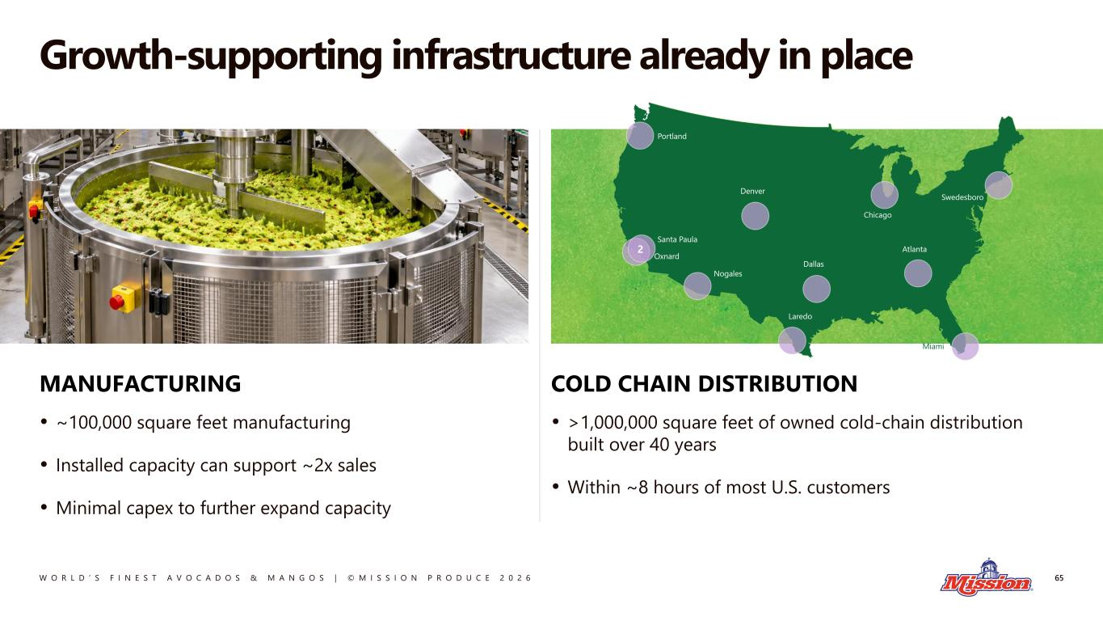
W O R L D ’ S F I N E S T A V O C A D O S & M A N G O S | © M I S S I O N P R O D U C E 2 0 2 6 Growth-supporting infrastructure already in place 65 COLD CHAIN DISTRIBUTION • >1,000,000 square feet of owned cold-chain distribution built over 40 years • Within ~8 hours of most U.S. customers MANUFACTURING • ~100,000 square feet manufacturing • Installed capacity can support ~2x sales • Minimal capex to further expand capacity

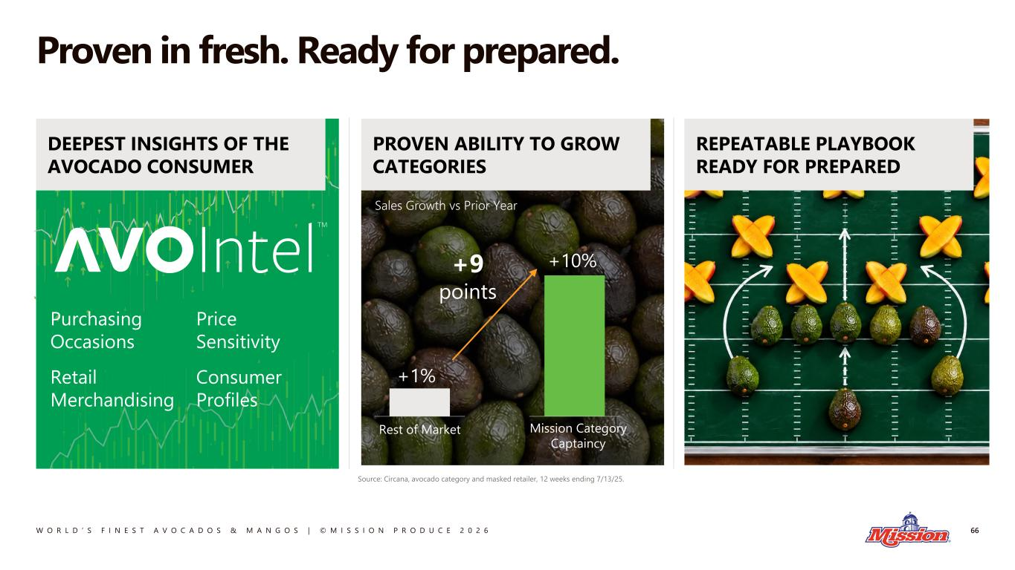
W O R L D ’ S F I N E S T A V O C A D O S & M A N G O S | © M I S S I O N P R O D U C E 2 0 2 6 Proven in fresh. Ready for prepared. 66 Sales Growth vs Prior Year REPEATABLE PLAYBOOK READY FOR PREPARED PROVEN ABILITY TO GROW CATEGORIES Rest of Market +1% Mission Category Captaincy +10%+9 points DEEPEST INSIGHTS OF THE AVOCADO CONSUMER Purchasing Occasions Retail Merchandising Price Sensitivity Consumer Profiles Source: Circana, avocado category and masked retailer, 12 weeks ending 7/13/25.

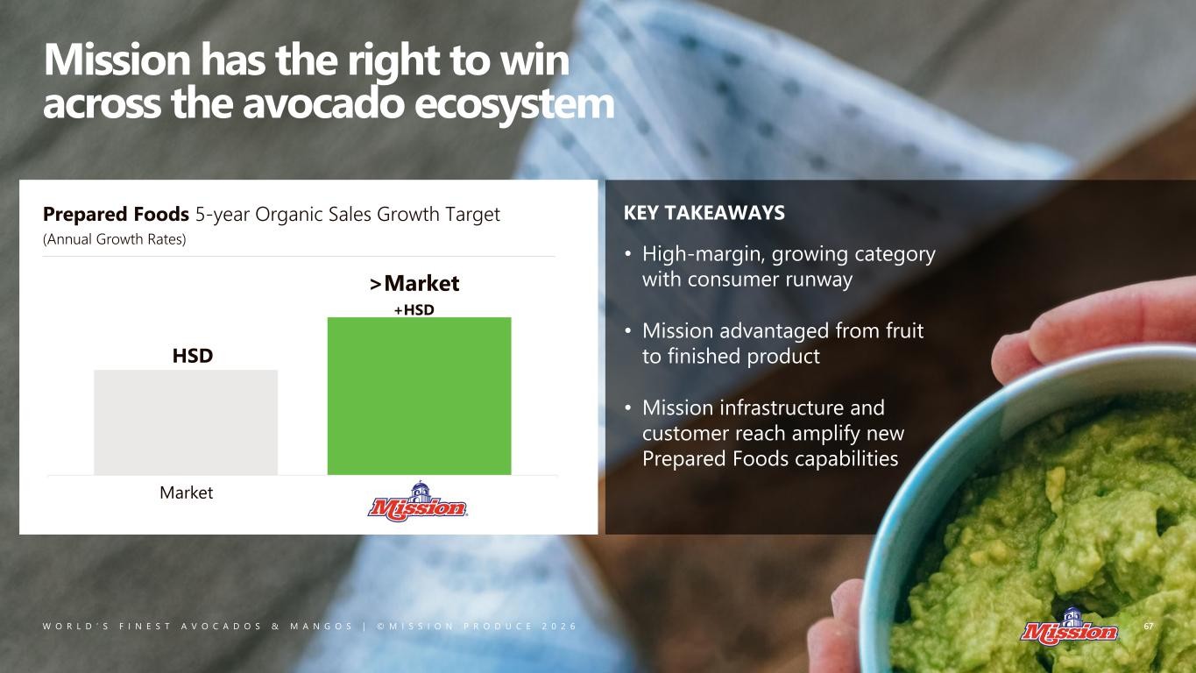
W O R L D ’ S F I N E S T A V O C A D O S & M A N G O S | © M I S S I O N P R O D U C E 2 0 2 6 Mission has the right to win across the avocado ecosystem KEY TAKEAWAYS HSD >Market +HSD Prepared Foods 5-year Organic Sales Growth Target (Annual Growth Rates) Market 67 • High-margin, growing category with consumer runway • Mission advantaged from fruit to finished product • Mission infrastructure and customer reach amplify new Prepared Foods capabilities

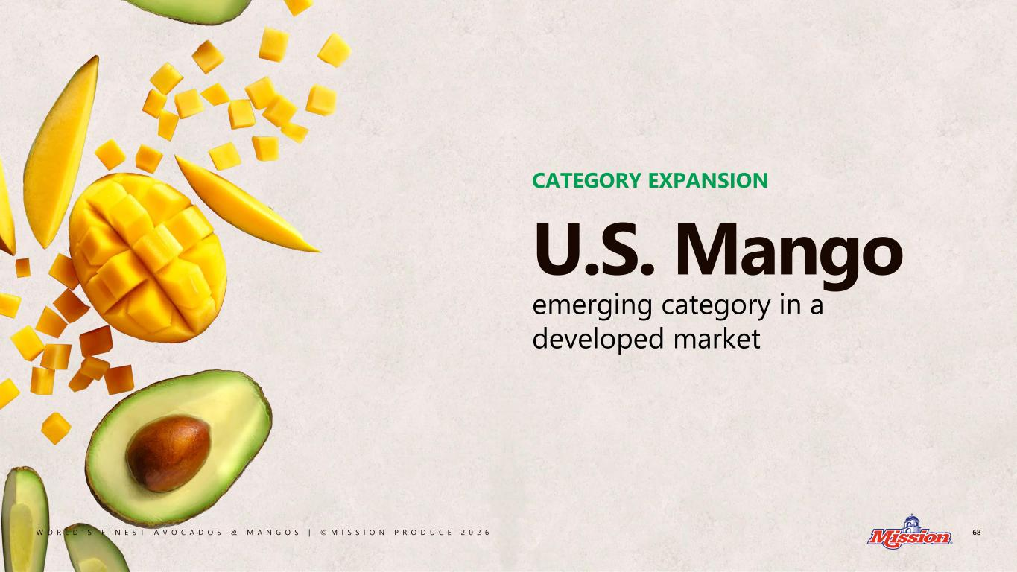
W O R L D ’ S F I N E S T A V O C A D O S & M A N G O S | © M I S S I O N P R O D U C E 2 0 2 6 68 U.S. Mango emerging category in a developed market CATEGORY EXPANSION

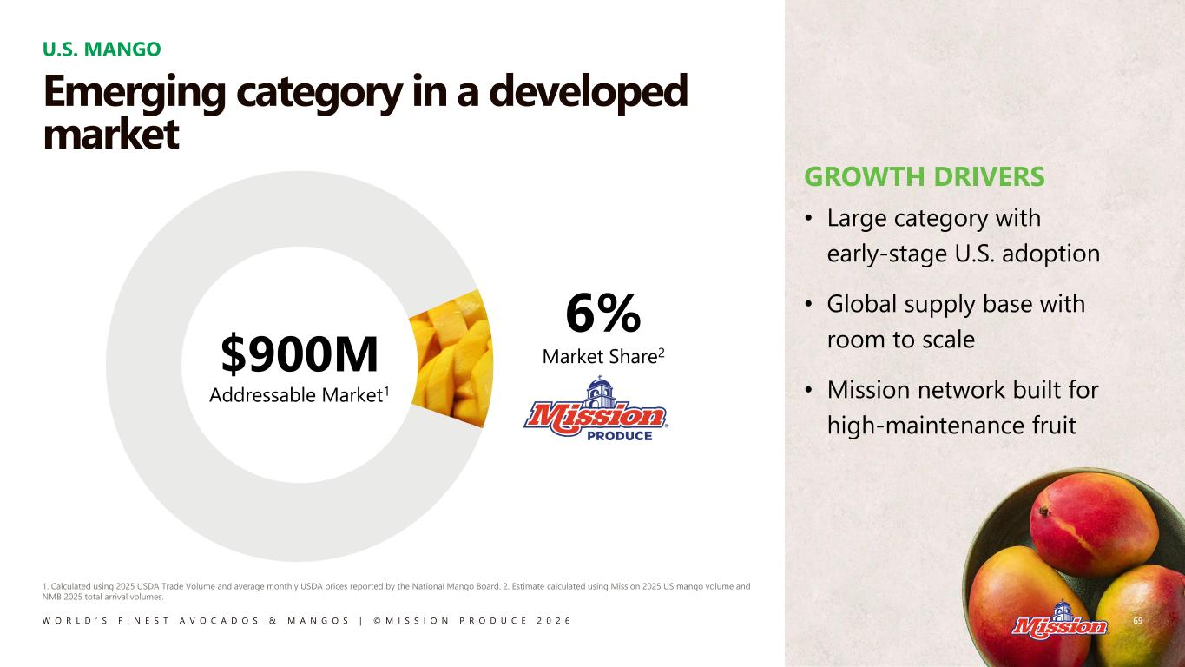
W O R L D ’ S F I N E S T A V O C A D O S & M A N G O S | © M I S S I O N P R O D U C E 2 0 2 6 GROWTH DRIVERS • Large category with early-stage U.S. adoption • Global supply base with room to scale • Mission network built for high-maintenance fruit U.S. MANGO 69 1. Calculated using 2025 USDA Trade Volume and average monthly USDA prices reported by the National Mango Board. 2. Estimate calculated using Mission 2025 US mango volume and NMB 2025 total arrival volumes. 6% Market Share2$900M Addressable Market1 Emerging category in a developed market

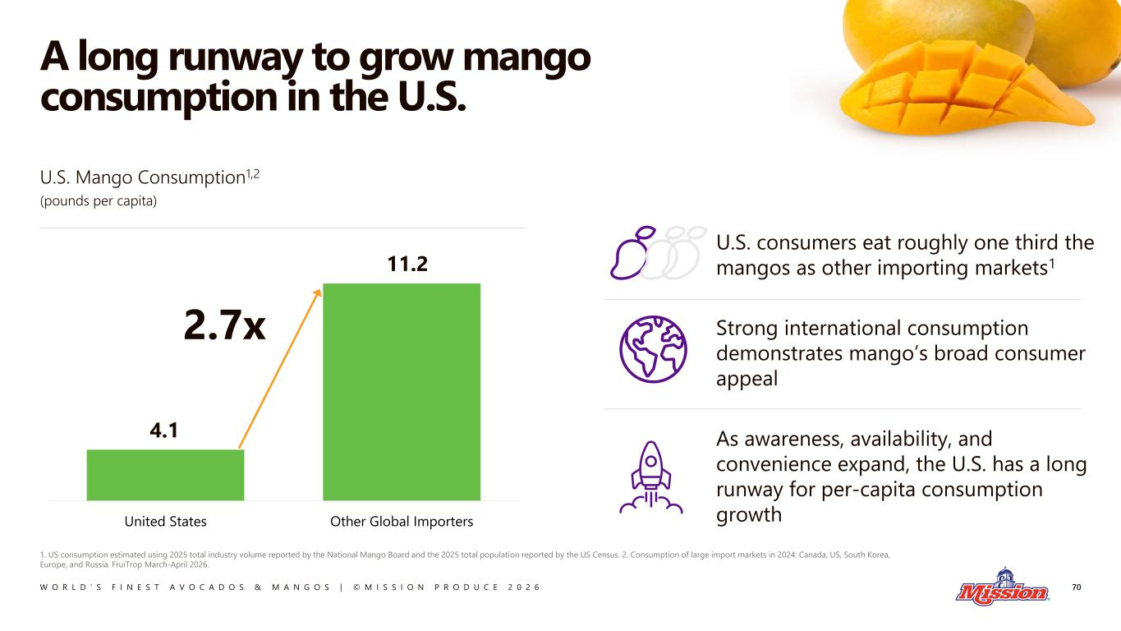
W O R L D ’ S F I N E S T A V O C A D O S & M A N G O S | © M I S S I O N P R O D U C E 2 0 2 6 United States Other Global Importers A long runway to grow mango consumption in the U.S. 70 1. US consumption estimated using 2025 total industry volume reported by the National Mango Board and the 2025 total population reported by the US Census. 2. Consumption of large import markets in 2024: Canada, US, South Korea, Europe, and Russia. FruiTrop March-April 2026. 4.1 11.2 U.S. consumers eat roughly one third the mangos as other importing markets1 Strong international consumption demonstrates mango’s broad consumer appeal As awareness, availability, and convenience expand, the U.S. has a long runway for per-capita consumption growth U.S. Mango Consumption1,2 (pounds per capita) 2.7x

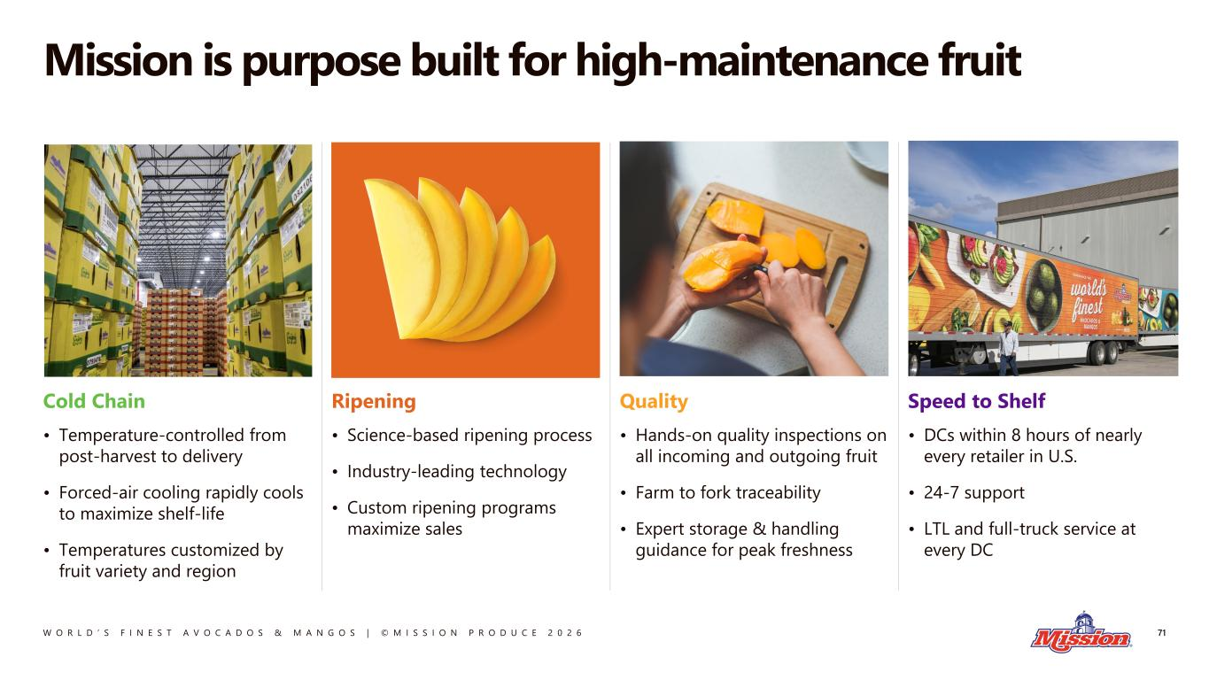
W O R L D ’ S F I N E S T A V O C A D O S & M A N G O S | © M I S S I O N P R O D U C E 2 0 2 6 Mission is purpose built for high-maintenance fruit 71 Speed to Shelf • DCs within 8 hours of nearly every retailer in U.S. • 24-7 support • LTL and full-truck service at every DC Quality • Hands-on quality inspections on all incoming and outgoing fruit • Farm to fork traceability • Expert storage & handling guidance for peak freshness Ripening • Science-based ripening process • Industry-leading technology • Custom ripening programs maximize sales Cold Chain • Temperature-controlled from post-harvest to delivery • Forced-air cooling rapidly cools to maximize shelf-life • Temperatures customized by fruit variety and region

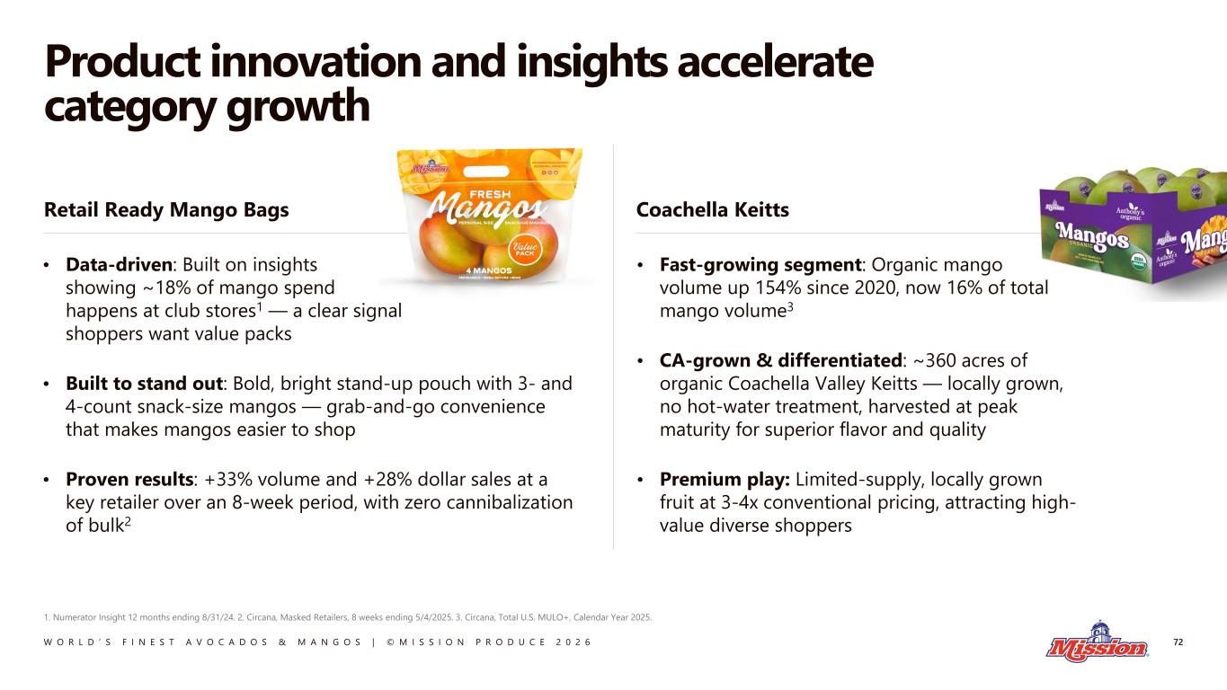
W O R L D ’ S F I N E S T A V O C A D O S & M A N G O S | © M I S S I O N P R O D U C E 2 0 2 6 Product innovation and insights accelerate category growth 72 1. Numerator Insight 12 months ending 8/31/24. 2. Circana, Masked Retailers, 8 weeks ending 5/4/2025. 3. Circana, Total U.S. MULO+, Calendar Year 2025. • Fast-growing segment: Organic mango volume up 154% since 2020, now 16% of total mango volume3 • CA-grown & differentiated: ~360 acres of organic Coachella Valley Keitts — locally grown, no hot-water treatment, harvested at peak maturity for superior flavor and quality • Premium play: Limited-supply, locally grown fruit at 3-4x conventional pricing, attracting high- value diverse shoppers • Data-driven: Built on insights showing ~18% of mango spend happens at club stores1 — a clear signal shoppers want value packs • Built to stand out: Bold, bright stand-up pouch with 3- and 4-count snack-size mangos — grab-and-go convenience that makes mangos easier to shop • Proven results: +33% volume and +28% dollar sales at a key retailer over an 8-week period, with zero cannibalization of bulk2 Retail Ready Mango Bags Coachella Keitts

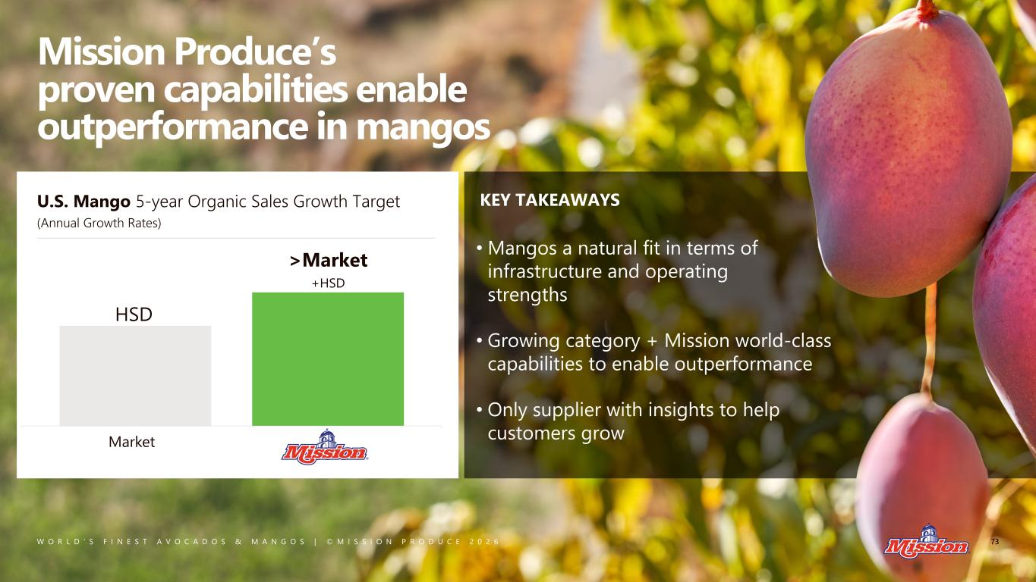
W O R L D ’ S F I N E S T A V O C A D O S & M A N G O S | © M I S S I O N P R O D U C E 2 0 2 6 Mission Produce’s proven capabilities enable outperformance in mangos KEY TAKEAWAYSU.S. Mango 5-year Organic Sales Growth Target (Annual Growth Rates) Market HSD >Market +HSD 73 • Mangos a natural fit in terms of infrastructure and operating strengths • Growing category + Mission world-class capabilities to enable outperformance • Only supplier with insights to help customers grow

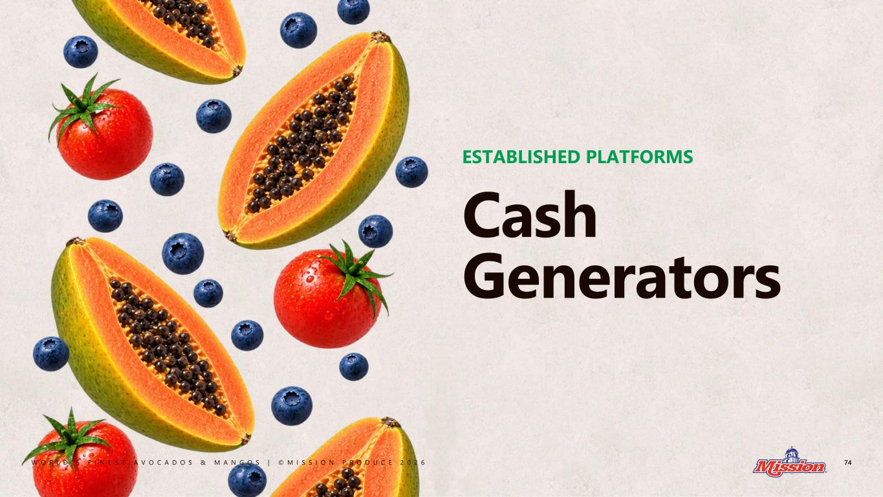
W O R L D ’ S F I N E S T A V O C A D O S & M A N G O S | © M I S S I O N P R O D U C E 2 0 2 6 74 Cash Generators ESTABLISHED PLATFORMS

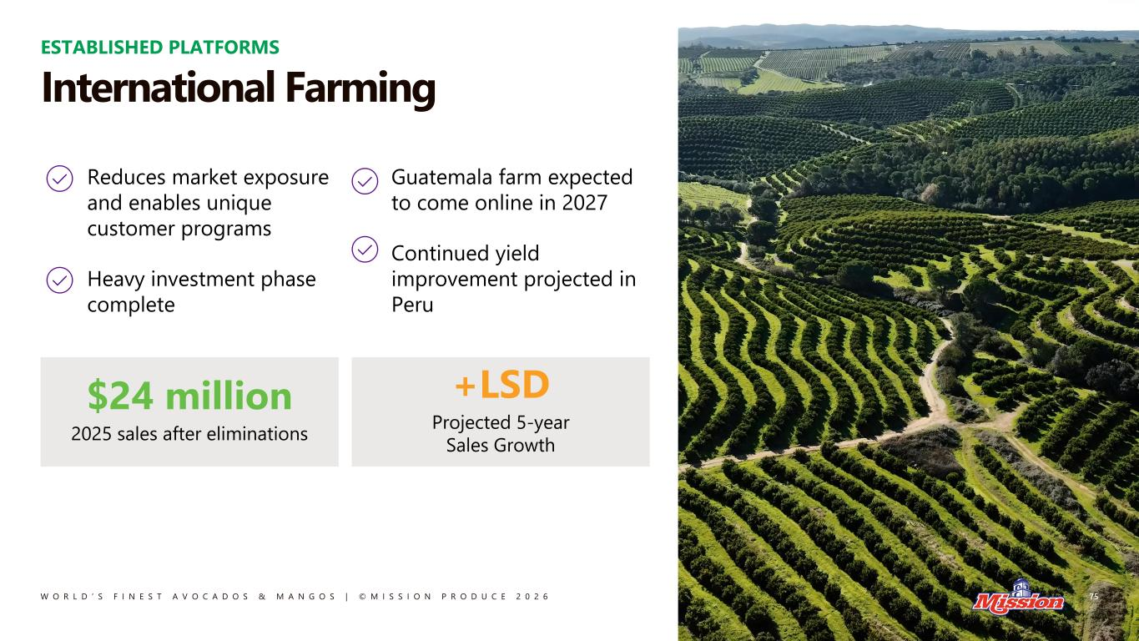
W O R L D ’ S F I N E S T A V O C A D O S & M A N G O S | © M I S S I O N P R O D U C E 2 0 2 6 75 Reduces market exposure and enables unique customer programs Heavy investment phase complete Guatemala farm expected to come online in 2027 Continued yield improvement projected in Peru ESTABLISHED PLATFORMS International Farming $24 million 2025 sales after eliminations +LSD Projected 5-year Sales Growth

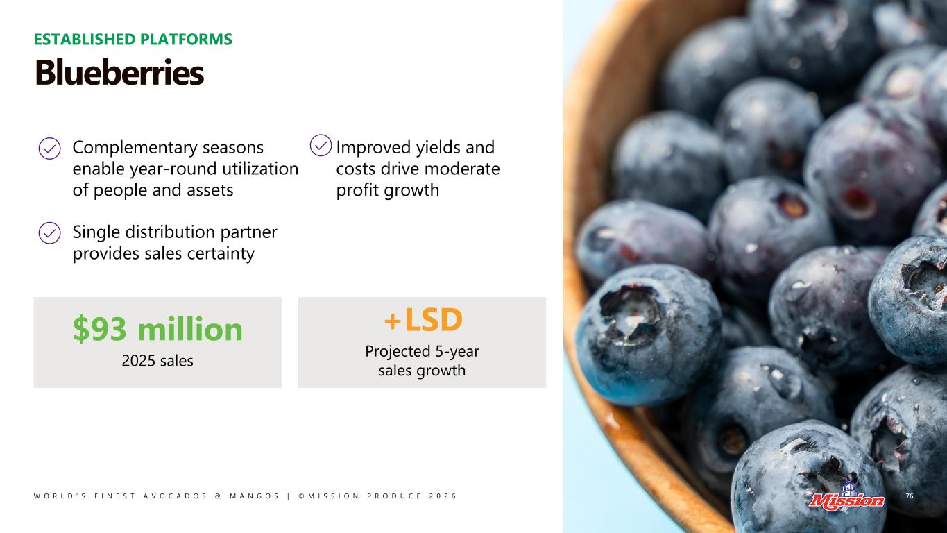
W O R L D ’ S F I N E S T A V O C A D O S & M A N G O S | © M I S S I O N P R O D U C E 2 0 2 6 76 ESTABLISHED PLATFORMS Blueberries $93 million 2025 sales +LSD Projected 5-year sales growth Complementary seasons enable year-round utilization of people and assets Single distribution partner provides sales certainty Improved yields and costs drive moderate profit growth

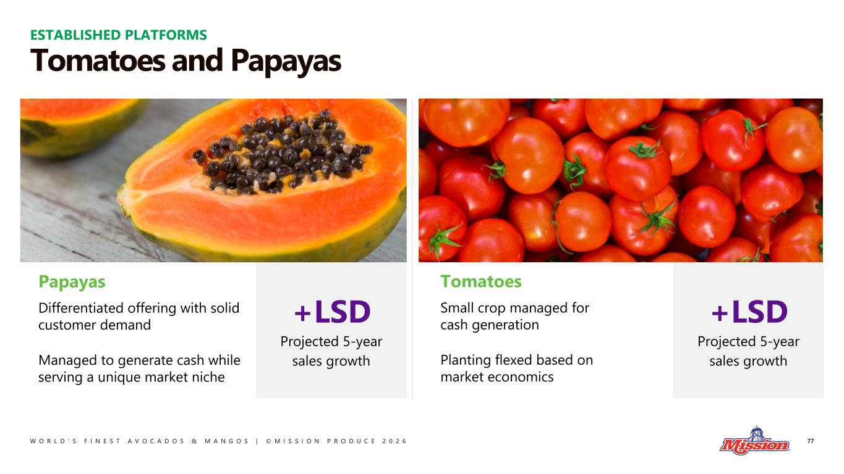
W O R L D ’ S F I N E S T A V O C A D O S & M A N G O S | © M I S S I O N P R O D U C E 2 0 2 6 +LSD Projected 5-year sales growth +LSD Projected 5-year sales growth Tomatoes and Papayas 77 Papayas Differentiated offering with solid customer demand Managed to generate cash while serving a unique market niche Tomatoes Small crop managed for cash generation Planting flexed based on market economics ESTABLISHED PLATFORMS

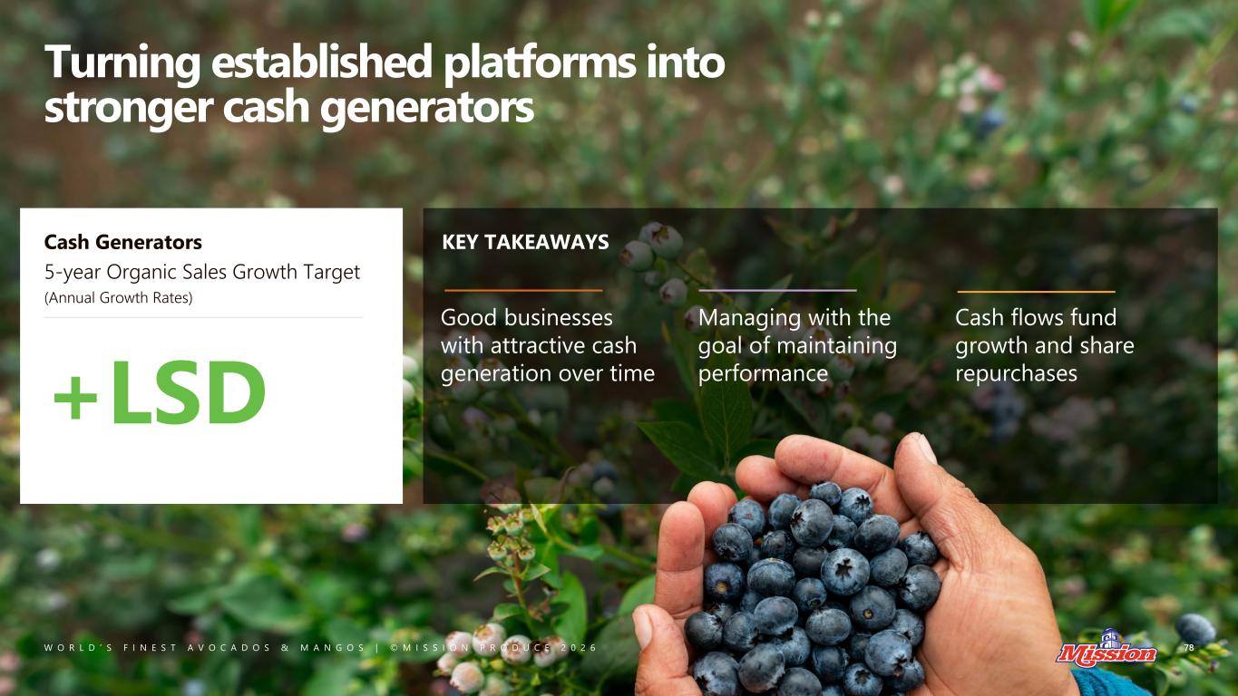
W O R L D ’ S F I N E S T A V O C A D O S & M A N G O S | © M I S S I O N P R O D U C E 2 0 2 6 Turning established platforms into stronger cash generators KEY TAKEAWAYSCash Generators 5-year Organic Sales Growth Target (Annual Growth Rates) 78 +LSD Good businesses with attractive cash generation over time Managing with the goal of maintaining performance Cash flows fund growth and share repurchases

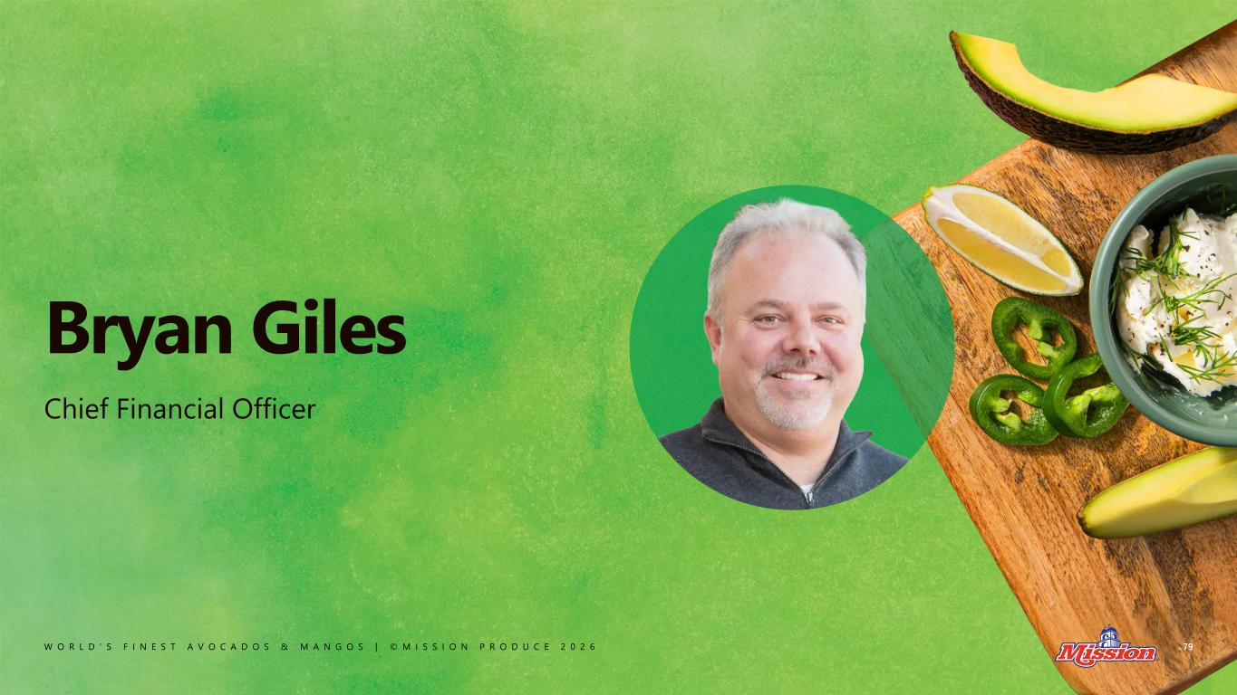
W O R L D ’ S F I N E S T A V O C A D O S & M A N G O S | © M I S S I O N P R O D U C E 2 0 2 6 Bryan Giles 79 Chief Financial Officer

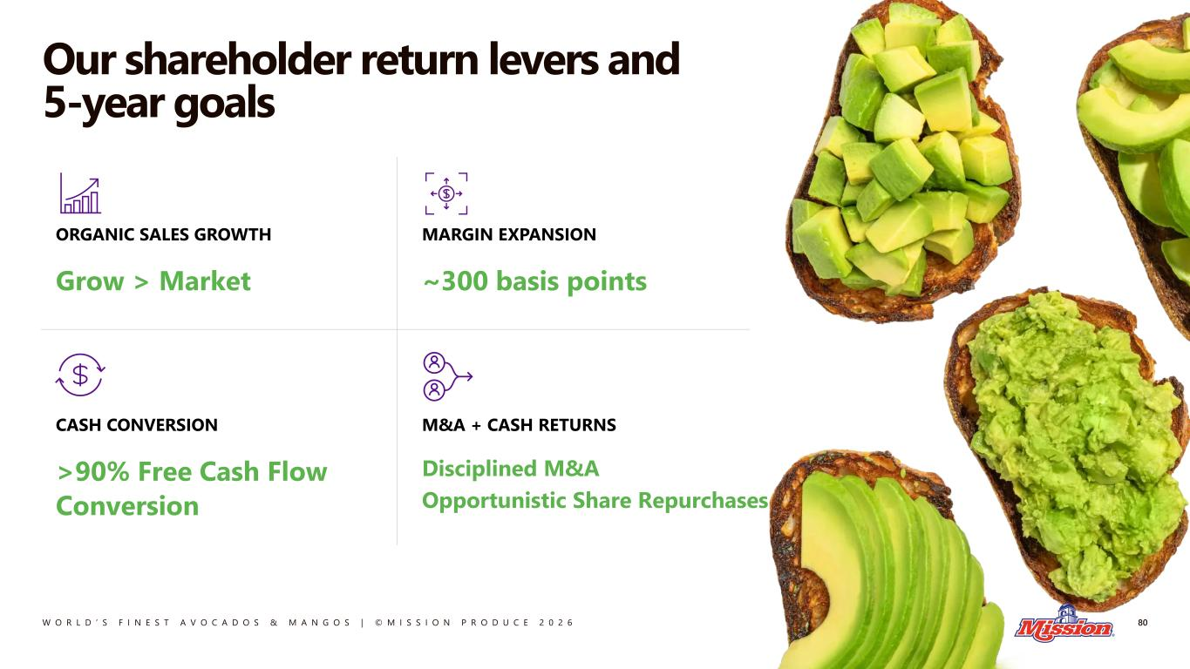
W O R L D ’ S F I N E S T A V O C A D O S & M A N G O S | © M I S S I O N P R O D U C E 2 0 2 6 ORGANIC SALES GROWTH Grow > Market MARGIN EXPANSION ~300 basis points CASH CONVERSION >90% Free Cash Flow Conversion M&A + CASH RETURNS Disciplined M&A Opportunistic Share Repurchases Our shareholder return levers and 5-year goals 80

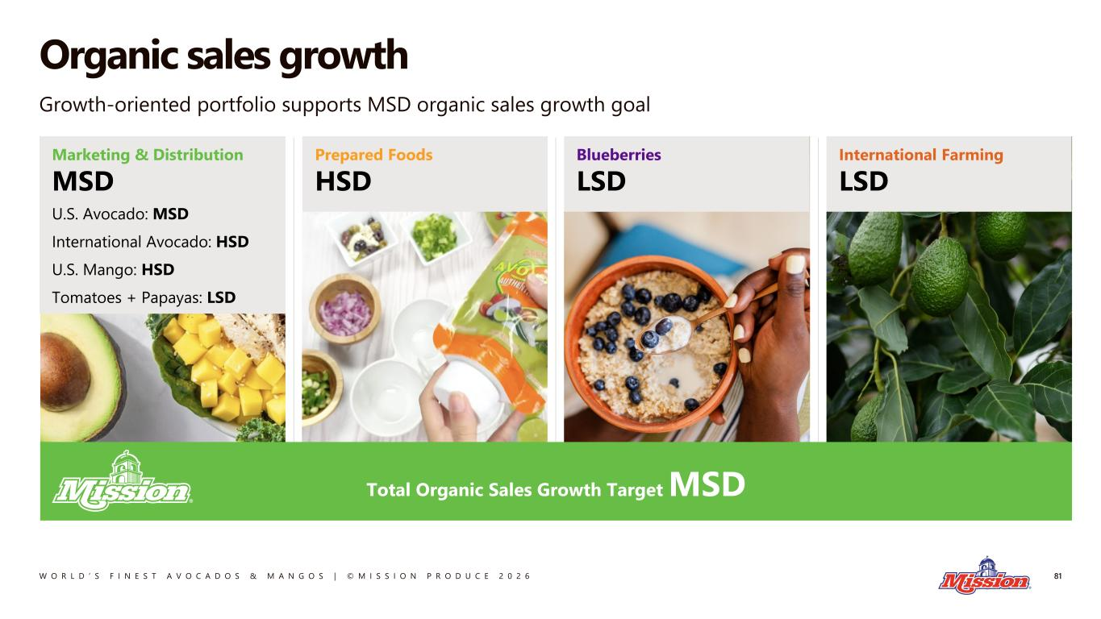
W O R L D ’ S F I N E S T A V O C A D O S & M A N G O S | © M I S S I O N P R O D U C E 2 0 2 6 Organic sales growth 81 Growth-oriented portfolio supports MSD organic sales growth goal Marketing & Distribution MSD U.S. Avocado: MSD International Avocado: HSD U.S. Mango: HSD Tomatoes + Papayas: LSD International Farming LSD Blueberries LSD Prepared Foods HSD Total Organic Sales Growth Target MSD

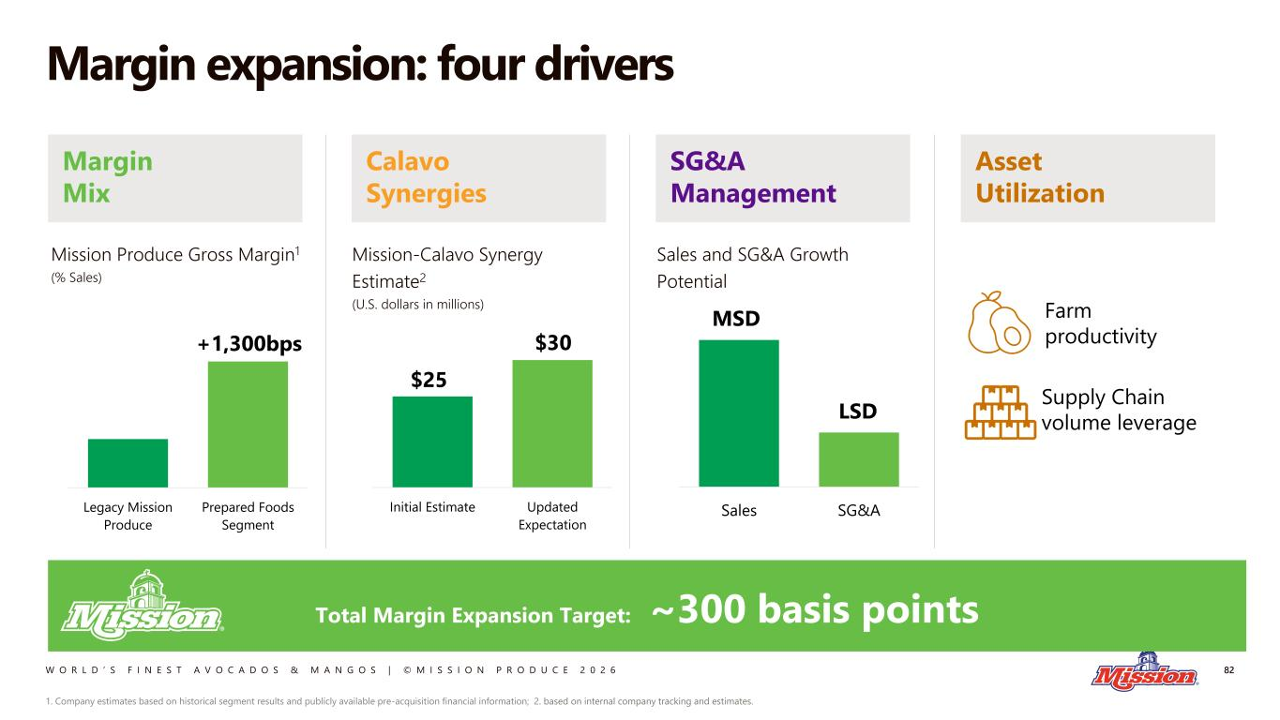
W O R L D ’ S F I N E S T A V O C A D O S & M A N G O S | © M I S S I O N P R O D U C E 2 0 2 6 Margin Mix Asset Utilization SG&A Management Calavo Synergies Margin expansion: four drivers 82 Total Margin Expansion Target: ~300 basis points Legacy Mission Produce Prepared Foods Segment Mission Produce Gross Margin1 (% Sales) +1,300bps Initial Estimate Updated Expectation Mission-Calavo Synergy Estimate2 (U.S. dollars in millions) $30 $25 Sales SG&A LSD MSD Sales and SG&A Growth Potential 1. Company estimates based on historical segment results and publicly available pre-acquisition financial information; 2. based on internal company tracking and estimates. Farm productivity Supply Chain volume leverage

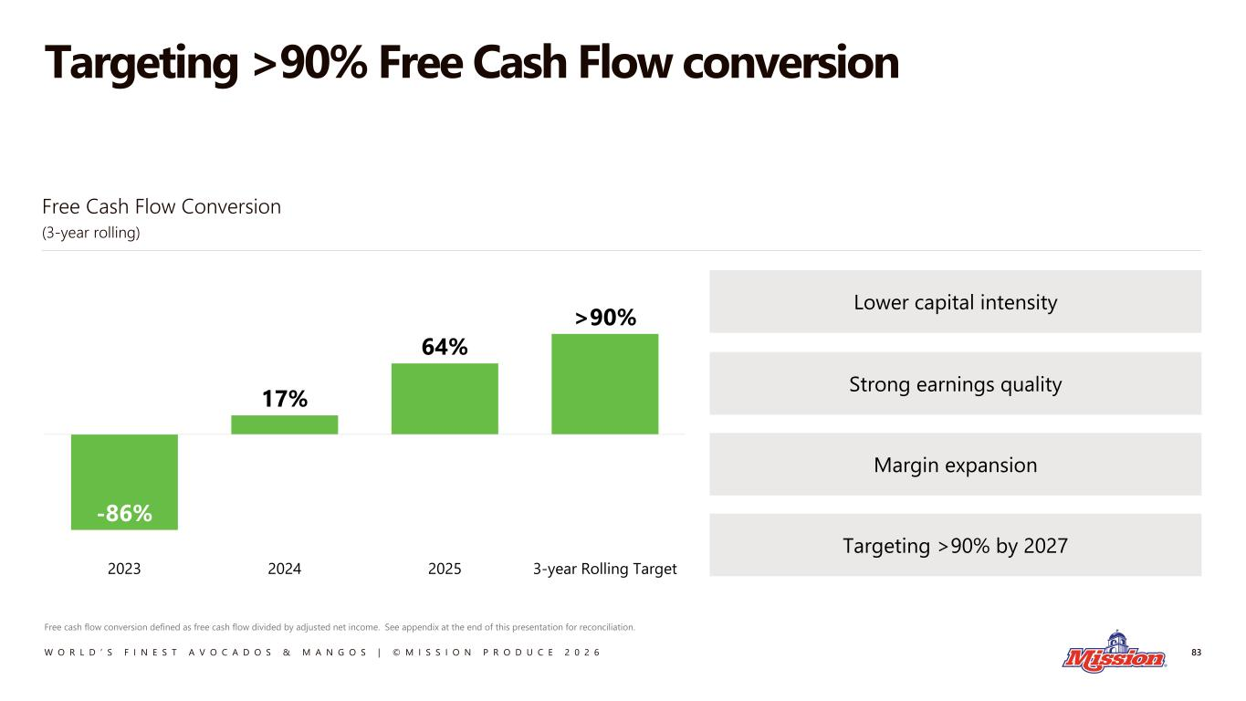
W O R L D ’ S F I N E S T A V O C A D O S & M A N G O S | © M I S S I O N P R O D U C E 2 0 2 6 Targeting >90% Free Cash Flow conversion 83 Free cash flow conversion defined as free cash flow divided by adjusted net income. See appendix at the end of this presentation for reconciliation. -86% 17% 64% >90% 2023 2024 2025 3-year Rolling Target Lower capital intensity Strong earnings quality Margin expansion Targeting >90% by 2027 Free Cash Flow Conversion (3-year rolling)

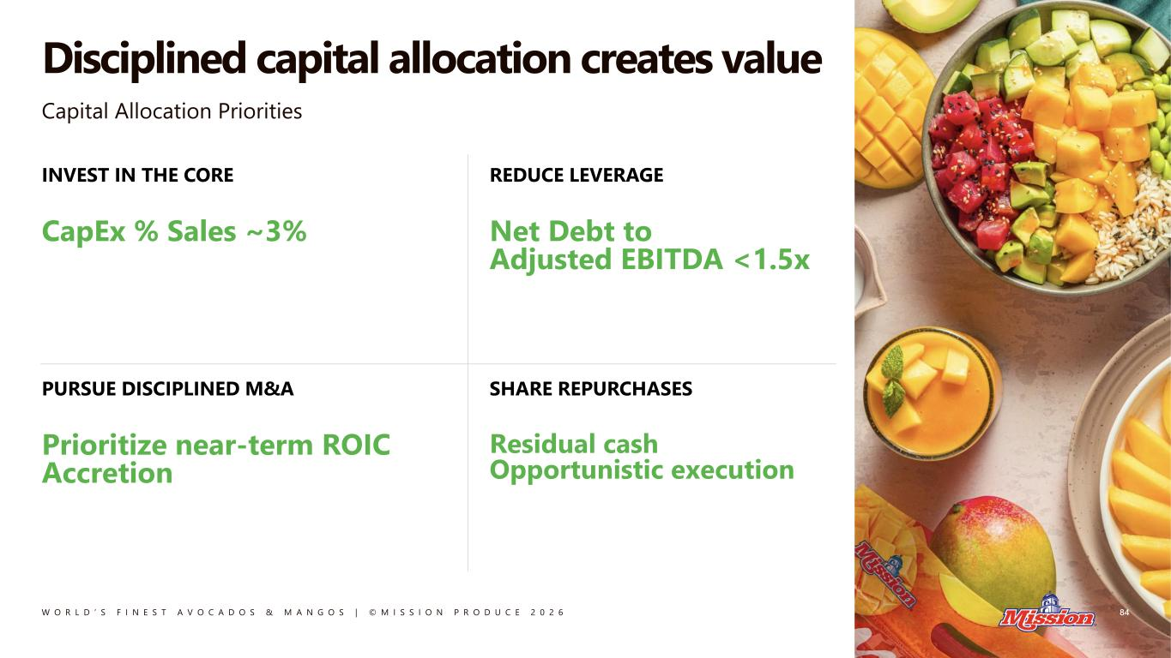
W O R L D ’ S F I N E S T A V O C A D O S & M A N G O S | © M I S S I O N P R O D U C E 2 0 2 6 Disciplined capital allocation creates value 84 Capital Allocation Priorities INVEST IN THE CORE CapEx % Sales ~3% REDUCE LEVERAGE Net Debt to Adjusted EBITDA <1.5x PURSUE DISCIPLINED M&A Prioritize near-term ROIC Accretion SHARE REPURCHASES Residual cash Opportunistic execution

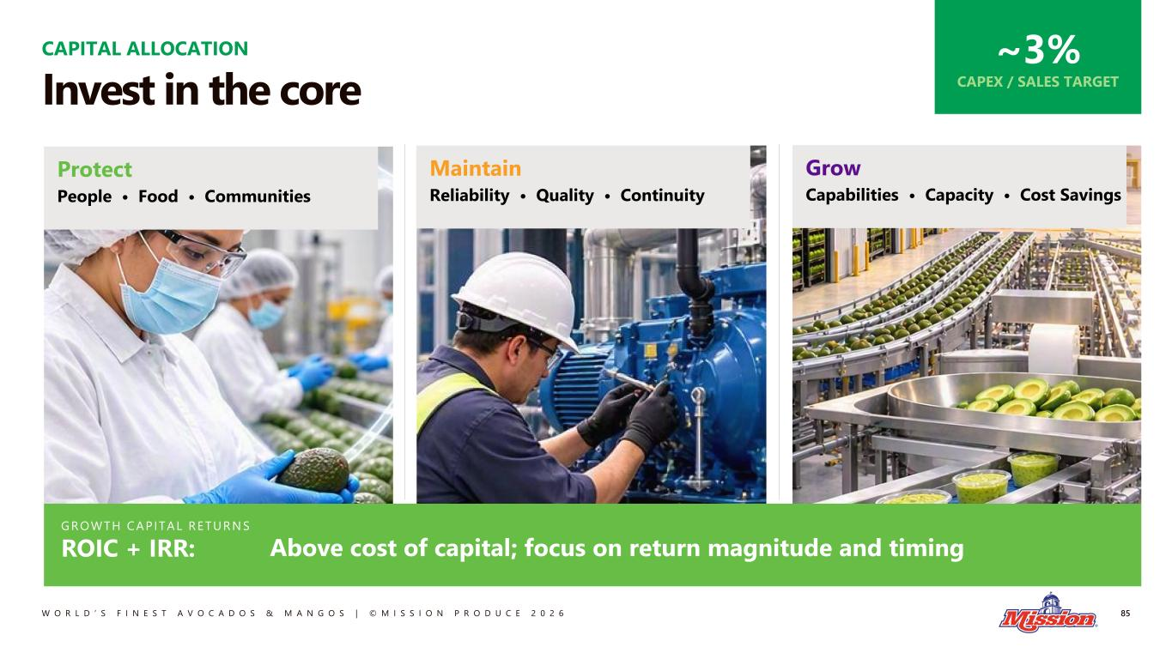
W O R L D ’ S F I N E S T A V O C A D O S & M A N G O S | © M I S S I O N P R O D U C E 2 0 2 6 ~3% CAPEX / SALES TARGET CAPITAL ALLOCATION Invest in the core Protect People • Food • Communities Grow Capabilities • Capacity • Cost Savings Maintain Reliability • Quality • Continuity 85 GROWTH CAP ITAL RETURN S ROIC + IRR: Above cost of capital; focus on return magnitude and timing

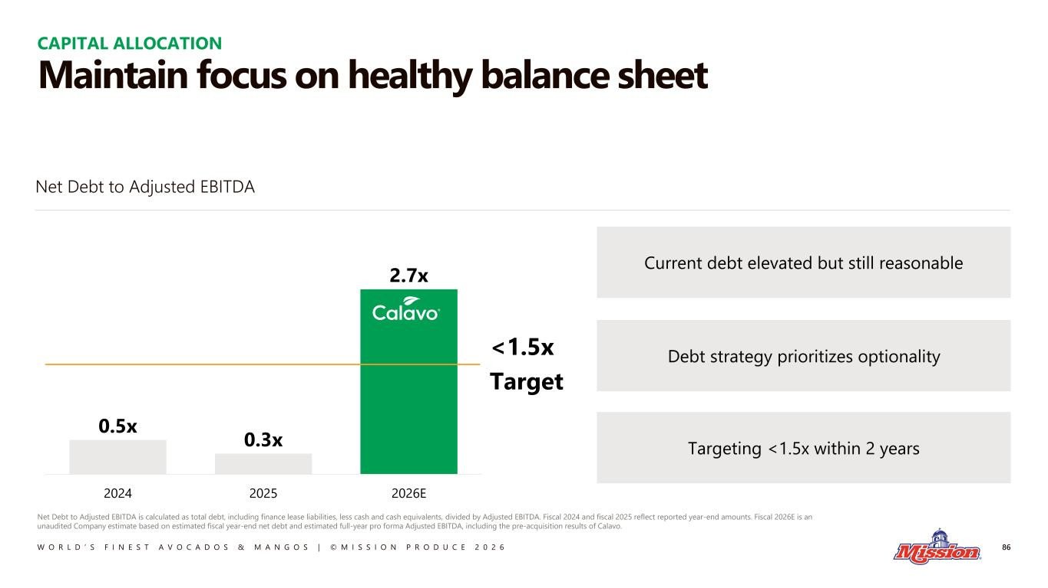
W O R L D ’ S F I N E S T A V O C A D O S & M A N G O S | © M I S S I O N P R O D U C E 2 0 2 6 Maintain focus on healthy balance sheet 86 Net Debt to Adjusted EBITDA is calculated as total debt, including finance lease liabilities, less cash and cash equivalents, divided by Adjusted EBITDA. Fiscal 2024 and fiscal 2025 reflect reported year-end amounts. Fiscal 2026E is an unaudited Company estimate based on estimated fiscal year-end net debt and estimated full-year pro forma Adjusted EBITDA, including the pre-acquisition results of Calavo. 0.5x 0.3x 2.7x 2024 2025 2026E <1.5x Target Current debt elevated but still reasonable Debt strategy prioritizes optionality Targeting <1.5x within 2 years Net Debt to Adjusted EBITDA CAPITAL ALLOCATION

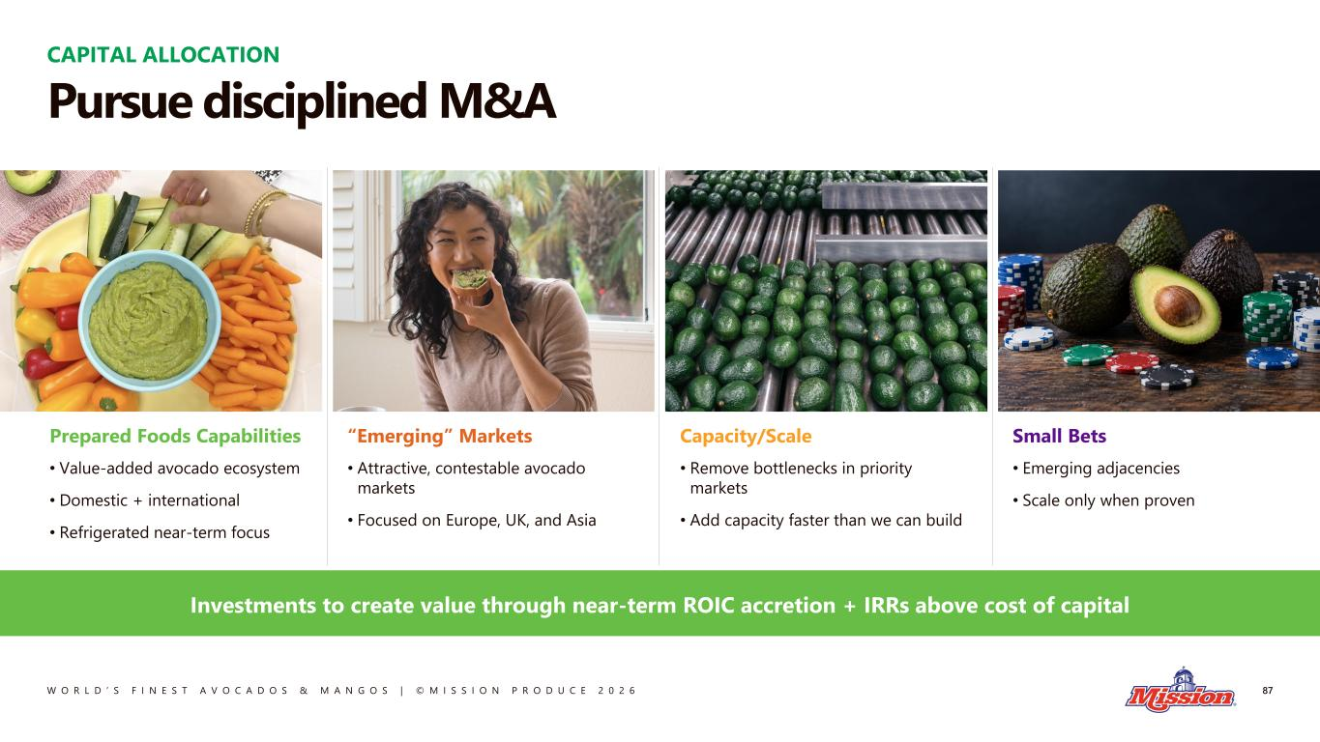
W O R L D ’ S F I N E S T A V O C A D O S & M A N G O S | © M I S S I O N P R O D U C E 2 0 2 6 CAPITAL ALLOCATION Pursue disciplined M&A “Emerging” Markets • Attractive, contestable avocado markets • Focused on Europe, UK, and Asia Small Bets • Emerging adjacencies • Scale only when proven Prepared Foods Capabilities • Value-added avocado ecosystem • Domestic + international • Refrigerated near-term focus Capacity/Scale • Remove bottlenecks in priority markets • Add capacity faster than we can build Investments to create value through near-term ROIC accretion + IRRs above cost of capital 87

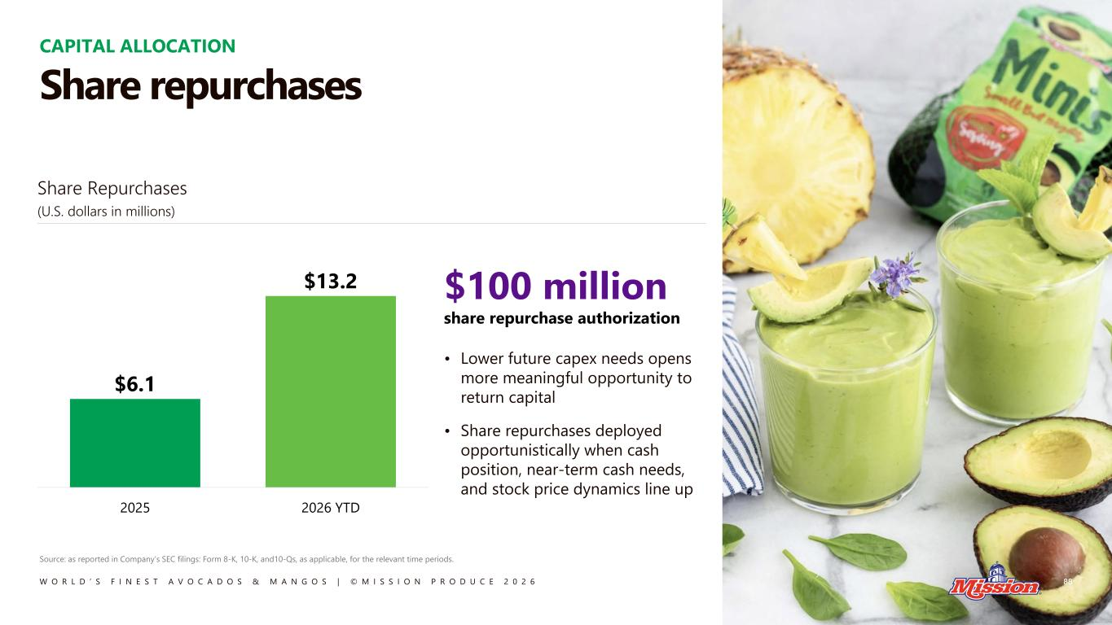
W O R L D ’ S F I N E S T A V O C A D O S & M A N G O S | © M I S S I O N P R O D U C E 2 0 2 6 $100 million share repurchase authorization • Lower future capex needs opens more meaningful opportunity to return capital • Share repurchases deployed opportunistically when cash position, near-term cash needs, and stock price dynamics line up $6.1 $13.2 2025 2026 YTD CAPITAL ALLOCATION Share repurchases 88 Share Repurchases (U.S. dollars in millions) Source: as reported in Company’s SEC filings: Form 8-K, 10-K, and10-Qs, as applicable, for the relevant time periods.

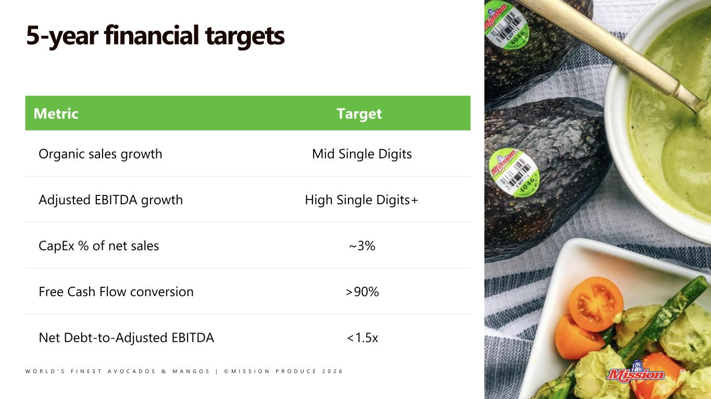
W O R L D ’ S F I N E S T A V O C A D O S & M A N G O S | © M I S S I O N P R O D U C E 2 0 2 6 5-year financial targets 89 Metric Target Organic sales growth Mid Single Digits Adjusted EBITDA growth High Single Digits+ CapEx % of net sales ~3% Free Cash Flow conversion >90% Net Debt-to-Adjusted EBITDA <1.5x

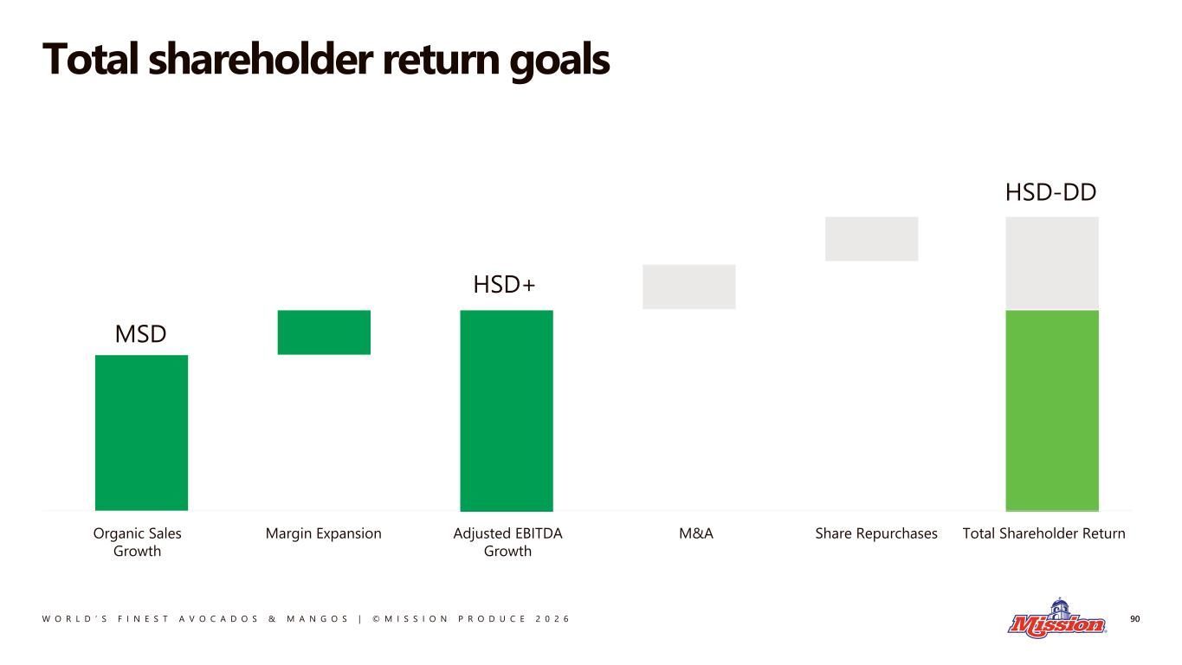
W O R L D ’ S F I N E S T A V O C A D O S & M A N G O S | © M I S S I O N P R O D U C E 2 0 2 6 Total shareholder return goals 90 Organic Sales Growth Margin Expansion MSD M&A Share Repurchases Total Shareholder Return HSD-DD HSD+ Adjusted EBITDA Growth

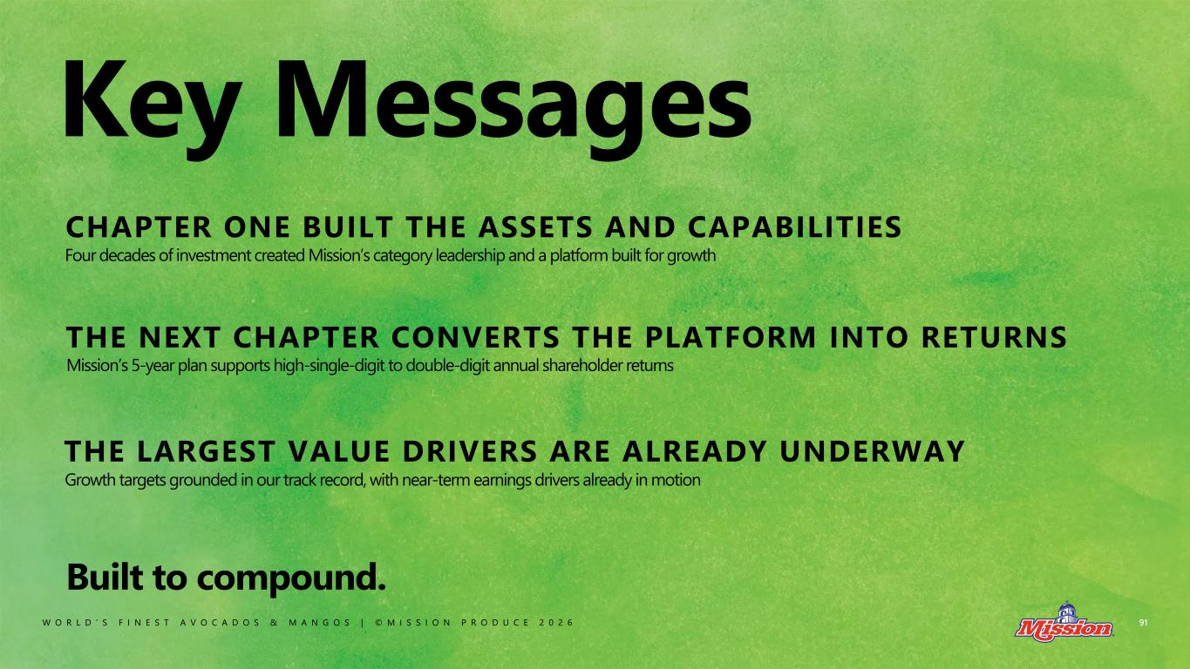
W O R L D ’ S F I N E S T A V O C A D O S & M A N G O S | © M I S S I O N P R O D U C E 2 0 2 6 Key Messages CHAPTER ONE BUILT THE ASSETS AND CAPABILITIES Built to compound. THE LARGEST VALUE DRIVERS ARE ALREADY UNDERWAY THE NEXT CHAPTER CONVERTS THE PLATFORM INTO RETURNS Four decades of investment created Mission’s category leadership and a platform built for growth Growth targets grounded in our track record, with near-term earnings drivers already in motion Mission’s 5-year plan supports high-single-digit to double-digit annual shareholder returns 91

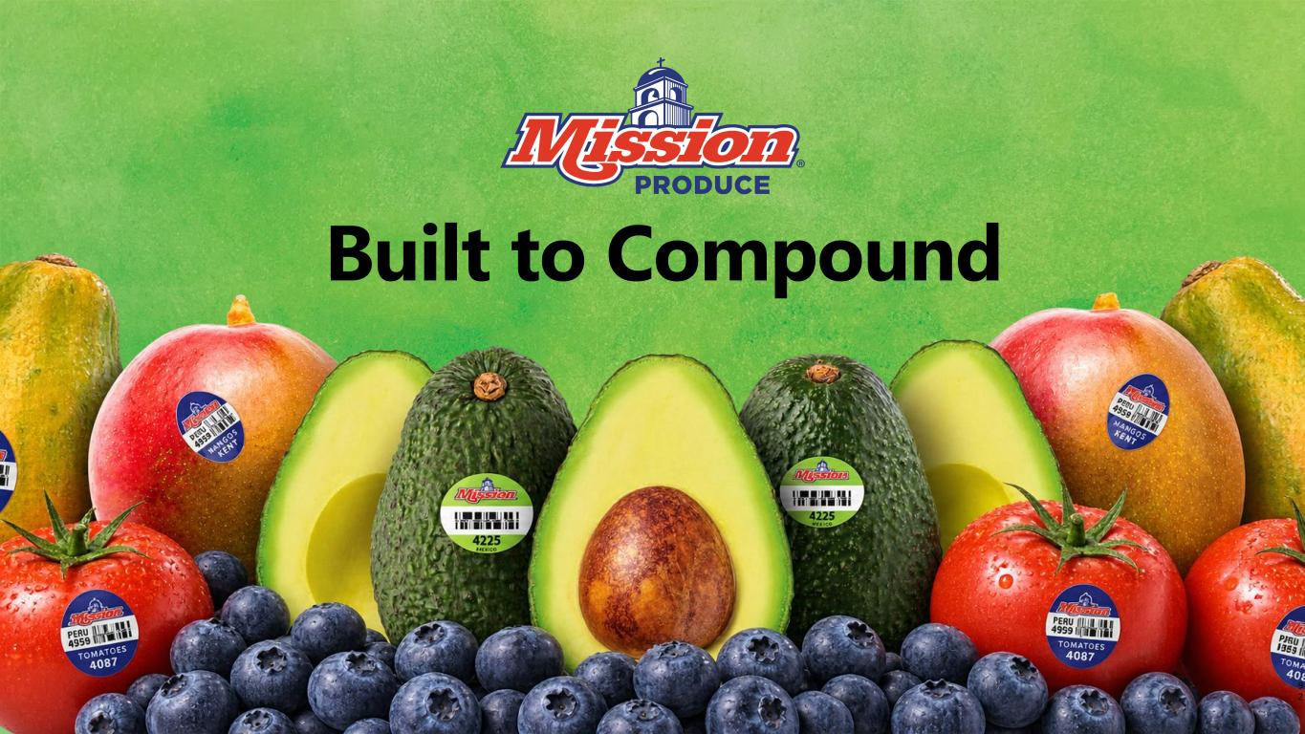
9 2 Built to Compound

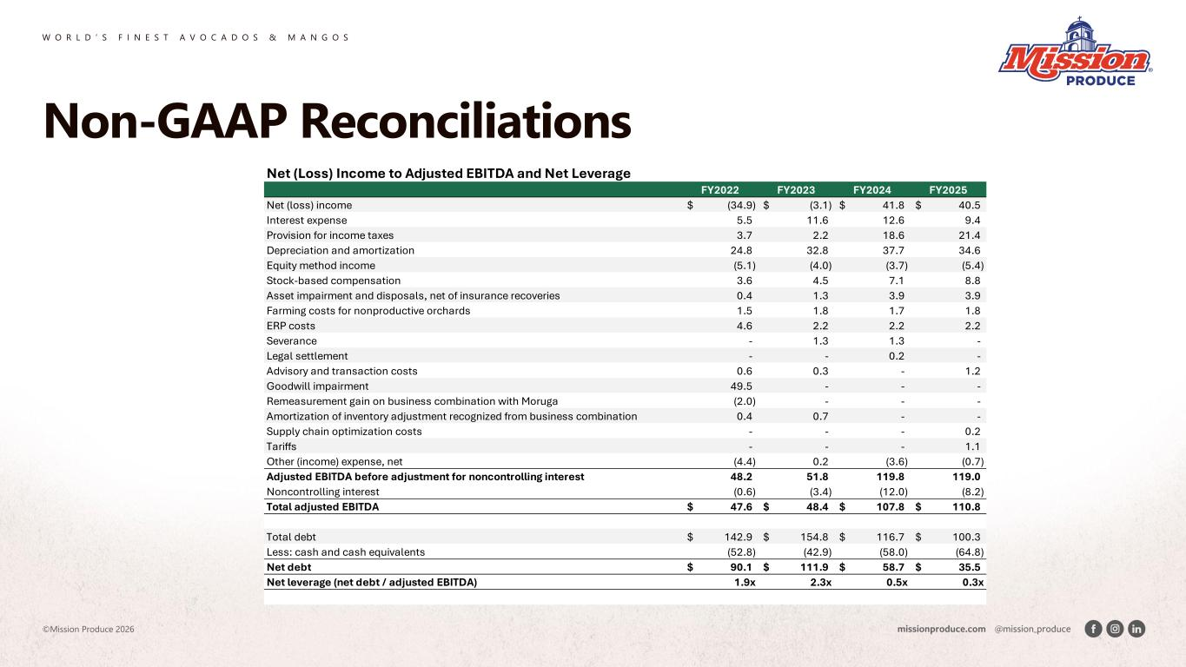
W O R L D ’ S F I N E S T A V O C A D O S & M A N G O S ©Mission Produce 2026 Non-GAAP Reconciliations Net (Loss) Income to Adjusted EBITDA and Net Leverage FY2022 FY2023 FY2024 FY2025 Net (loss) income (34.9)$ (3.1)$ 41.8$ 40.5$ Interest expense 5.5 11.6 12.6 9.4 Provision for income taxes 3.7 2.2 18.6 21.4 Depreciation and amortization 24.8 32.8 37.7 34.6 Equity method income (5.1) (4.0) (3.7) (5.4) Stock-based compensation 3.6 4.5 7.1 8.8 Asset impairment and disposals, net of insurance recoveries 0.4 1.3 3.9 3.9 Farming costs for nonproductive orchards 1.5 1.8 1.7 1.8 ERP costs 4.6 2.2 2.2 2.2 Severance - 1.3 1.3 - Legal settlement - - 0.2 - Advisory and transaction costs 0.6 0.3 - 1.2 Goodwill impairment 49.5 - - - Remeasurement gain on business combination with Moruga (2.0) - - - Amortization of inventory adjustment recognized from business combination 0.4 0.7 - - Supply chain optimization costs - - - 0.2 Tariffs - - - 1.1 Other (income) expense, net (4.4) 0.2 (3.6) (0.7) Adjusted EBITDA before adjustment for noncontrolling interest 48.2 51.8 119.8 119.0 Noncontrolling interest (0.6) (3.4) (12.0) (8.2) Total adjusted EBITDA 47.6$ 48.4$ 107.8$ 110.8$ Total debt 142.9$ 154.8$ 116.7$ 100.3$ Less: cash and cash equivalents (52.8) (42.9) (58.0) (64.8) Net debt 90.1$ 111.9$ 58.7$ 35.5$ Net leverage (net debt / adjusted EBITDA) 1.9x 2.3x 0.5x 0.3x

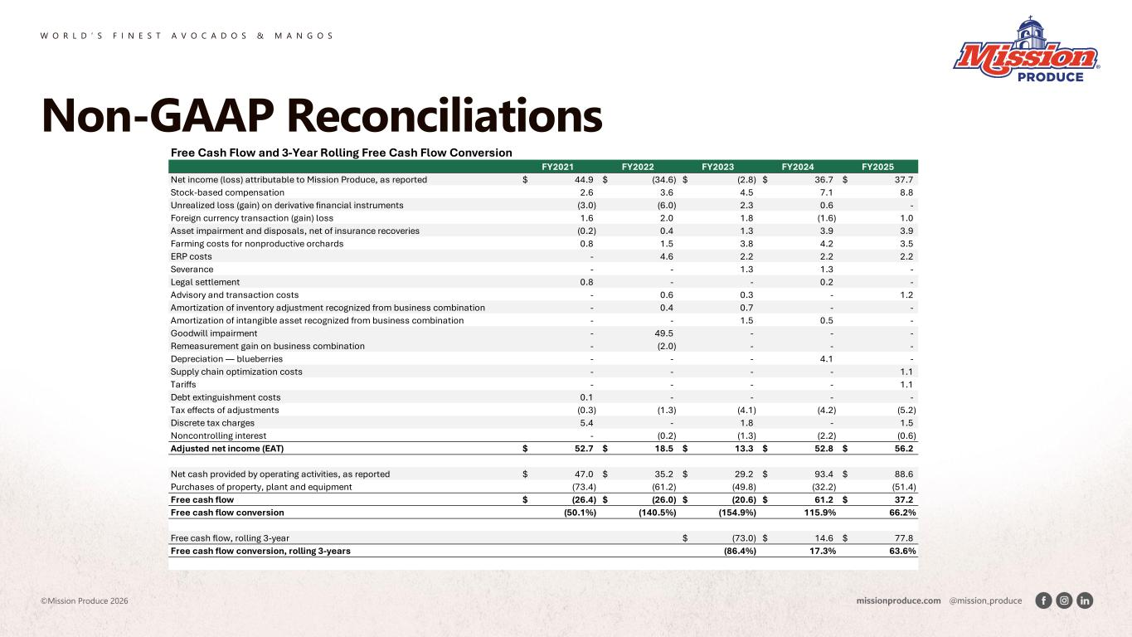
W O R L D ’ S F I N E S T A V O C A D O S & M A N G O S ©Mission Produce 2026 Non-GAAP Reconciliations Free Cash Flow and 3-Year Rolling Free Cash Flow Conversion FY2021 FY2022 FY2023 FY2024 FY2025 Net income (loss) attributable to Mission Produce, as reported 44.9$ (34.6)$ (2.8)$ 36.7$ 37.7$ Stock-based compensation 2.6 3.6 4.5 7.1 8.8 Unrealized loss (gain) on derivative financial instruments (3.0) (6.0) 2.3 0.6 - Foreign currency transaction (gain) loss 1.6 2.0 1.8 (1.6) 1.0 Asset impairment and disposals, net of insurance recoveries (0.2) 0.4 1.3 3.9 3.9 Farming costs for nonproductive orchards 0.8 1.5 3.8 4.2 3.5 ERP costs - 4.6 2.2 2.2 2.2 Severance - - 1.3 1.3 - Legal settlement 0.8 - - 0.2 - Advisory and transaction costs - 0.6 0.3 - 1.2 Amortization of inventory adjustment recognized from business combination - 0.4 0.7 - - Amortization of intangible asset recognized from business combination - - 1.5 0.5 - Goodwill impairment - 49.5 - - - Remeasurement gain on business combination - (2.0) - - - Depreciation — blueberries - - - 4.1 - Supply chain optimization costs - - - - 1.1 Tariffs - - - - 1.1 Debt extinguishment costs 0.1 - - - - Tax effects of adjustments (0.3) (1.3) (4.1) (4.2) (5.2) Discrete tax charges 5.4 - 1.8 - 1.5 Noncontrolling interest - (0.2) (1.3) (2.2) (0.6) Adjusted net income (EAT) 52.7$ 18.5$ 13.3$ 52.8$ 56.2$ Net cash provided by operating activities, as reported 47.0$ 35.2$ 29.2$ 93.4$ 88.6$ Purchases of property, plant and equipment (73.4) (61.2) (49.8) (32.2) (51.4) Free cash flow (26.4)$ (26.0)$ (20.6)$ 61.2$ 37.2$ Free cash flow conversion (50.1%) (140.5%) (154.9%) 115.9% 66.2% Free cash flow, rolling 3-year (73.0)$ 14.6$ 77.8$ Free cash flow conversion, rolling 3-years (86.4%) 17.3% 63.6%

